

Teaching and Learning in Action

Contents
Teaching and Learning in Action 1
What are our core principles for Teaching and Learning in Action? 4
The Model for Great Teaching 5
Curriculum and Teaching and Learning Principles 6
2025 -2027 6
What is the vision for Teaching? 8
Homework 9
Exemplification 11
Responsibilities 11
Implementing the Curriculum and Teaching Principles at a Faculty Level 12
Core Principles for 2023-25 13
Core Principles for 2023-25: Classroom management 14
Core Principles for 2023-25: Modelling 17
Core Principles for 2023-25: Checking for Understanding 19
Core Principles for 2023-25: Developing Student Responses 22
Core Principles for 2025-27 24
Core Principle for 25-27: adaptive teaching 25
Core Principle for 25-27: Using mini whiteboards to check for understanding 27
Core Principle for 25-27: ORACY 29
Core Principle for 25-27: literacy 31
Homework 33
Whole School CPD 34
Appendix 1: QA cycle for 2025 37
Appendix 2: Raising teacher standards program 38
Phase 1 of Teacher support process: HOS/HOF 38
Phase 2 of Teacher support process: Raising Teacher standards Informal Support 38
Phase 3 of Teacher support process: Raising Teacher standards formal Support 39
Appendix 3: Feedback Guidelines 40
Aims of the Feedback guidelines 42
What does the research say about marking? 42
Teachers’ standards 43
Ofsted recommendations 43
Managing Teachers’ workload 44
In Summary 44
Principles of Feedback 46
What does feedback look like at The Duston School? 46
Leadership monitoring & Quality assurance 48
Work scrutiny – Example RAG 49
Student voice 50
Examples of Whole-class feedback: English 51
Examples of Whole-class feedback: Maths 53
Appendix 4 – CPD Pathways 55
Appendix 5: Directory of expertise 64
Classroom Management 65
Modelling 65
Checking for Understanding 65
Developing Student Repsonses 65

What are our core principles for Teaching and Learning in Action?

These documents are designed to help identify and provide guidance on the elements of teaching practice which make the most difference to student learning within the context of The Duston School. They exemplify the principles that are outlined in the Curriculum and Teaching Principles document.
These principles have developed from our school vision over the last five years, and from the quality assurance process identifying where the most impact on student learning can be made in the classroom. They are formed from the principle of deliberate practice as a means to ensure staff are highly intentional and technique-aware in order to maximise student learning and provide ongoing professional development for teachers, allowing staff to reflect on their practice and make effective improvements and refinements as a result.
How do we monitor the effectiveness of the core principles?
The quality assurance process looks at each department in the school at three points throughout the year, using learning walks to monitor the effectiveness of teaching and learning in action. Leaders will use these learning walks to evaluate how staff are employing the teaching and learning principles and where further training and development is required. Staff who require support to improve these principles can be placed on the Raising Teacher Standards Program (Appendix 1)
How can core principles for Teaching and Learning be used practically in school?
- Guidance provided in staff briefing
- Guidance provided for staff via the Bluesky system
- Use of the Great Teaching Toolkit through the coaching programme and CPD pathways
- Through the QA process from feedback for learning walks
- Departmental CPD sessions

The Model for Great Teaching
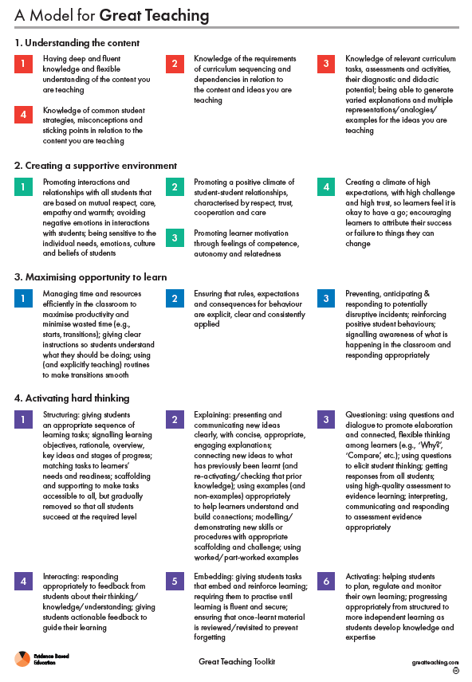
In 2025-27 we have introduced the Great Teaching Toolkit as a model to help teachers identify which areas of their own practice to focus on in order to target their professional learning to areas which will have the most impact on their own classes. Our school core principles can be seen to fit into the elements of Great Teaching, with the toolkit allowing staff to engage with resources targeted and developing their target areas and follow bespoke professional learning.

Curriculum and Teaching and Learning Principles

2025 -2027

At The Duston School our core aim is to help students climb the tree of knowledge, so they can access University, Higher Education, Employment or an Apprenticeship.
- Our curriculum is embedded in a knowledge rich approach and we firmly believe that knowledge begets knowledge.
- Through the enacted curriculum there is an expectation that students retain what they have been taught in their long term memory (schema).
- There is a strong emphasis on retrieval practice, sequencing and interleaving, with the curriculum seen as a progression model.
- Powerful knowledge gives students the cultural literacy they need to become active citizens in society and further their personal aspirations and ambitions.
Knowledge matters
- There is a strong emphasis on the core (key knowledge) and the hinterland (the concepts, stories, techniques etc. to hang it on).
- We teach rich and powerful knowledge and language, which is specified, taught, assessed and securely learnt in the long term student schema.
- Coherent, cumulative factual knowledge is vital for reading comprehension, literacy and critical higher-order thinking skills.
- Knowledge empowers students to make informed choices.
- Desirable skills, such as analysis, explanation, creativity, evaluation, interpretations are only possible when a wide knowledge base is secure. Pupils can then connect the knowledge together.
Sequence Matters
- Careful and skilful curriculum sequencing and planning is essential if pupils are to secure and retain knowledge.
- Pre-determined misconceptions are planned for.
- When and how core concepts and core knowledge will be recursively-revisited form an integral part of our sequencing. Additionally, cross-curricular links are actively promoted.
- Exemplar responses are used to model the standard of response expected at TDS.
- Interweaving and interleaving of subject content through careful sequencing of topics and planned retrieval, aids better retention of knowledge in the long-term memory (Schema).

Memory Matters
- Rigorous planning of the subject curriculum ensures retrieval practice is frequent and perceived as low in stake.
- Careful consideration of questioning, and the powerful knowledge that we want to test, reinforces and links prior and new learning.
- Retrieval practice gives pupils the confidence in their own knowledge and therefore automaticity and fluency.
- Knowledge Organisers allow pupils to ‘see the bigger picture.’ This allows pupils to make explicit links in their learning, independently review knowledge and recite core knowledge to support retrieval practice.
Assessment Matters
- Effective teaching uses assessment and feedback appropriately within the classroom.
- Formative assessment plays a crucial role and formative assessments should be centrally planned, agreed and shared within each subject community.
- All assessments should provide pupils and teachers with meaningful and purposeful feedback.
- Low stake assessments are of critical importance, with a clear bias and emphasis on knowledge based retrieval practice.
Teaching Matters
- Teachers must possess a deep knowledge of their curriculum.
- Teachers must meet and greet their pupils at the classroom door, engage them with an ‘ENGAGE’ retrieval practice starter and hinge their lessons around a BIG QUESTION.
- A significant proportion of a lesson should be retrieval practice.
- New material and delivery should be presented in a manner that best suits the class, the knowledge and the subject.
- Time should be spent to both scaffold and model the learning.
- The needs of all students should be met through careful scaffolding, personalised support and targeted questioning.

What is the vision for Teaching?
The Duston School approach to teaching is research-informed, drawing on Rosenshine’s Principles of Instruction and making the teacher as the expert.
- Our curriculum is embedded in a knowledge rich approach and we firmly believe that knowledge begets knowledge.
- Through the enacted curriculum there is an expectation that students retain what they have been taught in their long term memory (schema).
- There is a strong emphasis on retrieval practice, sequencing and interleaving, with the curriculum seen as a progression model.
- Powerful knowledge gives students the cultural literacy they need to become active citizens in society and further their personal aspirations and ambitions.
A knowledge rich approach
- Maintain deep and fluent knowledge of the curriculum content they teach
- Use of long term planning including mapping against the National Curriculum, as well as curriculum end points in order to ensure knowledge is sequential.
- Embed opportunities for students to widen their literacy repertoire to include disciplinary literacy, as well as academic language.
- To anticipate common misconceptions and plan teaching in order to address these.
The enacted curriculum
- Plan lessons with a single focus through the use of a Big Question – this is used as a hinge point through which students will access a range of deep knowledge to widen their thinking.
- Use workbooks to ensure that content is well planned and delivered using direct instruction principles, so that the content is clear and every student can access the lesson and tasks.
- Ensure all planned activities are high quality and teach to the top, with the use of “I do, We do and You do” modelling to ensure that all students are supported to achieve all tasks.
- Avoid low-value or filler tasks, as these do not lead to the creation of deep knowledge.
- Where appropriate technology such as visualisers should be used to allow students to receive live modelling of how to apply abstract knowledge to explicit contexts.
- Ensure that high attaining students are effectively provided for, allowing opportunities for deeper thinking.
- Ensure that SEND students are effectively provided for, through high quality teaching, and following strategies from the SEND profiles.
- Include regular periods of silent, independent work during lessons. This is essential to help students to concentrate and manage distraction.
Retrieval practice, sequencing and interleaving
- All lessons begin with an engage task, ideally consisting of 5 questions to activate prior knowledge and prepare students for the learning to come.
- Use workbooks to ensure that lessons are sequenced to help students develop their schema and link prior knowledge with new knowledge.
- Include regular low-stakes quizzing to assess where students have retained knowledge and where content needs to be revisited.
- Frequent use of mini whiteboards to ensure that the understanding of all members of the class is checked at key points during the lesson.
- Ensure that once content is taught, it is revisited throughout the course to ensure that students have a deep and complete knowledge and can recall this when needed.
- Assessment focuses on knowledge from across the course, not just that which has been recently learnt, to ensure that key knowledge has been retained.
Powerful knowledge gives students the cultural literacy they need
- Lessons include a focus on knowledge from both the core and hinterland. Teachers enhance students’ understanding through a range of examples from the real world and stories in order to develop a more complete understanding.
- Reading is prioritised across the curriculum. Opportunities to read high quality academic texts relevant to the subject are frequently provided with teachers carefully guiding students through the content to ensure understanding.
- Students are expected to have their own reading book and staff should encourage them to take opportunities to continue their own personal reading whenever possible and appropriate.
- Character culture lessons are delivered to all students on a weekly basis with staff delivering content to engage students in the aspects of citizenship, RE, PSHE and literacy to help them build the cultural literacy needed for the wider world.

Homework
- All homework is set through Knowledge Organisers which are available on the website and should be communicated to parents and students via ClassCharts.
- We set homework in order to consolidate students learning outside of the classroom to allow deeper thinking around the subject and key knowledge.
- Suitable homework activities will include reading, creation of notes, practicing of a specific area or skill in order to move learning to the long term memory.
- Subjects should set open-ended research homework particularly KS3, nor tasks such as model making unless explicitly relevant to the subject e.g. Art or Design Technology
- Reading is central to students’ personal development. The aim is for students to read for pleasure which is inspired through our academic reads.
- All homework will filter into the regular, low stakes retrieval tasks in order to establish the extent of students learning.

Exemplification
For the exemplification of the principles outlined in this document. These principles are designed to provide identification and guidance for elements of teaching practice which make the most difference to student learning i.e. how this might look in the classroom.
These principles exemplify:
- Adaptive teaching
- Modelling
- Checking for understanding
- Developing student responses
- Classroom Management
- Homework
- Low-stakes testing
- Embedded teaching of disciplinary oracy and literacy

Responsibilities

- All teachers are responsible for delivering the curriculum coupled with the assessment in line with faculty planning. Teachers are expected to have deep curriculum knowledge and are labelled as the ‘expert of the classroom’ for students to learn from.

- All faculty / middle leaders are responsible for ensuring the approach to curriculum and assessment are clearly planned, resourced and followed within each subject area. This includes the upkeep of schemes of work, work booklets and knowledge organisers. Faculty / middle leaders will ensure all teachers promote and permit the highest of standards and expectations in line with our Student Care approach. The calm classroom environment within each subject area will allow teachers to successfully deliver the curriculum.

- All Senior Leaders are responsible for overseeing the successful implementation, constant refinement and evaluation of the schools approaches to Teaching and Learning.

Implementing the Curriculum and Teaching Principles at a Faculty Level
Planning, documentation and organisation of curriculum
In order to enact the terms of the Curriculum and Teaching Principles, the following documentation should be centrally provided to teachers in faculties and updated copies such as kept in the Governing Body room:
- Departmental Curriculum Vision through which the vision and curriculum intent is clearly defined, as well as the units for each year group is outlined.
- Key Stage Curriculum Overview in which the links between the key stages are identified, as well as links to other subjects or areas of study.
- KS3 National Curriculum Map outlining the curriculum content covered mapped against the National Curriculum expectations.
- Curriculum end points outlining the core knowledge and/or skills that students should have gained at the end of each year group
- Learning journey graphic outlining the programme of study for students
- Schemes of work for individual topic and units, which give a clear sense of what content teachers should know in order to deliver and what knowledge students should learn.
- Standardised high quality resources for students including:
  - Workbooks for each term/unit containing a glossary of key terms, specified banks of relevant and powerful knowledge which has been carefully sequenced.
  - Standardised model answers contained with the Knowledge Organisers, along with guidance of how to use these
  - Standardised formative assessments in the form of low stakes knowledge quizzes, mid-term tests and interim assessments. Further details can be found within the Assessment Principles section in the appendices.
  - Standardised summative assessments including essays, end of unit tests and mock exam papers

Core Principles for 2023-25
From 2023, the teaching and learning team identified 4 key areas for all staff to focus on in order to build a foundation of excellent teaching and learning.
These core principles were:
- Classroom management
- Modelling
- Checking for understanding
- Developing student responses
As staff have continued to focus on these 4 areas, they have now become embedded in everyday teaching at TDS and continue to form the foundation of all excellent lessons.

Core Principles for 2023-25: Classroom management

An essential part of the teacher’s role is to create and maintain the conditions for learning to take palace, therefore teachers are expected to take a highly intentional approach to classroom management. All classrooms are led by the expert in the room (the teacher). To support both the teacher and the student each classroom is set up in the same way to support classroom management. Each classroom will have the following displays -

- Classroom code of conduct
- The Duston School Mission Statement
- The Knowledge Tree

All teachers create a calm environment for learning to take place. Students will be sat boy to girl with all tables in rows. This is the same for all classrooms.

Positive relationships | - Everyone has the right to feel safe, respected and valued; to feel they belong. Staff should establish norms around clear roles and boundaries.  - Focus on learning, free from distractions or emotional threats. Relationship with students should focus on the core purpose of achieving learning.  - Communicate trustable feedback that students will act upon  - Take the time to learn students’ names and their correct pronunciation.  - Combine assertiveness with warmth – staff should strongly enforce classroom expectation, whilst at the same time being warm, kin and caring when needed. Expectations should be applied consistently and fairly.
Establish your expectations | - What you permit, you promote. If you tolerate low standards, you have established that this is the norm.  - Staff should determine exactly what their expectations are for every aspect of running their lesson:  - How to listen when others are talking  - How to ask and answer questions  - How work should be completed  - How workbooks should be collected in and out  - Walk through the routines rehearsing how they work and use visual reminders for clarification  - Reinforce your expectations – if you weaken your commitment to your own expectations, this undermines their value  - When expectations are not met, use positive correction to redirect e.g. if you have asked for silence, it must be truly silent. Be very precise and direct.
Show me your best | - All adults using exactly the same language with students across the school enables the routine to be effective.  - A teacher instruction to a group of students to sit up straight, be silent, face the teacher and listen.  - When addressing a group of students ask them to ‘show you’ their ‘best’. “Good morning Year 7, show me your best”
Track Me | - All adults using exactly the same language with students across the school enables the routine to be effective.  - Making a clear request that students watch you is a reminder for them to pay attention to the learning.  - It enables an efficient transition between activities “tracking me in 3,2,1”-students put down their pens and follow you.  - Using the phrases “track me” or “track the text” to clearly request where pupils should pay attention.

An effective TDS classroom will have the following-
- Promote and inspire students with the passion that the expert holds.
- The school behaviour policy will be consistently applied across all subjects through referencing the ‘Classroom Code of Conduct’.
- High expectations will be demonstrated and modelled to all students through the use of the core principles listed above.
- Upon the teacher speaking, all students will be silent.

An ineffective TDS classroom will have the following-
- The teacher is reluctant or unwilling to demonstrate a passion for the subject when interacting with students.
- The teacher is reluctant or unwilling to enforce the Classroom Code of Conduct.
- The teacher is forced to repeatedly ask students to ‘lower the noise level’ during the lesson.
- The classroom is disorganised or ineffective in ensuring that all students are working hard and on task.

A classroom management check-list for observers-
- Clean and professional looking classrooms (avoiding cognitive overload with the displays)
  - Classroom Code of Conduct
  - The Duston School Mission Statement
  - The Knowledge Tree
- Staff interact with students in a positive manner using student names to call upon individuals to interact
- Expectations are applied consistently and fairly
- When expectations are not met the teacher uses positive reinforcement to highlight this to students

Core Principles for 2023-25: Modelling
Modelling is fundamental to clear, effective teaching and means explicitly demonstrating to students how to be successful in important learning activities. However, different subject disciplines and tasks require different approaches and there are many different ways to model. The principles below represent the core of an evidence based approach.
Model for clarity when setting tasks | - When setting tasks or activities, teachers should model exactly what students are expected to do  - Teachers use concrete examples wherever possible to ensure clarity of explanation  - Telling students what to do is not normally adequate  - Use of the I do, We do, You do approach will clarify for students the expectations of an activity.
Model for quality in all open-ended tasks | - Open-ended tasks should follow the I do, We do, You do, allowing graduated reduction in support when accessing extended writing tasks.  - Modelling should bring attention to key features of the work that represent quality.
Model writing | - For effective instructional teaching, teachers need to walk through a learning process themselves, highlighting key procedures and the thinking that underpins them.  - Use pre-prepared written models which cover the bandwidth of writing ability so that students are exposed to a range of work.  - Some models of writing used in school s are too basic. Models of writing should use advanced, academic writing an expression throughout secondary school.
Model processes | - Model practice or mental processes through the use of clear, logical sequences of instructions, which are demonstrated to students  - Worked examples should be chosen to provide clear and efficient guidance as to how to complete the process.
What are some of the typical features of effective modelling?
- Tasks will be clearly explained and all students will be able to complete them
- Where appropriate, emphasis will be put on quality in work “to do this really well, you need to…..”
- Lessons will contain a limited number of tasks, to allow time for teachers to explore models with students in depth
- Even small tasks e.g. a set of comprehension questions will include an element of modelling which promotes access and excellence
- There will be a constant sense of high value and challenge in the tasks set
- Students will be required to think and work hard to apply what they have learnt
- Feedback on student work, e.g. at the end of the lesson, will refer back to the qualities exposed in the modelling stage
How might we recognise ineffective or absent modelling?
- Once the teacher has set the task, weaker students will be unable to get started
- Higher attaining students may be able to complete the work, but it will not be challenging or difficult
- Written models will be of limited quality, using a limited range of language and vocabulary
- Models may be given to students but not referred to in detail; students will not be guided to explore the quality in the modelled work
- Modelling may be understood as only for extended writing or exam answers
A modelling check-list for observers
- Are students shown clearly how to access the task?
- Are students shown clearly how to achieve excellence in the completion of the task?
- Are models/examples being used to demonstrate the process as clearly as possible?

Core Principles for 2023-25: Checking for Understanding
A central idea in Rosenshine’s Principles is that more effective teachers systematically check for understanding from students. Teachers cannot assume students understand unless they receive feedback telling them that the student has understood. This information can then the used to inform the next steps in the learning sequence, as well as helping students to secure deeper understanding.
Use cold call to gauge responses | - Avoid asking questions to the whole class and only taking answers from those who put their hands up as these students will be the most likely to give a correct answer, creating an inaccurate picture of the understanding of the class.  - Target questions at individual students to check their answers demonstrate a clear understanding of the concepts taught.  - Avoid randomised questioning such as names on lollipop sticks or websites as this will avoid you targeting specific students as and when needed.
No opt-out | - When students are chosen to respond with cold call, ensure that they do not opt out with responses like, “I don’t know.”  - Ensure this is done in a non-threatening but assertive way.  - If students struggle with a response, scaffold their answers with lower-order questions to build up to an expected response.
Ensure all students are included | - Ensure there are opportunities throughout the lesson for you to check the understanding of every student in the class so that there are no opportunities for any students to be left with misconceptions. Mini whiteboards are encouraged as one of the most effective ways of checking understanding of whole classes.  - This may mean planning opportunities for hinge questions (see below) or checking student results on low-stakes quizzes and engage tasks.
Use hinge questions | - Design questions to be asked at key points in the lesson where you can assess whether students have fully grasped the concepts taught.  - Ensure that you can check the understanding of every student from the hinge question.  - Address misconceptions arising from the responses to your hinge questions immediately before moving on.
Use low-stakes quizzing | - Plan for regular opportunities to assess students’ knowledge with low-stakes quizzing throughout a unit of work.  - Answers should be self or peer assessed with no potential for grey-areas.  - Questions should include a range of material from the topic currently studied, as well as reviewing prior learning.  - Ensure that student responses to particular questions are used to inform future teaching and tackling misconceptions.
Tackling misconceptions | - Ensure that questioning and quizzing allows you to take note of where students have misconceptions or there are gaps in understanding.  - Ideally, these misconceptions should be addressed immediately before moving on.  - Plan for more activities in subsequent lessons where these misconceptions can be addressed to ensure a full understanding.  - Be prepared to adapt the lesson to go back and re-teach previous material if necessary.
Rejecting ‘self-report’ | - Even if a student says they have understood, there is no way of knowing unless students are able to answer a question correctly several times, that they have fully understood.  - Avoid asking questions like, “Has everyone understood? Can I move on?” or asking “Does anyone have any questions?” as these are not likely to reflect a level of understanding.
What are some typical features of effective checking for understanding?
- Cold-call to gauge understanding of specific students
- Hinge questions to check understanding of the whole class and identify areas of misconception
- Low-stakes quizzing to check understanding of the whole class and identify areas for re-teaching
- Student responses are scaffolded to help them access prior knowledge and form a response if they struggle to answer the initial question.
How might we recognise ineffective checking for understanding?
- Only those students with their hands up are chosen to respond to questions.
- Student understanding is checked with self-report
- Students are allowed to opt-out of responding to questions with answers like, “I don’t know.”
- Teachers move on to new material when students still have misconceptions about the material which has previously been taught.
A checking for understanding checklist for observers
- Is cold-call used?
- Has the teacher provided opportunities to check for understanding of all members of the class?
- Are misconceptions addressed before moving on?

Core Principles for 2023-25: Developing Student Responses
Dylan Wiliam suggests that, in approaching a learning goal, unless we know where we are going we will never get there. Teachers should therefore engage students in a process of clarifying the learning goals and to establish the expected standard of work. Through continuous teacher intervention be that verbal or written, student responses can become more concrete and demonstrate deeper understanding and application of disciplinary content.
Shaping your answers | - The ability to speak confidently in complete sentence is necessary for life.  - Insist on correct syntax, usage and grammar. Challenge any errors by using the interrogative to allow pupils to self-correct “we was walking down the street?” If they can’t self-correct with this prompt, begin the correction for them “We were…”  - Complete sentences format: insist on pupils speaking in full sentences.  - Audible format: insist that answers are delivered in a loud clear voice.
Say it again better | - This supports students to produce high quality verbal responses  - If you accept shallow responses without further development students will assume half-formed answers are the norm  - However, unless you allow students to offer their more basic ideas, you can deter them from trying in future  - With say it again better, you accept initial responses but develop them each time
Probing questions | - It is important to ask questions that make students probe their schema for the ideas being discussed  - Well-chosen questions can support students to make links between ideas, to rehearse explanations to support long-term memory, to connect abstract and concrete examples and to identify knowledge gaps and misconceptions  - Teachers should follow up with probing questions e.g. what’s the connections between A and B? It that always true or just in this instance? What would be the most important factor?
Think, Pair, Share | - Students need to time to develop thoughtful responses. Think, pair, share is used whenever possible to give students time to think about their own answer, compare and develop these with their peers, followed by an opportunity to respond and share with the class.  - Students should be encouraged to build on or challenge the responses of others in discussion rather than moving straight on
Feedback that moves forward | - Feedback plays a central role in securing student’s learning, supporting them to know how to deepen knowledge and understanding or improve performance  - Effective feedback needs to be understood and accept and to be actionable so that students can use it to secure improvements  - Teachers should use assessments to identify gaps for improvement in performance or gaps in understanding.  - Feedback should largely be framed in language that is positive and encouraging.  - Feedback should be as specific as possible e.g. rather than suggesting a student should ‘write a better conclusion’, specify how the conclusion could be improved.

What are some of the typical features of developing student responses?
- Teachers will select well-chosen questions that enable students to make links between ideas
- Teachers will follow up with probing questions to enable students to probe their schema
- Feedback is given to students that is specific allowing students to take action to improve their responses
- Teachers will correct syntax, usage and grammar to ensure the correct grammatical format
- Students will respond to questions in full sentences
- Students will respond in a loud clear voice
How might we recognise ineffective or absent developing of student responses?
- Students will respond with one word responses
- Students will not be audible to everyone in the room
- Teachers will pose questions that are on the whole surface responses i.e. what date did this happen? What was the name of?
- There will be limited feedback to students, or the feedback will be too broad and therefore students do not understand what steps to take to improve
A modelling check-list for observers
- Does the teacher ask a range of questions aimed to stretch and deepen the understanding of students?
- Is the feedback (verbal/written) specific enough to allow students to take action to improve?
- Are students grammatical errors picked up and corrected by the teacher?
- Does the teacher ask the student to raise the level of their voice if it is inaudible?
- Does the teacher insist that students respond in full sentences?

Core Principles for 2025-27
In order to continue to move teaching and learning forward, the focus of the teaching and learning team, through briefings, CPD and QA will be on the four principles below for 2025-27, in addition to those outlined above. These four priorities will allow teachers to focus on continuing to challenge our students and ensuring they are able to achieve their full potential.
These core principles are:
- Adaptive teaching
- Checking for understanding through the use of mini whiteboards
- Oracy
- Literacy

Core Principle for 25-27: adaptive teaching
Pupils are likely to learn at different rates and to requite different levels and types of support from teachers to succeed. Seeking to understand pupils’ differences, including their different levels of prior knowledge and potential barriers to learnings, is an essential part of teaching. Adapting teaching in a responsive way, including by providing targeted support to pupils who are struggling, is likely to increase pupil success.
Check understanding at key points | - Staff identify key points after each teaching episode during lessons to make sure they check understanding of the whole class.  - Ask a range of questions to gauge the depth of student understanding.
Re-teach misconceptions | - If a small number of students demonstrate misconceptions during checks for understanding, ensure that these misconceptions are addressed with these students. If the majority of students show misconceptions, then the material needs to be re-taught before checking for understanding again.
Use appropriate models | - Ensure that students are provided for models for all tasks they are required to complete. These models should reflect the level of expertise of the students in the group.  - Models can develop in complexity as students’ expertise increases.
Challenge More Able | - The Expertise Reversal Effect occurs when students who have already mastered a concept are given unnecessary support and scaffolding, which can cause extra cognitive load and challenge in tasks which they are able to complete with proficiency.  - Instead, offer additional challenge by introducing a range of models and approaches and discuss what expertise looks like and the additional ways to achieve this.  - Ensure that tasks and questions are open-ended for students who are becoming more expert in a task.
Use of SEND passports | - Staff should be familiar with the passports of all SEND students they teach and ensure that adaptations are made in lessons according to these.  - Regular checks should be made with SEND students to ensure understanding and avoid misconceptions.  - Staff should ensure that task instructions are delivered in a way that is accessible for all students and adapt instructions to ensure that SEND students understand what is required of them within lessons.
Avoid artificially differentiated tasks | - Adaptive teaching is less likely to be valuable if it causes the teachers to artificially create distinct tasks for different groups of pupils or to set lower expectations for particular pupils.
Avoid adapting to different learning styles | - There is a common misconception that pupils have distinct and identifiable learning styles.  - This is not supported by evidence and attempting to tailor lessons to learning styles is unlikely to be beneficial.

Core Principle for 25-27: Using mini whiteboards to check for understanding
It is essential that teachers are checking that key concepts are understood by all students in the class, rather than taking responses from a small number of students questioned as a measure of whole class understanding. Mini whiteboards are a tool to allow teachers to gauge understanding of the whole class on key concepts to ascertain whether to move on or re-visit key concepts.
Design hinge questions which are multiple choice or have one short, unambiguous response | - Hinge questions should be used at key points to elicit responses which will demonstrate any misconceptions which students might hold.  - Students should be able to answer quickly, with responses that are easy for teachers to glance around the room and gauge in less than 30 seconds.  - Questions with multiple-choice questions where students can record a number or letter response are ideal.  - Ensure questions have plausible distractors so that students are not using guesses to respond.  - If questions are not multiple choice, then answers should have one correct answer which students are able to record quickly and teachers can check quickly.
All students are expected to respond | - Teachers should be able to check the understanding of every student in the class so that all students are able to make progress.  - If students are unsure of the answer, they should be encouraged to record some sort of answer so that misconceptions or knowledge gaps can be addressed.
Give students a clear signal on which to show their responses in unison | - Students should be encouraged to record their answers in silence, without looking at other students’ responses so that teachers gain an accurate idea of the understanding of the whole class.  - If students hold up their whiteboards as soon as they have finished, other students may copy or change their answers, giving in inaccurate picture of understanding.  - A clear signal, such as 3, 2, 1, show me, allows an efficient and accurate check of the whole class.
Use further questioning to check with those students who give incorrect responses | - When checking all student whiteboards, staff should make a note of which students did not answer correctly.  - A quick explanation as to why the answer is incorrect might be sufficient.  - These students can be questioned further to ascertain misconceptions.  - It may be necessary to take some time later in the lesson to address misconceptions with these students.
If there are whole class misconceptions, material needs to be re-taught | - If it is clear that a significant number of students are answering incorrectly, the material will need re-teaching before moving on.  - A further explanation with more concrete examples may be needed, before moving onto more abstract examples.  - Students may need some more worked examples, with I do, we do, you do to secure their understanding.  - Following this, re-questioning will establish whether student understanding has improved.

Core Principle for 25-27: ORACY
It is essential that we recognise the different needs of all the students in each of the classes we teach and understand that each of them will learn new material at a different rate, depending on their prior knowledge and their different needs. Whilst our curriculum is planned and delivered using workbooks, staff should be using a range of strategies (as per the principle of Checking for Understanding) to gauge how well students understand the content and make decisions around how to adapt the lesson so that it matches the needs of the students.
Choral response | - New terms are introduced by the teacher, clearly modelling pronunciation.  - Students are expected to repeat back new terms using choral response.  - ‘I say, you say’ is used so that responses are clear and staff can hear if students are correct.  - All students are expected to respond.  - Individual students may then be called upon to repeat back and ensure accuracy.
Shaping your answers | - The ability to speak confidently in complete sentence is necessary for life.  - Insist on correct syntax, usage and grammar. Challenge any errors by using the interrogative to allow pupils to self-correct “we was walking down the street?” If they can’t self-correct with this prompt, begin the correction for them “We were…”  - Complete sentences format: insist on pupils speaking in full sentences.  - Audible format: insist that answers are delivered in a loud clear voice.
Say it again better | - This supports students to produce high quality verbal responses  - If you accept shallow responses without further development students will assume half-formed answers are the norm  - However, unless you allow students to offer their more basic ideas, you can deter them from trying in future  - With say it again better, you accept initial responses but develop them each time
Think, Pair, Share | - Students need to time to develop thoughtful responses. Think, pair, share is used whenever possible to give students time to think about their own answer, compare and develop these with their peers, followed by an opportunity to respond and share with the class.  - Students should be encouraged to build on or challenge the responses of others in discussion rather than moving straight on
Scaffolded responses | - When more challenging questions are posed, teachers understand that students may struggle to articulate their ideas.  - As well as giving take-up time, staff should plan and scaffold their questions so that students are able to give more detailed responses.  - Questions scaffolds may include sentence stems to help construct answers or may involve questioning that builds in complexity.
Add, build, challenge | - Students are encouraged to discuss ideas as a class, rather than relying on teacher-led, didactic discussion.  - Teachers may ask other students to add a new idea to a previous point, build on what another student has said, or challenge them.  - Sentence stems are provided to help students construct their responses to others.

Core Principle for 25-27: literacy
It is essential that we recognise the different needs of all the students in each of the classes we teach and understand that each of them will learn new material at a different rate, depending on their prior knowledge and their different needs. Whilst our curriculum is planned and delivered using workbooks, staff should be using a range of strategies (as per the principle of Checking for Understanding) to gauge how well students understand the content and make decisions around how to adapt the lesson so that it matches the needs of the students.
Key vocabulary | - Key vocabulary is selected for each lesson and explicitly taught.  - This may involve the use of Frayer models, the exploration of etymology, using the word in new sentences, etc.  - Glossaries are provided in workbooks and knowledge organisers.  - The definitions in glossaries are clear and straightforward for students to understand.  - Definitions are universal and do not change from unit to unit.
Reading is at the appropriate level | - Staff ensure they use up to date reading age data from class charts to ensure that any reading in lessons is accessible to all students in their class.  - Reading material that is more challenging can be broken down by the teacher into manageable chunks.  - Teachers should summarise key messages from the text and regularly check for understanding.
Reading in lessons is expertly modelled | - Teachers model fluency, reading out loud to students.  - Texts are projected under the visualiser, with the teacher modelling how to follow along with a ruler or their finger.  - Students are only chosen to read out loud of they are able to read clearly and fluently.  - All students are expected to track the text whilst reading is being modelled. They should place their finger on the text at the start and follow along with their finger or a ruler.  - If students are not following along, they should be challenged to ensure that they are giving the text their full understanding.
Reading for meaning | - Staff use a range of strategies to ensure students are able to understand the texts they read and engage with them on a deeper level.  - New vocabulary is explained as it is encountered.  - Short summaries are given following each chunk of reading.  - Complex ideas are re-phrased to ensure clarity.  - Following reading, summaries are offered and questioning is used to ensure understanding.
Writing is supported | - Before students complete a written task, they explore the Genre, Audience and Purpose (GAP) with their teacher.  - Teachers explore the conventions of genre or text type with students before they begin writing.  - Models are provided so that students understand the type of text they are being required to write.  - Teachers annotate the features in models and/or provide checklists so that students are clear what to include in their writing.  - Written tasks are broken down and scaffolded as appropriate.  - Students are given sentence stems and vocabulary banks, if necessary to support writing.

Homework
As students mature they are increasingly expected to prepare for assessments, some with high stakes such as public examinations. Homework can train students to learn the skills and habits needed to be successful. Students are therefore expected to complete homework that exposes them to a programme of student that deepens their knowledge, improves their fluency and confidence so that they are able to demonstrate their knowledge and understanding
Make homework efficient re workload | - Teachers should avoid setting homework that generates lots of marking  - Teachers should use the whole-class feedback pro-forma to ensure that students are receiving regularly feedback whist reducing workload
Use homework to deepen student understanding | - Use homework time to commit content to memory  - Include an accountability tasks to ensure that it is complete e.g. make revision cards or made (modelled) notes  - Follow up with a low-stakes test to check learning and retention
Use homework for practice | - Use homework time to apply the learning from class  - However, avoid generating lots of marking from homework where possible
Use homework for pre-reading or preparation | - Provide or specify the resource/article/website you want students to read  - Include an accountability task to ensure that it’s completed e.g. make revision cards or made (modelled) notes
Avoid ‘find out about’ homeworks | - Outcomes from ‘research’ homeworks are often very erratic, particularly for vulnerable students  - These types of homework also assume access to resources e.g. computers/internet that may not be freely available for all students  - Instead specify the knowledge that it is most helpful for students to retain about a topic – specific this knowledge in the knowledge organiser
Avoid time-consuming gimmicks | - Avoid setting elaborate and time-consuming “fun” tasks, such as making models. Instead, set these tasks as optional competitions.  - Low-value ‘filler’ tasks such as needlessly making posters or leaflets should be avoided

Whole School CPD
Staff at all levels should be committed to continuously developing their own knowledge. We recognise that running effective CPD/training sessions for all teaching staff is a challenge because of the range of CPD needs varies across individuals, and across subject areas. However, CPD can be a powerful took in ensuring that teachers are equipped to develop their subject knowledge in an ever evolving curriculum field.
Our understanding of the underpinning principles for a strong curriculum ensure that we form and engage with professional goals that enable us to continue to improve the quality of teaching and learning. In the words of Dylan Wiliam, “Every teacher needs to improve, not because they are not good enough, but because they can be even better.”
The Duston School CPD provides staff with a range of deliberately selected professional development that is tailored to individual staff needs and in alignment with the school improvement plan, in response to one-to-one discussions undertaken by the Principal.
Subject Level professional development | - A programme of subject-specific CPD, designed by Subject Leaders and pulling upon the expertise of the team.
CPD Pathways | - Staff can opt into a range of pathways which aim to provide access to a range of knowledge and experience of potential future roles:  DART  Teachers are encouraged to engage with research and apply this to their own teaching practice, as well as conducting their own research. Staff then led on INSET to share their outcomes with teaching staff, as well as being given the opportunity to present at ResearchED Northampton to share with the wider teaching community.  Early Career Pathway  Teachers deserve high quality support throughout their careers, particularly in those first years of teaching when the learning curve is steepest. It is essential that early career teachers are able to develop the knowledge, practices and working habits that set them up for a fulfilling and successful career in teaching. This two-year pathway will work alongside the Teach First ECT induction programme. Sessions will support key areas addressed during ECT seminars and self-directed study, focusing particularly on approaches used at The Duston School.  Responsive Teaching Pathway  The Model for Great Teaching builds on our whole school teaching and learning core priorities, taking each dimension and exploring the different elements which contribute to great teaching. Along with the Model, teachers have access to a large bank of resources within the Great Teaching Toolkit to help them develop their practice in each area, as well as student surveys to help prioritise dimensions of their own teaching.  Head of Department Pathway  This pathway will develop the strategic, operational, and interpersonal leadership skills required to lead a successful department.  It will also aim to build confidence and competence in managing curriculum, people, and performance. Participants will be encouraged to foster a reflective and forward-thinking approach to middle leadership that aligns with whole-school improvement.  Aspirant Senior Leaders Pathway  A two-year pathway aimed to develop middle leaders and prepare them for a role within a Senior Leadership Team in the future. ASLP delegates will be exposed to key strands of knowledge that is essential in stepping into leadership responsibilities in the future. ASLP delegates are expected to take this learning and apply this to driving a whole school improvement project in the second year.  Succeeding in Senior Leadership Pathway  This is a two-year pathway model that is designed for senior leaders operating at an Assistant/Senior Assistant Principal layer within the school. This pathway will expose delegates to the wider thinking involved in being a senior leader at a higher level, notably as a Vice Principal, Head of School, Principal and Executive Leader. This pathway will help to enrich the holistic understanding of staff and support them in their current leadership position.  Delivering Statistics Pathway  GCSE Statistics began being taught in 2024 with the first cohort to be examined in the Summer of 2025. With the time allocated this programme is to develop staff such that they have the confidence and ability to teach the GCSE Stats programme.  SEND Training Pathway  This Special Educational Needs and Disabilities (SEND) in the Classroom course will teach you what you need to know to ensure you are fulfilling your legal responsibilities and following the Graduated Approach to SEND (assess, plan, do, review). It also discusses best practice for supporting children in each of the four areas of need, and what Universal Provision (including high-quality teaching) should look like. The course was written in collaboration with SEND expert, Dr Anita Devi, who is a former SENCo, senior leader, school improvement adviser, and local authority SEND advisory teacher.
External CPD | - A range of external accredited courses to further develop all staff e.g. NPQLTD, NPQLT, NPQLBC and Masters.
Operation Programme | - A series of compulsory sessions that expose all staff to their legal obligations e.g. Annual safeguarding update, Prevent training etc
Deliberate Instruction Briefings | These sessions will be delivered to all staff through the Teaching and Learning briefings as they are fundamental to the approach of TDS.  - Using knowledge organisers: resources to support students’ knowledge checking  - Independent practice: letting students go to practise on their own  - Cold Call Variations: This includes pre-calling, batched calling, writing preparation, pair-share preparation and scaffold responses  - Probing Questions: Asking questions that probe the student’s schema  - Scaffolding: Providing temporary supports for learning  - SEND: Aim High, Plan Support  This information will be disseminated to staff via:  - Whole-school staff briefings  - Wider reading and resources found on BlueSky  - Podcasts for wider engagement

Appendix 1: QA cycle for 2025

Term | Focus | Subject/Year group | Date | Staff
1 | Book Look | All subjects – Year 7  All subjects – Year 8  All subjects – Year 9 | 30/9/25  7/10/25  14/10/25 | T&L team
2 | Curriculum review | English  Science  Maths  History  Geography  Languages  PE  Music  RE  Social sciences  Art and Design  CBI | 4/11/25  4/11/25  11/11/25  11/11/25  18/11/25  18/11/25  18/11/25  2/12/25  2/12/25  2/12/25  9/12/25  9/12/25 | RKI with KSH  NAD with TCL  KSH with TCL  RKI with GBE  TCL with RKI  GBI with NAD  RKI with TCL  RKI  KSH  GBE with NAD  RKI with TCL  KSH with GBE
3 | Book Look | All subjects – Year 10  All subjects – Year 11  All subjects – Year 12  All subjects – Year 13 | 20/1/26  27/1/26  3/2/26  10/2/26 | T&L team
4 | Student Voice | All subjects, all year groups | 3/3/25 | T&L team
5 | Curriculum review | English  Science  Maths  History  Music  PE  RE  Geography  Languages  Social sciences  Art and Design  CBI | 14/4/26  14/4/26  21/4/26  21/4/26  28/4/26  28/4/26  28/4/26  5/5/26  5/5/26  12/5/26  12/5/26  12/5/26 | RKI with KSH  NAD with TCL  KSH with TCL  RKI with GBE  KSH  RKI with TCL  KSH  TCL with RKI  GBI with NAD  GBE with NAD  RKI with TCL  KSH with GBE
6 | Book Look | All subjects – Year 7  All subjects – Year 8  All subjects – Year 9  All subjects – Year 10 | 16/6/26  23/6/26  30/6/26  7/7/26 | T&L team

Appendix 2: Raising teacher standards program

Phase 1 of Teacher support process: HOS/HOF
This first phase is led by the HOF/HOS and should look to address concerns raised during climate checks or workbook reviews.

Phase 2 of Teacher support process: Raising Teacher standards Informal Support
This second phase is led by the Teaching and Learning Team at the APP/AP layer. Here additional support is put in place as outlined below:
Teachers who are unable/unwilling to meet the expectations established by the Duston School and in line with the teaching standards are expected to participate in an intensive support system to raise their standards.
• 4-week programme
• Reduced timetable to 20 hours for a FT teacher
• Peer observations
• Lesson observation x2 (these are announced observations)
• CPD internal/external

The line manager and assigned T+L team member will then meet to decide whether the member of staff has made sufficient and sustained progress. If there is evidence of this, the member of staff will successfully complete the program. However, if there are still concerns the member of staff will move to Phase 3: formal support.

Phase 3 of Teacher support process: Raising Teacher standards formal Support
The second phase is led by the Director of Education and involves teachers who have demonstrated insufficient or inconsistent progress over the course of the Phase 3: Informal support.
- 12-week programme
- Reduced timetable to 20 hours for a FT teacher
- Formal mentor assigned at the direction of the Director of Education
- Directed CPD sessions
- Lesson observations x 4 conducted by the Director of Education or a member of the Teaching and Learning team. (these are both announced and unannounced observations)

At the end of the 12-week program the Principal will decide regarding the progress of the member of staff over the course of the program. If satisfactory progress has been made, the member of staff will come off the program but will be informally monitored over the course of 4 weeks to ensure standards are maintained.

If the member of staff is deemed to have made unsatisfactory or inconsistent progress the outcomes of the formal programme will form the basis of a move towards capability procedures.

Appendix 3: Feedback Guidelines

Contents
Teaching and Learning in Action 1
What are our core principles for Teaching and Learning in Action? 4
The Model for Great Teaching 5
Curriculum and Teaching and Learning Principles 6
2025 -2027 6
What is the vision for Teaching? 8
Homework 9
Exemplification 11
Responsibilities 11
Implementing the Curriculum and Teaching Principles at a Faculty Level 12
Core Principles for 2023-25 13
Core Principles for 2023-25: Classroom management 14
Core Principles for 2023-25: Modelling 17
Core Principles for 2023-25: Checking for Understanding 19
Core Principles for 2023-25: Developing Student Responses 22
Core Principles for 2025-27 24
Core Principle for 25-27: adaptive teaching 25
Core Principle for 25-27: Using mini whiteboards to check for understanding 26
Core Principle for 25-27: ORACY 27
Core Principle for 25-27: literacy 28
Homework 29
Whole School CPD 30
Appendix 1: QA cycle for 2025 33
Appendix 2: Raising teacher standards program 34
Phase 1 of Teacher support process: HOS/HOF 34
Phase 2 of Teacher support process: Raising Teacher standards Informal Support 34
Phase 3 of Teacher support process: Raising Teacher standards formal Support 35
Appendix 3: Feedback Guidelines 36
Aims of the Feedback guidelines 38
What does the research say about marking? 38
Teachers’ standards 39
Ofsted recommendations 39
Managing Teachers’ workload 40
In Summary 40
Principles of Feedback 42
What does feedback look like at The Duston School? 42
Leadership monitoring & Quality assurance 44
Work scrutiny – Example RAG 45
Student voice 46
Examples of Whole-class feedback: English 47
Examples of Whole-class feedback: Maths 49
Appendix 4 – CPD Pathways 51
Appendix 5: Directory of expertise 59
Classroom Management 60
Modelling 60
Checking for Understanding 60
Developing Student Repsonses 60

Aims of the Feedback guidelines

The aims are to:
- Provide clear guidelines on The Duston School’s approach to feedback
- Establish a coherent approach to feedback across all subjects
- Provide a system which is clear to students, staff and parents
- Establish a consistent approach to marking learners’ work so that students feel valued and have a clear understanding of how well they are doing and how they can improve their learning to reach their potential

What does the research say about marking?
These feedback guidelines are underpinned by research which suggests that providing feedback is one of the most effective and cost-effective ways of improving students’ learning. The studies produced by the EEF, Sutton Trust and Durham University – found that on average the provision of high-quality feedback led to an improvement of eight additional months’ progress over the course of a year (EEF 2016).
- Feedback is a ‘consequence’ of performance (Hattie & Timperley, 2007). If we consider this in relation to our core values at The Duston School, as well as our mission statement …to help students to climb the tree of knowledge so they can access University, Higher Education, Employment or an Apprenticeship and be the very best edit of themselves, then feedback has to contribute to this process.
- This policy also recognises that ‘feedback’ is central to a teacher’s role. However, while it is important to note that written marking is only one form of feedback and it offers an opportunity to provide students with clear and specific information, ‘a conversation with the child about what they have done well and what they need to do to improve …makes a difference to learning’ (M. Myatt 2013). Providing plenty of feedback during the lesson can be more appropriate and immediate which can better accelerate the learning journey that the student takes.
- At The Duston School we will ensure that students get the maximum benefit from their education through an entitlement to regular feedback from staff. This will enable them to understand their progress and achievement and identify to them what they need to do next to improve.
- As part of quality assurance cycles we will look at workbooks to uphold a high standard of presentation and to maintain our high expectations for developing literacy across the school.

Teachers’ standards
- Give students regular feedback, both orally and through accurate marking, and encourage students to respond to the feedback (MPS)
- Model best practice in giving feedback to deepen learning both orally and through accurate marking and encourage students to respond to the feedback (UPS)

Ofsted recommendations
- Teachers should provide pupils with incisive feedback, in line with the school’s Assessment & Reporting Policy, about what pupils can do to improve their knowledge, understanding and skills. The pupils should use this feedback effectively.
- Ofsted recognises that the amount of work in books and folders will depend on the subject being studied and the age and ability of the pupils.
- Ofsted does not expect to see any specific frequency, type or volume of marking and feedback; these are for the Academy to decide through its assessment policy. Marking and feedback should be consistent with that policy, which may cater for different subjects and different age groups of pupils in different ways, in order to be effective and efficient in promoting learning.
- While inspectors will consider how written and oral feedback is used to promote learning, Ofsted does not expect to see any written record of oral feedback provided to pupils by teachers.
- If it is necessary for inspectors to identify marking as an area for improvement for the Academy, they will pay careful attention to the way recommendations are written to ensure that these do not drive unnecessary workload for teachers.

Managing Teachers’ workload
Outcomes from the Eliminating unnecessary workload by the Independent Teacher Workload 2016 Review Group, March 2016 states:
- “determination to reduce workload and eliminate unnecessary tasks from the daily lives of teachers”.
- “help restore the work-life balance, passion and energy of teachers in this country”.
- “marking practice that does not have the desired impact on pupil outcomes is a time-wasting burden for teachers that has to stop”
- “help schools review their practice with the aim of shrinking the importance marking has gained over other forms of feedback and stopping unnecessary and burdensome practice”.

In Summary
- Feedback should only be used to promote learning (Feed up, Feedback and Feed forward (Hattie & Timperley 2007).
- Written feedback is useful but there are many other forms of feedback which can be more effective.
- “Feedback should be more work for the recipient than the donor” (D William, 2005)
- It is acceptable that some work will be left unmarked as students regularly receive a wide range of other types of feedback in addition to traditional marked work.
- But this does not mean you will not look at students’ workbooks. Immediate, fast and effectively planned feedback activities should result in you being able to review more work, more often, in a timelier way.
In light of these recommendations The Duston School has adopted a whole class feedback strategy in order to reduce teachers’ workload and this document outlined how this should be applied.

Principles of Feedback
- To deepen learning and allow students to make good progress
- To be rapid and immediate within lessons wherever possible.
- To employ a range of strategies that include live marking, self-assessment, peer-assessment as well as teacher assessment which could be formal data points or regular low stakes testing / checks. This is to ensure feedback is always effective in developing student learning (see below for examples)
- Whole class feedback allows students to receive detailed feedback which includes strengths, addresses misconceptions and gives students’ next steps for further development. In addition to this, written feedback is employed when necessary and meaningful, as part of live marking during learning.
- Teachers regularly look at students’ books to help ‘feedforward’ and plan effectively for lessons.
- Time is built in to develop student reflection through effective use of self and peer assessment.

What does feedback look like at The Duston School?
- Live marking (LM)
- Immediate marking of the work by the teacher. Students act immediately on this during in-class feedback.
- Teacher giving verbal feedback during lessons to small group, whole class or individuals. Students act upon this feedback.
- Consistent high-quality learning dialogue between teacher and student during the lesson. Students act upon this feedback in green pen.
- The teacher highlights misconceptions / incorrect work / poorly communicated subject knowledge whilst circulating in class. Students act upon this feedback in green pen.
- Self-assessment – (SA)
A supportive classroom environment lends itself to pupils feeling confident to read their work out in lessons and receive praise and feedback in front of their peers. For this to work in a meaningful way, teachers need to model good learning and fully share success criteria in language which students understand.
- Whenever possible, for example during low-stakes quizzing, the teacher provides students with the answers to mark their own work. This also helps their self-reflection, as it is instant feedback allowing them to consider if they understood the concept or not.
- Students make corrections in green pen allowing them to recognise areas they have misconceptions with and need further support.
- Providing students with success criteria so they are able to identify the key components that they have achieved and where they require further development.

- Verbal feedback (VF)
In practical subjects such as art, DT, drama, music and PE, there is a recognition of the importance of verbal feedback, which can have a significant impact on progress and attainment. It is the responsibility of subject leaders to ensure that effective systems are in place to promote verbal feedback and to monitor its effectiveness.
- Whole class feedback (WCF)
Use of written feedback should be recorded on the whole-class feedback sheet as designed by the subject/faculty (see Appendix 1-3 for examples from a range of subject areas). This should include the following areas:
- Areas of strength i.e. specific examples of what students have done well on the piece of work being reviewed
- Misconceptions i.e. areas where students have developed a key misunderstanding or misapplication of a concept which need to be addressed by the teacher before it embeds in their schema.
- Examples of good practice i.e. Models of work, with specific strengths or weaknesses, are crucially effective toward increasing student understanding. Seeing an outstanding exemplar helps lessen the load and gives students a high standard to reach for with their work.
- Literacy i.e. addressing of common misspellings of tier one and tier 2 vocabulary
- Next steps/feed it forward i.e. activities that student should undertake as a consequence of the feedback in order to improve their understanding or application of knowledge.
The Duston School recognises that teachers may feel it is more effective to provide 1-1 personalised feedback to students in Key stage 4 and 5 given the exam-based nature of the outcomes for these students. However, the principles of feedback should include the features outlined above.
Frequency of whole- class feedback
There is an expectation that subjects adhere to the following frequency in whole-class feedback
Subject area | Number of hours taught per week | Frequency of whole class feedback
Core Subjects e.g. English, Maths and Science | 5 | Once per fortnight
Subjects with 2 hours per week e.g. Humanities, Languages | 2 | Once every 3 weeks
Other subjects with 1 hour per week e.g. music, drama, art, RE | 1 | Once every 4 weeks

Leadership monitoring & Quality assurance
Within each unit of work, subject areas should identify key points within unit when lend itself to students’ receiving whole class feedback.
- Leaders at all levels will monitor the work in students’ workbooks to check the quality of education and the feedback that is being provided by the department/key stage.
- The scrutiny of marking and feedback should be carried out during a faculty meeting once per full term using the feedback template (see below).
- The Senior Leadership team will conduct a workbook scrutiny at least once per full term as indicated on the school calendar as part of the Subject Review cycles.
- Any feedback that is not in line in with the Feedback for Learning guidance must be tackled immediately with clear support, deadlines and expectations given for when this will need to be addressed.
- If this is not addressed or improvements are not seen, a plan should be in place to support the member of staff.

Work scrutiny – Example RAG

Focus | RAG | Comment (needed for amber or red)
Is feedback in line with the frequency expectations of the feedback guidelines?
Is there evidence of peer and/or self-assessment?
Is work completed and of a high quality? Is there enough work in work books?
Are they addressing misconceptions in green pen?
Are whole class feedback sheets being used? Do they contain all aspects outlined in the feedback guidance?

On completion of the work scrutiny proforma above this should be sent to the Director of Education so that a clear overview of all subjects is constantly updated.

Student voice
- As part of the Subject Reviews, leaders will meet a group of students to talk to them about their experiences in their subjects.
- Students will be expected to bring their books along so that they can talk through their experiences, the progress they are making and how the quality of feedback supports learning.

Examples of Whole-class feedback: English

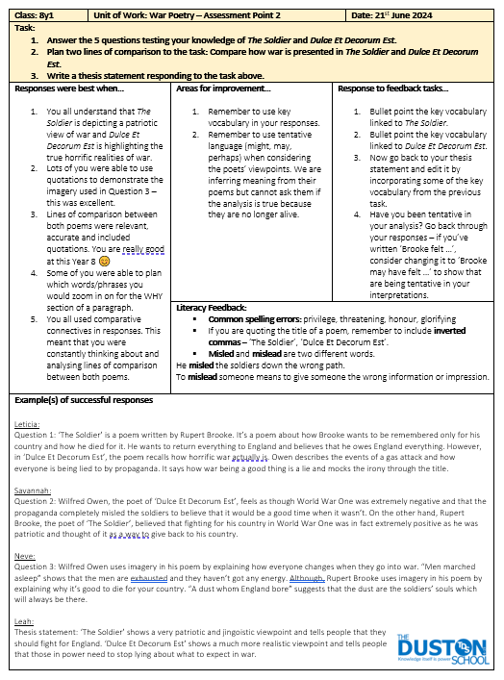

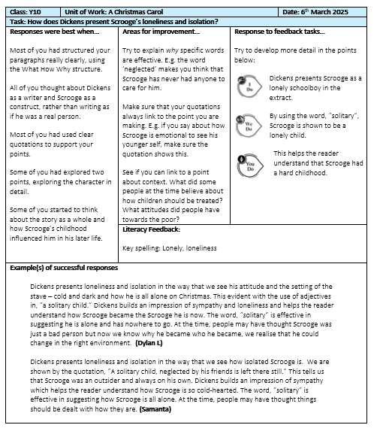

Examples of Whole-class feedback: Maths
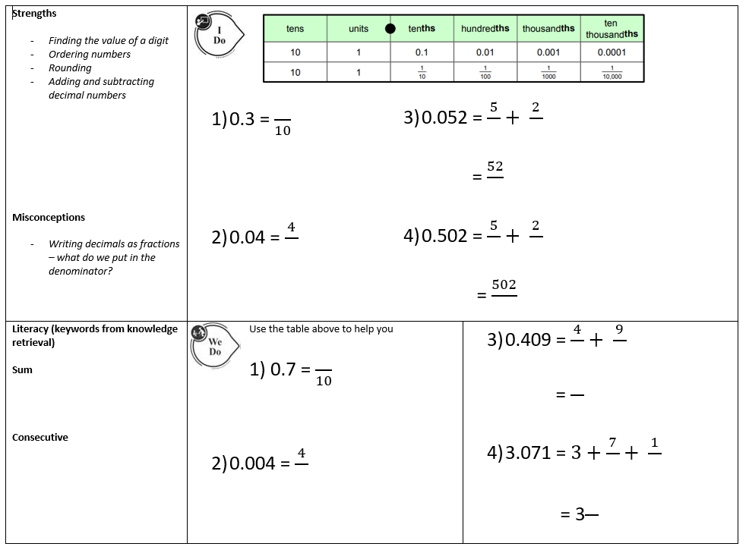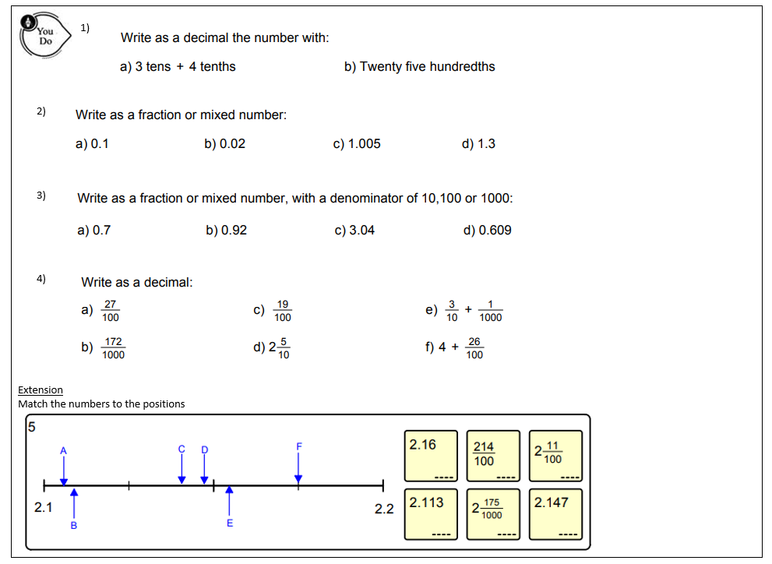
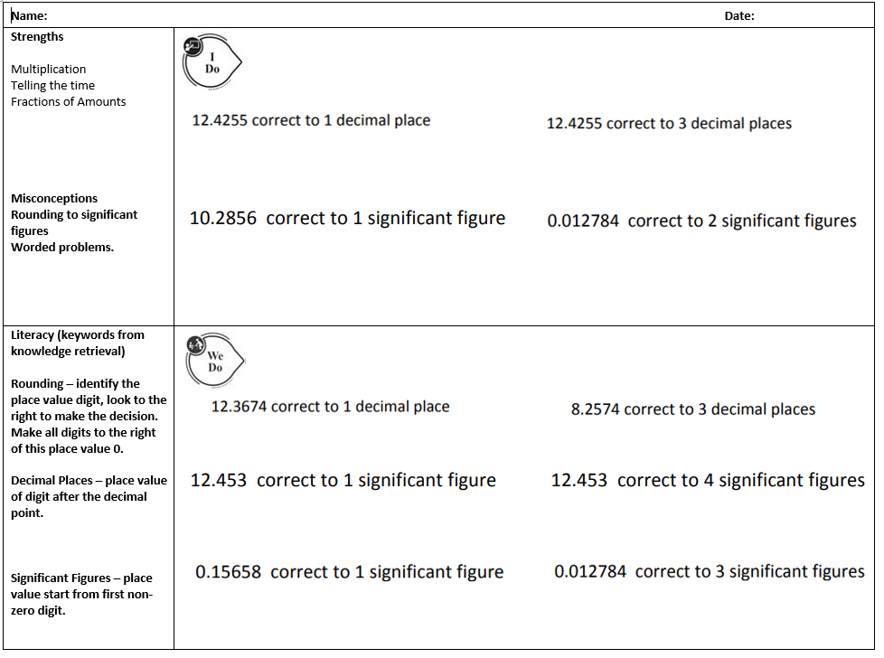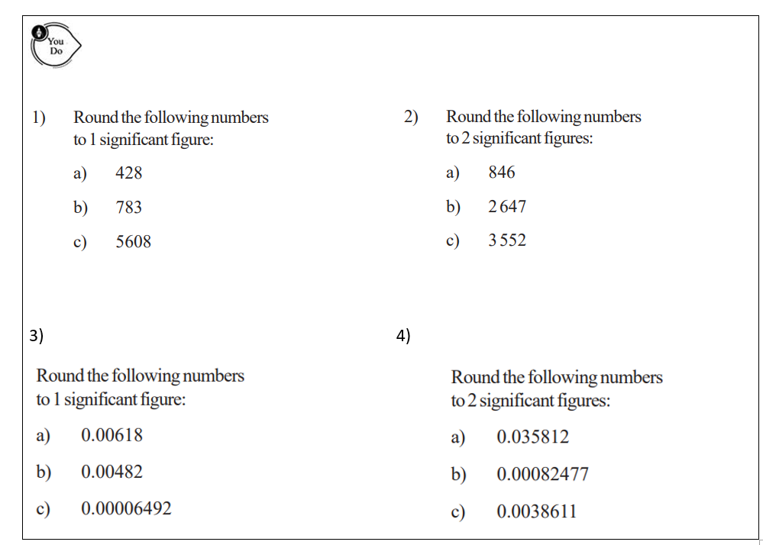

Appendix 4 – CPD Pathways


CPD Pathways 2025-2027
At The Duston School, staff are allocated twilight training time to engage with a range of CPD opportunities. The CPD programme for 2025-2027 has been inspired through response by staff and our current needs as a school which works on these previous cycles of CPD:
2021-2023: Pathways were focused around providing access to a range of knowledge and experience of potential future roles:
- Early Career Pathway
- Aspirant Subject Leaders Pathway
- Aspirant Student Care Pathway
- Expert Teaching Pathway
- Expert Middle Leaders Pathway
- Aspirant Senior Leaders Pathway
2023-2025: CPD Pathways were focused around using the Teaching WalkThrus designed by Oliver Caviglioli and Tom Sherrington:
- Pathway 1: Practice and Retrieval – Led by Katie Shires (AP for T&L)
- Pathway 2: Checking for Understanding – Led by Becky King (AP for T&L)
- Pathway 3: Classroom Management – Led by Simon Beal (AP for KS4)
- Pathway 4: Explaining and Modelling – Led by Natalie Adams (VP – Director of Education

Staff can access the CPD pathways in two main ways. Firstly, they can opt to follow a Pathway for the full course of the year, or they can pick and mix some sessions across the pathways that best suit their needs. Several are bespoke options based around career stage or future aspirations

Pathway 1: Responsive Teaching Pathway (KSH)

Introduction
The Model for Great Teaching builds on our whole school teaching and learning core priorities, taking each dimension and exploring the different elements which contribute to great teaching. Along with the Model, teachers have access to a large bank of resources within the Great Teaching Toolkit to help them develop their practice in each area, as well as student surveys to help prioritise dimensions of their own teaching.
Aims
The sessions will allow staff to use the feedback they receive from student surveys, along with their coaching goals to select training modules from the Great Teaching Toolkit and develop their practice within their chosen dimension.

Session overview: core sessions
Year 1 | Year 2
Introducing the Great Teaching Toolkit and linking to coaching | Revisiting the Great Teaching Toolkit and setting priorities for year 2
GTT course session 1 | GTT course session 1
GTT course session 2 | GTT course session 2
GTT course session 3 | GTT course session 3
GTT course session 4 and reflection | GTT course session 4 and reflection

Pathway 2: ECT Pathway (LFO & SAC)

Year 1
Introduction
Teachers deserve high quality support throughout their careers, particularly in those first years of teaching when the learning curve is steepest. It is essential that early career teachers are able to develop the knowledge, practices and working habits that set them up for a fulfilling and successful career in teaching.
This two-year pathway will work alongside the Teach First ECT induction programme. Sessions will support key areas addressed during ECT seminars and self-directed study, focusing particularly on approaches used at The Duston School.
Aims:
- To support ECTs through their Teach First induction programme.
- To identify teaching and learning strategies used at The Duston School and how these link to the Teachers’ Standards.
- To provide a support network for early career teachers, where they can share and discuss ideas with ECTs working in other faculties.

Session overview: core sessions
Year 1 | Year 2
How can you create an effective learning environment? | Developing pupils’ intrinsic motivation
How do pupils learn? | Supporting pupils to develop subject-specific skills
What makes classroom practice effective? | Using meaningful and memorable explanations
How can you use assessment and feedback to greatest effect? | Anticipating and addressing common misconceptions
How can you support all pupils to succeed? | Using structured talk to develop pupils’ literacy
Pathway 3: Head of Department - Aspirant or Current (TWI)

Year 1

Introduction & Aims
- To develop the strategic, operational, and interpersonal leadership skills required to lead a successful department.
- To build confidence and competence in managing curriculum, people, and performance.
- To foster a reflective and forward-thinking approach to middle leadership that aligns with whole-school improvement.

Session overview: core sessions
Year 1 | Year 2
Session 1: The Role of a Middle Leader | Session 6: Curriculum Leadership
Session 2: Leadership Styles and Emotional Intelligence | Session 7: Assessment and Data-Driven Leadership
Session 3: Vision and Strategic Thinking | Session 8: Leading Teaching and Learning
Session 4: Leading and Managing People | Session 9: Quality Assurance and Departmental Review
Session 5: Difficult Conversations and Conflict Resolution | Session 10: Managing Resources and Budgets

Pathway 4: Aspirant Senior Leader Pathway (NAD)

Year 1
A two-year pathway aimed to develop middle leaders and prepare them for a role within a Senior Leadership Team in the future. ASLP delegates will be exposed to key strands of knowledge that is essential in stepping into leadership responsibilities in the future. ASLP delegates are expected to take this learning and apply this to driving a whole school improvement project in the second year.
Aims:
• To support staff in considering what makes an effective senior leader
• To help staff to consider what the prerequisites of being an effective senior leader are
• To allow staff the time and space to consider the key research, real life examples and the opportunity to discuss what makes effective senior leadership
Session overview: core sessions
Year 1 | Year 2
Is Leadership a race? | The Law
Professional Conduct | Continuous School Improvement
Creating a Culture | Effective Lesson Observations
Behaviour | Working with Governors
The Curriculum | Finances

Pathway 5: DART (RKI)

Year 1 – Year 8 of DART

Year 1
Introduction
The Chartered College of Teaching is the professional body for teachers. As the professional body, their mission is to empower a knowledgeable and respected teaching profession. Through membership and accreditation, they are working to:
- develop effective, evidence-informed teachers and leaders
- improve the quality of professional learning
- establish more robust career pathways for teachers
- improve job satisfaction within the teaching profession.
Aims
The aim of the Duston Action Research Team is to foster a culture of reflective teaching. Practitioners are supported to engage with research, trial ideas and share their findings with each other and the wider staff base. Members will be given a membership to the CCT and encouraged to engage with the college’s CPD and research.

Session overview: core sessions
Year 1 | Year 2
Introduction to DART and the CCT | Goal setting
Application of GTC | Utilising CPD opportunities
Reading and discussion | Reading and discussion
CPD progress and intentions | Reading and discussion
End of year review | End of pathway celebration
Pathway 6: Succeeding in Senior Leadership Pathway (SST)

Year 1
Introduction
This is a two-year pathway model that is designed for senior leaders operating at an Assistant/Senior Assistant Principal layer within the school. This pathway will expose delegates to the wider thinking involved in being a senior leader at a higher level, notably as a Vice Principal, Head of School, Principal and Executive Leader. This pathway will help to enrich the holistic understanding of staff and support them in their current leadership position.
Aims
- To support existing leaders to consider their existing role as a leader and to develop their holistic understanding of being a leader at a higher level
- To support leaders to consider the multiple plates that need to be juggled as a higher-level leader
- To go beyond purely research and delve into the practical day-to-day realities of leadership
Session overview: core sessions
Year 1 | Year 2
What is leadership and who am I? | Positive mindsets and building a team / a culture
The core pillars of successful leadership | The curriculum is God, make it so
How to lead with impact | Working with stakeholders, including trust board, media and social media
People strategy and solution circles | Financial and legal considerations
Enabling the Halcyon Dream – getting behaviour right | Open hot seating
Pathway 7: SEND Training (ATH)

Introduction
The percentage of pupils with Special Educational Needs (SEN) support has been increasing recently, with 13.6% of children in England accessing SEN provision in 2023/24. In light of this growing need, it is vital that education professionals in all education settings understand how to support children with SEND to achieve their best possible outcomes. This is a statutory duty under the 2015 SEND Code of Practice.
https://www.highspeedtraining.co.uk/courses/education/special-educational-needs-and-disabilities-course/?_gl=1*1owppb5*_up*MQ..*_gs*MQ..&gclid=EAIaIQobChMI4df0qvfZjQMVgJNQBh00CQhtEAAYASAAEgJDF_D_BwE
Aims
This Special Educational Needs and Disabilities (SEND) in the Classroom course will teach you what you need to know to ensure you are fulfilling your legal responsibilities and following the Graduated Approach to SEND (assess, plan, do, review). It also discusses best practice for supporting children in each of the four areas of need, and what Universal Provision (including high-quality teaching) should look like. The course was written in collaboration with SEND expert, Dr Anita Devi, who is a former SENCo, senior leader, school improvement adviser, and local authority SEND advisory teacher.
Session overview: core sessions
Year 1 | Year 2
Module 1: Introduction to SEND | Module 6: Cognition and Learning Needs
Module 2: Roles and Responsibilities | Module 7: Social, Emotional, and Mental Health Needs
Module 3: The Graduated Approach | Module 8: Sensory and Physical Needs
Module 4: Universal Provision | Module 9: Consolidation and Resources
Module 5: Speech, Language, and Communication Needs
Delivering Statistics (TBU)

Introduction
A two-year pathway aimed to develop the mathematics faculty and prepare them for the teaching of GCSE Statistics. During Year 1, colleagues will be exposed to new mathematically content which they may not have delivered during their teaching career. The focus is to develop confidence in the delivery of these key strands of knowledge that are essential and commonly appear within the GCSE examinations. Colleagues are expected to take this knowledge and apply it to the delivery of the workbooks.
The second year is a continuation of year one, with further opportunities to develop confidence in the subject. However, the fundamental aim will be to focus on content which is historically answered badly at GCSE, and delivering strategies to help colleagues in supporting their students better with these types of questions. This will help to ensure that GCSE Statistics gets as good as possible results at GCSE; which will be beneficial to students as they leave KS4 education, as well as supporting whole school progress 8 scores.
Aims
- Develop subject knowledge of faculty colleagues, to improve confidence/by-in when delivering the stats curriculum.
- Identifying how KS4 subject knowledge is linked to existing knowledge taught as KS3, and identifying how we can develop students’ schema.
- To allow colleagues to reflect on their own knowledge and identify any future training needs.
Session overview: core sessions
Year 1 | Year 2
SKE - How to teach Time Series Graphs. | Lessons learned from the 2025 summer series GCSE Stats exams.
SKE – What are the differences in probability content when comparing GCSE Maths with GCSE Statistics. | Consistent teaching methods at KS3 of basic statistical methods
SKE – Understanding Index Numbers and how they relate to our existing Maths Curriculum. | Understanding Key terminology given within the GCSE questions; and how this understanding can be embedded within the KS3 curriculum.
SKE – Understanding Probability Distributions and how they relate to our existing Maths curriculum. | Subject Knowledge Audit – identifying areas of development and addressing misconceptions.
Supporting our students with revision materials. | SKE Development and final evaluations. – Identifying training needs for 26-27.

Appendix 5: Directory of expertise

At The Duston School we operate an open-door policy where staff are encouraged to share their expertise with others within their departments and across the school.
Throughout the year, we have ongoing coaching conversations to support performance management. Through these conversations, staff are encouraged to arrange lesson drop-ins to see other staff teaching in areas which might be beneficial to progressing towards their own targets.
A number of departments organise ‘Watch Others Work’ (WOW Walks) where all staff in the department will visit other members of the team with a clear focus in mind, which is then fed back to the rest of the department.
We encourage all staff to take the opportunity to benefit from sharing the expertise we have within the school; to help with this, we have compiled the following directory of staff whose teaching practice demonstrates considerable expertise in the key areas of teaching and learning and who have agreed to other staff visiting their lessons to see these principles in actions.
If you would like to arrange a lesson visit, please contact the member of staff from the directory in advance and arrange the lesson focus and when would be the best time to drop in.

Classroom Management

Simon Beal – Geography
Sonia Fadal – English
Peter Dewes – CBI
Donna Gioia – English
Sarah Malia – Geography
Craig Nelson – Science
Ingrid Weaver - Science

Modelling
Simon Bowman – History
Sarah Malia – Geography
Samantha Holden-Smith – Maths
Kirsty Britten – Art and Design
Ellen Honer – Languages
Natalie Adams – Geography
Gabbi Berrill - English

Checking for Understanding
Georgia Perry – History
Katie Shires – English
Becky King – English
Natalie Adams – Geography
Michelle Jones – English
Georgia Perry – History
Tom Clarke – Social Sciences
Emily Butcher - Business

Developing Student Repsonses
Donna Gioia – English
Simon Bowman – History
Ade Smith - DT

