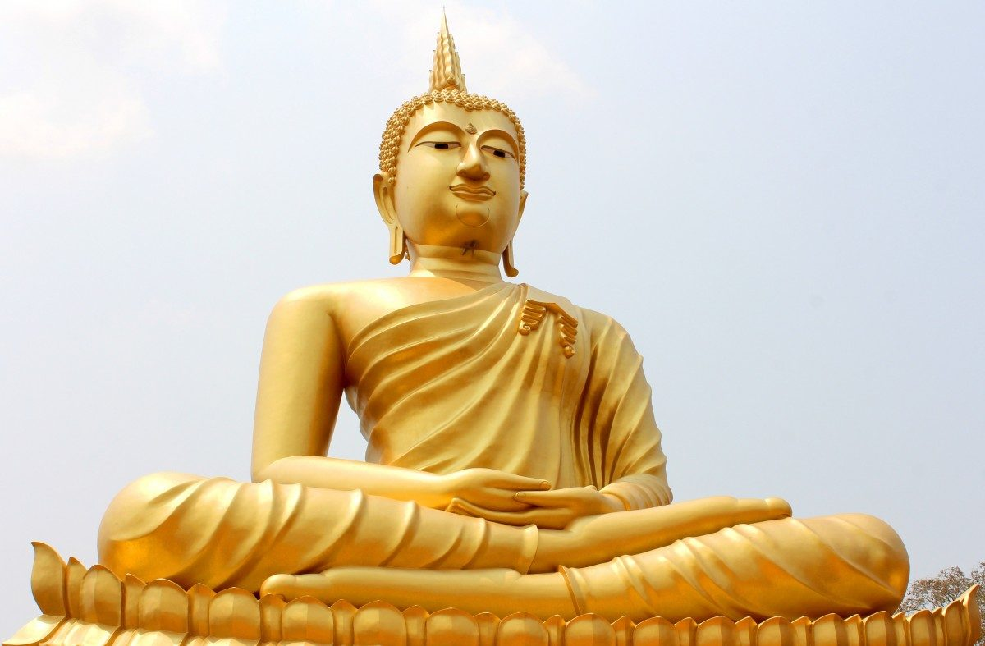

Year 7
Buddhism:
Buddhist Practices

Knowledge Organiser & Homework Booklet

Name………………………………………………………………….
Buddhist Practices – Knowledge Organiser
Key Words
Bardo | A state of being that exists between death and rebirth. | Mantra | A sacred phrase which is chanted during meditation.
Bhavacakra | A particular Tibetan Buddhist mandala depicting the cycle of samsara | Mindfulness | A type of meditation where the mind is focused on the present moment.
Bodhisattva | A person who has found enlightenment but is reborn to help others. | Pilgrimage | A journey, especially a long one, made to a sacred place as an act of religious devotion.
Dalai Lama | The leader of Tibetan Buddhism, said to be an incarnation of a Bodhisattva. | Shamanism | Religious practice, focused on an individual believed to be able to access the spirit world.
Kathina | A festival of gratitude to the Sangha. | Thai Forest Tradition | A form of Theravada Buddhists where the sangha are encouraged to retreat to the forest to practice mediation in solitude.
Laity | Religious believers who are not monks or nuns. | Theravada | School of Buddhism, views that Sangha as just monks and nuns, and views them as very important.
Mahayana | School of Buddhism which believes in Bodhisattvas and that ‘sangha’ refers to all Buddhists. | Vassa | The period of the rainy season, when monks stay in their monasteries.
Mandala | A circular pattern that has symbolic meanings and is used to help people meditate. | Wesak | A festival to commemorate the Buddha’s birth, enlightenment and death. Also known as ‘Buddha day’ in western cultures.
Key Ideas
Schools of Buddhism | Like with most religions, there are separate branches of Buddhism. By ‘school’ we are referring to a ‘school of thought’, which means a particular way of thinking, in the context of Buddhism, this would mean a particular way that some Buddhists choose to interpret the Buddha’s teachings and lead their lives. The two main schools of Buddhism are Theravada and Mahayana Buddhism. The schools of Buddhism are similar in many ways, they all follow the basic teachings of the Four Noble Truths and the Eightfold Path. They also both promote showing compassion and loving kindness to all living beings. However, there are differences in how the schools exactly interpret these teachings.  - Theravada Buddhism places a special emphasis on the role of the Sangha, who are greatly respected and are seen as being more likely to reach enlightenment.  - Mahayana Buddhism feel that the term ‘Sangha’ applies to all Buddhists, and everyone has an equal chance of reaching enlightenment. They also focus on Bodhisattvas, who is someone they believe has already reached enlightenment have chosen to be reborn and help others reach enlightenment
Tibetan Buddhism | Tibet is located in a mountainous area in the Himalayas that borders 2 vast countries: India and China. Tibetan Buddhism exists within the Mahayana tradition and developed alongside another type of spiritual belief called shamanism. The Tibetan school teaches that in between death and rebirth people spend time in a state called bardo, which involves Yama, King of the Dead helping the individual reflect upon their actions during life to determine their next life.  The leader of Tibetan Buddhism is the Dalai Lama, they believe that all Dalai Lamas are reincarnations of a Bodhisattva who originally became enlightened in the 14th century, the current Dalai Lama is believed to be the 14th reincarnation. The Dalai Lama regularly travels the world to meet Buddhist, religious and wold leaders.
Buddhism in the UK | Today, Buddhism is the fourth largest religion in the UK. Buddhism grew significantly in the UK in the 1950s when many Tibetan Buddhists fled to the UK due to the Chinese invasion, and in the 1960s, when world travel grew. One of the largest Buddhist centres in the UK is in Chithurst, Sussex. The monastery is part of the Thai Forest Tradition, which is a form of Theravada Buddhism which encourages monks and nuns to retreat into the forest, completely alone.  Meditation has become increasingly popular among non-Buddhists in the UK. One type of meditation is known as mindfulness, which focuses on meditating to focus on what is happening at the present moment. Mindfulness is now promoted by the NHS and NICE as a useful tool for treating and preventing some mental health conditions such as anxiety and depression.
Buddhist festivals | There are three very important festivals in Buddhism:  - Wesak: a time to remember the Buddha’s birth, enlightenment and his death. It happens on the first full moon in May. Early in the morning, Buddhists go to their nearest temple or monastery to celebrate.  - Vassa: In Theravada Buddhism, Vassa lasts for the 3 months of the Asian rainy season. Monks and nuns stay in their monasteries and avoid any travel. The laity might choose to give up things like meat and alcohol.  - Kathina: When Buddhists how gratitude to the Sangha through giving gifts, e.g. food, robes and sanitary supplies.
Buddhist art | Early Buddhists carved scenes from the life of the Buddha into stone and on to cave walls. They believed that it would be disrespectful to show the Buddha as a human, so he is often represented by an empty seat in early Buddhist art. In the second century CE, Greek stone carvers who were working in India were the first people to portray the Buddha in human form. The Buddha can be represented in various ways which symbolise something about the Buddha, e.g. long ear lobes show how he came from a life of luxury. Mandalas are circular patterns, with each part having a symbolic meaning. One important mandala is the bhavacakra, which depicts the cycle of samsara.
Inspirational Buddhist leaders | There are some well-known inspirational Buddhist leaders who have helped people through their acts of compassion and promoted peace. Two Nobel Peace Prize nominated Buddhist leaders are Maha Ghosananda who helped people when the Khmer Rouge took over Cambodia and restored the Buddhist faith, and Thich Nhat Hanh, who called for peace during the Vietnam war and is continuing to carry out pro-peace work to this day.
Homework 1: What is Meditation? Set W/B: Due W/B:
Read the following passage, answer the question and make notes of the key points in the bullet-points below the text. You will be quizzed testing your knowledge of this text in your next lesson.
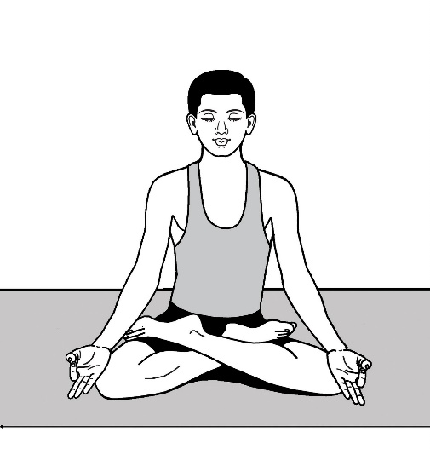
Meditation is important in all schools of Buddhism, we will be learning about one kind of meditation, mindfulness, in a bit more depth during a lesson, but it is important that you get a good idea of what it is in general.
The Buddha taught his followers that if they trained and controlled their minds through mediation they could reach nirvana. In chapter 3 of the Dhammapada, the Buddha likens the training of the mind to an archer:
‘Just as an archer straightens an arrow, so the discerning man straightens his mind – so fickle and unsteady, so difficult to guard’.
The lotus position.
To meditate, a Buddhist will usually find a quiet place where he or she can sit comfortably. Many will choose to sit cross-legged on the floor with their back straight and their arms lightly resting upon their knees or their lap. This is known as the lotus position, named after a flower which represents the states of mind… it grows in muddy water (which represents the cloudy, troubled, busy, unenlightened mind), however it still blossoms into a beautiful flower above the water – this represents the mind reaching enlightenment.
Meditators usually close their eyes and focus their mind, they do this by concentrating on their breathing and then brining it under control in a regular and calm pattern. Sometimes they may concentrate on an object – this could be a statue of the Buddha or a Bodhisattva, a candle or a flower. Many Buddhists meditate in silence, but often senior monks will lead guided meditation in which they talk while followers listen to the words of their leader. In some Buddhist schools, mantras are chanted.
What does a Buddhist do in order to meditate?
……………………………………………………………………………………………………………………………………………………………………………………………………………………………………………………………………………………………………………………………………………………………………………………………………………………………………………………………………………………………………………………………………………………………………………………………………………………………………………………………………………………………
Key Points:
*
*
*
————————————————————————————————————————————————————
Knowledge Quiz:
1. 4.
2. 5.
3. 6.

Homework 2: Buddhist Pilgrimage Set W/B: Due W/B:
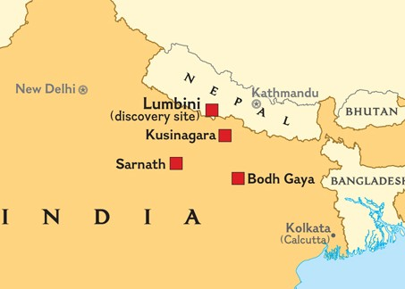
Read the following passage and make notes of the key points in the bullet-points below the text. You will be quizzed testing your knowledge of this text in your next lesson.
Just before he died, the Buddha told his followers to remember him by going on a pilgrimage to 4 places which were important in his life – the sites of his birth (Lumbini), enlightenment (Bodh Gaya), first teaching (Sarnath) and death (Kusinagara).
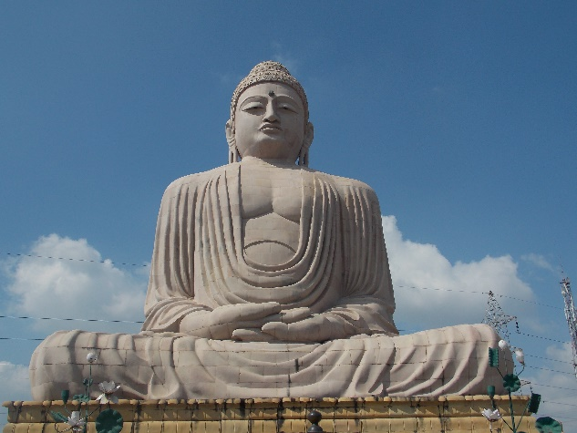
At these sites, there are temples and shrines containing relics of the Buddha. By visiting these sites, Buddhists can reflect on the events of the Buddha’s life and may feel a stronger connection to him. However there is no obligation for Buddhists to go on a pilgrimage, and many never do. For this homework, you will read about how people go on a pilgrimage to Bodh Gaya, where the Buddha achieved enlightenment, as this is considered to be the most important.
Map showing the location of the four main sites of Buddhist pilgrimage
Every year, hundreds of thousands of people visit Bodh Gaya from all over the world. The main attraction is the Mahabodhi Temple, believed to have been built by Emperor Ashoka. At the back of the temple, there is a Bodhi tree, which many believe is a descendant of the Bodhi tree the Buddha meditated under when he reached enlightenment. Pilgrims will often meditate around the tree believing that it will help them in their search for enlightenment. There is also a statue in Bodh Gaya called ‘The Great Buddha’, it stands 25 metres high and was completed in 1989 after 7 years of building by over 12,000 bricklayers.
The Great Buddha statue in Bodh Gaya
What might a pilgrim do in Bodh Gaya?
………………………………………………………………………………………………………………………………………………………………………………………………………………………………………………………………………………………………………………………………………………………………………………………………………………………………………………………………………………………………………………………
Key Points:
*
*
*
————————————————————————————————————————————————
Knowledge Quiz:
1. 4.
2. 5.
3. 6.

