Religion and Art
Knowledge Organiser

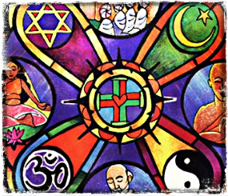

Year 8

Name………………………………………………………………….

Religion and Art – Knowledge Organiser
Key Words
Theological | Relating to the study of the nature of God and religious belief | Gospel | The teaching or revelation of Jesus Christ
Cathedral | A cathedral is the seat of the bishop and a centre of worship and Christian mission | Incarnation | The embodiment of God the Son in human flesh as Jesus Christ
Bless | Pronouncing words in a way invoke God’s favour upon someone | Abstract | Relating to or denoting art that does not attempt to represent external reality, but rather seeks to achieve its effect using shapes, colours, and textures
Christianity | The religion based on the person and teachings of Jesus Christ, or its beliefs and practices | Mandir | Large scale calamity, causing a large amount of devastation.
Imagery | visual images collectively | Mandir | Hindu temple
Scripture | The sacred writings of Christianity contained in the Bible | Patron | A person who gives financial or other support to a person, organization, or cause
Figurative | Departing from a literal use of words; metaphorical | Sacred | Connected with God or a god or dedicated to a religious purpose and so deserving veneration
Key Ideas
The spiritual expressed through art, music and literature | Throughout history, people have used art, music and literature to express their religious beliefs, and to help them to focus on practices such as prayer and worship. Beautiful words, images and objects have played a big part in many world religions, but there are some very different ideas about how they should be used.  Art, music and literature are important forms of expression for many people. Whether they are religious or not, many people believe that human beings have a spiritual existence. There is a wide variety of ideas about what this actually means, but put simply, it means that being human goes beyond what we can experience with our senses, minds and intelligence.
How abstract imagery is used in religious places of worship | The lack of pictures of saints, important figures, and depictions of God or the heavens in a place of worship, also shows us a lot about the beliefs of the worshippers who go there. For instance, Muslims and Jews believe that God is too great to try to capture in pictures or sculptures, and so they find other ways to adorn their holy spaces and make them look beautiful. Many mosques will have beautiful calligraphy and geometric patterns, while synagogues are often decorated with pictures of plants, trees and religious symbols. Geometric or Mosaic Art is when basic shapes are put together and repeated to make patterns. Islamic buildings often contain a mixture of both calligraphy art and geometric art.
How Biblical scenes inspire Christian devotion through art | In Christian art the artists suggest, in visual terms, the nature of Christian mysteries – such as the visions experienced, or miracles performed, by the saints – as well as other profound theological (religious) beliefs, such as the Holy Trinity or the Incarnation. These images are made to inspire and strengthen Christian faith through public and private devotion in churches or people’s homes. Christian art also features stories that range from Adam and Eve in the Garden of Eden to Noah’s Ark to David defeating Goliath, to Jesus’ Calming the Storm or healing the Paralysed Man who was brought to him on a stretcher that had been lowered down through the roof of the building that Jesus was in at Capernaum in Galilee.
How famous Biblical characters have been portrayed famously through art | Many of the great artists from the Renaissance Period (Fourteenth Century to Sixteenth Century) produced works of art that were based on scenes from the Bible. They were commissioned and paid huge sums of money to do so. Michelangelo also sculpted a famous Biblical figure from the Old Testament; David, who later became King David. In Michelangelo’s famous sculpture David is shown holding his slingshot, which he used to great effect in defeating and killing Goliath, the giant Philistine warrior.
What does modern religious art look like? | When contemporary artists tackle Christian subjects today, it is sometimes in an ironic or disrespectful fashion. For example, the Italian artist Maurizio Cattelan’s satirical sculpture ‘La Nona Ora’ (1999). Yet, even though we live in an era that is becoming ever more secular, the great tradition of Christian art still appears to be alive and well. The British artist Mark Wallinger, for example, has made several artworks that draw upon the machinery of religion and explore questions of faith. These include ‘Ecce Homo’ (1999), a life-size, white-resin cast of a young man representing Christ that was placed temporarily on top of the Fourth Plinth in Trafalgar Square.

Homework 1: The Maha Shivaratri Festival Due:
Read about The Maha Shivaratri Festival and make notes of the key points below.
The Maha Shivaratri Festival

The Maha Shivaratri festival is a celebration of the god Shiva and means 'The Great Night of Shiva.' Within
Hinduism, Shiva is the ‘Supreme Being’ who protects and transforms the universe. He simultaneously creates and
destroys but it is his engagement with the world which causes existence. In many forms of art, Shiva is seen as a
lord of dance whose never ending dance is the source of life.
The Maha Shivaratri is a major festival, but one that is solemn and marks remembrance of overcoming 'darkness
and ignorance' in life and the world. It is observed by remembering Shiva, praying, fasting, and meditating on the
great virtues of character. Curiously, there is a place in Europe where Shiva is thought about constantly and it
might surprise you to know that it is at the CERN Institute in Switzerland, home to the large Hadron Collider and
one of the leading research institutes in the world. As you go to this institute, you walk past a two metre tall statue
of Shiva which was a gift from the government of India. On a small plaque beside the statue there is a quote from
the great thinker Fritjof Capra which explains the relevance of the statue to modern physics.
Capra observes:
“Hundreds of years ago, Indian artists created visual images of dancing Shivas in a beautiful series of bronzes. In our
time, physicists have used the most advanced technology to portray the patterns of the cosmic dance. The
metaphor of the cosmic dance thus unifies ancient mythology, religious art and modern physics.”

The details at the heart of the ideas such as the ones found in CERN are light years away from many of the ideas in
ancient Hinduism, but if we focus on themes and images, we can find a startling and often unexplored kinship
between cultures.
Key Points:

*

*

*

Homework 2: Art in the Middle Ages Due:
Read about Art in the Middle Ages and make notes of the key points below.
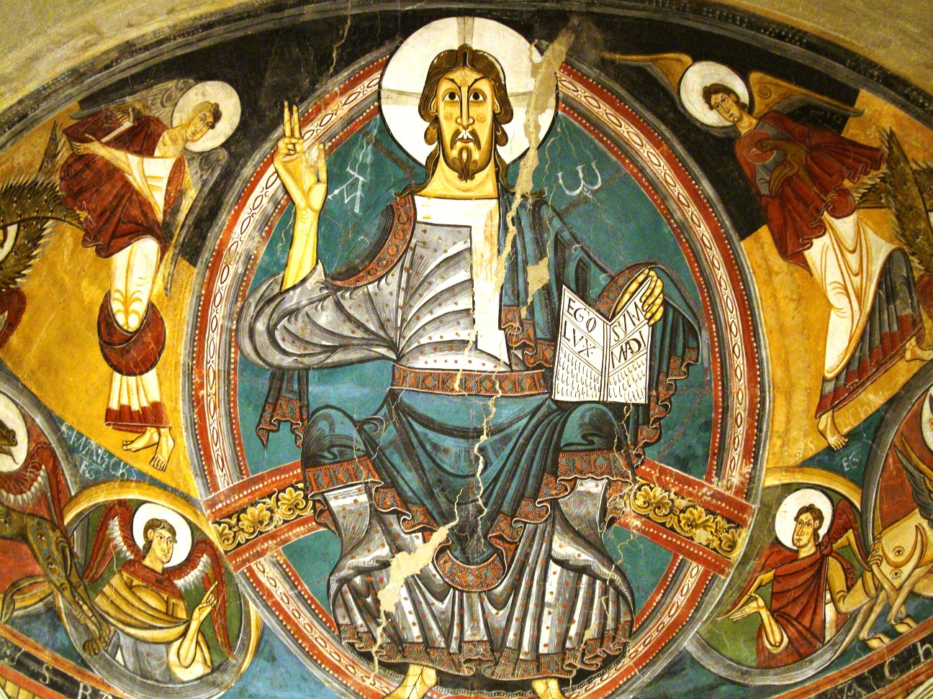
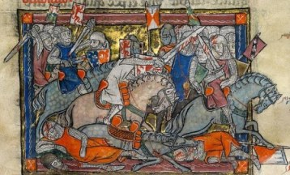
Art during the Middle Ages was different based on the location in Europe as well as the period of time. However, in general, Middle Age art can be divided up into three main periods and styles: Byzantine Art, Romanesque Art, and Gothic Art. Much of the art in Europe during the Middle Ages was religious art with Catholic subjects and themes. The different types of art included painting, sculpture, metal work, engraving, stained glass windows, and manuscripts.
The end of the Middle Ages is often signalled by a great change in art with the start of the Renaissance Period.
Byzantine Art
The start of the Middle Ages is often called the Dark Ages.
This is the period of time from 500 to 1000 AD. The main
form of art during that time was Byzantine art produced by
artists from the Eastern Roman Empire, also called Byzantium.
Byzantine art was characterized by its lack of realism. The artists did not try to make their paintings realistic, but focused on the symbolism of their art. Paintings were flat with no shadows and the subjects were generally very serious and sombre. The subjects of the paintings were almost entirely of battles, or religious with many paintings being of Christ and the Virgin Mary.
Romanesque Art
The period of Romanesque Art started around 1000 AD and
lasted to around 1300 with the beginning of the Gothic Art
period. Art prior to that is called pre-Romanesque.
Romanesque art was influenced by both the Romans and
Byzantine Art. Its focus was on religion and Christianity. It included architectural details like stained glass art, large murals on walls and domed ceilings, and carvings on buildings and columns. It also included illuminated manuscript art and sculpture.

Key Points:
*
*
*
————————————————————————————————————————————————————
Knowledge Quiz:
1. 4.
2. 5.
3. 6.

