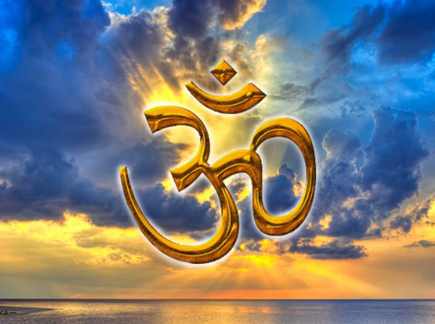

Year 9
Hindu Beliefs

Term 5

Knowledge Organiser & Homework Booklet

Name………………………………………………………………….
Hindu Beliefs – Knowledge Organiser
Key Words
Brahman | Brahman is the ultimate reality, a limitless, universal soul or consciousness, beyond human understanding and the source of all life. | Moksha | Freedom from samsara so that the atman joins up with Brahman.
Nirguna Brahman | The idea that God is everywhere but you cannot see him and he no form or shape. In this case the Om or AUM symbol is used to represent God. | Saguna Brahman | The idea that God has form and can be pictured. The different Hindu gods represent the different characteristics of God.
Ahimsa  (non-violence) | Hindu virtue based on the concepts of atman and reincarnation. | Brahma | Hindu deity that is part of the Trimurti –  The creator (NOT BRAHMAN).
Bhagavan | Most Hindus refer to Brahman as Bhagavan. | Vishnu | Hindu deity that is part of the Trimurti –  The preserver.
Dharma | The duty a Hindu should perform in their life. | Shiva | Hindu deity that is part of the Trimurti –  The destroyer.
Kama | Enjoying the pleasures of life. | Samsara | The continual cycle of life, death and rebirth.
Artha | Gaining wealth in a lawful way. | Sanskrit | An ancient Indian language.
Key Ideas
The Divine | Hindus think of the God (the divine) in three ways;  - A non-personal God  - Existing everywhere  - Brahman, Being in the heart of everyone – antaryami  In Hinduism, the word 'antaryami' means "inner witness". This presents Brahman as an immanent God. This part of God is representing his knowledge aspect and due to this, it shows God as the centre of most Hindu's meditation. Also, 'antaryami' is all-pervading to Hindus meaning that Brahman has an effect on everything. A personal God – Bhagavan – accessed through the deities living in a spirit world called vaikuntha.  This is the idea that Brahman is a supreme being that lives beyond the world and whilst he is beyond the world, he is also personal and understands them well.  Hindus think there are 3 very important aspects of God, these are represented by the Tri-murti; Brahma – The creator , Vishnu – The preserver and Shiva – The Destroyer
The Dalits | The Dalits are a large group in Hindu society, making up over 15% of India’s population. Dalits are excluded from the caste system, and they have experienced persecution. It is illegal in India to discriminate against anyone in employment, but caste groupings can still keep society unequal and unfair in some ways. A Hindu has to complete their dharma based on their caste but also based on what stage of life they are in. There are four stages of life, called ashramas, and a Hindu goes through all of these in their lifetime. The stage of life a Hindu is in decides what their dharma is.
Varnashrama dharma | These are the duties a Hindu should follow depending on their stage in life and their caste. There are four main traditional castes. The group a Hindu is born into can decide what jobs they may get and what their duties are in life.  Some aspects of this concept are controversial because they raise human rights issues about fairness and equality in Hindu societies today. The Rig Veda describes the whole of society as if it were a human body:  - The teachers and priests are like the head. These are regarded as those closest to achieving moksha.  - The warriors and leaders are like the upper body.  - The merchants, traders and farmers are like the strong legs.  - The manual workers and labourers are like the feet.
Atman | Atman is a Hindu word that means ‘soul or spirit’. It refers to the real person inside an individual. It is made of part of the spirit of Brahman, Therefore, it cannot be seen or touched, but it is eternal and everlasting. A key Hindu belief is the idea that when a person dies the atman will move on into the body of another being. This process is called samara. Hindus believe that the atman is about accumulating knowledge. When the atman moves on to another life, it is as if it is letting go of the ego and gaining true knowledge. In the Upanishads, a story used by Hindus to explain the idea of the atman. Just like salt in water, you know it is there but cannot see it. The atman, or part of Brahman, is there even though you cannot see it.
Free will and suffering | Hindus believe that they have free will. This is the idea that they can act and behave how they wish and are free to make their own choices in life. However, Hinduism has guidelines in the form of gurus, holy scriptures and key concepts. These guidelines show Hindus the morally correct ways to act and behave. An example of these guidelines is the concept of karma. A Hindu’s actions will result in either good or bad karma, depending on the action. Hindus believe they should use their free will to act in the best possible way in order to receive good karma. Free will is disrupted by the fact that Brahman is beyond time and knows what will happen in the future. In a way your decisions have already been made and cannot be altered. Free will does not exist when you achieve moksha because without suffering there isn't the freedom to make your own choices and learn from mistakes. Caste system goes against free will because you are placed in your cast without choice, and you will stay there till your next life therefore your quality of life is pre-destined and cannot be altered. Going against freedom of choice.

Homework 1: What do Hindus believe about reincarnation? Due:
Read the following passage, and make notes of the key points in the bullet-points below the text.

Hindus believe that each human has an atman (soul) which passes through a long cycle of existence occupying different bodies and experiencing repeated births, deaths and rebirths. This transmigration of the soul is known as reincarnation.
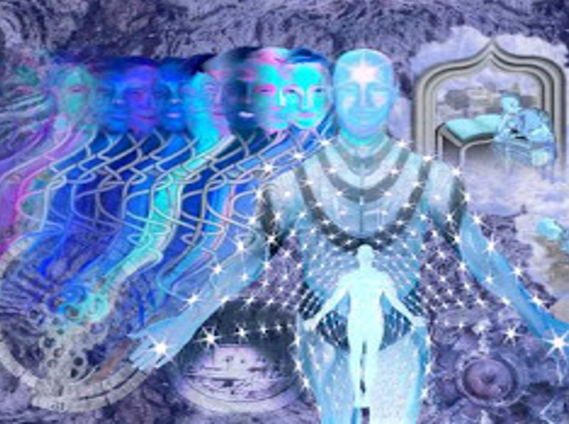
‘As a man casts off his worn-out clothes and takes on other new ones, so does the embodied soul cast off his worn-out bodies and enters other new.’ Bhagavad Gita 2:22

Reincarnation – Infinity
Infinity means endless, in Hinduism. This symbol represents the endless cycle of Samsara, (reincarnation).
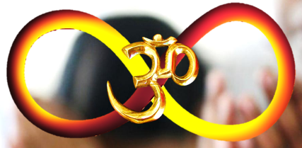
Re’ means ‘again’
‘in’ means ‘in’ (!)
‘carn’ means ‘flesh’
Meaning, ‘again in flesh’.

Rebirth might sound like a good thing but actually, Hindus believe that going around and around in the cycle of samsara is keeping humans souls (atman) trapped in the material world away from the sublime spiritual one.
Karma means action. This refers to the law of cause and effect i.e. actions and their consequences…
Hindus believe this is a law of the universe just like the law of gravity. The law: Every single action has an affect on something else. Karma decides where you come back and what you come back as. If your actions are good you will get a good rebirth into pleasant circumstances; if they are bad you will get a bad one…
In a lifetime people build up karma, both good and bad, based on their actions within that lifetime. This karma affects their future lives and existences…
There are lots of different types of rebirth in Samsara. You can come back as a human or a pig; as a god or a ghost; in heaven or in hell. Some Hindus believe you can even come back as a flower!
Moksha is … Salvation – of the soul which is rescued from the material world and delivered into the spiritual.
The Goal – of Hindus is to eventually achieve moksha. Though many accept this might not happen for their next carnation they aim to build up positive karma in the hope of a good rebirth that might be a little closer to moksha.
Key Points:
*
*
*

