

Knowledge Organiser
Year 11: Unit 3 [Mock Revision]
A Christmas Carol & Macbeth

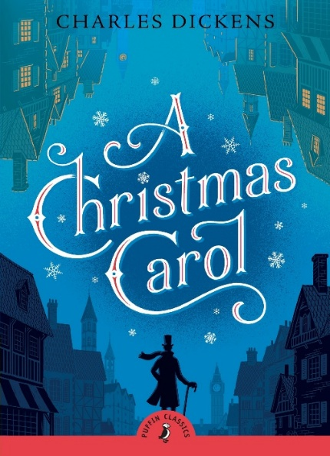
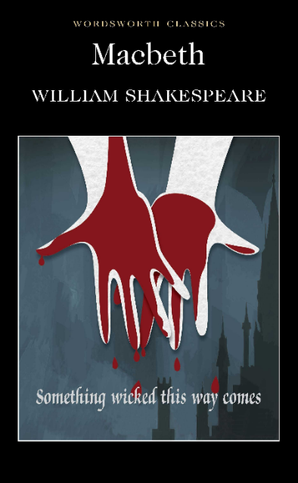

Name:

Class:

Big Questions

The big question for the unit is: How do writers explore the idea of conflict?

AQA GCSE English Literature Paper 1 Exam Details

Paper 1: Shakespeare and the 19th-century novel
What's assessed = Shakespeare plays & The 19th-century novel

How it's assessed: Written exam: 1 hour 45 minutes, 64 marks, 40% of GCSE

Questions:
Section A Shakespeare: students will answer one question on their play of choice. They will be required to write in detail about an extract from the play and then to write about the play as a whole.

Section B The 19th-century novel: students will answer one question on their novel of choice. They will be required to write in detail about an extract from the novel and then to write about the novel as a whole.

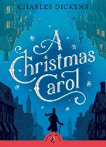
Key Terminology A Christmas Carol
 | Term | Definition
1 | Allegory | An expression created through fictional figures to expose a truth or idea about human existence.
2 | Characterisation | How a character is presented/ how they have been created/ designed.
3 | Contrast | Using two opposing things/ ideas within a text to highlight or exaggerate the difference between the two
4 | Empathy | Being able to understand someone else’s emotions, feelings or experiences by imagining what it might be like to be in that person’s particular situation
5 | Foil | A character with qualities that are in contrast with another character
6 | Generosity | The quality of being kind and being ready to give more to others than is necessary or expected
7 | Isolation | The process of being alone or apart from others
8 | Miser | A person who hoards money and wealth and spends as little money as possible/
9 | Morality | Principles, either personal or social, concerning the difference between right and wrong, going beyond legality and often religion.
10 | Motif | An element that reoccurs, such as a word, phrase, idea, image or symbol that appears throughout the play for emphasis
11 | Omniscient | All knowing/ all seeing
12 | Redemption | The action of saving or being saved from sin, error or evil
13 | Responsibility | Having a duty to deal with something/ being accountable or to blame for something
14 | Reverently | A feeling or attitude of deep respect tinged with awe, often used in relation to religion
15 | Suppressed | To forcibly put an end to/ to avoid considering something.

Key Quotations A Christmas Carol

Here are some key quotations to revise and there is some space to add some of your own

Stave | Key Quote | Info / Analysis
Stave One:  Marley’s Ghost visits Scrooge | Marley was dead, to begin with. | Suggests that rationality and logic do not apply here. Sets supernatural tone. Ghost story!
Stave One:  Marley’s Ghost visits Scrooge | Oh! But he was a tight-fisted hand at the grindstone, Scrooge! A squeezing, wrenching, grasping, scraping, clutching, covetous, old sinner! | Didactic narrator demonstrates his dislike of Scrooge.
Stave One:  Marley’s Ghost visits Scrooge | Hard and sharp as flint  (Flint = hard rock used to make tools) | Metaphor for Scrooge.
Stave One:  Marley’s Ghost visits Scrooge | Solitary as an oyster | Simile of loneliness, but with a pearl?
Stave One:  Marley’s Ghost visits Scrooge | External heat and cold had little influence on Scrooge. No warmth could warm, no wintry weather chill him. No wind that blew was bitterer than he, no falling snow was more intent on its purpose…” | Scrooge has an almost supernatural imperviousness to the effects of heat and cold.
Stave One:  Marley’s Ghost visits Scrooge | “I don’t make myself merry at Christmas, and I can’t afford to make idle people merry.” | Scrooge shows no pathos or empathy. Sees the poor as the ‘idle’.
Stave One:  Marley’s Ghost visits Scrooge | “Every idiot who goes about with ‘Merry Christmas’ on his lips should be boiled with his own pudding and buried with a stake of holly through his heart” | Scrooge thrills in his dour dislike of Christmas. An amusing, entertaining line – exaggerative villainy.
Stave One:  Marley’s Ghost visits Scrooge | “It’s enough for a man to mind his own business, and not to interfere with other people’s.” | Doesn’t see man’s role as one of responsibility for his fellow man.
Stave One:  Marley’s Ghost visits Scrooge | “Are there no prisons? Are there no workhouses?” | A cold, economic set of questions that shows his Malthusian view of the poor. Haunts and follows him.
Stave One:  Marley’s Ghost visits Scrooge | Bred and hidden in mountains of unseemly rags, masses of corrupted fat, and sepulchres of bones.  Marley’s ghost jaw drops down | Uses gothic horror imagery. Marley’s jaw almost amusingly grotesque.
Stave One:  Marley’s Ghost visits Scrooge | “I wear the chain I forged in life” Jacob Marley | Marley doomed to a purgatory of watching and not being able to do good. Chain the weight of his greed/sins. Miltonic phrasing.
Stave One:  Marley’s Ghost visits Scrooge | “There is no light part of my penance” Jacob Marley | He is weighed down by his punishment. (see chain imagery).
Stave One:  Marley’s Ghost visits Scrooge | “shun the path I tread” | Warning to Scrooge – hints at scope for redemption still.

Stave | Key Quote | Info / Analysis
Stave Two:  Ghost of Christmas Past | From the crown of its head there sprung a bright clear jet of light | Refers to Ghost of Christmas Past. The light symbolises enlightenment, joy, truth etc.
Stave Two:  Ghost of Christmas Past | “Your reclamation, then. Take heed!” Ghost of Christmas Past | The ghosts drive the recovery of Scrooge.
Stave Two:  Ghost of Christmas Past | “Your lip is trembling,” said the Ghost. “And what is that upon your cheek?” | Scrooge shows self-pity and remorse in seeing his younger self. He becomes unusually emotive. Tears are foreign to his cheeks.
Stave Two:  Ghost of Christmas Past | A solitary child, neglected by his friends, is left there still | Description of Scrooge. Scrooge knows this is him.
Stave Two:  Ghost of Christmas Past | “He has the power to render us happy or unhappy […] The happiness he gives is quite as much as if it cost a fortune.” | Scrooge sees the power of generosity in Fezziwig’s party.
Stave Two:  Ghost of Christmas Past | “I have seen your nobler aspirations fall off one by one, until the master passion, Gain, engrosses you.” | Belle leaves Scrooge because he is becoming a grasper of wealth. Belle means beauty in French. Beauty abandons him.
Stave Two:  Ghost of Christmas Past | “Another idol has displaced me; and if it can cheer and comfort you in time to come, as I would have tried to do, I have no just cause to grieve.” | Shows greed as a sin, a ‘false idol’.
Stave Two:  Ghost of Christmas Past | One vast substantial smile – Mrs Fezziwig | A rather limp description, since Dickens is best when describing the grotesque and gothic.
Stave Two:  Ghost of Christmas Past | “Remove me!” Scrooge exclaimed. “I cannot bear it!” | Scrooge is not ready to fully face his actions with the first ghost.

Stave | Key Quote | Info / Analysis
Stave Three  Ghost of Christmas Present | Scrooge entered timidly, and hung his head before this Spirit | Scrooge is compliant, believing and submissive to them by the second ghost.
Stave Three  Ghost of Christmas Present | As good as gold…and better  He hoped the people saw him in the church, because he was a cripple, it might be pleasant of them to think on Christmas Day, of who made lame beggars walk and blind men see. | Tiny Tim symbolising the noble poor.
Stave Three  Ghost of Christmas Present | “odious, stingy, hard, unfeeling” boss | Mrs Cratchit’s distaste for Scrooge.
Stave Three  Ghost of Christmas Present | “at all a small pudding for a large family”; Peter’s shirt is a hand-me down | Reinforces values of community and gratitude at Christmas. Is the materialism on show here problematic for the story?
Stave Three  Ghost of Christmas Present | Hallo! A great deal of steam! The pudding was out of the copper. A smell like washing day! That was the cloth. A smell like an eating-house and a pastrycook’s next door to each other, with a laundress’s next to that! That was the pudding! | Deeply excited and energetic portrayal of a meagre feast – celebrating with what they have.
Stave Three  Ghost of Christmas Present | “To hear the insect on the leaf pronouncing on the too much life amongst his hungry brothers in the dust!” | The Ghost reminds Scrooge of his earlier words about decreasing the population of the poor. He compares Scrooge to an insect.
Stave Three  Ghost of Christmas Present | With an interest he had never felt before…”No,no…Oh no, kind Spirit! Say he will be spared’ | Scrooge is affected by Tiny Tim’s childish innocence – just like he pities his own childish innocence in earlier visions. This drives his change.
Stave Three  Ghost of Christmas Present | “If he die, he better do it, and decrease the surplus population” | His own Malthusian words echoed back.
Stave Three  Ghost of Christmas Present | “I am sorry for him […] Who suffers by his ill whims? Himself, always.” | Fred pities Scrooge.
Stave Three  Ghost of Christmas Present | Uncle Scrooge had imperceptibly become so gay and light of heart | Scrooge just glad to be mentioned.
Stave Three  Ghost of Christmas Present | “This boy is Ignorance. This girl is Want. Beware them both.” “They are Man’s” | The two children are symbols of the failings of mankind and the dreadful impact of ignorance. Should be more wary of ignorance = we need education.
Stave Three  Ghost of Christmas Present | Yellow, meagre, ragged, scowling, wolfish; but prostrate too, in their humility. Where their faces should be plump in youth, a stale and shrivelled hand, like that of age, had pinched and twisted them, and pulled them to shreds | The horror of poverty.

Stave | Key Quote | Info / Analysis
Stave Four:  Ghost of Christmas Yet to Come | plundered and bereft, unwatched, unwept, uncared for, was the body of this man | Scrooge’s fate.
Stave Four:  Ghost of Christmas Yet to Come | Avarice, hard dealing, griping cares? They have brought him to a rich end, truly! | Scrooge sees the consequences of his actions before realising it is himself he describes.
Stave Four:  Ghost of Christmas Yet to Come | “Are these the shadows of the things that Will be, or are they the shadows of the things that May be only?” | Scrooge wonders if he can still be saved. He can – never too late for redemption.
Stave Four:  Ghost of Christmas Yet to Come | “Men’s courses will foreshadow certain ends” | Actions breed consequences.

Stave | Key Quote | Info / Analysis
Stave Five:  Scrooge is transformed | “No fog, no mist; clear, bright, jovial…heavenly sky, sweet, fresh air” | Change from earlier weather: (“it was cold, bleak, biting weather; foggy withal”)
Stave Five:  Scrooge is transformed | “I am as light as a feather, I am as happy as an angel, I am as merry as a schoolboy…I am as giddy as a drunken man” | Uses similes because he is not fluent in describing positive feelings.
Stave Five:  Scrooge is transformed | “I don’t know how long I have been among the Spirits. I don’t know anything. I’m quite a baby.” | He is reborn. Christian symbolism.
Stave Five:  Scrooge is transformed | Scrooge delighted everyone with a delighted smile. | He spreads good-will and cheer.
Stave Five:  Scrooge is transformed | He became as good a friend, as good a master, and as good a man, as the good old city knew | There are layers to his change – it is not superficial but total.
Stave Five:  Scrooge is transformed | His own heart laughed: and that was quite enough for him | His heart has changed. He learns to feel and love. Suggests inner contentment.

Big Ideas for A Christmas Carol:
- Dickens conveys the message that everybody is capable of redemption.
- Dickens emphasises the need for social responsibility and charity.
- Dickens highlights the importance of family and friendship.

Dickens ‘Key Methods’
- Dickens uses the spirits to propel Scrooge’s redemption.
- Dickens uses contrasts and juxtapositions to highlight social inequality and the redemption of Scrooge.
- The intrusive, omniscient narrator provides the reader with social commentary.

Thematic Overviews

Compassion, Forgiveness and Reclamation
Dickens uses a range of characters to show the importance of compassion and forgiveness, and the happiness of those that feel these things. Scrooge attains a capacity for these things and is reformed. Fred demonstrates it in Stave 5 by welcoming Scrooge back. This all contrasts sharply with Staves 1 and 4, and the darker aspects of mankind they present.

Logic and Time
Scrooge begins the novella with a clear and fixed sense of logic and cold calculation and initially is dismissive of the Ghosts and their reality. However, he later submits, undergoes fantastical journeys and visions and sees time warped to fit all of the visits and visions into the space of an hour. This discarding of logic reflects Dickens’ criticism of the heartless, economic logic that was used to create the New Poor Law.

Isolation versus Family
We quickly learn that Scrooge is unhappy in his self-imposed isolation, as Marley did when alive. Scrooge was Marley’s ‘sole friend and sole mourner’. Scrooges unhappiness in his miserable isolation is contrasted with scenes of companionship and joy, even with people who are physically isolated from society like the miners or the sailors. Dickens suggests that family and friendship are the bedrock of happiness, and to isolate oneself is to suffer needlessly.

Poverty and Greed
Dickens wanted to demonstrate the exploitation and suffering of the poor in London and juxtapose this with the selfish greed of many who embrace the pursuit of capital as their primary concern. He used to harshness of winter to further emphasise this. He also uses Scrooge as a vehicle to show that financial wealth does mean contentment. Scrooge is impoverished in other ways (family, friends, happiness). However, this is complicated by the materialism of both Fred and Fezziwig’s parties. Even Scrooge’s transformation is marked by a desire to enrich others’ lives through giving material things and sharing wealth.

Transformation
There are a number of significant transformations in the novel: young Scrooge into a miserly old man; his his rebirth as a benevolent one; Marley from scrounging businessman to ghost doing penance; the future transformed to avoid the death of Tiny Tim and Scrooge. Dickens highlights have change and transformation is always possible, and suggests that people have the autonomy and capacity to change and better themselves.

Social Justice and responsibility
Dickens response to the Malthusian argument that the poor should not be adequately sustained and supported is best shown through Tiny Tim and the symbolic children, Ignorance and Want. Scrooge’s Malthusian statements about prisons and workhouses, “are there no prisons?”, are echoed back to him and he feels revulsion as he looks at these pitiable children. However, Dickens solution lies in the individual, not the government or the church (hence, not a socialist), and he sees changing the attitudes of the wealthy as key to improving conditions for the destitute.

Plot Summary A Christmas Carol
Stave One
- The narrator introduces Scrooge at work in his counting-house (loan office) on Christmas Eve. The semantic field of cold and winter is used to portray him as a lonely, miserable and greedy character.
- Scrooge refuses to return the Christmas greetings of his nephew, Fred, refuses to give money to charity collectors and reluctantly allows his clerk, Bob Cratchit, to take Christmas Day off.
- On his return home, Scrooge sees the face of his dead business partner, Jacob Marley, appear in the door-knocker. A logical and cynical man, Scrooge initially ignores this supernatural appearance.
- The ghost of Marley appears wearing the chains that he must carry with him as ‘penance’ for his life of greed. He tells Scrooge that he will be visited by three spirits over the next three nights.

Stave Two
- The Ghost of Christmas Past visits Scrooge: he looks like an old man in a child’s body (to symbolise the onset of time) and has a bright light (truth and enlightenment) shining out his head.
- They first visit Scrooge as a child, alone and neglected in his schoolhouse: Scrooge feels self-pity.
- They visit young Scrooge at a Christmas party thrown by his popular boss, Mr Fezziwig. He feels remorse over how has treated his own employee.
- They observe a young Scrooge being left by his wife, Belle, because of his obsession with money.
- Scrooge cannot bear to see anymore and extinguishes the ghost’s light, although some light still shows: he cannot hide from the truth.

Stave Three
- The logical Scrooge is now ready for the second ghost, although his logic is disrupted by its lateness.
- The Ghost of Christmas Present is a Santa-type figure, but also with connotations of Christianity (crown of holly).
- Scrooge is now ‘timid’ and submits to the Spirit.
- They observe London’s impoverished streets, seeing how Christmas can bring happiness to even the poor. Scrooge begins to show some sympathy for the poor.
- They visit Bob Cratchit’s home during a typical Christmas dinner and see how a poor family can still be happy and content. The changing Scrooge shows concern and empathy for Bob’s ill son, Tiny Tim.
- They visit Fred’s house and Scrooge is warmed to see that they mention him (albeit in joking terms!).
- Scrooge is beginning his transformation, but the ghost taunts Scrooge by reminding him of the cruel and uncharitable things he has said in the past.
- Scrooge spots two impoverished children under the ghost’s cloak: the symbolic Ignorance and Want.

Stave Four
- The tone of the novella shifts with the arrival of the Ghost of Christmas Yet to Come. He is a deathly figure who shows Scrooge a dark and immoral version of future Christmases.
- They visit a beetling shop in an impoverished corner of London, where people are selling the stolen possessions of a dead and ‘uncared for man’. Scrooge is too ignorant to realise that the dead man is him.
- Scrooge asks to see someone who shows emotion at the man’s death, but the ghost cannot find anyone: they visit someone who owes Scrooge money, and they are pleased; they visit the Cratchit’s house and his wife is pleased; Scrooge also learns that Tiny Tim will eventually die.
- The ghost forces Scrooge to look at his own name on a gravestone and Scrooge finally realises that he is the dead man. Scrooge is in ‘agony’ and begs to know whether it is too late to change his ways.

Stave Five
- He wakes and it’s Christmas morning: all three spirits seem to have (illogically) visited him in one night.
- He is now enlightened and transformed: he discards logic and wishes a young boy Merry Christmas, and also sends the gift of a turkey to Bob Cratchit’s house.
- Scrooge is forgiven (key concept of Dickens’ Christmas) by others: he goes for dinner at Fred’s house.
- Scrooge is the saviour of himself and also of Tiny Tim (we learn that the boy lives).

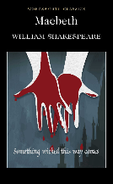
Key Terminology Macbeth
 | Term | Definition
1 | Ambition | A strong desire to achieve something
2 | Catharsis | Finding release/ releasing strong emotions
3 | Conflict | A serious disagreement or argument
4 | Desire | A strong wish for something or someone
5 | Duplicity | Deceitfulness/ being two faced e.g. The duplicitous nature of Lady Macbeth is one of the things that makes her so dangerous.
6 | Hamartia | A fatal flaw within the protagonist that leads to their tragic downfall
7 | Hubris | Excessive pride or self-confidence/ arrogance
8 | Machiavellian | The characteristic of being evil, cunning and sly
9 | Monarchy | The king, queen and royal family in a country
10 | Patriarchal/ Patriarchy | A society that is typically one in which men are seen as the dominant gender
11 | Prophecy | A prediction that is made about the future
12 | Soliloquy | A speech given to the audience in a play in which the character speaks their thoughts aloud and alone on stage
13 | Superstition | A belief in supernatural influences that there is no evidence for
14 | Tyranny/ Tyrannical | An unfair, unjust or cruel leadership/ rule e.g. Macbeth’s tyrannical nature is something that ultimately is his hamartia.
15 | Usurp | To take someone else’s place either illegally or by force

Key Quotations Macbeth

Here are some key quotations to revise and there is some space to add some of your own

Character | Key Quote
Macbeth | Captain: For brave Macbeth—well he deserves that name— Disdaining fortune, with his brandished steel, Which smoked with bloody execution, Like valour’s minion carved out his passage (Act I, Scene ii)
Macbeth | Stars hide your fires let not light see my black and deep desires. (Act I, Scene IV)
Macbeth | I have no spur To prick the sides of my intent, but only Vaulting ambition which o’erleaps itself And falls on th’other. (Act I, Scene vii)
Macbeth | Will all great Neptune's ocean wash this blood clean from my hand? (Act II, Scene ii)
Macbeth | Upon my head they placed a fruitless crown/ and put a barren sceptre in my gripe (Act III, Scene i)
Macbeth | O full of scorpions is my mind, dear wife! (Act III, Scene ii)
Macbeth | I am cabin’d, cribb’d, confin’d, bound in saucy doubts and fears. (Act III, scene Iv)
Macbeth | Thou canst not say I did it; never shake thy gory locks at me! (Act III, scene Iv)
Macbeth | I have lived long enough. My way of life Is fallen into the sear, the yellow leaf, And that which should accompany old age, As honour, love, obedience, troops of friends, I must not look to have; but in their stead Curses, not loud but deep (Act V, Scene iii)
Macbeth | To-morrow, and to-morrow, and to-morrow, Creeps in this petty pace from day to day, To the last syllable of recorded time; And all our yesterdays have lighted fools The way to dusty death. (Act V, Scene v)
Macbeth | Out, out, brief candle! Life's but a walking shadow, a poor player, That struts and frets his hour upon the stage, And then is heard no more. It is a tale Told by an idiot, full of sound and fury, Signifying nothing. (Act V, Scene v)
Lady Macbeth | Yet do I fear thy nature; It is too full o' the milk of human kindness. (Act I, Scene V)
Lady Macbeth | Come, you spirits That tend on mortal thoughts, un-sex me here And fill me from the crown to the toe topfull Of direst cruelty (Act I, Scene v)
Lady Macbeth | Screw your courage to the sticking-place, and we’ll not fail. (Act I, Scene vii)
Lady Macbeth | My hands are of your colour, but I would shame to wear a heart so white. (Act ii, Scene ii)
Lady Macbeth | What’s done is done. Macbeth: We have scorch’d the snake, not kill’d it. (Act III, Scene ii)
Lady Macbeth | Out, damned spot! out, I say! (Act V, Scene i)
Lady Macbeth | Here’s the smell of blood still; all the perfumes of Arabia will not sweeten this little hand. (Act V, Scene i)
Duncan | O worthiest cousin!/ The sin of my ingratitude even now/ Was heavy on me (Act I Scene iv)
Duncan | This castle hath a pleasant seat; the air/ Nimbly and sweetly recommends itself/ Unto our gentle senses. (Act I, Scene vi)
Duncan | Macbeth: [about Duncan]: his virtues/ will plead like angels, trumpet-tongued, against/ the deep damnation of his taking-off (Act I Scene vii)
Banquo | And oftentimes, to win us to our harm, the instruments of darkness tell us truths (Act I scene iii)
Banquo | Thou hast it now, King, Cawdor, Glamis, all., as the weird sisters promis’d, and I fear Thou hast play’d most foully for’t (Act III scene i)
The Witches | Fair is foul, and foul is fair, Hover through the fog an filthy air. (Act I, Scene i)
The Witches | When shall we three meet again in thunder, lightning, or in rain? When the hurlyburly 's done, When the battle 's lost and won. (Act I, Scene i)
The Witches | Double, double toil and trouble; Fire burn, and cauldron bubble. (Act IV, Scene i)
The Witches | Second Apparition: Be bloody, bold and resolute. Laugh to scorn The power of man, for none of woman born Shall harm Macbeth (Act IV, scene i)
Malcom | Of this dead butcher and his fiend-like queen (Act V, Scene ix)
Macduff | O nation miserable! With an untitiled tyrant, bloody-sceptred (Act IV Scene iii)
Macduff | Macduff was from his mother’s womb untimely ripp’d. (Act V, Scene viii)
Macduff | Turn, hell-hound, turn (Act V Scene viii)

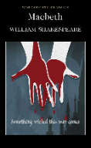
Big Ideas for Macbeth:
- Shakespeare uses the play and Macbeth’s illegitimate rule to demonstrate the terrible consequences of disrupting the natural order.
- Shakespeare uses the play to demonstrate the consequences of engaging with the supernatural.
- Shakespeare uses Macbeth’s role as a tragic hero to highlight how vulnerable people are to the destructive temptation of power.

Shakespeare’s ‘Key Methods’
- Shakespeare uses blood as a metaphor for guilt through the play. As the guilt increases, the volume of blood increases.
- Shakespeare uses apparitions to present the consequences of ungodly behaviour and is ambiguous about whether they are real or imagined. As the consequences intensify, the apparitions become more intense and public.
- Shakespeare’s characterisation of Macbeth and Lady Macbeth establishes the idea that ungodly deeds do not go unpunished.

Thematic Overviews
Foul and Fair:
The phrase ‘fair is foul, and foul is fair’ (A1S1) sets the tone for the play – one of a world turned upside down and a natural order uprooted. There are a whole range of things which appear fair but are really foul in the play – Shakespeare is establishing the idea of appearance and reality being uncertain things. Importantly, the same language appears again and again throughout the play: with Macbeth (so foul and fair a day), with Duncan (calling Lady Macbeth ‘fair’), with Banquo (calling the prophecy ‘fair’ but then stating Macbeth has ‘played foully’ to achieve it). Might this imply the Witches control and manipulate events, in a manner which is certainly not natural?

Lennox and the Old Man speak of the disrupted natural world:
In Act 2 Scene 4, Lennox and an Old Man discuss unusual natural events that were witnessed on the night of Duncan’s murder: horses eat one another, an owl hunts an eagle, darkness shrouds daylight (tis day,
And yet dark night strangles the travelling lamp). The world has been wronged and the natural order has been uprooted by Macbeth’s actions. Even earlier in Act 2 Scene 3, Lennox describes how the ‘earth did shake’ during the night, suggesting a cataclysmic upheaval and emphasising the scale of Macbeth’s crime. The earth itself trembles at this regicide.

Darkness and ambition:
Both Macbeth and Lady Macbeth call upon darkness in order to pursue regicide and attain power. Lady Macbeth calls ‘come, thick night’, Macbeth later calls ‘come, seeling night.’ Both know the wrong of their deeds. That they call to be shrouded in darkness highlights the unnatural nature of their words and deeds – they must be hidden from nature.

Macbeth’s ‘fruitless crown’:
Macbeth’s illegitimacy is conveyed through his doomed line: Banquo shall beget kings, in a long and unbroken line to James I, whilst he shall remain childless. Key references here include Macbeth’s Act 3 Scene 1 soliloquy (‘fruitless crown’, ‘barren sceptre’) which conveys his bitterness at his own ‘unlineal hand’ and the ‘rancours in the vessel of [his] peace’ that now consume him. This idea recurs in the scene with Banquo’s ghost when it takes Macbeth’s seat at the table, implying that it is rightfully for the descendants of Banquo to rule. Finally, the final apparitions, the line of Banquo’s heirs and successors, are the third time Banquo has appeared to Macbeth after his death. This implies the inevitability of his family’s rule and the assertion of their divine right over Macbeth’s unnatural claim. That Banquo’s apparition appears ‘smiling’ at this line of future kings suggests a mocking of the futility of Macbeth’s rule.

The kingly qualities of Duncan/Malcom/Banquo vs the tyrant Macbeth:
Macbeth’s tyrannical nature is often contrasted with more regal and kingly characters in order to highlight his deficits and the illegitimacy of his rule in comparison to those appointed by God. Even Macbeth himself describes how Duncan’s ‘virtues will plead like angels’ and he has been ‘so clear’ as king (A1S7). Macduff describes how ‘sacrilegious murder hath broke ope/ The Lord's anointed temple’ when Duncan is killed (A2S3), yet 3 acts later he will describe Macbeth as a ‘hellhound’ (A5S8). The former is sacred and appointed by God, whilst the latter achieved kingship through darker influences. Finally, Malcom described in Act 4 Scene 3 those qualities which would be kingly: ‘the king-becoming graces,/ As justice, verity, temperance, stableness,/ Bounty, perseverance, mercy, lowliness,/ Devotion, patience, courage, fortitude’. We see few or none of these in Macbeth by the end.

The torture of guilt:
Guilt serves as punishment that the Macbeth’s suffer for their unnatural regicide. It consumes Lady Macbeth despite her assertions in Act 1 that she might be ‘unsex[ed]’ and heaven might not ‘peep through the blanket of the dark’. Her flippancy in Act 2 Scene 2 when she claims a ‘little water clears us of this deed’ is rendered absurd by Act 5, when she raves ‘out, damned spot’. Macbeth also seems to suffer for his guilt: he is robbed of sleep (and perhaps innocence, security etc.) (‘Macbeth hath murdered sleep’ A2S2) and he sees bloody apparitions (Banquo’s ghost, the dagger). Only by discarding all morality and humanity does he seem to escape the fate of Lady Macbeth: ‘I am in blood/ Stepp'd in so far that, should I wade no more,/ Returning were as tedious as go o'er:’ (A3S4).

The isolation of Macbeth and Lady Macbeth:
As the play goes on, Macbeth becomes increasingly reliant on soliloquy and increasingly isolated on stage. By act 5 he cuts a tragic figure as king, speaking only to subordinates with both Banquo and Lady Macbeth dead. After their roles shift in Act 3 and Lady Macbeth attempts to cover for her husband’s disturbance in seeing Banquo’s ghost, they aren’t seen on stage together again. His final line in her presence is ‘we are yet but young in deed’ (A3S4), and yet he now drives his tyranny forward alone. This is an important consequence of their unnatural and immoral actions.
His isolation and lack of lineal successor leaves Macbeth nihilistic and bitter. Life becomes ‘a tale told by an idiot, full of sound and fury, signifying nothing’. (A5S5)

The death of Macbeth:
It is important that Macbeth die in order to demonstrate the idea that death is the inevitable consequence for disrupting and betraying the natural order of the world and a king’s divine right to rule, much as it was for those plotters who conspired to assassinate James I in 1605. Following his death, Malcom reasserts good Christian values and condemns ‘the dead butcher and his fiend-like queen’ (A5S9). He ends with: ‘what needful else/ That calls upon us, by the grace of Grace,/ We will perform in measure, time and place’ – God’s order has been restored.

The control of the Witches:
The witches assert influence and control right from the opening lines: ‘when shall we three meet again/ in thunder, lightning or in rain?’ This line helps to establish their prescience and control of time, whilst also establishing a turbulent tone, highlighting a world in darkness and upheaval and suggesting their otherworldly nature. They continue to assert structural control of the play, driving events forward by prophesying and opening both acts 1 and 4. Their language creeps into that of other characters, particularly ‘foul’ and ‘fair’ (see above) and their equivocation is the source of much of Macbeth’s ruin. Whilst he is driven by his own ambition, he also follows the prophecies of the Witches blindly and to his own destruction when he learns Macduff was ‘untimely ripp’d’ from the womb. That Banquo initially mistrusts them is perhaps Shakespeare’s indication of how we should react to their forecasts and to the supernatural in general – that Macbeth seeks to hear more highlights their influence: ‘Stay, you imperfect speakers’ and ‘Would they had stay'd!’ (A1S2) Banquo’s resistance magnifies Macbeth’s failure.

Supernatural visions:
Macbeth’s psychological uneasiness and the ‘scorpions in his mind’ are also illustrated through the ghostly visions that he sees. The supernatural influences acting upon Macbeth and the unnatural nature of his crimes also exact a supernatural torture upon him.

The noble Macbeth:
Macbeth’s qualities are made clear in Act 1 Scene 2 in order to ensure that as a tragic hero he falls from a high place. He is ‘brave Macbeth’, ‘valour’s minion’, ‘Bellona’s bridegroom’ – the language emphasises his courage and turns his ability to kill well into a great virtue. Here, his violence is a source of nobility and he is hailed by Duncan as ‘worthy gentleman!’ and ‘valiant cousin!’.

Macbeth’s Hamartia – ‘vaulting ambition’:
As a tragic hero Macbeth needs a hamartia – his is his ‘vaulting ambition’ (A1S7). He is subject to external influences in Lady Macbeth and the Witches, but ultimately wields the knife that kills Duncan and orders the murders of Banquo, Fleance and Macduff’s family. That he personifies his ambition as ‘vaulting’ is perhaps an attempt to distance himself from it; perhaps it places his desires beyond his control or imply that they own him, rather than he shape them.

Lady Macbeth as both catalyst and a foil:
That Lady Macbeth so obviously desires darkness and cruelty whilst he was ‘full of the milk of human kindness’ emphasises his uncertainty and highlights that he had goodness and nobility within him at the beginning. Their role reversal as he becomes tyrannical foregrounds the depth of his fall, particularly as she is mentally undone by a single murder committed indirectly whilst he continues to murder apace.

Banquo’s role as a foil:
That Banquo and Macbeth begin the play together as ‘two captains’ highlights Macbeth’s fall. Where Banquo is steadfast, suspicious of the witches (although he is interested in what they have to say to him) and loyal to Duncan, Macbeth is not. Most importantly, Banquo’s long line of successors (as shown in the apparitions of Act 4 Scene 1) and the placement of his ghost in Macbeth’s seat emphasise Macbeth’s illegitimacy and the doomed nature of his kingship.

Bestial imagery and Macbeth:
Macbeth is initially described by the sergeant in Act 1 Scene 2 as a ‘lion’ and an ‘eagle’, suggesting a martial strength and a nobility of nature. He must later become a ‘serpent’ when persuaded to dissemble by Lady Macbeth. After committing murder, he exclaims that his mind is full of ‘scorpions’, before he is finally described as a ‘hellhound’ by Macduff in Act 5. The progression of this bestial imagery mirrors his fall from bold nobility to poisoned and poisonous duplicity and, finally, to satanic evil.

The massacre of Macduff’s family:
This represents a critical point in the play and the greatest depth of Macbeth’s cruelty. The annihilation of Macduff’s line perhaps reflects Macbeth’s inability to prevent Banquo’s descendants, but is also represents an act free from morality or humanity. He states ‘the firstlings of my heart shall be/ the firstlings of my hand’: he will no longer be held back by any sort of moral code or duty, much like Lady Macbeth wished in Act 1 but fell short of (‘no compunctious visitings of nature shake my fell purpose’). His ambition and desire for power have led him to utter evil, emphasised here because he isn’t removing a threat implies by the Witches – he believes himself immune to danger from Macduff so this is his evil.

The pointlessness of his power:
The tragedy of Macbeth’s rise to power is emphasised by the futility of it. He never finds security in his role as king (‘to be thus is nothing, but to be safely thus’ – A3S1) and he is left desolate and alone (‘my way of life/ Is fall'n into the sear, the yellow leaf;/ And that which should accompany old age,/ As honour, love, obedience, troops of friends,/ I must not look to have’ (A5S3).

Plot Summary Macbeth
Act 1 Scene 1: Three witches plan to meet Macbeth.

Act 1 Scene 2: Duncan, king of Scotland, hears an account of the success in battle of his noblemen Macbeth and Banquo. Duncan orders the execution of the rebel thane of Cawdor and sends messengers to announce to Macbeth that he has been given Cawdor’s title.

Act 1 Scene 3: The three witches greet Macbeth as “Thane of Glamis” (as he is), “Thane of Cawdor,” and “king hereafter.” They then promise Banquo that he will father kings, and they disappear. Almost as soon as they are gone, Ross and Angus arrive with news that the king has named Macbeth “Thane of Cawdor.” Macbeth contemplates killing Duncan in order to become “king hereafter” as the witches have called him.

Act 1 Scene 4: Duncan demands and receives assurances that the former thane of Cawdor has been executed. When Macbeth, Banquo, Ross, and Angus join Duncan, he offers thanks to Macbeth and Banquo. He then announces his intention to have his son Malcolm succeed him as king and his plan to visit Macbeth at Inverness. Macbeth sets out ahead of him to prepare for the royal visit. Now that Malcolm has been named Duncan’s successor, Macbeth is convinced that he can become king only by killing Duncan.

Act 1 Scene 5: Lady Macbeth reads her husband’s letter about his meeting the witches. She fears that Macbeth lacks the ruthlessness he needs to kill Duncan and fulfill the witches’ second prophecy. When she learns that Duncan is coming to visit, she calls upon supernatural agents to fill her with cruelty. Macbeth arrives, and Lady Macbeth tells him that she will take charge of the preparations for Duncan’s visit and for his murder.

Act 1 Scene 6: Duncan and his attendants arrive at Inverness. Lady Macbeth welcomes them.

Act 1 Scene 7: Macbeth contemplates the reasons why it is a terrible thing to kill Duncan. Lady Macbeth mocks his fears and offers a plan for Duncan’s murder, which Macbeth accepts.
__________________________________________________________________________

Act 2 Scene 1: Banquo, who has accompanied Duncan to Inverness, is uneasy because he too is tempted by the witches’ prophecies, although only in his dreams. Macbeth pretends to have forgotten them. Left alone by Banquo, Macbeth sees a gory dagger leading him to Duncan’s room. Hearing the bell rung by Lady Macbeth to signal completion of her preparations for Duncan’s death, Macbeth exits to kill the king.

Act 2 Scene 2: Lady Macbeth waits anxiously for Macbeth to return from killing Duncan. When Macbeth enters, he is horrified by what he has done. He has brought with him the daggers that he used on Duncan, instead of leaving them in the room with Duncan’s servants as Lady Macbeth had planned. When he finds himself incapable of returning the daggers, Lady Macbeth does so. She returns to find Macbeth still paralyzed with horror and urges him to put on his gown and wash the blood from his hands.

Act 2 Scene 3: A drunken porter, answering the knocking at the gate, plays the role of a devil-porter at the gates of hell. He admits Macduff and Lennox, who have come to wake Duncan. Macbeth appears and greets them. Macduff exits to wake Duncan, then returns to announce Duncan’s murder. Macbeth and Lennox go to see for themselves. When they return, Lennox announces that Duncan’s servants are the murderers. Macbeth reveals that he has slain the servants. When his motives are questioned, Lady Macbeth interrupts by calling for help for herself. Duncan’s sons, Malcolm and Donalbain, plan to flee for their lives—Malcolm to England, Donalbain to Ireland.

Act 2 Scene 4: An old man and Ross exchange accounts of recent unnatural happenings. Macduff joins them to report that Malcolm and Donalbain are now accused of having bribed the servants who supposedly killed Duncan. Macduff also announces that Macbeth has been chosen king. Ross leaves for Scone and Macbeth’s coronation, but Macduff resolves to stay at his own castle at Fife.
__________________________________________________________________________

Act 3 Scene 1: Banquo suspects that Macbeth killed Duncan in order to become king. Macbeth invites Banquo to a feast that night. Banquo promises to return in time. Macbeth, fearing that Banquo’s children, not his own, will be the future kings of Scotland, seizes upon the opportunity provided by Banquo’s scheduled return after dark to arrange for his murder. To carry out the crime, Macbeth employs two men whom he has persuaded to regard Banquo as an enemy.

Act 3 Scene 2: Both Lady Macbeth and Macbeth express their unhappiness. Macbeth speaks of his fear of Banquo especially. He refers to a dreadful deed that will happen that night but does not confide his plan for Banquo’s murder to Lady Macbeth.

Act 3 Scene 3: A third man joins the two whom Macbeth has already sent to kill Banquo and Fleance. The three assassins manage to kill Banquo. Fleance escapes.

Act 3 Scene 4: As Macbeth’s banquet begins, one of Banquo’s murderers appears at the door to tell Macbeth of Banquo’s death and Fleance’s escape. Returning to the table, Macbeth is confronted by Banquo’s ghost, invisible to all but Macbeth. While Lady Macbeth is able to dismiss as a momentary fit Macbeth’s expressions of horror at the ghost’s first appearance, the reappearance of the ghost and Macbeth’s outcries in response to it force Lady Macbeth to send all the guests away. Alone with Lady Macbeth, Macbeth resolves to meet the witches again. He foresees a future marked by further violence.

Act 3 Scene 5: The presentation of the witches in this scene (as in 4.1.38 SD–43 and 141–48) differs from their presentation in the rest of the play. Most editors and scholars believe that neither this scene nor the passages in 4.1 were written by Shakespeare.

Act 3 Scene 6: Lennox and an unnamed lord discuss politics in Scotland. Lennox comments sarcastically upon Macbeth’s “official” versions of the many recent violent deaths. The nameless lord responds with news of Macduff’s flight to England to seek help in overthrowing Macbeth.
__________________________________________________________________________

Act 4 Scene 1: Macbeth approaches the witches to learn how to make his kingship secure. In response they summon for him three apparitions: an armed head, a bloody child, and finally a child crowned, with a tree in his hand. These apparitions instruct Macbeth to beware Macduff but reassure him that no man born of woman can harm him and that he will not be overthrown until Birnam Wood moves to Dunsinane. Macbeth is greatly reassured, but his confidence in the future is shaken when the witches show him a line of kings all in the image of Banquo. After the witches disappear, Macbeth discovers that Macduff has fled to England and decides to kill Macduff’s family immediately.

Act 4 Scene 2: Ross visits Lady Macduff and tries to justify to her Macduff’s flight to England, a flight that leaves his family defenseless. After Ross leaves, a messenger arrives to warn Lady Macduff to flee. Before she can do so, Macbeth’s men attack her and her son.

Act 4 Scene 3: Macduff finds Malcolm at the English court and urges him to attack Macbeth at once. Malcolm suspects that Macduff is Macbeth’s agent sent to lure Malcolm to his destruction in Scotland. After Malcolm tests Macduff and finds him sincere, Malcolm reveals that Edward, king of England, has provided a commander (Siward) and ten thousand troops for the invasion of Scotland. Ross then arrives with the news of the slaughter of Macduff’s entire household. At first grief-stricken, Macduff follows Malcolm’s advice and converts his grief into a desire to avenge himself on Macbeth.
__________________________________________________________________________

Act 5 Scene 1: A gentlewoman who waits on Lady Macbeth has seen her walking in her sleep and has asked a doctor’s advice. Together they observe Lady Macbeth make the gestures of repeatedly washing her hands as she relives the horrors that she and Macbeth have carried out and experienced. The doctor concludes that she needs spiritual rather than medical aid.

Act 5 Scene 2: A Scottish force, in rebellion against Macbeth, marches toward Birnam Wood to join Malcolm and his English army.

Act 5 Scene 3: Reports are brought to Macbeth of the Scottish and English forces massed against him. He seeks assurance in the apparitions’ promise of safety for himself. But he is anxious about Lady Macbeth’s condition and impatient with her doctor’s inability to cure her.

Act 5 Scene 4: The rebel Scottish forces have joined Malcolm’s army at Birnam Wood. Malcolm orders each soldier to cut down and carry a bough from the Wood so as to conceal their numbers from Macbeth.

Act 5 Scene 5: Macbeth is confident that he can withstand any siege from Malcolm’s forces. He is then told of Lady Macbeth’s death and of the apparent movement of Birnam Wood toward Dunsinane Castle, where he waits. He desperately resolves to abandon the castle and give battle to Malcolm in the field.

Act 5 Scene 6: Malcolm arrives with his troops before Dunsinane Castle.

Act 5 Scene 7: On the battlefield Macbeth kills young Siward, the son of the English commander. After Macbeth exits, Macduff arrives in search of him. Dunsinane Castle has already been surrendered to Malcolm, whose forces have been strengthened by deserters from Macbeth’s army.

Act 5 Scene 8: Macduff finds Macbeth, who is reluctant to fight with him because Macbeth has already killed Macduff’s whole family and is sure of killing Macduff too if they fight. When Macduff announces that he is not, strictly speaking, a man born of woman, having been ripped prematurely from his mother’s womb, then Macbeth is afraid to fight. He fights with Macduff only when Macduff threatens to capture him and display him as a public spectacle. Macduff kills Macbeth, cuts off his head, and brings it to Malcolm. With Macbeth dead, Malcolm is now king and gives new titles to his loyal supporters.

Mark schemes Literature Paper 1

Assessment objectives (AOs)

AO1 Read, understand and respond to texts. Students should be able to:

• maintain a critical style and develop an informed personal response

• use textual references, including quotations, to support and illustrate interpretations.

AO2 Analyse the language, form and structure used by a writer to create meanings and effects, using relevant subject terminology where appropriate.

AO3 Show understanding of the relationships between texts and the contexts in which they were written.

AO4 Use a range of vocabulary and sentence structures for clarity, purpose and effect, with accurate spelling and punctuation
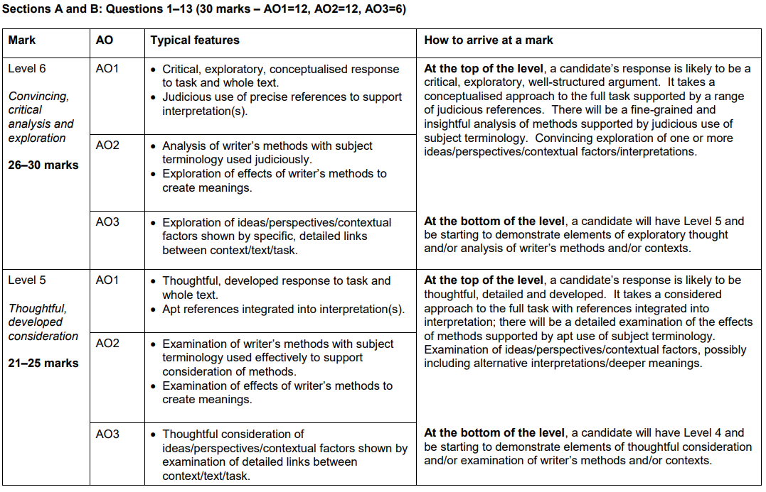

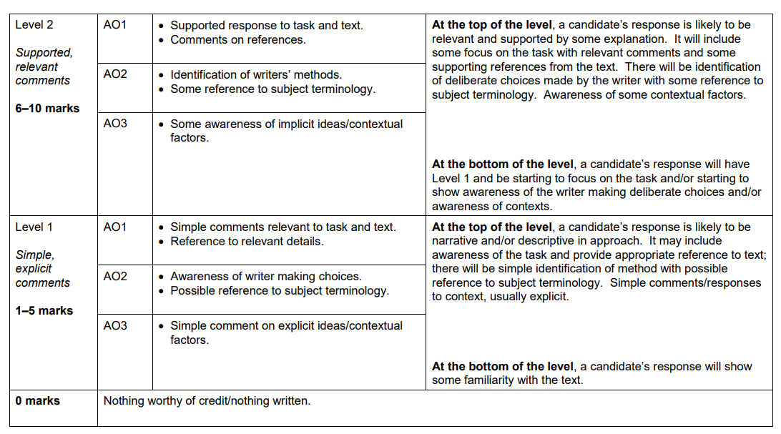
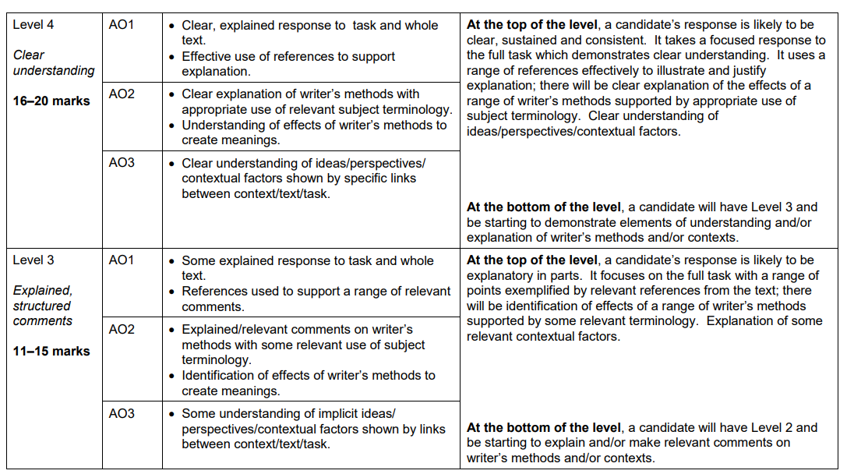

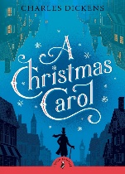
Model Exam Answer – A Christmas Carol
Starting with this extract, explore how Dickens presents the effects of greed in A Christmas Carol.
Write about:
- how Dickens presents the effects of greed in this extract
- how Dickens presents the effects of greed in the wider novella.

The motif of fire in “A Christmas Carol” symbolises the greed of some characters and the generosity of others, in an attempt by Dickens to prove that money does not equal happiness. Added to the setting of Christmas-time this message is particularly impactful as the Christian values of giving and not taking are coming into play not only with the characters, but the selfish, aristocratic audience too.

One of the first fires in the novella is that of Scrooge’s clerk, Bob Cratchit, and it is described to be “so much smaller that it looked like one coal”, the hyperbolic language emphasising the coldness of his greedy, ungenerous boss, Scrooge. Further into the novella, the most symbolic appearance of fire is the “light like a candle”, on the head of the Ghost of Christmas past. Being “a strange figure: Like a child, yet not so like a child” suggests its wisdom without age, perhaps a re-incarnation of Bob Cratchit’s child, Tiny Tim, who is also wise due to his illness despite still being so young. This insightful ghost shows Scrooge the full effect that his greed can have on his own self, when it takes him to see his past love, Belle. The immense pain this puts Scrooge in causes him to “press down with all his force” in an attempt to physically “hide the light” and therefore all of its metaphorical meanings and Christian connotations. Scrooge here realises that he cannot hide from the blinding loneliness his greedy actions cause to him and others, including Bob Cratchit, so makes a positive and symbolic change in “buy[ing] another coal scuttle”.

To again push the message that money doesn’t equal happiness, Dickens uses his own experience of his family living in a single room to explore the importance of a family being together, much like the Cratchits on Christmas day gathered in a “half-circle” around the hearth. “A small room, not very large or handsome, but full of comfort” uses a subordinate clause for emphasis on the fact that Dicken’s audience shouldn’t judge their happiness by the size of their aristocratic houses, but instead by the comfort within them. Scrooge cannot relate to this, though, as his money has bought him an enormous house that he couldn’t fill with a family or it's comforts. Belle’s insight was perfectly correct, which hits Scrooge hard when he comes to realise his money cannot “cheer and comfort you in time to come”, and that ultimately, Belle could have, sparking regret that will go on to fuel his change from greedy to generous in the latter parts of the novella.

The “golden” “idol” that Belle is displaced by could parallel that sprinkled by the Ghost of Christmas Present, the only difference between the two being that one is given to the poor and one to the rich. In excess this “golden” money is an obsessive burden to Scrooge, but if only he “sprinkled” it over the poor like the Ghost of Christmas Present, he would help those in need whilst simultaneously freeing himself of “Gain”, “the master-passion”. By capitalising “Gain”, Dickens brings this greedy quality to life, as he similarly does to “Ignorance and Want”. Dickens sets Scrooge parallel to his “Girl and a boy. Yellow, meagre, scowling wolfish” by syntactically paralleling their structures: “Scrooge. A squeezing, wrenching, grasping, scraping…”. Dickens ultimately describes how Scrooge, and those who, like him, are greedy, become “engrossed” and taken over by Gain, Ignorance, and Want, the three personified demons of the novella; the counterparts to the guide-like ghosts (the “nobler aspirations”), and warns his readers of the true isolation these demons can cause if change is not made from greed to generosity soon.

Model Exam Answer – Macbeth
Starting with this extract, how does Shakespeare present the theme of Ambition?
Write about:
- how Shakespeare presents ambition in this extract
- how Shakespeare presents ambition in the play as a whole

Ambition is an important theme in Macbeth and is the driving force of the play because Shakespeare allows ambition to overpower Macbeth’s morals when he commits the regicide of King Duncan. Even though the witches and Lady Macbeth have influenced Macbeth, he may not have been able to kill Duncan if his ambition wasn’t so strong.

Shakespeare shows that ambition changes even the most noble people in this speech. He allows Lady Macbeth to describe Macbeth’s nature as being ‘too full o th’ milk of human kindness’ in her soliloquy. The noun ‘milk’ has connotations of purity and innocence, implying that Macbeth isn’t evil enough to act on his ambitions. However, during Macbeth’s reign as King, he is described as a ‘butcher’ a powerful adjective that emphasises Macbeth’s cruelty and the amount of people he has killed without reason. This change in character from being kind and loyal to tyrannical surprises the audience and conveys the dangers of having ambitions that lead to bad deeds.

Furthermore, Shakespeare also presents ambition as being able to take over one’s morals and reasons. In Lady Macbeth’s speech, Shakespeare allows her to say ‘Art not without ambition, but without the illness should attend it’. The noun ‘illness’ creates an impression to the audience of ambition being different from acting on it, and describing it as an ‘illness’ emphasises the amount of destruction it can cause to an audience. ‘illness’ could also suggest that acting on ambition can cause someone to act immorally and in a tyrannical way. Macbeth also acknowledges his own ‘vaulting ambition’ after listing all the reasons not the kill Duncan. The metaphor suggest that Macbeth’s ambition is stronger than his moral conscience and is the only reason left for him to murder Duncan.

Macbeth’s ambition is also contrasted with Banquo who was also present when the witches gave the prophecies. Macbeth immediately begins to believe the witches, and when he becomes the Thane of Cawdor, proving that the first prediction has come true, he begins to believe them more and then act on his ambition to be King. Banquo however, is the opposite of Macbeth and acts as a foil to him. Although he does believe the witches, he does not act on his ambitions and even suspects that Macbeth has ‘played most foully for it’. This contrast in attitudes towards the supernatural and ambition two-fold structure of Macbeth that sees his rise to power and his downfall further emphasises the destructive nature of ambition, but also conveys to the audience that being able to control your ambitions can prevent a tragedy like Macbeth’s from occurring.

In conclusion, Shakespeare presents ambition as being able to change people and take over their morals and reasons and can also lead to one’s downfall if it isn’t controlled. This allows Shakespeare to also convey to the audience the destruction that someone would experience if they attempted to assassinate the monarch, like King James I at the time the play was performed as a warning about committing a sinful act such as regicide.

Homework Tasks.

Knowledge is power, so the more you know, the more secure you will be in your learning.

Year 11: Unit 3 Homework: Literature Paper 1: A Christmas Carol + Macbeth
Task 1: | Due date:  WEEK 2 | - Complete the Knowledge Quiz for A Christmas Carol  - This will be marked in class with your teacher
Task 3: | Due date:  WEEK 4 | - Complete the Knowledge Quiz for Macbeth  - This will be marked in class with your teacher
Task 3:  Optional Additional Homework | Due date:  Teacher to specify the due in date | - Choose one of the exam questions and complete an essay plan and a minimum of 2 paragraphs of the essay  - You must make sure to choose something you would find the most challenging in the exam!

If you have ‘no homework’, or you have finished all of the above, try these tasks on a weekly basis to ensure your understanding is secure.
- Use the Wider Reading page on the back of the Knowledge Organiser and download some more practice papers from AQA, revise online using some of the YouTube Resources, use SENECA to revise key areas of your exam or listen to a Massolit Lecture
- Add words to your key terminology grid on page 6 of the Knowledge Organiser
- Read for at least 20 minutes per day – a mixture of fiction and non-fiction texts.

Homework 1

Complete the Knowledge Quiz questions for A Christmas Carol

1.What year was A Christmas Carol published?

2. What was the Poor Law and what did it introduce?

3. What social class did Dickens aim to critique in his novella?

4. How did the Industrial Revolution impact the poor?

5. What does the term ‘Malthusian’ refer to in the novella?

6. How did Dickens’ childhood experiences influence his writing?

7. Who is Jacob Marley? What is his relationship to Scrooge?

8. What does Bob Cratchit represent in the novella?

9. Who is Fred and what is his relationship to Scrooge?

10. Who is Tiny Tim and what does he represent in the novella?

11. Where does the Ghost of Christmas Past take Scrooge? Name at least 2 places.

12. ‘like a __________ yet not so like a __________ as like an old _____________’

13. Who are the portly gentlemen? What do they want from Scrooge?

14. What does Jacob Marley’s chain symbolise?

15. ‘then they had better do it and __________ the _____________ population’

16. Define the term Redemption.

17. Scrooge is a miser. What does this mean?

18. What is the correct term for someone who avoids humankind?

19. What is a counting house and how does this relate to Scrooge’s personality?

20. What does the Ghost of Christmas Past look like?

21. Who is Belle and what is her relationship to Scrooge?

22. ‘another ___________ has displaced me, a __________ one’

23. Who are Ignorance and Want?

24. What do Ignorance and Want symbolise?

25. What does the Ghost of Christmas Present look like?

26. What is a ‘beetling shop’ shown to us in Stave 4?

27. What does Fezziwig symbolise in the novella?

28. What happened to Scrooge’s sister?

29. What does Light symbolise in the novella?

30. What is the opening line of the novella?

31. Define the term morality.

32. What is generosity?

33. Scrooge sends something to a house at the start of Stave 5. What is this and where does it go to?

34. What is the Ghost of Christmas Present holding?

35. What is a ‘scabbard’ and why is it empty on the Ghost of Christmas Present?

36. What does Scrooge see on the gravestone in Stave 4?

37. What do the Cratchit family have on Christmas Day to eat?

38. ‘I wear the ___________ I forged in life. I made it link by link and yard by yard.’

39. What is the method Dickens uses in the novella to show the weather reflecting the mood?

40. At the end of the novella Scrooge says he is ‘as light as a ______________’ and as ‘merry as a _______________’

41. What is written on the forehead of Ignorance?

42. Where does Scrooge go in Stave 5?

43. What does Scrooge tell Bob he is going to do for him in Stave 5?

44. What is a philanthropist?

45. Give an example of isolation from the novella.

46. What is social responsibility?

47. What is injustice?

48. How long has Marley been dead at the start of the novella?

49. What time does the first ghost appear to Scrooge?

50. What does the term melancholy mean?

Mark / 50

Homework 2

Complete the Knowledge Quiz questions for Macbeth
1. Which monarch was on the throne when Macbeth was first performed?

2. What title does Macbeth hold at the beginning of the play?

3. In which act and scene does Macbeth encounter the witches?

4. What does Regicide mean?

5. What is the name of Banquo’s son?

6. What title does King Duncan reward Macbeth with for fighting so bravely?

7. Which character says, ‘Look, how our partner’s rapt’?

8. Where is Macbeth’s castle located?

9. Which character says ‘Look like the innocent flower’?

10. In which year is it generally thought that the play was first performed?

11. What is the name of King Duncan’s eldest son?

12. In which act does Macbeth see a floating dagger?

13. After murdering Duncan, is it true or false that Macbeth returns with the murder weapons?

14. Which character says ‘This is a sorry sight’?

15. Which character is the first to discover Duncan’s body?

16. To which country does Donalbain flee after he discovers Duncan has been murdered?

17. In which act and scene does Macbeth see Banquo’s ghost?

18. What does Tyrannical mean?

19. What does Hamartia mean?

20. What genre is Macbeth? (History, Comedy or Tragedy)

21. In which act and scene does Macbeth visit the witches for the second time?

22. What title does Macduff hold?

23. Which character says, ‘Thou liest, though shag-hair’d villain’?

24. In which act and scene is Macduff’s wife and children killed?

25. What is Lady Macbeth referring to when she describes the ‘golden round’?

26. Which word from the original Greek means excessive pride or self-confidence?

27. Which character says ‘Bleed, bleed poor country!’?

28. Which character informs Macduff that his wife and children have been killed?

29. Which character says ‘Out! Damned Spot! Out I say!”?

30. Which wood do Malcolm and Macduff’s army gather by towards the end of the play?

31. Which castle is Macbeth based in at the end of the play?

32. How many acts does Macbeth have in total?

33. Which character says ‘What’s the boy Malcolm’?

34. In which act and scene is Macbeth informed that his wife, Lady Macbeth is dead?

35. Which character informs Macbeth that Lady Macbeth has died?

36. Macbeth says ‘At least we’ll die with harness on our back’ What is he referring to?

37. Which character says ‘Tyrant, show thy face’?

38. How does Banquo die?

39. Who is Macbeth referring to when he says ‘Of all men else I have avoided thee!’?

40. In which act and scene is Macbeth killed?

41. Who kills Macbeth and how?

42. Who is Malcolm referring to when he says ‘dead butcher’?

43. Where will Malcolm eventually be crowned?

44. What is the word that describes a society ruled by men?

45. What is the word that describes a monologue delivered on stage by a character?

46. Who was the monarch before James I?

47. Which characters are referred to as the ‘weird sisters’?

48. How many marks are available for the Macbeth section of the exam?

49. Roughly how much time should you spend planning and writing your response to the Macbeth question?

50. What is the name of the dissertation that James I published on necromancy and witchcraft?

Mark / 50

Homework 3: Additional Homework for Teacher to set

Read both exam questions on A Christmas Carol and Macbeth and complete one exam answer with the minimum of:
- A plan
- 2 paragraphs of the essay completed

SPACE FOR PLANNING YOUR ANSWER

Macbeth

Read the following extract from Act 1 Scene 2 of Macbeth and then answer the question that follows.

At this point in the play, the Captain tells Duncan about Macbeth’s part in the recent battle.

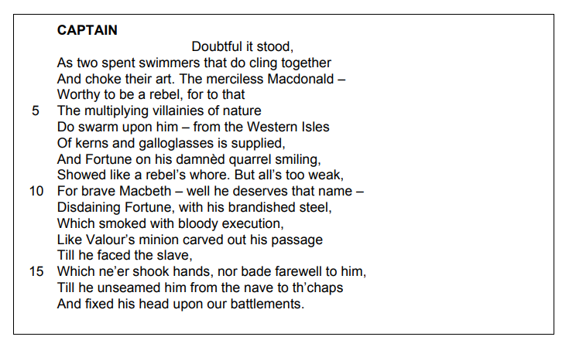

Starting with this speech, explore how far Shakespeare presents Macbeth as a violent character.

Write about:
• how Shakespeare presents Macbeth in this extract
• how far Shakespeare presents Macbeth as a violent character in the play as a whole.

[30 marks]
AO4 [4 marks]

A Christmas Carol

Read the following extract from Chapter 4 of A Christmas Carol and then answer the question that follows.

In this extract, Scrooge meets the Ghost of Christmas Yet to Come.
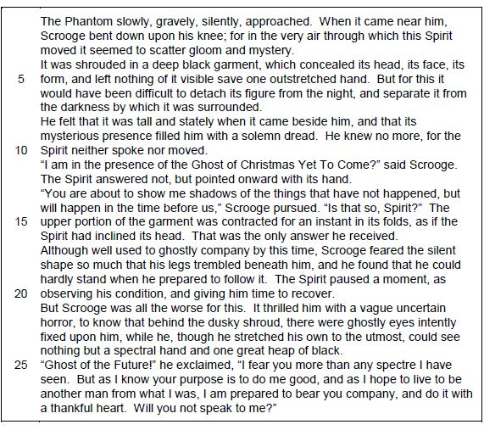

Starting with this extract, explore how Dickens presents Scrooge’s fears in A Christmas Carol.

Write about:
• how Dickens presents what Scrooge is frightened of in this extract.
• how Dickens presents Scrooge’s fears in the novella as a whole.

[30 marks]

__________________________________________________________________________________________________________________________________________________________________________________________________________________________________________________________________________________________________________________________________________________________________________________________________________________________________________________________________________________________________________________________________________________________________________________________________________________________________________________________________________________________________________________________________________________________________________________________________________________________________________________________________________________________________________________________________________________________________________________________________________________________________________________________________________________________________________________________________________________________________________________________________________________________________________________________________________________________________________________________________________________________________________________________________________________________________________________________________________________________________________________________________________________________________________________________________________________________________________________________________________________________________________________________________________________________________________________________________________________________________________________________________________________________________________________________________________________________________________________________________________________________________________________________________________________________________________________________________________________________________________________________________________________________________________________________________________________________________________________________________________________________________________________________________________________________________________________________________________________________________________________________________________________________________________________________________________________________________________________________________________________________________________________________________________________________________________________________________________________________________________________________________________________________________________________________________________________________________________________________________________________________________________________________________________________________________________________________________________________________________________________________________________________________________________________________________________________________________________________________________________________________________________________________________________________________________________________________________________________________________________________________________________________________________________________________________________________________________________________________________________________________________________________________________________________________________________________________________________________________________________________________________________________________________________________________________________________________________________________________________________________________________________________________________________________________________________________________________________________________________________________________________________________________________________________________________________________________________________________________________________________________________________________________________________________________________________________________________________________________________________________________________________________________________________________________________________________________________________________________________________________________________________________________________________________________________________________________________________________________________________________________________________________________________________________________________________________________________________________________________________________________________________________________________________________________________________________________________________________________________________________________________________________________________________________________________________________________________________________________________________________________________________________________________________________________________________________________________________________________________________________________________________________________________________________________________________________________________________________________________________________________________________________________________________________________________________________________________________________________________________________________________________________________________________________________________________________________________________________________________________________________________________________________________________________________________________________________________________________________________________________________________________________________________________________________________________________________________________________________________________________________________________________________________________________________________________________________________________________________________________________________________________________________________________________________________________________________________________________________________________________________________________________________________________________________________________________________________________________________________________________________________________________________________________________________________________________________________________________________________________________________________________________________________________________________________________________________________________________________________________________________________________________________________________________________________________________________________________________________________________________________________________________________________________________________________________________________________________________________________________________________________________________________________________________________________________________________________________________________________________________________________________________________________________________________________________________________________________________________________________________________________________________________________________________________________________________________________________________________________________________________________________________________________________________________________________________________________________________________________________________________________________________________________________________________________________________________________________________________________________________________________________________________________________________________________________________________________________________________________________________________________________________________________________________________________________________________________________________________________________________________________________________________________________________________________________________________________________________________________________________________________________________________________________________________________________________________________________________________________________________________________________________________________________________________________________________________________________________________________________________________________________________________________________

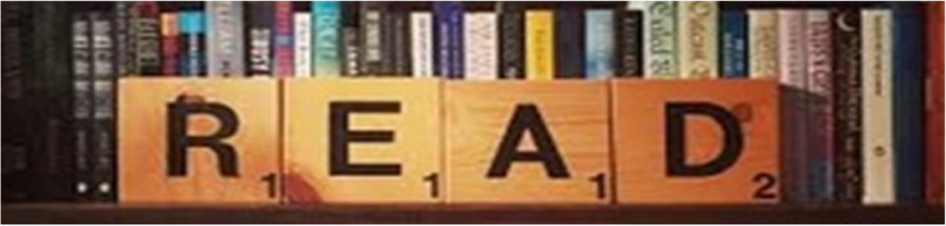

Wider reading list + Revision resources
Some useful revision resources you can use to help support your practice of the exam questions are below:

Mr Bruff’s YouTube Channel
Literature Paper 1 Playlist – lots of useful videos and resources for you to use here

Macbeth Playlist https://www.youtube.com/playlist?list=PLqGFsWf-P-cCMpq89C0yaU5scvuYiIKuL
Dr Jekyll & Mr Hyde Playlist https://www.youtube.com/playlist?list=PLqGFsWf-P-cD6Q25r3wSEIHP6JIU8UK-f

AQA English Literature Paper 1 Past Papers
Literature Paper 1 samples for you to practice with – lots of resources for home study
https://www.aqa.org.uk/subjects/english/gcse/english-literature-8702/assessment-resources?f.Component%7C7=Paper+1

Stacey Reay’s YouTube Channel
Literature Paper 1– lots of useful videos and resources for you to use here
https://www.youtube.com/channel/UCJhuqpyhE8NzYZFkwTzi_7g/playlists

SENECA Learning
Log into your account and start quizzing on the modules for your exams! If you don’t have an account, speak to your teacher.
https://senecalearning.com/en-GB/

MASSOLIT
Lectures and additional resources you can listen to
https://www.massolit.io/

Lightbulb Revision
Online resources to help you with your revision
https://lightbulbrevision.com/

