
Name:
Class:

Knowledge Organiser
Year 11 Support: Unit 3
Language Skills using Gothic Fiction

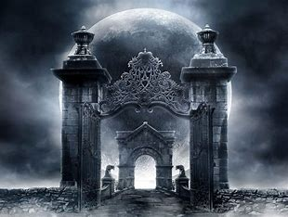

Name:

Class:

Big Questions:

The big question for the unit is: How can I practise AQA Language skills through a range of gothic texts?
Week 1 | BQ: How is a sense of mystery and intrigue created in the opening of gothic fiction?  BQ: How can I build mystery and suspense in my writing?  BQ: How can I build tension in my writing? Extended Writing 1
Week 2 | BQ: How can I improve my creative writing? Feedback  BQ: How is mystery and suspense created in the middle of the film ‘The Others’?  BQ: How can I show an opinion based on facts from the film ‘The Others’?
Week 3 | BQ: How does the ending of the film ‘The Others’ create an element of surprise?  BQ: How can I show my reading comprehension skills?  BQ: How do writers create an unsettling feeling in their writing?
Week 4 | BQ: How do writers create pathetic fallacy in their writing?  BQ: How can I create a sense of foreboding in my writing?  BQ: How can I create a foreboding atmosphere in a description of a journey?
Week 5 | BQ: How does Susan Hill create a sense of terror in her writing?  BQ: How is tension created in The Woman in Black?  BQ: How can I create my own tense and frightening piece of writing?
Week 6 | BQ: How can I approach Language Paper One, Question 5 with confidence?  BQ: How can I use both structural and language techniques to create tension?  BQ: How can I improve my creative writing?

Big Questions

Prior knowledge
Before you begin learning about gothic fiction: What do you know about the gothic genre or gothic stories?
Brainstorm your knowledge below.

Knowledge learned throughout the unit
As you are learning about gothic fiction, add any new knowledge in a brainstorm below.

Context of gothic fiction
The gothic genre is a genre of literature that:
- became increasingly popular during the Victorian era.
- plays on the fears and emotions of the era, an era that was especially fearful since their beliefs had been ripped out from under them, largely by contrasting modern science with medieval superstition and belief.
- sprung forth rather suddenly as the increasing preoccupation with individual consciousness that begins in the early 18th century collides with the unique cultural anxieties of the late 18th century. It seems to reflect a specific historical moment characterized by increasing disillusionment with Enlightenment rationality.
- introduced characters who are externalized in a radical new way; their deepest passions and fears are literalised through sometimes supernatural phenomena.
- deals with the nature of fear; fear of imprisonment or entrapment, of rape and personal violation, of the triumph of evil over good and chaos over order.
- places an emphasis on portraying the terrifying, a common insistence on archaic settings, a prominent use of the supernatural, the presence of highly stereotyped characters, barbarism as opposed to elegance.
- subverts reality, deconstructed and dismembered it
- raises issues about boundaries and duality of self what was socially acceptable and what wasn't examining the blurring the line between man and beast, man and God
- presents the theme of madness within the novels, especially that of usually stable and rational male characters. Threats to body, mind and soul are recurrent, with extremes of optimism and pessimism during times of crisis, threatening the collapse of the characters' surrounding worlds. The male protagonists frequently demonstrate signs of hysteria and madness.
- demonstrates the supernatural as key in increasing a sense of horror.
- came to be applied to the literary genre precisely because the genre dealt with such emotional extremes and dark themes, and because it found its most natural settings in the buildings of this style.

Typical features of gothic fiction include:
- Set in a haunted castle or house or a strange and isolated setting (often used to juxtapose two periods of time).
- A damsel in distress.
- An atmosphere of mystery and suspense.
- There is a ghost or monster.
- The weather is always awful.
- Dreaming/nightmares.
- Burdened male protagonist.
- Melodrama.
- Death.
- The beast within.

Key Terminology
 | Term | Definition
1 | Metaphor | A direct comparison of two things in which it is representative or symbolic of something else.
2 | Imagery | Language in a text that helps create a visual image for the reader.
3 | Semantic Field | When we have words that are all linked in meaning used to create a particular image/ feeling and keep this consistent in the mind of the reader.
4 | Pathetic Fallacy | Where the writer uses the weather and/or atmosphere to reflect the mood in a text.
5 | Foreboding | A feeling that something bad will happen; fearful apprehension.
6 | Tone | The overall feeling, mood or atmosphere created by a writer.
7 | Hyperbole | Extreme exaggeration for effect.
8 | Simile | A comparison of two things using the words ‘like’ and/or as’.
9 | Onomatopoeia | When a word imitates a sound like ‘bang’.
10 | Shift in Focus | When a writer deliberately crafts the text to draw our attention to something else.
11 | Dialogue | Sections of a text that are identifiable by characters speaking.
12 | Alliteration | When words start with the same sound or letter ‘Ghastly ghouls grew in the greyness.’
13 | Narrative Perspective | The point of view the text is written from.
14 | Foreshadowing | Where a writer drops hints in the text at events to come later on.
15 | Gothic Fiction | Stories that include supernatural and eerie elements.
16 | Climax | The height of the action in a text
17 | Sibilance | A literary device and figure of speech that involves repeating letter sounds that create a hissing or hushing quality. Usually using the letter ‘S’ repeatedly.
18 | Sinister | Giving the impression that something harmful or evil is happening or will happen
19 | Eerie | Strange and frightening, something that creates a chill down your spine.
20 | Tension | In literary terms, something that creates mental or emotional strain.

Additional Terminology
 | Term | Definition

1

2

3

4

5

6

7

8

9

10

11

12

13

14

15

Homework.

Knowledge is power, so the more you know, the more secure you will be in your learning.

Year 11: Unit 3 Homework: Language skills through Gothic Fiction
Task 1:  Week 2 | Due date: | Homework 1: (on pages 8 and 9)  Read the key word ‘Foreboding’ and the boxes. Underneath the diagram, write five sentences using the key word or a synonym. Write a foreboding a paragraph using the image.
Task 2:  Week 4 | Due date: | Homework 2: (on pages 10 and 11)  Read the key word ‘Sinister’ and the boxes. Underneath the diagram, write five sentences using the key word or a synonym. Write a sinister paragraph using the image
Task 3:  Week 6 | Due date: | Homework 3: (on pages 12 and 13)  Read the key word ‘Eerie’ and the boxes. Underneath the diagram, write five sentences using the key word or a synonym. Write an eerie paragraph using the image.

If you have ‘no homework’, or you have finished all of the above, try these tasks on a weekly basis to ensure that you are constantly practising writer’s craft and flair.
- Brainstorm possible gothic settings for creative writing.
- Choose 2 and write a setting description for each – consider the gothic features you could use in each.

Homework 1: Read the key word and the boxes. Underneath the diagram, write five sentences using the key word or a synonym. Write a foreboding a paragraph using the image.

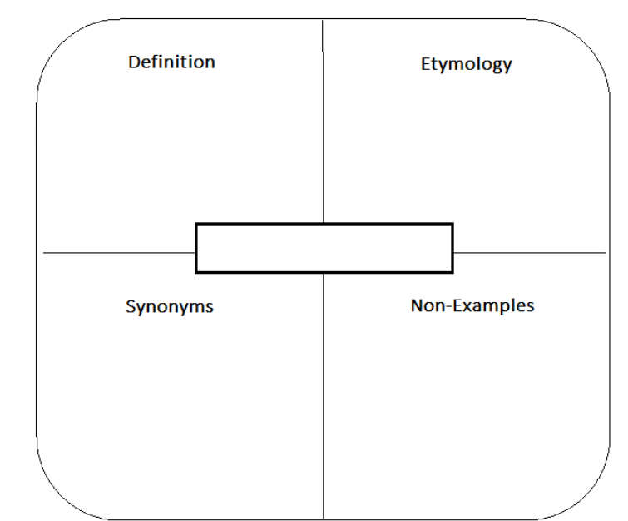
favourable
heartening
relaxed
calm
tranquil
encouraging
welcoming
promising

apprehension
anxiety
perturbation
trepidation
disquietude
uneasiness
misgiving
suspicion
Foreboding
This Middle English term was formed by combining 'fore,' meaning 'before,' and 'bodung,' meaning 'a foretelling' or 'a prophecy.' 'Foreboding' originally referred to a sense of apprehension or anxiety about future events
a strong feeling that something unpleasant or dangerous is going to happen

_________________________________________________________________________________________________________________________________________________________________________________________________________________________________________________________________________________________________________________________________________________________________________________________________

Write a paragraph creating a foreboding atmosphere. Use the image to help you.

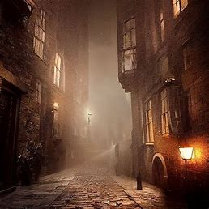

_____________________________________________________________________________________________________________________________________________________________________________________________________________________________________________________________________________________________________________________________________________________________________________________________________________________________________________________________________________________________________________________________________________________________________________________________________________________________________________________________________________________________________________________________________________________________________________________________________________________________________________________________________________________________________________________________________________________________________________________________________________________________________________________________________________________

Homework 2: Read the key word and the boxes. Underneath the diagram, write five sentences using the key word or a synonym. Write a sinister paragraph using the image.
being or showing a sign of evil or calamity to come
The word sinister, suggestive of darkness or evil, comes from a Latin word meaning “on the left side.” The association of “left” with “evil” is likely because of the dominance of right-handed people within a population.
Sinister
favourable
benign
bright
promising
encouraging
unthreatening
auspicious

ominous
menacing
threatening
bleak
dark
foreboding
sombre
murky
portentous

_________________________________________________________________________________________________________________________________________________________________________________________________________________________________________________________________________________________________________________________________________________________________________________________________

Write a paragraph that creates a sinister atmosphere. This paragraph must use sibilance (see key word).

Use the image to help you.

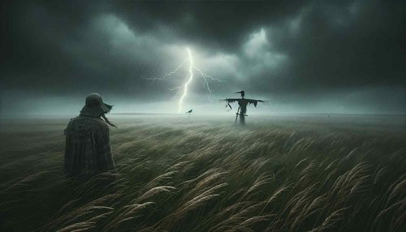

________________________________________________________________________________________________________________________________________________________________________________________________________________________________________________________________________________________________________________________________________________________________________________________________________________________________________________________________________________________________________________________________________________________________________________________________________________________________________________________________________________________________________________________________________________________________________________________________________________________________________________________________________________________________________________________________________________________________________________________________________________________________________________________________________________________________________________________________________________________________________________________________________________________________

Homework 3: Read the key word and boxes. Underneath the diagram, write five sentences using the key word or a synonym. Write an eerie paragraph using the image.
normal
common
natural
every-day
routine
familiar
predictable

creepy
haunting
spookish
spooky
uncanny
unearthly
weird
Eerie
Eerie is variant of an Old English word:
north England and Scottish variant of Old English earg "cowardly, fearful, wretched; slow, indolent, useless,"
The word eerie is an adjective that describes something that is strange and frightening, that sends a chill down your spine.

________________________________________________________________________________________________________________________________________________________________________________________________________________________________________________________________________________________________________________________________________________________________________________________________________________________________________________________

Write a paragraph that creates an eerie atmosphere. Use the image to help you.

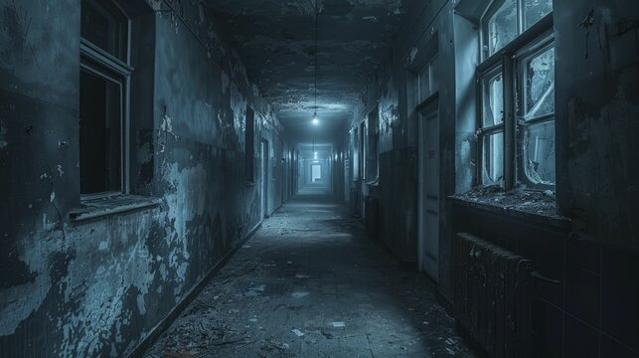

_____________________________________________________________________________________________________________________________________________________________________________________________________________________________________________________________________________________________________________________________________________________________________________________________________________________________________________________________________________________________________________________________________________________________________________________________________________________________________________________________________________________________________________________________________________________________________________________________________________________________________________________________________________________________________________________________________________________________________________________________________________________________________________________________________________________



Wider reading list
Fictional books with a gothic setting or links to the supernatural
- ‘Breathe’ by Cliff NcNish – An evil presence lurks in the 200-year-old farmhouse that Jack moves into with his mother. Jack can communicate with ghosts (an ability he recognized after his father's death), and on his first day in the house, he senses that it harbours many secrets.
- ‘Wait Till Helen Comes’ by Mary Downing Hahn – Ghost story master Mary Downing Hahn spins a suspenseful yarn about two children who dislike their malicious younger stepsister, Heather and tensions that escalate when Heather starts talking to a ghost named Helen.
- ‘The Woman in Black’ by Susan Hill – Arthur Kipps, a junior solicitor, is summoned to attend the funeral of Mrs Alice Drablow, the sole inhabitant of Eel Marsh House. The house stands at the end of a causeway, wreathed in fog and mystery, but it is not until he glimpses a wasted young woman, dressed all in black, at the funeral, that a creeping sense of unease begins to take hold.
- ‘Miss Peregrine’s Home for Peculiar Children’ by Ransom Riggs – A horrific family tragedy sets sixteen-year-old Jacob journeying to a remote island off the coast of Wales, where he discovers the crumbling ruins of Miss Peregrine's Home for Peculiar Children. As Jacob explores its abandoned bedrooms and hallways, it becomes clear that the children who once lived here--one of whom was his own grandfather--were more than just peculiar. They may have been dangerous.
- ‘Flowers in the Attic’ by Virginia Andrews – Chris, Cathy, Cory and Carrie have perfect lives – until a tragic accident changes everything. Now they must wait, hidden from view in their grandparents’ attic, as their mother tries to figure out what to do next. But as days turn into weeks and weeks into months, the siblings endure unspeakable horrors and face the terrifying realisation that they might not be let out of the attic after all.
- ‘The Mystery of Black Hollow Lane’ by Julia Nobel – Twelve-year-old Emmy, who's shipped off to a prestigious British school. But her new home is hiding a secret society … and it may be the answer to Emmy's questions about her missing father. With a dad who disappeared years ago and a mother who's a bit too busy to parent, Emmy is shipped off to Wellsworth, a prestigious boarding school in England, where she's sure she won't fit in.
- ‘The Graveyard Book’ by Neil Gaiman – Jack murders every member of his family, except a child upstairs. When the child crawls to a graveyard nearby, Mr and Mrs Owens, both ghosts, decide to bring him up.
- ‘The Haunting’ by Margaret Mahy – The family of Barney's dead mother are aware that there is something special about this particular boy. As he resigns himself to being haunted again, Barney's sister and brother set out to discover the reason behind his supernatural attraction.
- ‘The Haunting of Aveline Jones’ by Phil Hickes – Aveline Jones loves reading ghost stories and a dreary half-term becomes much more exciting when she discovers a spooky old book. It belonged to Primrose Penberthy, who vanished mysteriously, never to be seen again. Intrigued, Aveline decides to investigate Primrose’s disappearance.



Scan the QR code for more information on Gothic Literature

