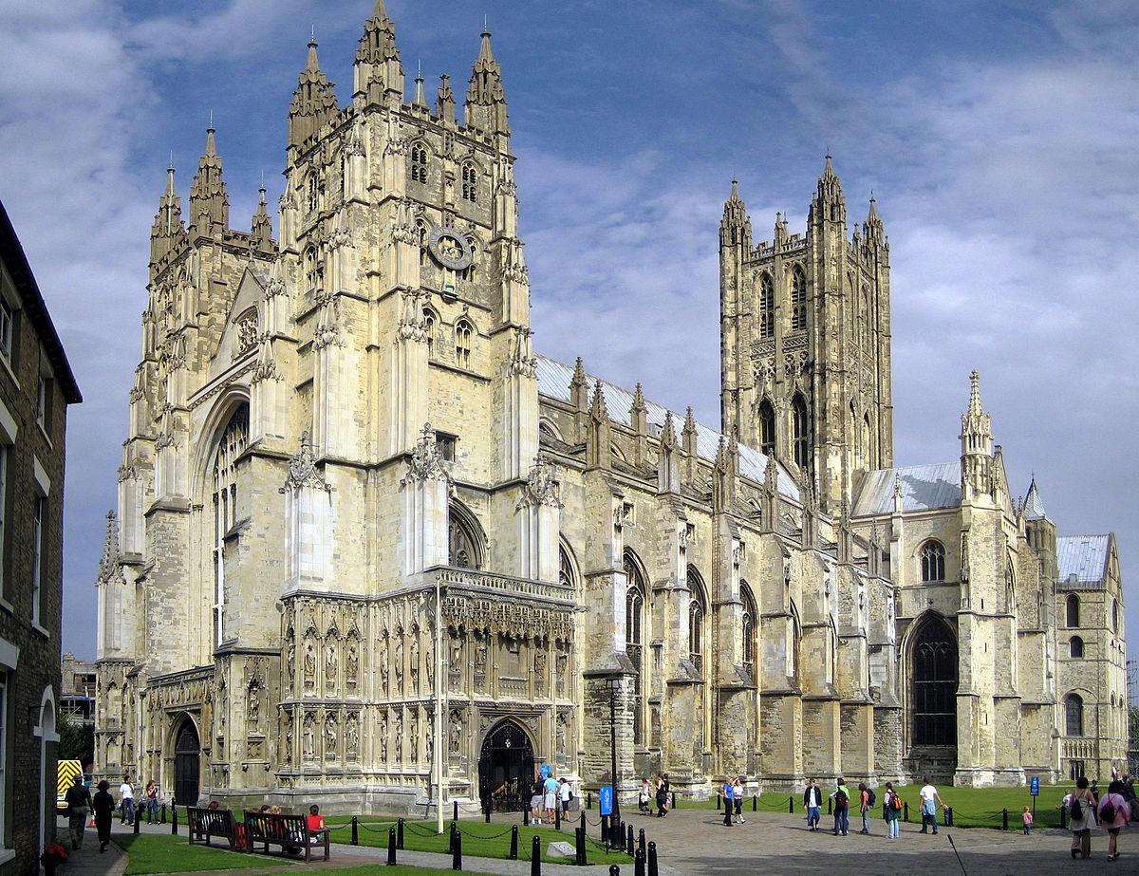

Year 9
Christianity
Christian Practices

Knowledge Organiser & Homework Booklet

Name………………………………………………………………….
Christian Practices – Knowledge Organiser
Key Words
Archbishop | A bishop of higher rank. | Grace | The gift of God's love and support regardless of whether or not a person has done God's will.
Baptism | Rite of initiation involving immersion in, or sprinkling or pouring of water; a sacrament marking the start of Christian life. | Great Schism | Split of the church into Roman Catholic and Easter Orthodox in 1054 AD.
Christmas | The annual festival of the Christian church commemorating the birth of Jesus: celebrated on December 25 and now generally observed as a legal holiday and, for many, an occasion for exchanging gifts. | Lent | The 40 day period preceding Easter, which is devoted to fasting, abstinence, and penitence in commemoration of Christ's fasting in the wilderness.
Church | A building dedicated to public Christian worship | Pope | Bishop of Rome, head of the catholic church.
Denomination | A branch of Christianity | Prayer | Communication with God. A means of developing a personal relationship with God.
Easter | Most important festival of Christianity, celebrating the resurrection of Jesus. | Reformation | The movement that separated the Western Church into the Catholicism and Protestantism
Eucharist | A service celebrating the sacrificial death and resurrection of Jesus Christ, using elements of bread and wine. | Sacrament | A ceremony that Christians believe brings them closer to God and helps them to receive God’s grace.
Key Ideas
Britain as a ‘Christian Country’ | The proportion of people who said they were Christian fell by over 10 per cent between 2001 and 2011 (from 72% to 59%), however, this is still the majority of British citizens.  Arguments ‘for’ Britain being a Christian country include: the monarch being the head of the church, the national anthem mentioning God and the importance of Christmas and Easter in British culture  Arguments ‘against’ include: only 5% of the population attending church, the country becoming increasingly diverse and religion having decreased influence over politics and views regarding social issues.
Schisms | Originally, the Church was united under the Pope (Bishop of Rome). However, as the Roman Empire became less important and influential, people began to question why the Bishop of Rome should be seen as so important and should remain as the head of the Church. This disagreement led to the ‘Great Schism’ – a split in the church.  This is where the church in the East became known as the Eastern Orthodox Church and the church in the west became the Catholic Church.  Christianity in the West split again when Martin Luther protested against the catholic church on various grounds (for example, thinking they were corrupt). His teachings were used to create the Protestant Church.  The Catholic Church in England faced another divide, when the Pope wouldn’t allow Henry VIII to divorce Catherine of Aragon, so Henry created the Church of England (so he could be in charge of the church and allow the divorce.
Catholic Church | Today, approximately half of Christians follow Catholicism. Catholics have some beliefs and practices that other Christians do not share: Transubstantiation is the idea that when the bread and wine consumed at communion actually turns into the body and blood of Christ when the priest repeats the words from the last supper. Confession is when Christians explain how they have sinned to a Priest, who will give them a penance so they can show they are truly sorry. At the entrance of a Catholic Church, there will often be a bowl of water than has been blessed by a priest, which is known as ‘Holy water’. Catholics also emphasise the importance of the Virgin Mary, believing that she was born without sin, went immediately to heaven and will act on Catholic’s behalves when they reach heaven
Churches | A church is a building used for public Christian worship. Catholic and Anglican (C of E) are the most common churches in the UK. The catholic church is run by the Pope and the Anglican church is ultimately run by the monarch, but a bishop is chosen to be the Archbishop of Canterbury, who is the spiritual leader of the church.  The main function of a church is as a place of worship, through services and private prayer. They are also used for rites of passage, such as baptism, marriage and funerals. However, churches also emphasise helping the local community, e.g. through charity, wellbeing events and foodbanks.
Festivals | The 2 main Christian festivals are Christmas and Easter. Christmas celebrates the birth of Jesus, however, some say that Christmas has lost its religious meaning and is now just a part of British culture.  Easter celebrations consist of Lent and the Holy Week. The Holy Week starts with Palm Sunday, then Maundy Thursday, Good Friday (where Christians remember Jesus dying for human sin), then Easter Sunday (where Christians celebrate Jesus’ resurrection. Christians celebrate this week in a variety of ways, from putting up palm crosses to gifting easter eggs.
Prayer | Christians describe prayer as a conversation with God. There are 5 main components of prayers_ adoration, confession, thanksgiving, supplication and intercession. Christians pray to deepen their faith and understanding of God. They may also pray as the hope that God will answer their prayers, e.g. through a miracle. The most important prayer in Christianity is the Lord’s Prayer, as this is how Jesus instructed his followers to pray.
Baptism | Baptism is the rite of initiation into Christian life, many Christians carry this out in order to cleanse people of original sin and makes them fully part of the Christian community.  Infant baptism is where a family have their new-born babies baptised, this is common within Catholicism, orthodox churches and encouraged in the Church of England. Believers’ baptism is where someone who is able to make a conscious decision about their faith is baptised (e.g. because they’re old enough). This is promoted by the Baptist church.  There are arguments regarding which form is preferable – some argue that believers’ baptism is more meaningful, whereas others argue that infant baptism is better as it allows the child to go to heaven if they die young.
Homework 1: Origins of the Church of England Due:
Read the following passage and answer the question, in full sentences.
In 1534, Henry VIII used Parliament to grant the Act of Supremacy, which allowed him to annul his marriage to Catherine as it made the monarch the head of the English Church. Henry broke with Rome for a range of reasons:
Wanting to end his marriage
After 1529, Henry continued in vain to attempt to get his annulment. However, by 1533 Henry was desperate to find another solution to end his marriage. This contributed to England breaking with the Catholic Church in Rome, and the development of the Church of England.
The influence of Anne Boleyn
In 1526, Henry became romantically interested in one of Catherine of Aragon’s ladies in waiting, Anne Boleyn. Anne was an intelligent woman who had encountered reformist ideas, such as those of Martin Luther, during her teenage years in France. Sources from the time suggest that Anne believed in many of these reformist ideas, and she was known to have had a significant influence over Henry. Anne had also said that she would not consummate her relationship with Henry unless he married her.
The rise of Protestantism
In the years before the break with Rome, groups of people who were attracted to Protestant ideas had begun to gather in England. Networks of men and women met secretly and shared Protestant books, which had been smuggled into England from Europe. With the help of Anne Boleyn, new figures such as Thomas Cromwell and Thomas Cranmer, who had Protestant sympathies, began to rise at court.
Wealth and Power
The power of the Pope was criticised in Protestant texts. In 1531, Henry had Protestant thinkers and university academics compile historical and religious works which showed that a king could make religious decisions in his own kingdom. One such book was called the Collectanea Satis Copiosa, or the Sufficiently Abundant Collections. It argued that Henry should have the power to annul his own marriage in England.
Protestants also criticised the wealth of the Catholic Church. They argued that the clergy, monks and nuns did not lead humble lives. Diverting the wealth of the Church from Rome to Henry would help him with his financial issues. Henry always needed money to fund armies, build new castles and expand the Navy.
Explain TWO of the reasons for why Henry VIII broke from the Catholic Church, in your own words
………………………………………………………………………………………………………………………………………………………………………………………………………………………………………………………………………………………………………………………………………………………………………………………………………………………………………………………………………………………………………………………………………………………………………………………………………………………………………………………………………………………………………………………………………………………………………………………………………………………………………………………………………………………………………………………………………………………………………………………………………………………………………………………………………………………………………………………………………………………………………………………………………………………………………………………………………………………………………………………………………………………………………………………………………………………………………………………………………………………………………………………………………………………………………
Homework 2: Inside the Church Due:
Read the following passage and answer the questions, in full sentences. Then write down 3 key facts you have learned from the homework in full sentences (2 pages)
Churches and chapels have many different internal features, which are designed to help people worship. The features and layout of different denominations can differ somewhat.
Catholic churches
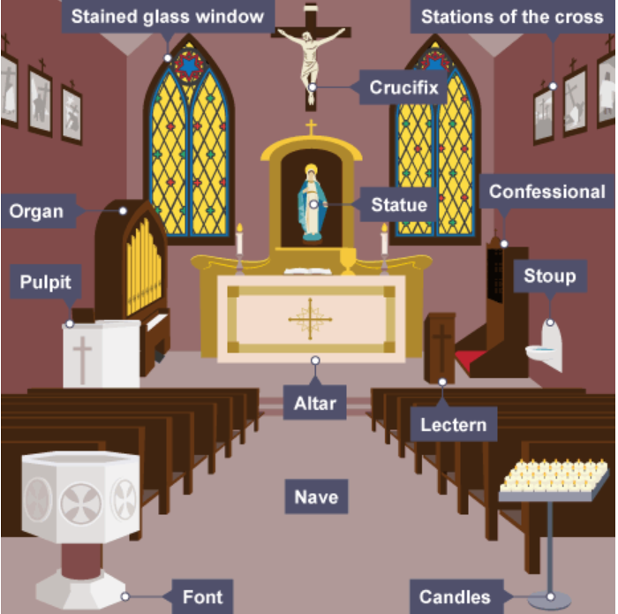
Catholic churches are traditionally built in the shape of a cross with the top of the cross facing Jerusalem.
The east end of the church is called the sanctuary and contains:
- the altar – a table where the bread and wine are blessed during the Eucharist
- the lectern – a stand where the Bible is read from
- the pulpit – where the priest delivers sermons
- a crucifix – a cross with Jesus on
- There is a rail which acts to separate the sanctuary from the place where the congregations sits, known as the nave. In the nave there are often rows of pews where the congregation sit in rows on benches.

Around the church there are 14 framed pictures, known as the Stations of the Cross, which show the events of Jesus’ crucifixion.
Other features that can be found in the Catholic Church include:
- a font – a large stone bowl containing holy water used to baptise babies
- a stoup – usually a small basin containing holy water, which Catholics dip their hand in to make the sign of the cross to renew their baptism promises
- statues of religious figures, eg Christ, Mary or saints
- stained glass windows – often depicting biblical stories or religious teachings
- candles – often lit by Catholics when they are praying
- an organ to be played during hymn singing
- a confessional – a small enclosed cupboard or cabinet, where Catholics can confess their sins to the priest

Describe THREE features of a CatholicChurch
………………………………………………………………………………………………………………………………………………………………………………………………………………………………………………………………………………………………………………………………………………………………………………………………………………………………………………………………………………………………………………………………………………………………………………………………………………………………………………………………………………………………………………………………………………………………………………………………………………………………………………………………………………………………………………………………………………………………………………………………………………………………………………………………………………………………………………………………………………………………………………………………………………………………………………………………………………………………………………………………………………………………………………………………………………………………………………………………………………………………………………………………………………………………………
Homework continued on next page.

Anglican churches
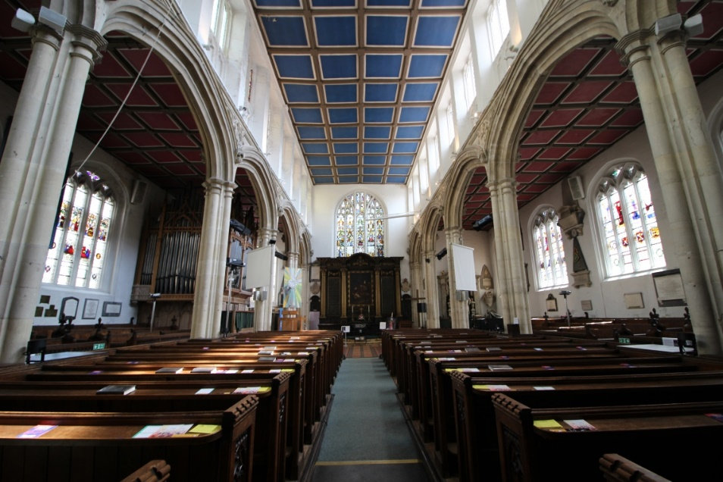
The inside of Anglican churches can be similar in appearance to Catholic churches. Anglican churches are also often in the shape of a cross, with a sanctuary at the east end.
Anglican churches are often a lot plainer than Catholic churches, and have fewer statues and candles.
An Anglican church will usually have a simple cross displayed rather than a crucifix. Although there may be a font, there won't be a stoup containing holy water.

Explain the differences between the interiors of Catholic and Anglican churches
………………………………………………………………………………………………………………………………………………………………………………………………………………………………………………………………………………………………………………………………………………………………………………………………………………………………………………………………………………………………………………………………………………………………………………………………………………………………………………………………………………………………………………………………………………………………………………………………………………………………………………………………………………………………………………………………………………………………………………………………………………………………………………………………………………………………………………………………………………………………………………………………………………………………………………………………………………………………………………………………………………………………………………………………………………………………………………………………………………………………………………………………………………………………………
_______________________________________________________________________________________
Key Facts
*
*
*

