
Name:
Class:

Knowledge Organiser
Year 9: Unit 1
The Hate U Give
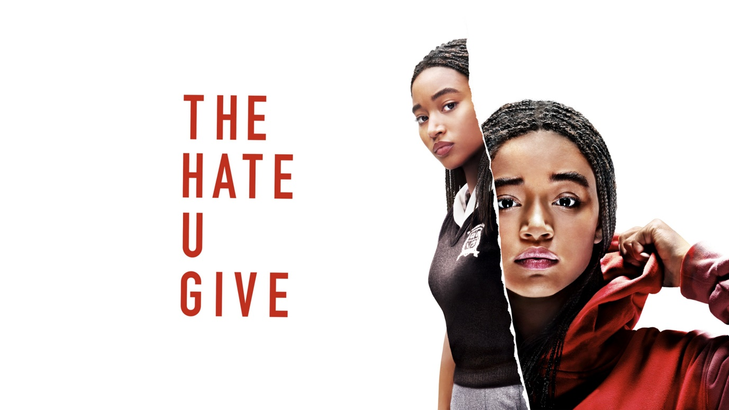

Name:
Class:

Big Questions
Week 1 | BQ: What societal issues are explored in ‘The Hate U Give’?
Week 1 | BQ: What does the exposition reveal about Starr Carter in ‘The Hate U Give’?
Week 1 | BQ: What is the conflict in ‘The Hate U Give’?
Week 1 | BQ: What is cinematography and mise-en-scene?
Week 2 | BQ: How has the director used cinematography and mise-en-scene to convey meaning?
Week 2 | BQ: What do we learn in the exposition and conflict stages of the ‘The Hate U Give’?
Week 2 | BQ: What happens at the ‘rising action’ stage of the ‘The Hate U Give’?
Week 3 | BQ: How can language be used to create an atmosphere?
Week 3 | BQ What is code-switching?
Week 3 | BQ: How do I write exposition and conflict in a narrative?
Week 3 | BQ: How can I improve my writing?
Week 4 | BQ: How can I use reported speech in my narrative?
Week 4 | BQ: How are stereotypes presented in Chapter 7?
Week 4 | BQ: What happens at the ‘rising action’ stage of the ‘The Hate U Give’?
Week 4 | BQ: How can language choices reflect a message or deeper meaning?
Week 5 | BQ: What is oppression?
Week 5 | BQ: How has the director used cinematography and mise-en-scene to convey meaning?
Week 5 | BQ: How do I signify time jumps/ changes?
Week 6 | How can I improve my creative writing?
Week 6 | BQ: How is Mr Lewis presented in Chapter 11 of The Hate U Give?
Week 6 | BQ: How do news values shape what we see in the news?
Week 6 | BQ: How does Star’s attitude and actions change?
Week 7 | BQ: What is DeVante’s role in the narrative?
Week 7 | BQ: How is privilege presented in Chapter 14?
Week 7 | BQ: What is a screenplay?
Week 7 | BQ: How do I write a screenplay?
Week 8 | BQ: How can I improve my writing?
Week 8 | BQ: What happens are the rising action stage of the narrative?
Week 8 | BQ: How does Starr show courage in Chapter 16 and 17?
Week 8 | BQ: How can I create a shift in mood through my language choices?
Week 9 | BQ: How is Starr feeling when the trial starts?
Week 9 | BQ: How has cinematography and mise-en-scene been used to convey emotions?
Week 9 | BQ: What is representation?
Week 9 | BQ: What happens at the ‘rising action’ stage of the ‘Hate U Give’ narrative?
Week 10 | BQ: How do I write?
Week 10 | BQ: How can I improve my writing?
Week 10 | BQ: What happens at the ‘rising action’ stage of the ‘Hate U Give’ narrative?
Week 10 | BQ: What other ways are there to structure my writing in timed conditions?
Week 11 | BQ: How can I use language to imply characteristics?
Week 11 | BQ: What happens in the climax of the ‘Hate U Give’?
Week 11 | BQ: What happens in the climax of the ‘Hate U Give’?
Week 11 | BQ: What happens in the climax of the ‘Hate U Give’?
Week 12 | BQ: What happens in the resolution of the ‘Hate U Give’?
Week 12 | BQ: How is cinematography and mise-en-scene used to show a resolution?
Week 12 | BQ: How do I write an effective narrative structure?
Week 12 | BQ: How can I improve my creative writing?
Week 13 | BQ: Why should I choose GCSE film?
Week 13 | BQ: Why should I choose GCSE media?

Content you will study during this unit
Text | The Hate U Give by Angie Thomas  Published 2017  The story revolves around Starr Carter, a 16-year-old African-American girl who navigates between two worlds: the poor, predominantly Black neighbourhood where she lives and the wealthy, mostly white private school she attends. Starr's life changes dramatically when she witnesses the fatal shooting of her childhood best friend, Khalil, by a white police officer during a traffic stop. As the only witness, Starr faces intense pressure from all sides: her community demands justice, her family wants her safety, and the police seek to discredit her. The film follows Starr's journey as she struggles to find her voice and speak out against the systemic injustice that led to Khalil's death.
Film | The Hate U Give (2018)  Directed by George Tillman Jr  The film is an adaptation of the critically acclaimed 2017 young adult novel of the same name by Angie Thomas. The movie addresses complex themes such as racial identity, police brutality, and the struggle for justice, making it both a compelling drama and a relevant social commentary.

Key Terminology
 | Key Term | Definition
1 | Activism | Campaigning to bring about political or social change.
2 | Brutality | Savage physical violence; great cruelty.
3 | Cinematography | The art of photography and camerawork in filmmaking.
4 | Code-switching | Alternating between two or more languages or varieties of language and behaviour
5 | Community | A group of people living in the same place or having a particular characteristic in common.
6 | Disempowerment | To deprive of power, authority, or influence: make weak, ineffectual, or unimportant.
7 | Empowerment | Authority or power given to someone to do something. The process of becoming stronger and more confident, especially in controlling one's life and claiming one's rights.
8 | Flashback | Where the narrative goes back in time to reveal some information
9 | Inequality | The unfair situation in society when some people have more opportunities, money, etc. than other people.
10 | Influential power | Where the text producer attempts to influence the audience’s opinion through their language choices and it is up to the audience whether they comply.
11 | Injustice | Lack of fairness or justice.
12 | Instrumental power | Power presented through the producer’s position of power and there are usually consequences should the audience not comply.
13 | Mise-en-scene | The arrangement of the scenery, props, etc. on the stage of a theatrical production or on the set of a film.
14 | Oppression | Prolonged cruel or unjust treatment by a person or people in authority:
15 | Power | The ability to direct or influence the behaviour of others or the course of events.
16 | Privilege | An advantage, or immunity only available to a particular person or group
17 | Protest | A statement or action expressing disapproval of or objection to something.
18 | Representation | The description or portrayal of someone or something in a particular way.
19 | Stereotype | A widely held but fixed and oversimplified image or idea of a particular type of person or thing.
20 | Societal expectation | A social norm for individuals and organisations, thus for society as a whole, about what people should do.

Additional Terminology
 | Term | Definition

1

2

3

4

5

6

7

8

9

10

11

12

13

14

15

16

Example creative writing
Some days I can barely remember that night, though I try to. I never want to fully forget the horror that I saw. Some days the event is crystal clear like it happened yesterday. Today is one of those days. I now live confined to my home, the only place I truly feel safe. Whenever there is a knock at the door, I cower in the corner and when that knock persists, like a meek child, I slowly attempt to open it. My days are spent reading, cleaning or writing. I try to keep myself busy to distract me from my thoughts but some days, my thoughts are too overwhelming. I pick up my latest detective thriller but I can’t concentrate, the vision that haunts me is all too consuming.
Sparklers being swing by laughing children started what was to be the worst night of my life. It was November fifth, firework night, a night I always looked forward to. We had arrived early to get a good spot along the river, close enough to the bonfire to feel the warmth and see the fiery red glow on our faces. The smell of the bonfire mixed with the smoke from the extinguished sparklers announced Autumn was here. My favourite time of year.
Slowly, the crowd grew bigger and bigger until it stretched for an eternity. The bustle and excitement from the crowd made me giddy and jubilant. I glanced down at my watch impatient for the fireworks to begin. Looking back now, I wish they never did.
When the fireworks eventually began, I was mesmerised looking up in awe at the fluorescent fireworks reaching high into the sky. They bellowed and boomed scaring the small children who were clearly overstimulated by the noise. Maybe they sensed what was coming.
The fireworks had barely gotten started when things started to go wrong. When the first firework flew into the crowd it sent people into shock and sheer panic but people didn’t realise the true extent of the damage. People hoped it was a one off, a quick mistake, it would all be fine. It wasn’t fine. That first firework sparked a fire that soon would grow into a deadly inferno. What made the fire spread, I do not know.
I saw the worst of humanity that night. It was every man for themselves. People ran, they screamed, they shoved. Following a barrage of blows from the frightened crowd that tried rushing to safety, I was dragged to the floor. All light escaped from my vision and darkness enveloped my whole being. My fear numbed me from the pain, thankfully, as thousands of people seemed to trample me oblivious to what they were doing.
Looking back I am not sure how I ever escaped the hell I was faced with. I must have made it out of the crowd, I must have made it home, how though I will never know. All I know is when I try to visualise leaving my house again, I am taken back to the fear I felt in that crowd, in that terrifying, traumatising, torturous situation. I don’t want to live like this, like a hermit hiding from society, but I can’t foresee getting over this trauma.

Example opinion writing: the writing mark scheme

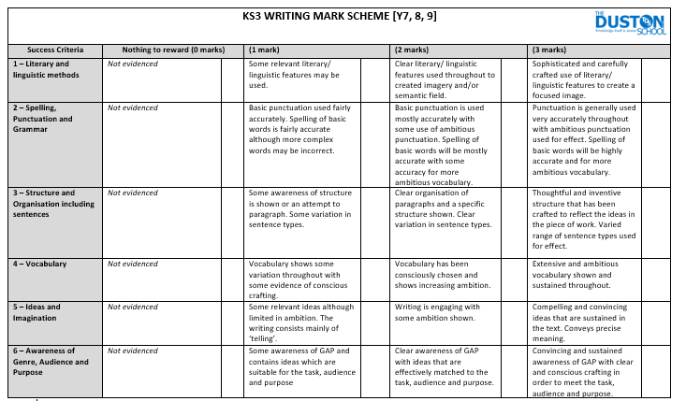

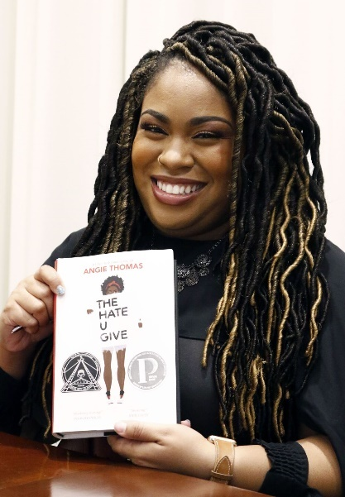
Key Information

Angie Thomas
- Angie Thomas was born and raised in Mississippi, but now calls Atlanta her home. She is a former teen rapper whose greatest accomplishment was an article about her in Right-On Magazine. She holds a BFA in Creative Writing from Belhaven University.
- Angie is an inaugural winner of the Walter Dean Myers Grant 2015, awarded by We Need Diverse Books.
- Her debut novel, THE HATE U GIVE, started as a senior project in college. It was later acquired by HarperCollins Publishers and debuted at #1 on the New York Times bestseller list.
- THE HATE U GIVE was adapted into a critically acclaimed film from Fox.
- Angie’s second novel, ON THE COME UP, is a #1 New York Times bestseller as well, and a film is in development with Paramount Pictures with Angie acting as a producer.
- In 2020, Angie released FIND YOUR VOICE: A Guided Journal to Writing Your Truth as a tool to help aspiring writers tell their stories.
- In 2021, Angie returned to the world of Garden Heights with CONCRETE ROSE, a prequel to THE HATE U GIVE focused on seventeen-year-old Maverick Carter that debuted at #1 on the New York Times bestseller list.

The Hate U Give

This is Angie Thomas’ debut novel and was published in 2017. The book was inspired by the Black Lives Matter movement.
- Sixteen-year-old Starr Carter moves between two worlds: the poor neighborhood where she lives and the fancy suburban prep school she attends. The uneasy balance between these worlds is shattered when Starr witnesses the fatal shooting of her childhood best friend Khalil at the hands of a police officer. Khalil was unarmed.
- Soon afterward, his death is a national headline. Some are calling him a thug, maybe even a drug dealer. Protesters are taking to the streets in Khalil’s name. What everyone wants to know is: what really went down that night? And the only person alive who can answer that is Starr.
- But what Starr does—or does not—say could upend her community. It could also endanger her life.

Black Lives Matter

#BlackLivesMatter was founded in 2013 in response to the acquittal of Trayvon Martin’s murderer. Black Lives Matter Global Network Foundation, Inc. is a global organization in the US, UK, and Canada, whose mission is to eradicate white supremacy and build local power to intervene in violence inflicted on Black communities by the state and vigilantes. By combating and countering acts of violence, creating space for Black imagination and innovation, and centering Black joy, we are winning immediate improvements in our lives.

George Floyd

George Floyd was a Black man who died in May 2020 after a white police officer, Derek Chauvin, kneeled on his neck for over nine minutes during an arrest in Minneapolis, Minnesota. Floyd was accused of using a fake $20 bill at a store, and when the police arrived, they tried to arrest him. Even though Floyd said he couldn’t breathe and people around begged the officer to stop, Chauvin kept kneeling on his neck until Floyd lost consciousness and eventually died.

Floyd’s death was recorded on video, and it quickly spread across the world. Many people were outraged and started protesting against police brutality and racism. These protests were part of a larger movement called Black Lives Matter, which fights for justice and equal treatment for Black people. The case led to Derek Chauvin being charged and later convicted of murder, and it sparked important conversations about how police treat people of colour and how society can work toward fairness and equality for everyone.

Homework Tasks

Knowledge is power, so the more you know, the more secure you will be in your learning.

Year 9: Unit 1 Homework: The Hate U Give
Task 1:  Week 2 | Due date: | - Using the key information on pages 8-9, answer the 10 knowledge retrieval questions on page 10.  - These questions will be peer assessed in class and your teacher will check that you have completed your homework.
Task 2:  Week 4 | Due date: | - Read the summary of Emmett Till’s death on page 12  - Answer the 10 knowledge retrieval questions on page 13  - These questions will be peer assessed in class and your teacher will check that you have completed your homework.
Task 3  Week 6 | Due date: | - Read the extract from ‘Dear Mr Martin’ by Nic Stone on page 14-15  - Answer the 10 knowledge retrieval questions on page 16  - These questions will be peer assessed in class and your teacher will check that you have completed your homework.
Task 4  Week 8 | Due date: | - Read the introduction from ‘This book is anti-racist’ by Tiffany Jewell on page 17-18  - Answer the 10 knowledge retrieval questions on page 19  - These questions will be peer assessed in class and your teacher will check that you have completed your homework.
Task 5  Week 10 | Due date: | - Read the interview with Jason Reynolds, the author of Long Way Down on page 20-21  - Answer the 10 knowledge retrieval questions on page 22  - These questions will be peer assessed in class and your teacher will check that you have completed your homework.
Task 6  Week 12 | Due date: | - Based on your knowledge of the ‘The Hate U Give’ unit so far, answer the 10 knowledge retrieval questions on page 23.  - These questions will be peer assessed in class and your teacher will check that you have completed your homework.

If you have ‘no homework’, or you have finished all of the above, try these tasks on a weekly basis to ensure your understanding of The Hate U Give is secure.
- Research the author Angie Thomas. Look at her life and works. Read some of her other novels. They may be available in our library.
- Research other texts that links with themes of injustice. Can you identify any similarities or differences?

Homework Task 1- You can find all the answers on pages 8-9
 | Write your answer in the box below each question. | 
1 | Where does Angie Thomas live now?
2 | What is the name of the prequel to The Hate U Give?
3 | How is Starr’s school described?
4 | Who is fatally shot?
5 | How are they connected to Starr?
6 | When was the Black Lives Matter movement founded?
7 | Why was the Black Lives Matter movement started?
8 | What is the Black Lives Matter mission?
9 | When did George Floyd die?
10 | What crime was George Floyd accused of?
TOTAL

Homework 2 Wider Reading: Summary of the death of Emmett Till
This is a summary of what happened to Emmett Till, the young boy who Starr posted a picture of on her tumblr page (a blog website).
Emmett Till was a 14-year-old African American boy from Chicago. In 1955, he travelled to Mississippi to visit relatives. While he was there, he was accused of whistling at or speaking to a white woman — something that, at the time, could be very dangerous for a Black person in the southern United States.
A few days later, two white men kidnapped Emmett from his great-uncle’s home. They beat him brutally and murdered him. His body was found in a river days later.
The two men who admitted to kidnapping Emmett were put on trial — but an all-white jury found them not guilty, even though there was strong evidence.
This showed that the legal system at the time often did not protect Black people. Many people, especially in the South, were treated unfairly simply because of their race.
Emmett Till’s mother, Mamie Till-Mobley, made a brave choice: she had an open-casket funeral, allowing the world to see what had been done to her son. Photos of Emmett’s body were published in newspapers and shocked people across the country.
This moment became a turning point in the Civil Rights Movement — a movement where people fought peacefully for equal rights and to end racism in America.
In The Hate U Give, Starr witnesses the police shooting of her friend Khalil. Like Emmett, Khalil doesn’t get justice. His story spreads through the community, just like Emmett Till’s did, and Starr speaks out — much like Emmett’s mother did. Both stories show how one tragic event can wake people up and inspire others to demand change.

Homework Task 2
 | Write your answer in the box below each question.
1 | How old was Emmett Till?
2 | Why was Emmett Till in Mississippi in 1955?
3 | What was Emmett Till accused of doing?
4 | How did Emmett Till die?
5 | How was the trial unjust?
6 | What was the outcome of the trial of the two men involved in Emmett’s murder?
7 | What was the impact of the open casket?
8 | In what ways are Emmett Till’s and Khalil’s stories similar?
9 | How did the actions of his mother Mamie Till-Mobley spark social change?
10 | Why might this be considered courageous?
TOTAL
Homework 3 Wider Reading: Extract from Dear Mr Martin by Nic Stone
This is an extract from a YA book describing a scene where Justyce leaves a party to take his drunk ex-girlfriend home and stop her from drink driving but he is stopped by a police officer.
Justyce can hear the approaching footsteps, but he stays focused on getting Melo strapped in. He wants it to be clear to the cop that she wasn’t gonna drive so she won’t be in even worse trouble.
Before he can get his head out of the car, he feels a tug on his shirt and is yanked backward. His head smacks the doorframe just before a hand clamps down on the back of his neck. His upper body slams onto the trunk with so much force, he bites the inside of his cheek, and his mouth fills with blood.
Jus swallows, head spinning, unable to get his bearings. The sting of cold metal around his wrists pulls him back to reality
Handcuffs.
It hits him: Melo’s drunk beyond belief in the backseat of a car she fully intended to drive, yet Jus is the one in handcuffs.
The cop shoves him to the ground beside the police cruiser as he asks if Justyce understands his rights. Justyce doesn’t remember hearing any rights, but his ears had been ringing from the two blows to the head, so maybe he missed them. He swallows more blood.
“Officer, this is a big misundersta—” he starts to say, but he doesn’t get to finish because the officer hits him in the face.
“Don’t you say anything to me, I knew your punk ass was up to no good when I saw you walking down the road with that goddamn hood on.”
So the hood was a bad idea. Earbuds too. Probably would’ve noticed he was being trailed without them. “But, Officer, I—”
“You keep your mouth shut.” The cop squats and gets right in Justyce’s face. “I know your kind: punks like you wander the streets of nice neighbourhoods searching for prey. Just couldn’t resist the pretty white girl who’d locked her keys in her car, could ya?”
Except that doesn’t even make sense. If Mel had locked the keys in the car, Jus wouldn’t have been able to get her inside it, would he? Justyce finds the officer’s nameplate; Castillo, it reads, though the guy looks like a regular white dude. Mama told him how to handle this type of situation, though he must admit he never expected to actually need the advice: Be respectful; keep the anger in check; make sure the police can see your hands (though that’s impossible right now). “Officer Castillo, I mean you no disresp—”
“I told your punk ass to shut the hell up!”
He wishes he could see Melo. Get her to tell this cop the truth. But the dude is blocking his view.
“Now, if you know what’s good for you, you won’t move or speak. Resistance will only land you in deep trouble. Got it?”
Cigarette breath and flecks of spit hit Justyce’s face as the cop speaks, but Justyce fixes his gaze on the glowing green F of the FarmFresh sign.
“Look at me when I’m talking to you, boy.” He grabs Justyce’s chin. “I asked you a question.”
Justyce swallows. Meets the cold blue of Officer Castillo’s eyes. Clears his throat.
“Yes sir,” he says. “I got it.”

Homework Task 3
 | Write your answer in the box below each question.
1 | How does the police officer get Justyce’s attention?
2 | What did the police officer say before arresting Justyce?
3 | “Officer, this is a big misundersta—” he starts to say  Why did Justyce not finish his sentence?
4 | How would you describe the police officer’s tone when talking to Justyce?
5 | How would you describe Justyce’s tone when talking to the police officer?
6 | What about Justyce’s appearance did the police officer use to stereotype him?
7 | What three pieces of advice did Justyce’s mama give him about dealing with the police?
8 | How does Justyce find out the police officer’s name?
9 | How is this scene similar to The Hate U Give?
10 | What is the relevance of Melo’s race in this scene (she is white)?
TOTAL

Homework 4 Wider reading: Introduction to the book ‘This book is anti-racist’ by Tiffany Jewell
This book is guide that explains what racism is, how it operates in society and how individuals- especially young people- can take action to fight against it.

To all of you,
I wrote this book for you. It’s for everyone. The words on these pages are for our ancestors and those who should not yet be our ancestors, but who passed on too soon. I wrote this for you out of a love for liberation and our humanity.
This is the book I wish I’d had when I was younger. And it’s the book I will share with my own children. It contains information I never learned when I was younger and you will probably not be taught in school.
I wrote these words for you while carrying a heavy heart. It aches for Emmett Till, Tamir Rice, Korryn Gaines, Michael Brown, Eric Garner, Sandra Bland, Bobby Hutton, Antwon Rose Jr., Stephon Clark, Rekia Boyd, Stephen Lawrence, Charleena Lyles, Alton Sterling, Philando Castile, Aiyana Stanley-Jones, and Trayvon Martin, and for all those who we honour with hashtags, our tears, our frustration and rage, our exhaustion and the fire to move on.
My optimism has brought me to action and to sharing these words with you because I believe you will help to dismantle and work toward ending racism. We need justice. No one’s names should be memorialized in hashtags.
My hope is you will use this book as a way to start your journey in the big work of anti-racism. You are resisting racism and oppression just by opening these pages. You are entering into a consciousness that wakes you up and allows you to see the world in a whole new way.
Some may tell you you’re too young to talk about race. People may tell you that you should stop talking about skin colour and see everyone as a “global citizen.” You may have been told racism isn’t a problem anymore and that calling it out or bringing it up in conversation is wrong. Some people may have given you the impression that you are wrong and stirring up trouble. You are not! Racism is a problem, a very serious problem, and it needs to be talked about because it isn’t going away if we do nothing. It is okay for you to continue on with this book and I am so proud of you for picking this up and opening these pages.
Please know you are not alone on this journey. I am here with you. There are many, many folk who are here with you, who came before you, and who will come long after us. I hope you will share this book with your friends and families because fighting racism really isn’t something you can do all on your own.
There are many moments to pause in this book so you can check in with yourself and grow into your activism. You will learn more about yourself, our history, how racism came to be, and why we’re still so deep within it. We will work together, in solidarity, to disrupt racism and become anti-racist accomplices. This book is meant to be read in order. Each chapter builds on the previous chapter and you will gain a deeper understanding of becoming your anti-racist self. And you will probably want to read and reread this. This is a start. Anti-racism is lifelong work.
In solidarity,
Tiffany

Homework Task 4
 | Write your answer in the box below each question.
1 | Who does the writer say the book is written for?
2 | Why does the writer list so many names of people who died due to racism?
3 | What does the writer believe the reader is doing just by opening the book?
4 | Why has the writer chosen to share these words (her book) with the audience?
5 | Why does the writer think it is right for young people to talk about racism?
6 | What does the writer mean by ‘you are not alone on this journey’?
7 | Why is it important to read the chapters in order?
8 | What does the final line ‘Anti-racism is lifelong work’ suggest?
9 | Why might the author have chosen to address the reader directly using “you” throughout the text?
10 | What is the effect of using the style of an open letter as an introduction?
TOTAL

Homework 5 Wider reading: Article/ Interview with writer Jason Reynolds about his book Long Way Down.

Jason Reynolds, a 34-year-old from Washington DC, didn’t grow up expecting to be a writer: indeed, he was 17 before he read a book from start to finish. But it might be his atypical* background that allows him to connect so powerfully with teenage readers. He has published a dozen novels – mostly for young adults – in the US, has been a National Book award finalist and is a fixture on the New York Times bestseller list. He was also recently named on the Guardian’s Frederick Douglass 200 list, which honours the 200 living individuals who best embody the work and spirit of the American abolitionist and politician. Now one of Reynolds’s books, Long Way Down, is being released in the UK. Told in verse, it follows Will, a 15-year-old boy out for revenge after his older brother is shot dead.
The starting point for Long Way Down came from personal experience. What happened to you?
When I was 19, a friend of mine was murdered. That night my friends and I went to his mom’s house and we were all planning to figure out who did this to him so we could exact revenge. So we could murder the man who murdered our friend. And I just remember the pain – the pain of the lost friend but also the pain of meeting a part of myself that I didn’t know existed. A part of myself that could lose control to the point where I could commit a murder. That’s a very human thing. I think that most of us don’t ever meet that part of ourselves that exists within all of us. This rage that, when triggered, will cause you to do things that you don’t necessarily understand that you’re doing.
There’s an author’s note in Long Way Down where you recognise that young people, particularly boys, don’t like to read. Then you add: “So here’s what I plan to do: NOT WRITE BORING BOOKS.”
To me that’s one plus one is two. Young people – especially young men – it’s not that they hate reading, it’s that they hate boredom. So my thing was: I need to write a story that is interesting, that is gripping, that can connect to them and their experiences, and write something that’s not very intimidating, because there’s so much white space.
You didn’t finish a book until you were 17 – Richard Wright’s 1945 memoir, Black Boy, about growing up in the American south. Was that unusual where you grew up?
The only thing that’s unusual about my story is that I became a writer. But me not reading is the norm. And me not reading till I was 17 – none of my friends did. Most of my friends still don’t, and that’s boys and girls.
You’ve had a lot of success now, but you still do a lot of talks at schools and juvenile detention centres. Why is that important?
It’s a push-pull thing. One side is about staying engaged, so I can be truthful about the things I’m writing about: you’ve got to know them in order to show them. But it’s also about making sure that they know that they can be me. Because they can’t be what they can’t see. It isn’t rocket science, we’ve seen it happen over and over. Think about golf: Tiger Woods starts playing golf and all of a sudden black kids all over the world are like: “Yo!” Serena and Venus Williams, they play tennis, they have beads in their hair, they’re from Compton, California, and black kids who felt like they didn’t have a place in tennis, suddenly tennis feels more palatable. This is the way it works.
You’ve been writing an average of three books a year for the past few years. What drives you?
At first it was the fear of it all going away. It’s like when you’ve been hungry, or when you’ve tried and failed, or when you’ve hit the bottom, when you get a second chance, you do anything you can to secure your spot. You do anything you can to force people to take note of what you’re doing. Now, though, I just have so much to say and I want to make sure I say it all.
Is it true you unwind by crocheting?
Not any more. I used to and I still can; I could still sit down and crochet a hat or a sweater if I needed to. But I’ve been thinking about it, though: it taught me patience, it taught me diligence. It taught me that it’s one stitch at a time. No matter what it is in life, if you skip a loop, you have to undo it and start again. If you skip a step then the thing you make will be distorted, it’ll be gathered and bunched in places, it’ll be ill-fitting. One stitch at a time and that’s life! That’s how it works.

Glossary

*atypical- not usual or normal

Homework Task 5
 | Write your answer in the box below each question.
1 | How old was Jason Reynolds when he first read a book?
2 | In Long Way Down, why is Will seeking revenge?
3 | What is the main emotion Jason Reynolds remembers after the death of his friend?
4 | What does he believe rage can make you do?
5 | What reason does he give for why teenage boys don’t like reading?
6 | Why does Jason Reynolds give talks in schools and juvenile detention centres?
7 | Which black role models does he mention as examples for young people?
8 | What drives or motivates Reynolds to keep writing?
9 | What has he learnt from his hobby crocheting?
10 | Remind yourself of Angie Thomas’s motivation for writing, how is it similar to Jason Reynolds?
TOTAL

Homework Task 6
 | Write your answer in the box below each question.
1 | What is mise-en-scene?
2 | What is cinematography?
3 | What is the exposition of a story?
4 | What is the climax of a story?
5 | What was Khalil reaching for in the car?
6 | What is code-switching?
7 | What is Uncle Carlos’s job?
8 | Why did Starr have to testify in front of the Grand Jury?
9 | Why is Starr suspended from school?
10 | Where does the title The Hate U Give come from?
TOTAL


Wider reading list
Other recommended texts/ films based on the themes and ideas of this unit
Fiction Texts
Dear Martin—YA Novel by Nic Stone
Justyce is a top student at his mostly white prep school in Atlanta, Georgia. Despite his achievements, he faces racial profiling and discrimination. After a disturbing encounter with the police where he is wrongfully arrested, Justyce begins writing letters to Dr. Martin Luther King Jr. in a journal, seeking guidance on how to live by Dr. King’s principles in a world that seems stacked against him.
As the story unfolds, Justyce experiences more instances of racism, both overt and subtle. He struggles with the expectations placed on him by society, his friends, and his own community. Tragedy strikes when Justyce's best friend, Manny, is shot and killed by an off-duty police officer during a confrontation. This event shakes Justyce deeply and forces him to confront his feelings of anger, fear, and confusion.

Love, Hate and Other Filters—YA Novel by Samira Ahmed
Maya Aziz is torn between her parents' traditional expectations and her own aspirations. Her parents want her to attend college close to home in Chicago and eventually marry a suitable Muslim boy. However, Maya dreams of moving to New York to study film and pursue her passion for filmmaking.
While Maya grapples with these personal dilemmas, her life takes a dramatic turn when a terrorist attack occurs in a nearby city. The attack leads to a surge of Islamophobia, and the suspect, who shares her last name, causes suspicion and hostility to be directed toward her and her family. The prejudice she faces at school and in her community intensifies, forcing her to confront the harsh realities of being a Muslim in America.

Concrete Rose (The Hate U Give Prequel)— YA Novel by Angie Thomas
Maverick Carter, known as Mav, is a 17-year-old living in Garden Heights, a neighbourhood plagued by gang violence and poverty. Mav is a member of the King Lords, the gang led by his father’s friend, King. Despite his involvement in the gang, Mav is trying to make ends meet by selling drugs, but he dreams of a better life.
Mav's world is turned upside down when he finds out that he is the father of a baby boy named Seven, the result of a relationship with his friend, Iesha. Suddenly, Mav is faced with the huge responsibility of being a father while still being a teenager himself. This new role forces him to re-evaluate his life choices and consider what kind of future he wants for himself and his son

Black Enough- Collection of Short stories by Ibi Zoboi et al.
"Black Enough: Stories of Being Young & Black in America" is an anthology edited by Ibi Zoboi that features a collection of short stories written by various Black authors. Published in 2019, the anthology explores the diverse experiences of Black teens in America, capturing the complexities of identity, culture, and belonging.
The stories in Black Enough highlight the many ways in which young Black people navigate their identities in a society that often tries to define what it means to be "Black enough." The collection brings together a variety of voices, each with its own unique perspective, and spans a wide range of genres, from contemporary realism to magical realism.

Non-fiction Texts
Feel Free by Zadie Smith
"Feel Free" is a collection of essays by the acclaimed British author Zadie Smith, published in 2018. The book gathers a wide range of essays written over several years, reflecting Smith’s thoughts on culture, politics, art, and personal experiences. The essays are grouped into five sections: "In the World," "In the Audience," "In the Gallery," "On the Bookshelf," and "Feel Free."

I’m Still Here by Austin Channing Brown
"I'm Still Here: Black Dignity in a World Made for Whiteness" is a memoir by Austin Channing Brown that explores her experiences as a Black woman in America and provides a powerful critique of systemic racism, particularly in predominantly white spaces. Published in 2018, the book combines personal stories with sharp insights into race, identity, and social justice.
Austin Channing Brown begins by reflecting on her name, which often leads people to assume she is a white man. This misconception illustrates the ways in which whiteness is often seen as the default or norm in American society. Her name becomes a metaphor for the broader experience of navigating a world that was not built for people like her.

Documentaries/Films:
Black Panther, 2018, Ryan Coogler (Rated 12A)
Black Panther is a groundbreaking superhero film that follows T'Challa, the newly crowned king of the technologically advanced African nation of Wakanda.

Fruitvale Station, 2013, Ryan Coogler (Rated 15)
Fruitvale Station is an autobiographical film that tells the story of Oscar Grant’s life and death in the hours leading up to his shooting by police on New Year’s Day 2009.

