

Knowledge Organiser
Year 10: Unit 1
Language Paper 1 &
An Inspector Calls

Name:
Class:
Teacher:

Homework Tasks.

Knowledge is power, so the more you know, the more secure you will be in your learning.

Year 10: Unit 1 Homework: English Language Paper 1 and An Inspector Calls
Task 1: | Due date:  WEEK 2 | - Read the opening of a short story called ‘Lost Hearts’ by M.R. James on page 13. Then answer the two Language Paper questions that follow.  - Your teacher will check your answers in class
Task 2: | Due date:  WEEK 4 | - Read the article called ‘An Introduction to An Inspector Calls’ by Chris Power on p16.  - Answer the 10 questions on this – these will be marked in class with your teacher
Task 3: | Due date:  WEEK 6 | - Read the article called ‘Priestley’s Political Journey’ on p19.  - Answer the 10 questions on this – these will be marked in class with your teacher
Task 4: | Due date:  WEEK 8 | - Read the article called ‘An Inspector Calls: An overview’ on p22.  - Answer the 10 questions on this – these will be marked in class with your teacher
Task 5: | Due date:  WEEK 10 | - Re-read the final section of the story from – ‘Lost Hearts’ by M.R James on p28. Then answer the Language Paper 1, question 4.  - Your teacher will check your answer in class

If you have ‘no homework’, or you have finished all of the above, try these tasks on a weekly basis to ensure your understanding is secure.
- Use the Wider Reading page on the back of the Knowledge Organiser and download some more practice papers from AQA.
- Add words to your key terminology grid in the Knowledge Organiser
- Read for at least 20 minutes per day – a mixture of fiction and non-fiction texts.
- Revise online using YouTube and refer to Mr Bruff, Stacey Reay and AQA revision channels.

Big Questions

Our study of Language Paper 1 and An Inspector Calls will follow the structure below:
Language Paper 1: Section A | - BQ: How can I effectively read and annotate a fiction text?  - BQ: How can I successfully analyse language methods used by a writer? [Q1 + Q2]  - BQ: How can I evaluate the structure of a text? [Q3 focus]  - BQ: How can I critically evaluate a text? [Q4 focus]  - BQ: How can language be used to reflect the ideas in a text? [Q1 + Q2 focus]  - BQ: How do I approach analysing language in fiction texts? [Q1 + Q2 focus] Ext writing  - BQ: What structural methods can I evaluate in a text? [Q3 focus]  - BQ: How can I develop my appreciation and analysis of language?  - BQ: How can I consider the semantic field of a text? [Q1 + Q2 focus]  - BQ: How does the way a text is structured impact on the message conveyed? [Q3 focus]  - BQ: How can I engage with a statement and write critically? [Q4 focus]  - BQ: How does a writer use language to describe? [Q1 + Q2 focus]  - BQ: What does a successful language analysis answer consist of? [Q1 + Q2 focus]  - BQ: How can structure be used to build suspense? [Q3 focus]  - BQ: What makes a successful and clear critical evaluation? [Q4 focus]  - BQ: How can a writer use language to establish the genre of a text? [Q1 + Q2 focus]  - BQ: How can a writer use structure to interest a reader? [Q3 focus]  - BQ: How can I write an evaluative critical analysis? [Q4 focus] Extended writing  - BQ: How can a writer use language to reflect the themes in a text? [Q1 + Q2 focus]  - BQ: How can I develop my critical analysis?
An Inspector Calls | - BQ: What compelled Priestley to write the play? (Big Lecture)  - BQ: How does Priestley use dramatic irony in Act 1? (2 lessons)  - BQ: How is Mr Birling presented at the start of the play? Extended Writing 1  - BQ: How does Priestley construct the character of the Inspector?  - BQ: How does Priestley introduce the character of Eva Smith?  - BQ: How does Priestley show the impact of the Inspector on Sheila?  - BQ: How does Priestley present the relationship between Sheila and Mrs Birling?  - BQ: How does Priestley present Gerald in Act 2?  - BQ: How can Gerald be seen as an ambiguous character?  - BQ How is Gerald presented? Extended Writing 2  - BQ: What is the significance of the name ‘Daisy Renton’?  - BQ: How is Mrs Birling presented in Act 2?  - BQ: How is the character of Eric Birling presented in Act 3?  - BQ: How does Priestley construct the character of Eric Birling?  - BQ: What is the significance of the Inspector’s final speech?  - BQ: How is the Inspector presented as an omniscient character?  - BQ: How have the characters developed over the course of the play?  - BQ: How are the two generations presented in the play? (Extended writing 3)  - BQ: How can An Inspector Calls be read as a morality play?  - BQ: What are the big ideas and themes of the play?  - BQ: How is a good GCSE Literature essay structured?  - BQ: How can I prepare for the summative assessment?  - BQ: How is social responsibility presented? (Summative assessment)  - BQ: Why does Priestley use a cyclical structure?  - BQ: How does Priestley use symbols to convey his ideas?  - BQ: How does Priestley present hypocrisy/duplicity in the play?  - BQ: How does Priestley present social class in the play?  - BQ: How does Priestley present gender in the play?  - BQ: How does Priestley present power in the play?  - BQ: How does Priestley present selfishness in the play?

Exam Criteria and Assessment Objectives for Language Paper 1

Assessment Objectives
AO1 | Pick out and understand pieces of explicit and implicit information from the text(s).  Collect and put together information from different texts.
AO2 | Explain how writers use language and structure to achieve their purpose and influence readers.  Use technical terms to support your analysis of language and structure.
AO3 | Identify different writers’ ideas and perspectives.  Compare the method used by different writers to convey their ideas.
AO4 | Critically evaluate texts, giving a personal opinion about how successful the writing is.  - Provide detailed evidence from the text to support your opinion.

Paper Timings for Language Paper 1
 | Question | Time | Skills assessed
15 minutes reading time
Paper One  1hr 45mins | Q1: List four things…  4 marks | 5 minutes | AO1
Paper One  1hr 45mins | Q2: How does the writer use language…  8 marks | 10mins | AO2
Paper One  1hr 45mins | Q3: How does the writer use structure…?  8 marks | 10mins | AO2
Paper One  1hr 45mins | Q4: Statement and to what extent do you agree?  20 marks | 20mins | AO4
Paper One  1hr 45mins | Q5: Creative writing  40 marks | 45mins | AO5 and AO6

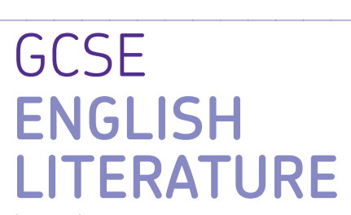
AQA GCSE English Literature Paper 2

Paper 2: Modern texts and poetry

What’s assessed = Modern Prose or Drama text, Poetry Anthology, Unseen Poetry

How it’s assessed: Written exam 2 hours 15 minutes, 96 marks, 60% of GCSE

Questions:

Section A Modern Prose or Drama: students will answer one essay question from a choice of two on their studied modern text

Section B Poetry: students will answer one comparative question on one named poem printed on the paper from their chosen anthology cluster.

Section C Unseen Poetry: students will answer one question on one unseen poem and one question comparing this unseen poem to another unseen poem.

Mark schemes Literature Exams

Assessment objectives (AOs)

AO1 Read, understand and respond to texts. Students should be able to:

• maintain a critical style and develop an informed personal response

• use textual references, including quotations, to support and illustrate interpretations.

AO2 Analyse the language, form and structure used by a writer to create meanings and effects, using relevant subject terminology where appropriate.

AO3 Show understanding of the relationships between texts and the contexts in which they were written.

AO4 Use a range of vocabulary and sentence structures for clarity, purpose and effect, with accurate spelling and punctuation
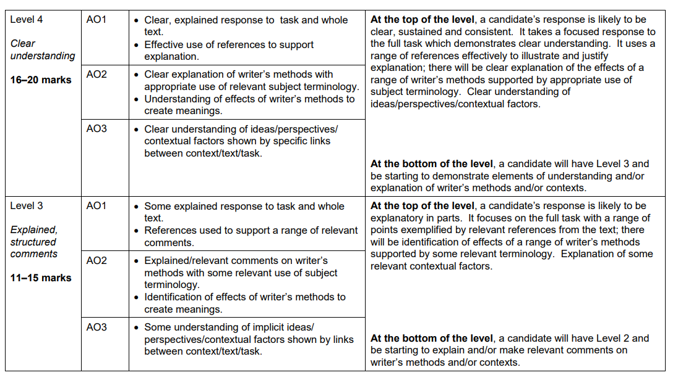
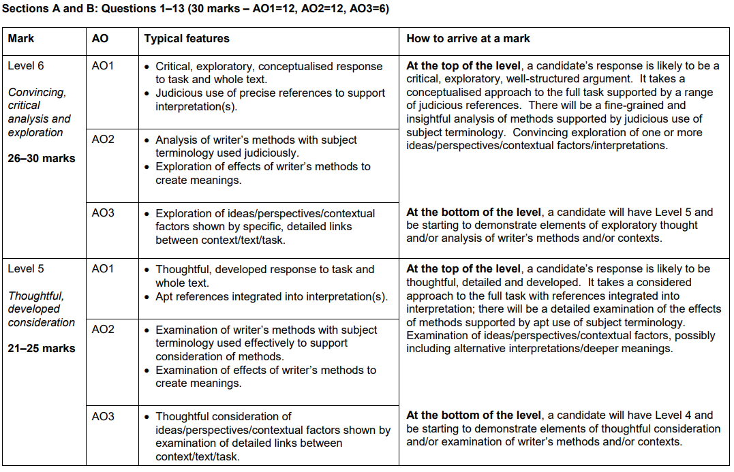

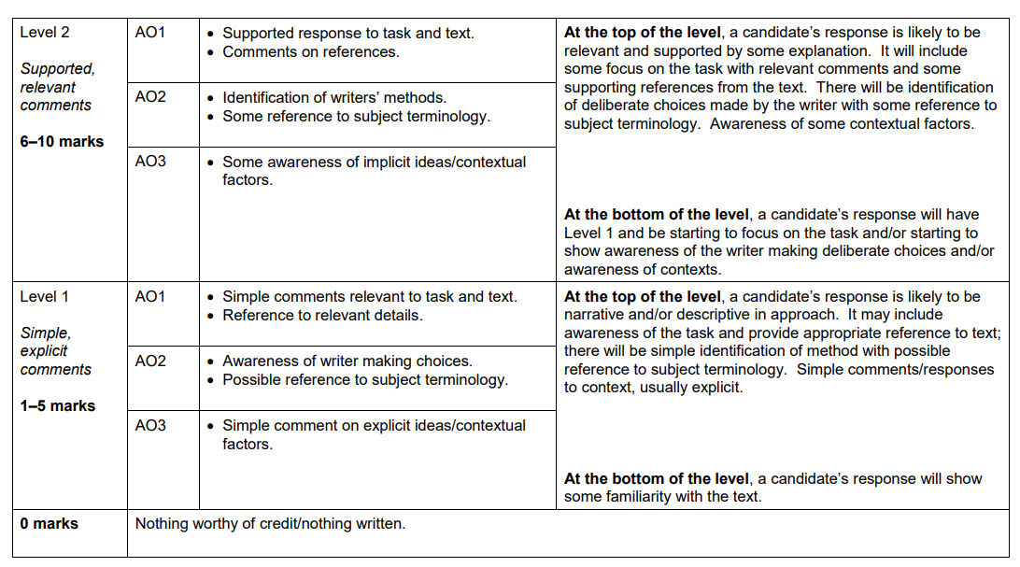

Key Terminology

 | Term | Definition
1 | Ambiguous | A situation or statement that is unclear because it can be understood in more than one way.
2 | Capitalism | A political or social viewpoint that believes key values of Capitalism which are individual responsibility, private ownership of a country’s trade and industry and rewards for those that are most financially successful.
3 | Didactic | Intended to teach (often in a moral way).
4 | Dramatic irony | Where the audience know something that the characters do not.
5 | Hypocrisy | Claiming an idea or belief and then not following it yourself.
6 | Empathy | The ability to understand and share the feelings of another.
7 | Ignorant | To have a lack of knowledge or information.
8 | Injustice | Lack of fairness or justice.
9 | Inequality | Difference in size, degree, circumstances, etc.; lack of equality.
10 | Intuitive | A feeling or instinct that something is true.
11 | Microcosm | A community or situation that represents the features of something much larger, like a complete society.
12 | Naïve | Showing a lack of experience, wisdom, or judgement.
13 | Omniscient | Knowing everything.
14 | Patriarchy | A system, society or government that is led by men.
15 | Prejudiced | Having a dislike or distrust of a person or people based upon little evidence.
16 | Privilege | A special right, advantage only available to a particular person or group of people.
17 | Remorseful | Sorry or full of regret for actions or behaviour.
18 | Socialism | The set of beliefs that states that all people are equal and should share equally in a country’s money or the political systems based on these beliefs.
19 | Stage directions | An instruction in the text of a play indicating the movement, position, or tone of an actor, or the sound effects and lighting.
20 | Sympathy | To feel sorry for someone.

Space for Additional Terminology

Example questions

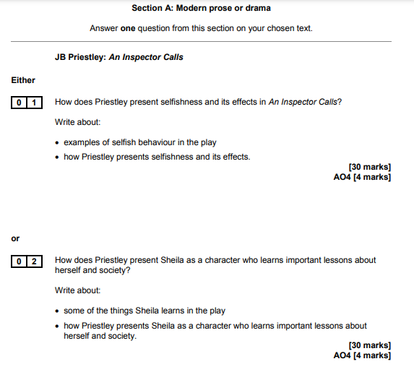

Example essay

How does Priestley use the character of the Inspector to suggest that society needed to change?

‘An Inspector Calls’ is about how people should be more responsible. Priestley uses the Inspector as his mouthpiece, to challenge the selfish capitalist views of many of the middle and upper classes and to promote his belief in greater equality for everyone. Through the Inspector’s questioning of each of the characters, Priestley demonstrates how a lack of responsibility for others can have tragic consequences. Eric and Sheila’s ability to take responsibility for their actions conveys Priestley’s belief in the chance for a better society for the future.

The Inspector’s questioning of Arthur Birling reveals how poorly some of the working classes were treated by wealthy business owners. Early in the play, Arthur Birling proudly boasts that ‘a man has to mind his own business, look after himself and his own’. Priestley makes it clear that Arthur Birling prioritises his own interests above the interests of his workers. When questioned by the Inspector about how he responded to his workers’ request for a payrise, Birling responds with the words ‘I refused of course’. The words ‘of course’ demonstrate the arrogance in Arthur Birling’s character; he feels entirely justified in behaving in the way he did and does not wish to be questioned by the Inspector. The fact that Birling ‘refused’ without even discussing the payrise with his workers, and went as far as firing the person leading the strike, demonstrates how few rights the working classes had in 1912. Priestley deliberately presents Arthur Birling as a character who is unable to accept any responsibility for his actions and who remains concerned with his own reputation throughout, even offering the Inspector ‘thousands’ in order to keep quiet. Priestley does this in order to demonstrate to his audience that society will only improve if wealthy business owners like Arthur Birling admit their mistakes and try to take more responsibility for their workers.

Priestley uses the Inspector’s questioning of Sybil Birling to demonstrate the need for a welfare system to help the working classes. When questioned about her actions, Priestley makes it clear that Sybil Birling was prejudiced towards Eva Smith. Priestley has Sybil refer to the working classes as ‘girls of that class’ and ‘of that sort’, which demonstrates that she is snobbish and looks down on the working classes. He also has Sybil proudly say she was ‘perfectly justified’ in doing what she did, admitting that she was prejudiced against Eva Smith due to her ‘impertinent’ use of the Birling name. Priestley deliberately chooses to have Sybil Birling run a private charity as he is able to use her character to suggest that charities run by wealthy people would never offer the help that society needed. Priestley wanted to make the case for a welfare state, which would offer more help to the working classes. Many of Priestley’s 1945 audience would have voted for the Labour Party, who came into power in 1945 and established the NHS, thus would have felt equally critical of Sybil Birling’s actions.

Through the Inspector’s questioning of Sheila and Eric, Priestley demonstrates that the younger generation may be able to change society for the better. Whereas Sybil and Arthur Birling are relieved and delighted when they realise the Inspector wasn’t real, Sheila and Eric remain guilty and remorseful for their actions. Eric challenges his parents for pretending that ‘nothing really happened at all’, which highlights the difference in the way the characters take responsibility for their actions. Priestley wanted to propose to the audience that the younger generation, many of whom may have voted for the recently elected Labour Party in 1945, would be able to change society for the better, as they were more willing to recognise their mistakes.

The Inspector is Priestley’s mouthpiece throughout, challenging capitalist views and proposing different ways of thinking. Priestley uses stage directions to indicate that the inspector is willing to interrupt the Birling’s capitalist views by having the inspector cut ‘in massively’ while the Birlings are talking. Whereas Sybil and Arthur Birling believe themselves to be superior, Priestley makes clear it is in fact the inspector that is more powerful. Priestley’s choice to have the inspector ‘cutting in’ on Birling’s and Sybil’s speeches conveys that the inspector is not intimidated by their superior class. Priestley could have decided to have the inspector cut in on the Birlings to show that capitalist viewpoints deserve to be interrupted and ended. Furthermore, the adverb ‘massively’ demonstrates that what the inspector has to say is more important than what the Birlings have to say. The audience is therefore encouraged to trust the Inspector and to believe the things he is saying to the Birlings. Priestley has the Inspector promote socialist ideals when he says to the Birlings ‘We are all members of one body. We are all responsible for each other’. Priestley’s repetition of the pronoun ‘we’ when the Inspector talks contrasts with the way Arthur and Sybil Birling speak, as they more often say the word ‘I’, seeming more preoccupied with their own interests. This demonstrates Priestley’s belief in the clear distinction between socialism, which focuses on the many, and capitalism, which focuses on self-interest.

Homework 1: Practice Language Paper 1, question 1 and 2
Read the opening of a short story called ‘Lost Hearts’ by M.R. James. Then answer the two questions that follow.

It was, as far as in September of the year 1811 that a post-chaise (horse drawn carriage) drew up before the door of Aswarby Hall, in the heart of Lincolnshire. The little boy who was the only passenger in the chaise (horse drawn carriage), and who jumped out as soon as it had stopped, looked about him with the keenest curiosity during the short interval that elapsed between the ringing of the bell and the opening of the hall door. He saw a tall, square, red-brick house, built in the reign of Anne; a stone-pillared porch had been added in the purer classical style of 1790; the windows of the house were many, tall and narrow, with small panes and thick white woodwork. A pediment, pierced with a round window, crowned the front. There were wings to right and left, connected by curious glazed galleries, supported by pillars, with the central block. These wings plainly contained the stables and offices of the house. Each was surmounted by an ornamental dome with a gilded (gold) vane.
An evening light shone on the building, making the window-panes glow like so many fires. Away from the Hall in front stretched a flat park studded with oaks and fringed with firs, which stood out against the sky. The clock in the church-tower, buried in trees on the edge of the park, only its golden weather-cock (instrument used for showing the direction of the wind) catching the light, was striking six, and the sound came gently beating down the wind. It was altogether a pleasant impression, though tinged with the sort of melancholy (melancholy = deep sadness) appropriate to an evening in early autumn, that was conveyed to the mind of the boy who was standing in the porch waiting for the door to open to him.
The post-chaise (horse drawn carriage) had brought him from Warwickshire, where, some six months before, he had been left an orphan. Now, owing to the generous offer of his elderly cousin, Mr Abney, he had come to live at Aswarby.
That night he had a curious dream. At the end of the passage at the top of the house, in which his bedroom was situated, there was an old disused bathroom. It was kept locked, but the upper half of the door was glazed, and, since the muslin curtains which used to hang there had long been gone, you could look in and see the lead-lined bath affixed to the wall on the right hand, with its head towards the window.
On the night of which I am speaking, Stephen Elliott found himself, as he thought, looking through the glazed door. The moon was shining through the window, and he was gazing at a figure which lay in the bath.
His description of what he saw reminds me of what I once beheld myself in the famous vaults of St Michan’s Church in Dublin, which possesses the horrid property of preserving corpses from decay for centuries. A figure inexpressibly thin and pathetic, of a dusty leaden colour, enveloped in a shroud-like garment, the thin lips crooked into a faint and dreadful smile, the hands pressed tightly over the region of the heart.
As he looked upon it, a distant, almost inaudible moan seemed to issue from its lips, and the arms began to stir. The terror of the sight forced Stephen backwards and he awoke to the fact that he was indeed standing on the cold boarded floor of the passage in the full light of the moon. With a courage which I do not think can be common among boys of his age, he went to the door of the bathroom to ascertain if the figure of his dreams were really there. It was not, and he went back to bed.

Q1 – 4 marks – 5 minutes
Use lines 1-11 from the short story.
List four things you learn about the house the boy arrives at (remember to write in full sentences).

1.______________________________________________________________________________________
2.______________________________________________________________________________________
3.______________________________________________________________________________________
4.______________________________________________________________________________________

Q2– 8 marks – 10 minutes
Using lines 29-37 from the short story.
How does the writer use language to describe the strange figure (person) Stephen sees?
Follow this paragraph structure:
WHAT: Idea linked to the question and supporting evidence (quotation)
HOW: Analyse the word choices and/ or methods in the quotation.
WHY: Writer’s intention/ purpose? Effect on the reader?
_______________________________________________________________________________________
_______________________________________________________________________________________
_______________________________________________________________________________________
_______________________________________________________________________________________
_______________________________________________________________________________________
_______________________________________________________________________________________
_______________________________________________________________________________________
_______________________________________________________________________________________
_______________________________________________________________________________________
_______________________________________________________________________________________
_______________________________________________________________________________________
_______________________________________________________________________________________
_______________________________________________________________________________________
_______________________________________________________________________________________
_______________________________________________________________________________________
_______________________________________________________________________________________
_______________________________________________________________________________________
_______________________________________________________________________________________
_______________________________________________________________________________________
_______________________________________________________________________________________
_______________________________________________________________________________________
_______________________________________________________________________________________
_______________________________________________________________________________________
_______________________________________________________________________________________
_______________________________________________________________________________________
______________________________________________________________________________________________________________________________________________________________________________
_______________________________________________________________________________________
_______________________________________________________________________________________
_______________________________________________________________________________________
_______________________________________________________________________________________

Homework 2: Read the article and answer the 10 questions that follow.
An Introduction to An Inspector Calls by Chris Power
https://www.bl.uk/20th-century-literature/articles/an-introduction-to-an-inspector-calls

Chris Power introduces An Inspector Calls as a morality play that denounces (criticises) the hypocrisy and callousness (cruelty) of capitalism and argues that a just society can only be achieved if all individuals feel a sense of social responsibility.
J B Priestley’s play An Inspector Calls, first performed in 1945, is a morality play disguised as a detective thriller. The morality play is a very old theatrical form, going back to the medieval period, which sought to instruct audiences about virtue and evil. Priestley’s play revolves around a central mystery, the death of a young woman, but whereas a traditional detective story involves the narrowing down of suspects from several to one, An Inspector Calls inverts this process as, one by one, nearly all the characters in the play are found to be guilty. In this way, Priestley makes his larger point that society is guilty of neglecting and abusing its most vulnerable members. A just society, he states through his mysterious Inspector, is one that respects and exercises social responsibility.
What is social responsibility?
Social responsibility is the idea that a society’s poorer members should be helped by those who have more than them. Priestley was a socialist, and his political beliefs are woven through his work. There are many different types and degrees of socialism, but a general definition is as follows: an ideal socialist society is one that is egalitarian – in other words, its citizens have equal rights and the same opportunities are available to everybody; resources are shared out fairly, and the means of production (the facilities and resources for producing goods) are communally owned.
Therefore, socialism stands in opposition to a capitalist society, such as ours, where trade and industry is mostly controlled by private owners, and these individuals or companies keep the profits made by their businesses, rather than distributing them evenly between the workers whose labour produced them.
It is precisely this difference between a socialist and a capitalist society that Arthur Birling is discussing in Act 1 when Inspector Goole arrives:
MR BIRLING: “But the way some of these cranks talk and write now, you’d think everybody has to look after everybody else, as if we were all mixed up together like bees in a hive – a man has to mind his own business and look after himself…”

The Inspector’s arrival cuts Arthur Birling off mid-sentence, enacting in miniature the clash between two ideological positions that unfolds throughout the rest of the play.
The play’s structure and setting
An Inspector Calls is a three-act play with one setting: the dining room of ‘a fairly large suburban house belonging to a fairly prosperous manufacturer’. The year is 1912, and we are in the home of the Birling family in the fictional industrial city of Brumley in the North Midlands. In the dining room five people are finishing their dinner: four members of the Birling family and one guest. Arthur Birling is a factory owner; his wife Sibyl is on the committee of a charity, and is usually scolding someone for a social mistake. Their adult children are Sheila and Eric, and their guest is Gerald Croft, Sheila’s fiancé, who is from a wealthier manufacturing family than the Birlings. One other person is present: Edna the maid, who is going back and forth to the sideboard with dirty plates and glasses.
Priestley’s description of the set at the beginning of the play script stresses the solidity of the Birlings' dining room: ‘It is a solidly built room, with good solid furniture of the period’. But a later section of this scene-setting – on the walls are ‘imposing but tasteless pictures and engravings’, and the ‘general effect is substantial and comfortable and old-fashioned but not cosy and homelike’ – suggests that although the Birling’s have wealth and social standing, they are not loving to one another or compassionate to others. The setting of the play in a single room also suggests their self-absorption, and disconnectedness from the wider world.
Priestley establishes each of the characters in this opening scene. Arthur Birling is a capitalist businessman through and through, entirely focussed on profit even when discussing the marriage of his daughter:
Mr BIRLING: I’m sure you’ll make her happy. You’re just the kind of son-in-law I’ve always wanted. Your father and I have been friendly rivals in business for some time now – though Crofts Limited are both older and bigger than Birling and Company – and now you’ve brought us together, and perhaps we may look forward to the time when Crofts and Birlings are no longer competing but are working together – for lower costs and higher price
Homework 2: Now answer the questions on the article.
 | Write your answer in the box below each question. | 
1 | What does Chris Power argue that all individuals need to feel for a just society?
2 | When was the play first performed?
3 | What type of play is it?
4 | According to Priestley, what is society guilty of neglecting?
5 | What is social responsibility?
6 | What is socialism? Look up a definition if you can’t find the answer in the article.
7 | What is capitalism? Look up a definition if you can’t find the answer in the article.
8 | An ‘act’ is a section of a play. How many acts are there in the play, An Inspector Calls?
9 | What does the Birling family’s dining room suggest about them?
10 | What is Mr Birling focussed on even when discussing his daughter’s marriage?
TOTAL

Homework 3: Read the article and answer the questions that follow.

‘Priestley’s Political Journey’
https://www.bl.uk/20th-century-literature/articles/an-inspector-calls-and-j-b-priestleys-political-journey

Alison Cullingford explores how J B Priestley's childhood in Bradford and experiences during two world wars shaped his socialist beliefs and fuelled the anger of his play An Inspector Calls, a work that revolves around ideas of social responsibility and guilt.
An Inspector Calls poses troubling questions: how can people live together? To what extent are individuals responsible for others? Gareth Lloyd Evans described the play as ‘perhaps the clearest expression made by Priestley of his belief that “no man is an island” – the theme is guilt and social responsibility’. This article explores how and why J B Priestley came to this belief.
‘Substantial and heavily comfortable’: Bradford before the War
Priestley was born in 1894 in Bradford, in Yorkshire’s West Riding. Bradford was an industrial town soon to become a city (in 1897), which had grown very quickly around the wool and dyeing industries. Young ‘Jack’ Priestley himself found work in the wool trade, as a junior clerk with Helm and Company, whose offices were in the (now demolished) Swan Arcade.
Jack found this work dull, but otherwise, for a youngster who enjoyed sport, landscape, literature, music, art and socialising, Bradford had much to offer. In his novel Bright Day, he looked back from the austerity of 1946 to a golden age of freedom, plenty, hospitality, conviviality, generosity, solid comfort and strong community, where, at Christmas, brass bands played and choirs sang in the streets; you went not to one friend’s house but to a dozen; acres of rich pound cake and mince-pies were washed down by cataracts of old beer and port, whisky and rum; the air was fragrant and thick with cigar smoke, as if the very mill chimneys had taken to puffing them.
The bright young lad realised even then, though, that Bradford was not perfect. Working and living conditions had improved from the hellish days of the 1840s, when cholera and starvation were serious threats, but many still lived in poverty. Priestley’s political views were heavily influenced by the West Riding’s strong socialist traditions, represented by the Bradford Pioneer newspaper and his schoolteacher father, Jonathan.
Jack also noticed that the city’s respectable folk could be smug (too pleased with themselves), even hypocritical: ‘badly-divided men’ were pompously religious on Sundays, but on Saturday nights could be seen ill-using young women. In When We Are Married (1937), Priestley made great comedy of turning the world of three respectable couples upside down when it emerged that they had not been legally married. An Inspector Calls also shattered the world of an outwardly respectable family, this time, however, revealing the true social and political consequences of the selfishness of the Birlings and others like them.

The First World War: men thrown away for nothing
This world was itself shattered by the Great War, which broke out in August 1914. Twenty-year-old Jack, drawn to prove himself, went alone to Halifax to volunteer for the Duke of Wellington’s West Riding Regiment. He served in the British Army for five years, as a private and lance-corporal, and, much later, as an officer with the Devonshires.
Despite being buried alive by a trench mortar explosion and gassed, Priestley survived relatively unscathed physically; but the experience of war changed him forever. He bore witness to the horrors of the front and his realisation of the implications of social inequalities that went far beyond what he had seen in his home city. As he wrote in his memoir, Margin Released (1962):
‘The British command specialised in throwing men away for nothing. The tradition of an officer class, defying both imagination and common sense, killed most of my friends as surely as if those cavalry generals had come out of the chateaux with polo mallets and beaten their brains out. Call this class prejudice if you like, so long as you remember … that I went into that war without any such prejudice, free of any class feeling. No doubt I came out of it with a chip on my shoulder; a big, heavy chip, probably some friend’s thigh-bone’.
Bradford could never be the same for Priestley after the war: so many of his friends had been killed, many of them in the 'Bradford Pals' battalions destroyed at the Battle of the Somme. After a venture into academia, taking his degree at the University of Cambridge, he decided to focus on writing and moved to London. The 1920s were years of hard work to make a living. We have the sense that he had a kind of survivor's guilt: he had to make something of his life when so many better men had been killed.

Homework 3: Now answer the questions on the article.
 | Write your answer in the box below each question.
1 | What political beliefs did Priestley have?
2 | What are the big ideas that An Inspector Calls revolves around?
3 | What questions does the play pose?
4 | When and where was Priestley born?
5 | How could the city’s “respectable folk” act?
6 | When did WW1 break out?
7 | Which regiment did J.B. Priestley join?
8 | What happened to Priestley during the war?
9 | What did Priestley think men were thrown away for during the war?
10 | What did Priestley mean when he thought he had “survivor’s guilt”?
TOTAL

Homework 4: Read the article and answer the 10 questions that follow.

https://www.bl.uk/works/an-inspector-calls

‘An Inspector Calls: An overview’

An Inspector Calls is J B Priestley’s most performed play. It’s set in the household of a prosperous northern manufacturer, Arthur Birling. It’s 1912 and the Birling family are celebrating the engagement of daughter Sheila, when a stranger, who introduces himself as Inspector Goole, shows up at their door. He’s there to question them about the death of a young working-class woman, Eva Smith, who killed herself by drinking disinfectant. As Goole interrogates the family – Birling, his wife Sybil, his son Eric, Sheila and her fiancé Gerald – it comes to light that they have all, to some extent, been responsible for the young woman's decline in circumstances. They may not have killed her, but through action – and inaction – they all played a role in the events that led to her death. Arthur dismissed her from her job at his mill, Sheila contrived to have her fired from her new post in a department store, both Gerald and Eric slept with her and Sybil denied her charity when she came to her in desperation.

After Goole departs, Birling becomes suspicious and calls the chief constable. He discovers that there is no Inspector Goole and there have been no recent suicides. Birling and his wife see this as cause for celebration, but their children are more chastened by the night’s events. The ending twists things further, concluding with a phone call to the Birlings telling them that the police are on their way to talk to them about the death of a young woman in a suspected case of suicide.

An Inspector Calls is scathing in its criticism of middle-class hypocrisy. The play gives voice to Priestley’s strong socialist principles, and carries a clear moral message, stressing the importance of social responsibility: ‘We don’t live alone. We are members of one body. We are responsible for each other’.

Key productions of An Inspector Calls

The play was first performed in Russia (then part of the USSR) in 1945, before being produced in the UK in 1946. The role of Inspector Goole was written for Ralph Richardson, who starred in the original London production.

The play fell out of fashion for a while in the latter half of the 20th century. This changed in 1992, with Stephen Daldry’s lauded and award-winning revival for the National Theatre which has itself become iconic thanks to Ian McNeill’s ingenious stage design. Instead of the more familiar Edwardian interior, his set placed a miniature house in a desolate, war-ravaged landscape. Daldry’s production is often credited with generating a renewed interest in Priestley’s work.

Homework Task 4: Now answer the questions on the article.
 | Write your answer in the box below each question.
1 | What is the Inspector investigating?
2 | What was Sheila’s involvement with Eva?
3 | What was Sybil Birling’s involvement with Eva?
4 | What happens after Goole departs?
5 | Why does the ending “twist things”?
6 | What is the play a criticism of?
7 | What does the play give a voice to?
8 | Where was the play first performed?
9 | When was the play first performed in UK?
10 | The play fell out of fashion but when did this change?
TOTAL

Homework 5: Read the article and answer the questions that follow.
The following text, by Dr John Baxendale, is a programme essay for a production Of An Inspector Calls at the Canadian Shaw Festival, 2008.
An Inspector Calls is about the death of a young woman. But it is not a whodunnit – at least, not of the conventional, forensic kind. An inspector arrives to investigate the death, but the questions he asks the well-heeled, complacent Birlings are not those of your typical policeman. In any case, the death is a suicide: there is no killer to be unmasked. Instead, a different kind of culpability (guilt) is being investigated, as we, and the Birlings, are led through a series of revelations which pass the moral blame for the girl’s death from one family member to another – and, ultimately, to a whole social system and set of values.
Priestley wrote An Inspector Calls at top speed during the last winter of the Second World War, 1944-5. Victory was now inevitable, but the climactic events of 1945 – the death of Hitler, the A-bomb, Labour’s landslide election victory – were still in the future. At that moment, Priestley was one of Britain’s best-known and most admired public figures. He had already become famous in the 1930s as a best-selling and hugely prolific novelist, playwright and journalist, but the war turned him into something more. His BBC radio broadcasts, starting in June 1940 and continuing through the Blitz, made him a popular propagandist second only to Churchill; but there was more to them than morale-boosting. As Graham Greene (who disliked Priestley’s writing) said, ‘he gave us an ideology’. Priestley spoke of the future, of how life should be after the war. For him, this was a ‘People’s War’, in which survival depended on the spirit and commitment of the ordinary people, who, if they seized the opportunity, could at last enter into their long-denied inheritance. We were not fighting for a return to the status quo – that was gone for ever – but for a new kind of society – as he put it, ‘a nobler world in which ordinary, decent folk can not only find justice and security but also beauty and delight’, a world in which we could stop thinking in terms of property and start thinking of the nation as a community. The war was making people realise, Priestley told his listeners, that we were all in the same boat – and it was a boat which could land us in a better world after the war was over.
This visionary radicalism inevitably got Priestley into trouble with more conservative members of society, including the Prime Minster, Churchill, who felt that talk of postwar reconstruction was premature and raised unrealistic expectations – and, no doubt, that things were better left to those in charge. Priestley, undaunted, was led into one of his occasional bouts of political activism, as chairman of the newly formed and rather ad hoc Common Wealth Party, which was to win several wartime by-election victories against Conservative candidates. We can see all this as part of the radical political mood of wartime, out of which the reforming Labour government of 1945-51 was to emerge. Priestley campaigned for Labour in 1945 and 1950, but his attitudes and beliefs were shaped by growin up in Bradford in the politically turbulent Edwardian years. The socialist culture of that city, and of his schoolmaster father had a big influence on him. When in 1930 he finally became successful with his runaway best-seller The Good Companions, the world slump was under way, and Priestley used the freedom which his fame and fortune gave him to turn his hand to social criticism, in popular journalism, in novels and in plays.
An Inspector Calls is undeniably a product and expression of the radical moment of 1945, but it also has roots much deeper in Priestley’s life and ideas. Brumley, where the play is set, is an industrial town much like Bradford, its self-satisfied business elite much like those satirised in Priestley’s ‘Yorkshire farcical comedy’ When We Are Married (1938). Arthur Birling, according to the stage directions ‘rather provincial in his speech’, has the air of an upwardly-mobile self-made man. His wife, we are told, is his social superior; his daughter is about to marry the scion of a wealthier business family; there may even be a knighthood in the offing. All this is the product of a philosophy which holds that ‘a man has to make his own way’, keeping his business costs down and his workers firmly in their place – and not listening to those cranks, of whom the Inspector turns out to be one, who thinks ‘everybody has to look after everybody else’, and bangs on about ‘community and all that nonsense’. When, in the climactic speech of the play, the Inspector warns the Birlings that ‘We don’t live alone. We are members of one body. We are responsible for each other’, he is echoing Priestley’s wartime message, and his hopes for the postwar world. But he also speaks for the whole English socialist tradition of which Priestley was a part, and its rejection of Birling’s laissez-faire individualism. In the 1945 election, Labour won a landslide victory and formed its first majority government. That government went on to found the National Health Service and nationalise key industries, all of which remained in place for the next three decades, until Margaret Thatcher tried to roll them back in the 1980s. Not surprisingly, when the play was revived at Britain’s National Theatre in 1992, the production was hailed as an explicit critique of the prevailing Thatcherite – or should we say Birlingite – values.
But if An Inspector Calls is ‘really’ about 1945, why is it set in 1912? The Edwardian years had a particular fascination for Priestley. They were the years of his Bradford youth, when he was working in a wool merchants’ office and trying to become a writer, before enlisting in 1914, aged 20, at the start of the Great War, after which nothing was ever the same again. For Priestley, these were years of missed opportunity: there was a fork in history’s path, and the wrong direction was taken. A more democratic England had seemed to be emerging, but the hope was lost in the mud and blood of Flanders and the monstrous betrayal of the survivors after the war ended. These were years which Priestley revisited repeatedly in his novels and plays and memoir. Many of his plays are preoccupied with time, perhaps he wanted to rewind history to the point where things could have turned out differently. Arthur Birling is a man of Edwardian Britain. He believes in progress, which has put him where he is; he believes in the technological future: aeroplanes, motor-cars, even (a little obviously, perhaps) the Titanic, that great enduring metaphor which is just about to make its first and last voyage; and he believes that progress has made war impossible. So that when the Inspector, shamelessly invoking the hindsight of the audience, threatens ‘fire, blood and anguish’ if people in 1912 will not learn the lesson that we are responsible for each other, we know something the Birlings don’t, and we may well wonder what history has in store for the two young men in the cast. This is dramatic irony on a historic scale: unlike the Birlings, 1945 audiences are being told, you’ve had two doses of ‘fire, blood and anguish’: have you learned the lesson yet? And this, remember, was written before Hiroshima.
An Inspector Calls is the work of Priestley the socialist, but even more so of Priestley the visionary. The play is not about social reform, better health care or full employment, important though these things are, but about a vision of how life could be different if we acknowledge the truth that we are all members of one another. Later in 1945, Priestley recalled for his radio audience the summer of 1940, when ‘we had a glimpse of what life might be if men and women freely dedicated themselves, not to their appetites and prejudices, but to some great communal task’, and amidst the brute threat of war there appeared on the horizon ‘the faint radiance of some far-off promised land’. Everyone must find their own interpretation of the play’s enigmatic ending, but Priestley may be telling us that second chances do come, even out of the most unpromising circumstances; and if the vision was lost in 1914, and even in 1945, all may not be lost forever. Let us hope he is right.

Homework Task 5: Now answer the questions on the article.
 | Write your answer in the box below each question.
1 | When did WW2 end?
2 | What did Priestley become famous for in the early 1940s?
3 | The article describes Priestley as a “visionary”. Look up a definition for this word.
4 | What did Priestley believe people should be fighting for?
5 | In the play, what does the Inspector warn the Birlings?
6 | What did the 1945 Labour government go on to do?
7 | Which years had a particular fascination for Priestley?
8 | Why are Priestley’s plays ‘preoccupied with time’?
9 | Give an example of dramatic irony in the play.
10 | According to the last paragraph, what is the play really about?
TOTAL

Homework Task 6: Language Paper 1, Question 4
Re-read the final section of the story from Homework 1 – ‘Lost Hearts’ by M.R. James. Then answer the Language Paper 1, question 4 that follows.

The post-chaise (horse drawn carriage) had brought him [the little boy] from Warwickshire, where, some six months before, he had been left an orphan. Now, owing to the generous offer of his elderly cousin, Mr Abney, he had come to live at Aswarby.
That night he had a curious dream. At the end of the passage at the top of the house, in which his bedroom was situated, there was an old disused bathroom. It was kept locked, but the upper half of the door was glazed, and, since the muslin curtains which used to hang there had long been gone, you could look in and see the lead-lined bath affixed to the wall on the right hand, with its head towards the window.
On the night of which I am speaking, Stephen Elliott found himself, as he thought, looking through the glazed door. The moon was shining through the window, and he was gazing at a figure which lay in the bath.
His description of what he saw reminds me of what I once beheld myself in the famous vaults of St Michan’s Church in Dublin, which possesses the horrid property of preserving corpses from decay for centuries. A figure inexpressibly thin and pathetic, of a dusty leaden colour, enveloped in a shroud-like garment, the thin lips crooked into a faint and dreadful smile, the hands pressed tightly over the region of the heart.
As he looked upon it, a distant, almost inaudible moan seemed to issue from its lips, and the arms began to stir. The terror of the sight forced Stephen backwards and he awoke to the fact that he was indeed standing on the cold boarded floor of the passage in the full light of the moon. With a courage which I do not think can be common among boys of his age, he went to the door of the bathroom to ascertain if the figure of his dreams were really there. It was not, and he went back to bed.

A student said “The writer creates a creepy and atmosphere at this point. He builds the tension and creates a vivid image of the dream.”
To what extent do you agree?
In your response, you could:
• write your own impressions about the characters
• evaluate how the writer has created these impressions
• support your opinions with references to the text.

Follow this paragraph structure:
WHAT: Idea linked to the question and supporting evidence (quotation)
HOW: Analyse the word choices and/ or methods in the quotation.
WHY: Writer’s intention/ purpose? Effect on the reader?
_______________________________________________________________________________________
_______________________________________________________________________________________
_______________________________________________________________________________________
_______________________________________________________________________________________
_______________________________________________________________________________________
_______________________________________________________________________________________
_______________________________________________________________________________________
_______________________________________________________________________________________
_______________________________________________________________________________________
_______________________________________________________________________________________
_______________________________________________________________________________________
_______________________________________________________________________________________
_______________________________________________________________________________________
_______________________________________________________________________________________
_______________________________________________________________________________________
_______________________________________________________________________________________
_______________________________________________________________________________________
_______________________________________________________________________________________
_______________________________________________________________________________________
_______________________________________________________________________________________
_______________________________________________________________________________________
_______________________________________________________________________________________
_______________________________________________________________________________________
_______________________________________________________________________________________
_______________________________________________________________________________________
______________________________________________________________________________________________________________________________________________________________________________
_______________________________________________________________________________________
_______________________________________________________________________________________
_______________________________________________________________________________________
_______________________________________________________________________________________
_______________________________________________________________________________________
_______________________________________________________________________________________
_______________________________________________________________________________________
_______________________________________________________________________________________
_______________________________________________________________________________________
_______________________________________________________________________________________
_______________________________________________________________________________________
_______________________________________________________________________________________
_______________________________________________________________________________________
_______________________________________________________________________________________
_______________________________________________________________________________________
_______________________________________________________________________________________
_______________________________________________________________________________________
_______________________________________________________________________________________
_______________________________________________________________________________________
_______________________________________________________________________________________
_______________________________________________________________________________________
‘AN INSPECTOR CALLS’ QUOTATIONS BY CHARACTER
MR BIRLING | MRS BIRLING | ERIC | SHEILA | GERALD | THE INSPECTOR
‘…Crofts and Birlings… working together, for lower costs and higher prices.’  ‘We’re in for a time of steadily increasing prosperity.’  ‘I’m talking as a hard-headed, practical man of business. And I say there isn’t a chance of war.’  There’ll be peace and prosperity and rapid progress everywhere.’  ‘I don’t want to lecture you two fellows again.’  ‘Community and all that nonsense’  ‘Just keep quiet, Eric, and don’t get excited.’  ‘It has nothing to do with the wretched girl’s suicide.’  ‘I can’t accept any responsibility.’  ‘She was a lively good looking-girl.’  ‘There isn’t the slightest reason why my daughter should be dragged into this unpleasant business.’  ‘It isn’t going to do us much good. The Press might easily take it up-‘  ‘Look, Inspector – I’d give thousands – yes, thousands ‘  ‘There’ll be a public scandal.’  ‘The famous younger generation who know it all. And they can’t even take a joke-‘ | ‘When you’re married you’ll realise that men with important work to do sometimes have to spend nearly all their time and energy on their business. You’ll have to get used to that, just as I had.’  ‘Girls of that class-’  ‘Though naturally I don’t know anything about this girl.’  ‘We’ve done a great deal of useful work in helping deserving cases.’  ‘I think she had only herself to blame.’  ‘I didn’t like her manner.’  ‘I did nothing I’m ashamed of.’  ‘I used my influence to have it refused.’  ‘You have no power to make me change my mind.’  ‘I’ve done nothing wrong – and you know it.’  ‘Go and look for the father of the child. It’s his responsibility.’  ‘She was here alone, friendless, almost penniless, desperate.’  ‘As if a girl of that sort would ever refuse money.’  ‘I accept no blame for it at all.’  ‘You don’t get drunk.’  ‘If you want to know, it’s you two who are being childish.’  ‘In the morning they’ll be as amused as we are.’ | ‘What about war?’  ‘What’s the joke? Started telling stories?’  ‘Yes, you’ve piled it on a bit tonight, Father’  ‘He could have kept her on instead of throwing her out. I call it tough luck.’  ‘Why shouldn’t they try for higher wages?’  ‘Could I have a drink first?’  ‘I was in that state when a chap easily turns nasty.’  ‘She was pretty and a good sport.’  ‘You’re not the kind of father a cha could go to when he’s in trouble – that’s why.’  ‘Then – you killed her. She came to you to protect me’  ‘My God – I’m not likely to forget.’  ‘The money’s not the important thing. It’s what happened to the girl and what we all did to her that matters.’  ‘You lot may be letting yourselves out nicely, but I can’t.’ | ‘Careful! I’ll never let it go out of my sight for an instant.’  ‘I can’t help thinking about this girl – destroying herself so horribly…’  ‘You talk as if we were responsible.’  ‘But these girls aren’t cheap labour – they’re people.’  ‘So I’m really responsible?’  ‘If I could help her now, I would.’  ‘It’s the only time I’ve ever done anything like that, and I’ll never, never do it again.’  ‘You mustn’t try to build up a kind of wall between us and that girl.’  ‘No, he’s giving us the rope – so that we’ll hang ourselves.’  ‘And probably between us we killed her.’  ‘You were the wonderful Fairy Prince. You must have adored it, Gerald.’  ‘I rather respect you more than I’ve ever done before.’  ‘You and I aren’t the same people who sat down to dinner here.’  ‘I suppose we’re all nice people now.’ | ‘I’ve told you – I was awfully busy at the works at the time.’  ‘And I drink to you – and hope I can make you as happy as you deserve to be.’  ‘You seem to be a nice well-behaved family’  ‘Unless Eric’s been up to something. And that would be awkward, wouldn’t it?’  ‘It’s a favourite haunt of women of the town –‘  ‘I made her go to Morgan Terrace because I was sorry for her… I didn’t ask for anything in return.’  ‘I became at once the most important person in her life.’  ‘She was very gallant about it.’  ‘I’m rather more – upset – by this business than I probably appear to be.’  ‘That man wasn’t a police officer.’  ‘But how do we know it’s the same girl?’  ‘Everything’s all right now, Sheila. What about this ring?’ | ‘He creates at once an impression of massiveness, solidity and purposefulness’  ‘She’d swallowed a lot of strong disinfectant.’  ‘She was in great agony.’  ‘A chain of events.’  ‘There are a lot of young women living that sort of existence in every city and big town in this country.’  ‘A girl died tonight. A pretty, lively sort of girl, who never did anybody any harm.’  ‘If there’s nothing else, we’ll have to share our guilt.’  ‘Public men, Mr Birling, have responsibilities as well as privileges.’  ‘I shall do my duty.’  ‘Each of you helped to kill her.’  ‘Remember what you did.’  ‘There are millions and millions and millions of Eva Smiths and John Smiths…’  ‘We are members of one body. We are responsible for each other.’  ‘They will be taught it in fire and blood and anguish.’



Character arc: Mr Birling

‘portentous man in his middle fifties with fairly easy manners but rather provincial in his speech’.

Act 3
Act 1

Act 2


Character arc: Mrs Birling

‘…about fifty, a rather cold woman and her husband’s social superior.’

Act 3
Act 1

Act 2


Character arc: Sheila Birling

‘…a pretty girl in her early twenties, very pleased with life and rather excited.’

Act 3
Act 1

Act 2


Character arc: Eric Birling

‘…in his early twenties, not quite at ease, half shy, half assertive.’

Act 3
Act 1

Act 2


Character arc: Gerald Croft

‘An attractive chap about thirty, rather too manly to be a dandy but very much the easy well-bred young man-about-town’.

Act 3
Act 1

Act 2


Character arc: Inspector Goole

Act 3
Act 1

Act 2


Character arc: Eva Smith/ Daisy Renton

Act 3
Act 1

Act 2



Wider reading list
Make sure you are reading a wide range of texts at home and use the Library in school to help support you when selecting a text to read.

Some useful revision resources you can use to help support your practice of the exam questions are below:

Literature Paper 2:
Mr Bruff’s YouTube Channel
https://www.youtube.com/user/mrbruff

Stacey Reay’s YouTube Channel
https://www.youtube.com/channel/UCJhuqpyhE8NzYZFkwTzi_7g

SENECA Learning
Set up a free account and start quizzing! There are courses on all the GCSE Literature texts and the Language units.
https://senecalearning.com/en-GB/

MASSOLIT
Lectures and additional resources you can listen to. It is free to sign up with your school email.
https://www.massolit.io/

Film adaptations
There is a BBC film of the play https://www.bbc.co.uk/programmes/p02z80kq

GCSE English Language

BBC Bitesize Guide to English Language
https://www.bbc.co.uk/bitesize/examspecs/zcbchv4

AQA Information
https://www.aqa.org.uk/subjects/english/gcse/english-language-8700

