

Knowledge Organiser
Year 11: Unit 1
Poetry Anthology & Language Paper 1 Section B


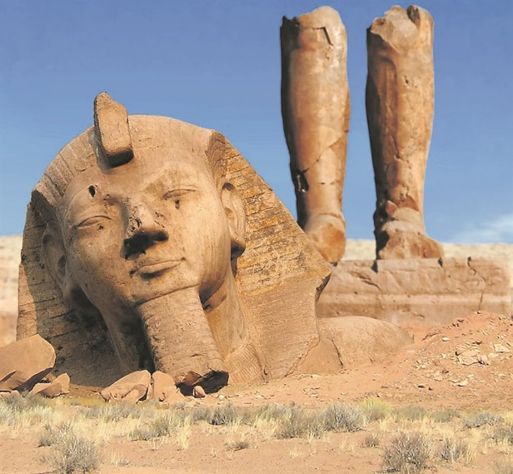

Name:
Class:

Contents Page
p.2 | Big Questions
p.3 | AQA English Literature Assessment Objectives
p.4-5 | AQA English Literature Mark Scheme
p.6 | AQA English Language Assessment Objectives
p.7-9 | AQA English Language Mark Scheme
p.10-11 | Key Terminology
p.12 | Homework Overview
p.13-15 | Homework 1
p.16-19 | Homework 2
p.20 | Wider Reading

Big Questions

Our study of Language Paper 1 will follow the structure below:
- BQ: how can I construct a piece of creative writing?
- BQ: how can I write with precision, accuracy and imagination?
- BQ: how can I craft my writing to create a narrative hook?
- BQ: what makes an engaging character? [Extended Writing 1]
- BQ: how can I develop my creative writing? [Whole Class Feedback]
- BQ: how can I consider the semantic field of a text?
- BQ: how can I create a cyclical structure in my writing?
- BQ: how can I structure my writing to build tension? [Extended Writing 2]
- BQ: how can I develop my creative writing [Whole Class Feedback]
- BQ: how can I use figurative language in my description?
- BQ: how can I develop perceptive analysis of language? [Question 2 focus]
- BQ: what structural methods can I evaluate in a text? [Question 3 focus]
- BQ: how can I engage with a statement critically?
- BQ: how can I write an imaginative piece of creative writing? [Extended Writing 3]
- BQ: how can I develop my creative writing? [Whole Class Feedback]

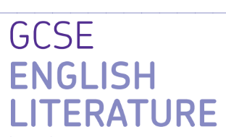
AQA GCSE English Literature Paper 2

Paper 2: Modern Texts and Poetry

What’s assessed = An Inspector Calls, Power and Conflict Poetry Anthology & Unseen Poetry

How it’s assessed: Written exam 2 hours 15 minutes, 96 marks, 60% of GCSE

Questions:

Section A Modern Drama/ Prose: students will answer one essay question on their studied text

Section B Poetry Comparison: students will answer one comparison essay question on their studied anthology

Section C: Unseen Poetry: students will answer two questions- one analytical question on an unseen poem AND a comparison question about two unseen poems.

Mark schemes Literature Exams

Assessment objectives (AOs)

AO1 Read, understand and respond to texts. Students should be able to:

• maintain a critical style and develop an informed personal response

• use textual references, including quotations, to support and illustrate interpretations.

AO2 Analyse the language, form and structure used by a writer to create meanings and effects, using relevant subject terminology where appropriate.

AO3 Show understanding of the relationships between texts and the contexts in which they were written.

AO4 Use a range of vocabulary and sentence structures for clarity, purpose and effect, with accurate spelling and punctuation

Poetry Comparison Essay Mark Scheme

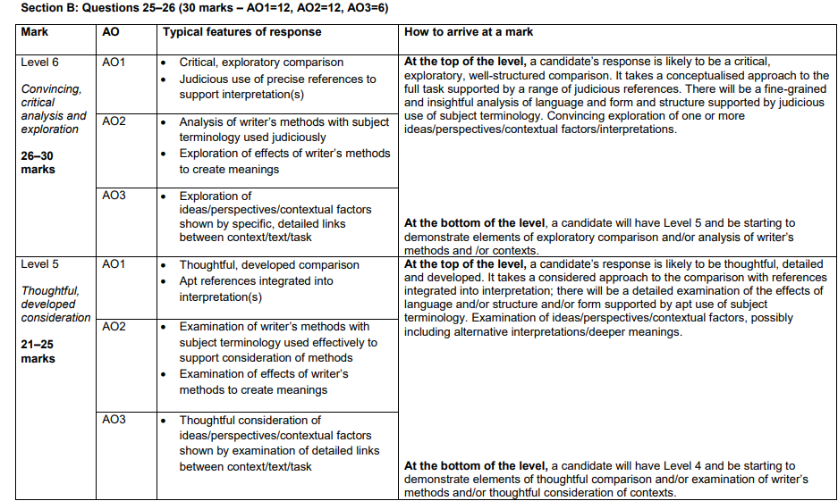

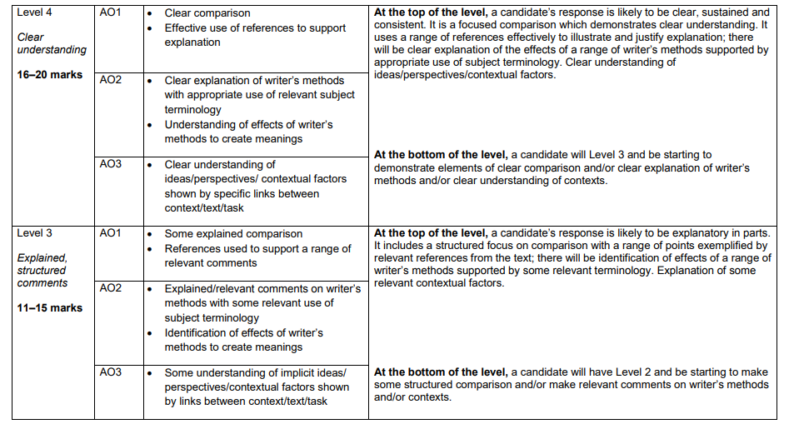

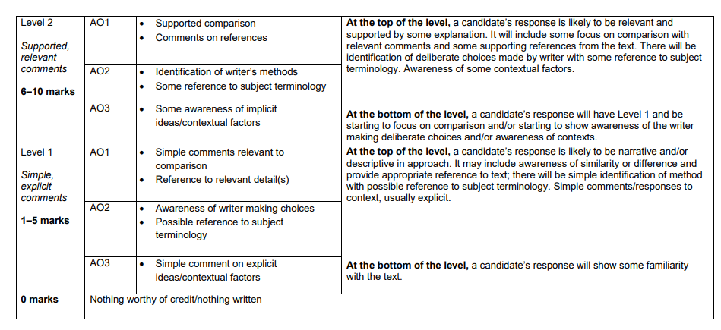

Exam Criteria and Assessment Objectives for Language Paper 1

Assessment Objectives
AO1 | Pick out and understand pieces of explicit and implicit information from the text(s).  Collect and put together information from different texts.
AO2 | Explain how writers use language and structure to achieve their purpose and influence readers.  Use technical terms to support your analysis of language and structure.
AO3 | Identify different writers’ ideas and perspectives.  Compare the method used by different writers to convey their ideas.
AO4 | Critically evaluate texts, giving a personal opinion about how successful the writing is.  - Provide detailed evidence from the text to support your opinion.
AO5 | Communicate clearly, effectively and imaginatively, selecting and adapting tone, style and register for different forms, purposes and audiences.  Organising information and ideas, using structural and grammatical features to support coherence and cohesion of texts.
AO6 | Students must use a range of vocabulary and sentence structures for clarity, purpose and effect, with accurate spelling and punctuation.

Paper Timings for Language Paper 1
 | Question | Time | Skills assessed
15 minutes reading time
Paper One  1hr 45mins | Q1: List four things…  4 marks | 5 minutes | AO1
Paper One  1hr 45mins | Q2: How does the writer use language…  8 marks | 10mins | AO2
Paper One  1hr 45mins | Q3: How does the writer use structure…?  8 marks | 10mins | AO2
Paper One  1hr 45mins | Q4: Statement and to what extent do you agree?  20 marks | 20mins | AO4
Paper One  1hr 45mins | Q5: Creative writing  40 marks | 45mins | AO5 and AO6

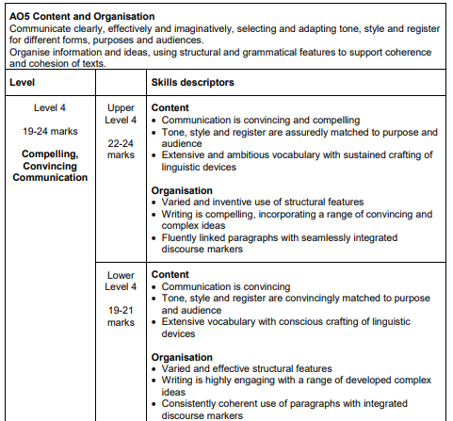

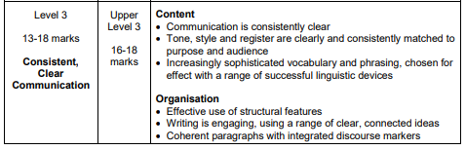
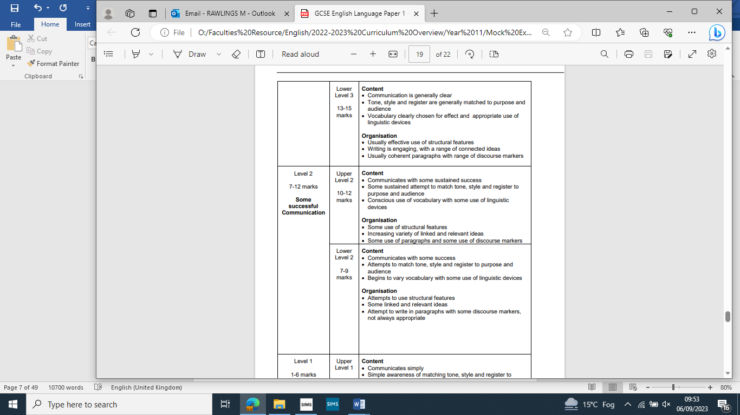

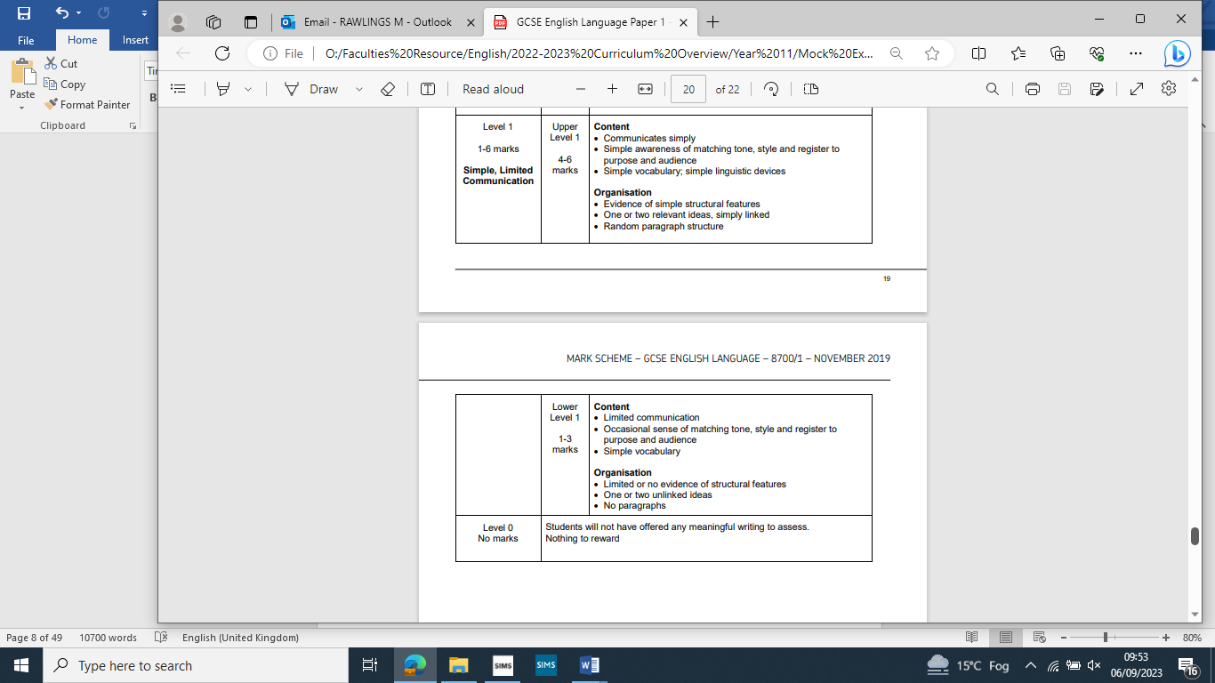

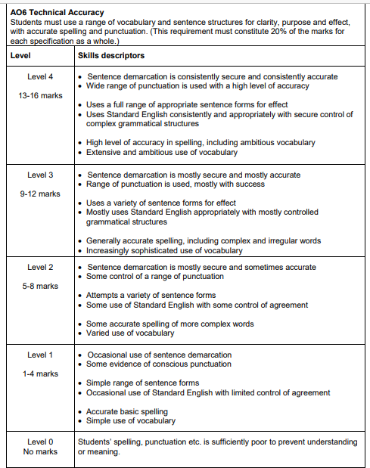

Key Vocabulary
Metaphor | A direct comparison of two things in which it is representative or symbolic of something else.
Imagery | Language in a text that helps create a visual image for the reader.
Semantic Field | When we have words that are all linked in meaning used to create a particular image/ feeling and keep this consistent in the mind of the reader
Pathetic Fallacy | Where the writer uses the weather and/or atmosphere to reflect the mood in a text.
Adjective | A word that is used to describe a noun. ‘The ugly man.’
Tone | The overall feeling, mood or atmosphere created by a writer.
Personification | Giving an object human characteristic
Antithesis | Where two things are the direct opposite and contrast with one another.
Simile | A comparison of two things using the words ‘like’ and/or as’
Oxymoron | Where two contrasting words are placed next to one another e.g. ‘Bitter Sweet’
Onomatopoeia | When a word imitates a sound like ‘bang’.
Shift in Focus | When a writer deliberately crafts the text to draw our attention to something else.
Dialogue | Sections of a text that are identifiable by characters speaking.
Alliteration | When words start with the same sound or letter ‘Sammy sold seashells’
Chronology | The arrangement of events in time order – or as they occurred in sequence.
Foreshadowing | Where a writer drops hints in the text at events to come later on.
Juxtaposition | Placing two images or ideas close together for the purpose of comparison similarity or contrast.
Climax | The height of the action in a text.
Narrative Perspective | The point of view the text is written from.
Evaluate | To judge and assess something using evidence.
SPACE FOR ADDITIONAL VOCABULARY

Homework Tasks.

Knowledge is power, so the more you know, the more secure you will be in your learning.

Year 11: Unit 1 Homework: Macbeth
Task 1: | Due date:  WEEK 2 | - Answer the 25 multiple choice questions on the Power and Conflict Poetry Anthology – these will be marked in class with your teacher.  - Match the poem to the opening line.
Task 2: | Due date:  WEEK 4 | - Use one of the character prompts to create a character profile.  - Write an extended writing piece exploring your character. Use the requirements and information from the prompts to guide you.

If you have ‘no homework’, or you have finished all of the above, try these tasks on a weekly basis to ensure your understanding is secure.
- Use the Wider Reading page on the back of the Knowledge Organiser and download some more practice papers from AQA.
- Add words to your key terminology grid in the Knowledge Organiser
- Read for at least 20 minutes per day – a mixture of fiction and non-fiction texts.

Homework 1: Power and Conflict Poetry Anthology

Task 1: Answer the following multiple choice questions. There may be more than one correct answer
- In the poem “London" what is the speaker doing?
a) Sitting | c) Walking
b) Driving | d) Painting
- In "Ozymandias," what does the shattered statue represent?
a) Hope | c) Nature's beauty
b) Power and decay | d) Love and passion
- What war is referenced in Wilfred Owen's poem "Exposure"?
a) World War I | c) The Korean War
b) World War II | d) The Vietnam War
- What literary device is used in the first line of "Exposure"?
a) Simile | c) Personification
b) Metaphor | d) Onomatopoeia
- "The Charge of the Light Brigade" is about which historical event?
a) The Battle of Trafalgar | c) The Crimean War
b) The American Civil War | d) The Battle of Gettysburg
- In "London" by William Blake, what is the speaker's primary emotion?
a) Joy | c) Sadness
b) Anger | d) Indifference
- What is the central theme of "London" by William Blake?
a) Nature's beauty | c) Love and romance
b) Political corruption and social injustice | d) The power of the imagination
- In "Exposure" by Wilfred Owen, what weather conditions do the soldiers face?
a) Snow | c) Extreme cold
b) Intense heat | d) Strong winds
- Which poem features the line "Exploding comfortably down on the cliffs"?
a) "Ozymandias" | c) "The Prelude: stealing the boat"
b) "Storm on the Island" | d) "The Charge of the Light Brigade"
- What is the main message of "My Last Duchess" by Robert Browning?
a) The beauty of nature | c) The joy of love
b) The dangers of excessive pride and control | d) The inevitability of death
- Who is the speaker addressing in "My Last Duchess"?
a) The Duke's deceased wife | c) A visitor or envoy
b) The Duke's current lover | d) The Duke's family
- What kind of conflict is depicted in "Bayonet Charge"?
a) Internal conflict | c) Conflict with authority
b) Environmental conflict | d) Conflict in warfare
- In "Checking Out Me History", what does the speaker want to learn about?
a) Ancient history | c) European history
b) His own cultural history | d) Science and technology
- What is the main subject of "Kamikaze"?
a) The beauty of nature | c) The joys of family life
b) The experience of a kamikaze pilot | d) The thrill of adventure
- In "The Emigree", what does the speaker remember about her homeland?
a) The joy and beauty of the place | c) The oppressive government
b) The pain and suffering of war | d) The excitement of travel
- What literary device is used in the line "spits like a tame cat turned savage"?
a) metaphor | c) juxtaposition
b) simile | d) caesura
- In "Storm on the Island," what is the primary threat to the islanders?
a) A nuclear attack | c) An invasion by foreign forces
b) A natural storm | d) Economic collapse
- What is the central theme of "Remains”?
a) The horrors of war and guilt | c) The power of love
b) The beauty of nature | d) The importance of history
- What scares the boy in "The Prelude"?
a) A storm | c) A mountain
b) A boat | d) A city
- Which poem explores the theme of the destructive power of nature?
a) "Ozymandias" | c) "Storm on the Island"
b) "The Charge of the Light Brigade" | d) “London”
- In "The Prelude," what lingers in the thoughts of the boy?
a) ‘huge and mighty forms’ | c) ‘green fields’
b) ‘images of trees’ | d) ‘living men’
- What is the main emotion conveyed in "Poppies"?
a) Joy | c) Anger
b) Sadness and loss | d) Love and nostalgia
- In "Remains," what does the speaker use to try and forget his memories?
a) Therapy | c) Drugs and Alcohol
b) Video Games | d) Violence
- In "The Prelude," what is the central event that shapes the speaker's perspective?
a) A battle | c) A childhood memory
b) A journey into nature | d) A visit to a city
- What is the main message of "Tissue"?
a) The fragility of human life | c) The importance of paper
b) The power of nature and time | d) The joy of creativity

Task 2: Match the opening lines to the correct poem

- Ozymandias a) Our brains ache, in the merciless iced east winds
- London b) We are prepared: we build our houses squat
- Extract from The Prelude c) Three days before Armistice Sunday
- My Last Duchess d) I met a traveller from an antique land
- Charge of the Light Brigade e) Dem tell me
- Exposure f) Paper that lets the light
- Storm on the Island g) One summer evening (led by her) I found
- Bayonet Charge h) On another occasion, we get sent out
- Remains i) There once was a country . . . I left it as a child
- Poppies j) Half a league, half a league
- War Photographer k) I wander through each chartered street
- Tissue l) Her father embarked at sunrise
- The Emigrée m) That’s my last Duchess painted on the wall
- Checking out me history n) In his darkroom he is finally alone
- Kamikaze o) Suddenly he awoke and was running- raw

1. | 2. | 3. | 4. | 5.
6. | 7. | 8. | 9. | 10.
11. | 12. | 13. | 14. | 15.
Homework 2: English Language Paper 1 Section B

Instructions:
Choose one of the following character prompts and create a detailed character profile and story opening:

Prompt 1:
Imagine a character who has just discovered a magical ability. Describe their appearance, personality, and the moment they first realized their power. What challenges and adventures await them as they learn to control it?

Prompt 2:
Create a character who finds an old, mysterious letter in their attic. Describe their background, motivations, and the contents of the letter. What does this discovery set in motion for their life?

Prompt 3:
Invent a character who is about to embark on a once-in-a-lifetime journey. Where are they going, and why? Delve into their fears, hopes, and dreams as they prepare for this life-changing adventure.

Requirements:

- Develop a character profile that includes the character's name, age, appearance, personality traits, and background.
- Write a short backstory for the character, explaining key events or experiences that have shaped who they are.
- Include at least one major conflict or challenge the character will face in a potential story.
- Use descriptive language and provide insights into the character's thoughts and emotions.
- Feel free to include any additional details or quirks that make your character unique.

Character Profile:

Name
Age
Appearance

Personality Traits

Background

Independent Writing
__________________________________________________________________________________________________________________________________________________________________________________________________________________________________________________________________________________________________________________________________________________________________________________________________________________________________________________________________________________________________________________________________________________________________________________________________________________________________________________________________________________________________________________________________________________________________________________________________________________________________________________________________________________________________________________________________________________________________________________________________________________________________________________________________________________________________________________________________________________________________________________________________________________________________________________________________________________________________________________________________________________________________________________________________________________________________________________________________________________________________________________________________________________________________________________________________________________________________________________________________________________________________________________________________________________________________________________________________________________________________________________________________________________________________________________________________________________________________________________________________________________________________________________________________________________________________________________________________________________________________________________________________________________________________________________________________________________________________________________________________________________________________________________________________________________________________________________________________________________________________________________________________________________________________________________________________________________________________________________________________________________________________________________________________________________________________________________________________________________________________________________________________________________________________________________________________________________________________________________________________________________________________________________________________________________________________________________________________________________________________________________________________________________________________________________________________________________________________________________________________________________________________________________________________________________________________________________________________
__________________________________________________________________________________________________________________________________________________________________________________________________________________________________________________________________________________________________________________________________________________________________________________________________________________________________________________________________________________________________________________________________________________________________________________________________________________________________________________________________________________________________________________________________________________________________________________________________________________________________________________________________________________________________________________________________________________________________________________________________________________________________________________________________________________________________________________________________________________________________________________________________________________________________________________________________________________________________________________________________________________________________________________________________________________________________________________________________________________________________________________________________________________________________________________________________________________________________________________________________________________________________________________________________________________________________________________________________________________________________________________________________________________________________________________________________________________________________________________________________________________________________________________________________________________________________________________________________________________________________________________________________________________________________

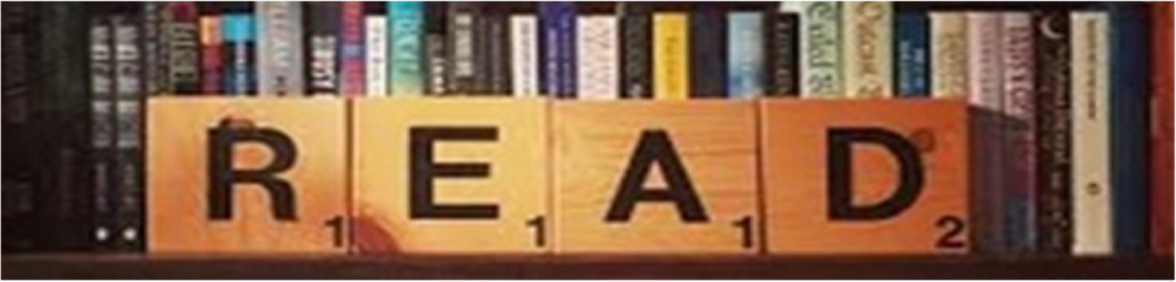

Wider reading list + Revision resources
Make sure you are reading a wide range of texts at home and use the Library in school to help support you when selecting a text to read.

Some useful revision resources you can use to help support your practice of the exam questions are below:

Literature Paper 2:
Mr Bruff’s YouTube Channel
https://www.youtube.com/user/mrbruff

Stacey Reay’s YouTube Channel
https://www.youtube.com/channel/UCJhuqpyhE8NzYZFkwTzi_7g

SENECA Learning
Log into your account and start quizzing!
https://senecalearning.com/en-GB/

MASSOLIT
Lectures and additional resources you can listen to
https://www.massolit.io/

