

Knowledge Organiser
Year 11: Unit 1
Shakespeare: Macbeth

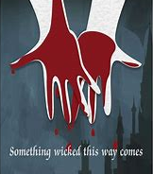
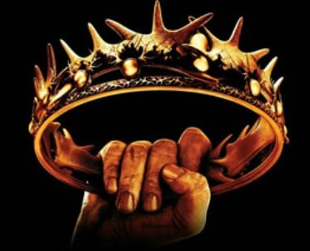

Name:
Class:

Contents Page
p.2 | Big Questions
p.3 | AQA English Literature Assessment Objectives
p.4-5 | AQA English Literature Mark Scheme
p.6-7 | Key Terminology
p.8 | Key Scenes and Characters Fact-file
p.9-12 | Macbeth Scene Summaries
p.13-14 | Example Macbeth Essay
p.15-17 | Character Trackers
p.18-22 | Quotation Collections
p.23- 45 | Homework
p.46 | Wider Reading

Big Questions

Our study of Macbeth will follow the structure below:
- What is the plot of Macbeth?
- How is the supernatural presented?
- How does Shakespeare introduce the character of Macbeth?
- How does Shakespeare present Macbeth and Banquo’s reaction to the supernatural?
- Who is Macbeth loyal to?
- How is Lady Macbeth presented?
- Who is Macbeth loyal to?
- How is guilt presented?
- How does Shakespeare present ideas about guilt?
- How is nature vs chaos presented?
- How are Macbeth’s fears presented?
- How does Shakespeare present Macbeth and Lady Macbeth’s relationship?
- Why is the motif of sleep used throughout the play?
- How has Macbeth changed since the start of the play?
- How is the supernatural presented?
- How is Lady Macbeth an unconventional woman?
- How has Macbeth changed since the start of the play?
- How has Lady Macbeth changed since the start of the play?
- How does Shakespeare present Lady Macbeth as a powerful woman?
- How does Shakespeare build tension?
- Why is the motif of clothes used throughout the play?
- How does Shakespeare present the character of Macbeth in the final scene?
- How does Shakespeare present Macbeth as heroic?
- How does Shakespeare explore ideas about ambition?
- How does Shakespeare present ideas about deception?

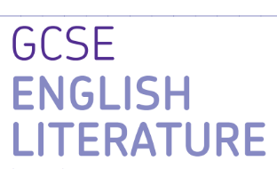
AQA GCSE English Literature Paper 1

Paper 1: Shakespeare and 19th Century Prose

What’s assessed = A Shakespeare play: Macbeth and a 19th Century novel: Jekyll and Hyde

How it’s assessed: Written exam 1 hour 45 minutes, 64 marks, 40% of GCSE

Questions:

Section A Shakespeare: students will answer one essay question on their studied Shakespeare text

Section B 19th Century Prose: students will answer one essay question on their studied 19th century novel.

Mark schemes Literature Exams

Assessment objectives (AOs)

AO1 Read, understand and respond to texts. Students should be able to:

• maintain a critical style and develop an informed personal response

• use textual references, including quotations, to support and illustrate interpretations.

AO2 Analyse the language, form and structure used by a writer to create meanings and effects, using relevant subject terminology where appropriate.

AO3 Show understanding of the relationships between texts and the contexts in which they were written.

AO4 Use a range of vocabulary and sentence structures for clarity, purpose and effect, with accurate spelling and punctuation
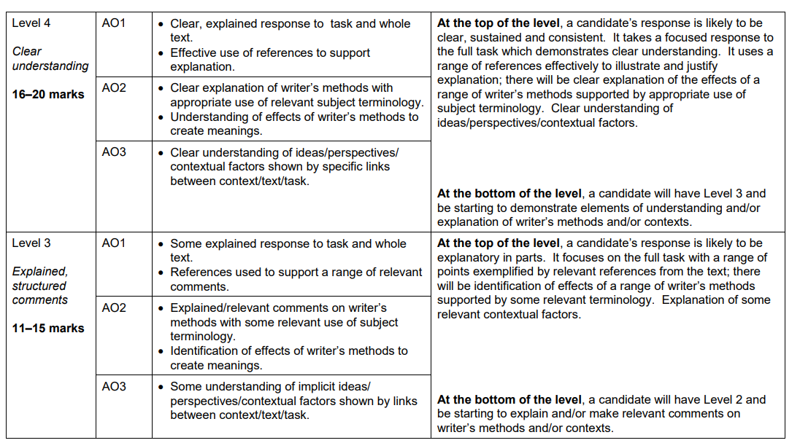
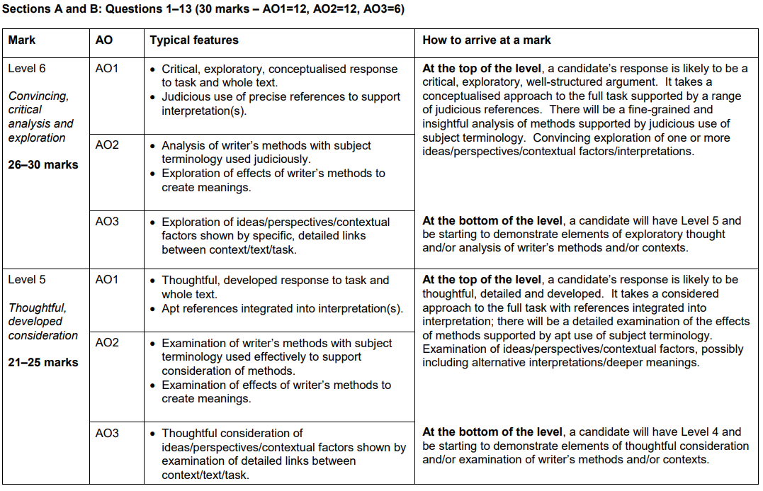

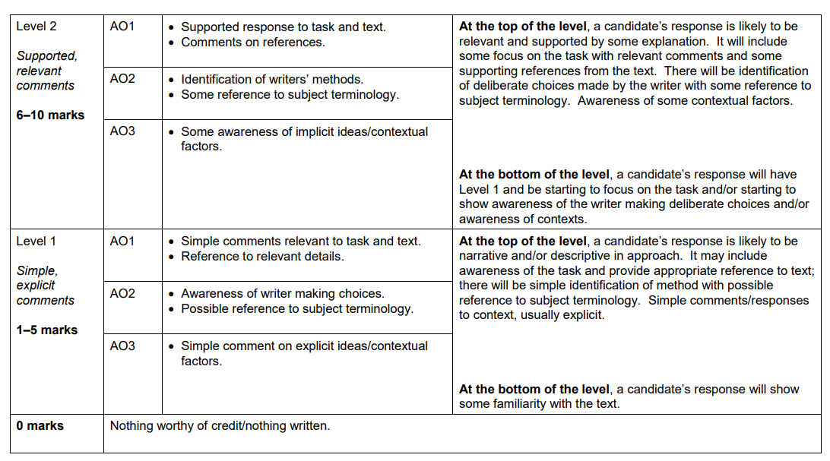

Key Terminology

 | Term | Definition
1 | Allusion | Unacknowledged reference and quotations that authors assume their readers will recognize.
2 | Aside | a part of an actor’s lines that are not meant to be heard by the other characters on stage and intended only for the audience.
3 | Blank Verse | Unrhymed iambic pentameter
4 | Characterisation | how a character is presented/ how they have been created/ designed.
5 | Divine Right of Kings | The belief in Christianity that the monarch of a country is chosen by God himself to be his representative on Earth.
6 | Epithet | a word or phrase applied to a person to describe an actual or credited quality.
7 | Façade | a front or a mask that is put up to disguise something or someone’s true character.
8 | Fate | the development of events outside an individual’s control, it is sometimes said to be determined by a supernatural power.
9 | Foil | a character with qualities that are in contrast with another character
10 | Great Chain of Being | the belief in medieval Christianity that al life an matter on earth was organised into a hierarchy by God.
11 | Hamartia | a character’s tragic flaw
12 | Iambic Pentameter | An iamb is two stressed syllables (da-DUM, da-DUM, da- DUM) it mimics a heart-beat and follows the natural flow of speech. Pentameter means there are ten syllables per line.
13 | Metaphor | A direct comparison of something to something else
14 | Morality | principles, either personal or social, concerning the difference between right and wrong, going beyond legality and often religion.
15 | Motif | an element that reoccurs, such as a word, phrase, idea, image or symbol that appears throughout the play for emphasis
16 | Soliloquy | dramatic device whereby a character stands alone on stage and addresses the audience, giving a voice to their deepest thought and feelings.
17 | Symbolism | using one object or character to expose a broader idea running throughout the play.
18 | Tragic Hero | a character who is usually depicted as perfect and honourable but has one ‘fatal flaw or ;hamartia’ that brings them to their inevitable downfall.
19 | Trochaic Tetrameter | a trochee is the opposite of an iamb so emphasises the first beat (DUM- da, DUM-da) Tetrameter means there are eight syllables per line.
20 | Tyrant | a cruel and oppressive ruler

Space for Additional Terminology

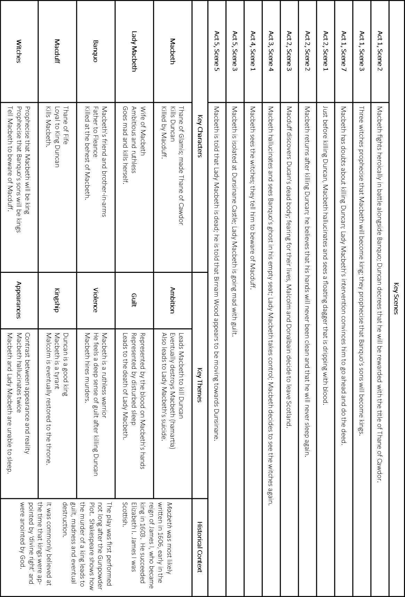

Macbeth Summary
Act 1 Scene 1: Three witches plan to meet Macbeth.

Act 1 Scene 2: Duncan, king of Scotland, hears an account of the success in battle of his noblemen Macbeth and Banquo. Duncan orders the execution of the rebel thane of Cawdor and sends messengers to announce to Macbeth that he has been given Cawdor’s title.

Act 1 Scene 3: The three witches greet Macbeth as “Thane of Glamis” (as he is), “Thane of Cawdor,” and “king hereafter.” They then promise Banquo that he will father kings, and they disappear. Almost as soon as they are gone, Ross and Angus arrive with news that the king has named Macbeth “Thane of Cawdor.” Macbeth contemplates killing Duncan in order to become “king hereafter” as the witches have called him.

Act 1 Scene 4: Duncan demands and receives assurances that the former thane of Cawdor has been executed. When Macbeth, Banquo, Ross, and Angus join Duncan, he offers thanks to Macbeth and Banquo. He then announces his intention to have his son Malcolm succeed him as king and his plan to visit Macbeth at Inverness. Macbeth sets out ahead of him to prepare for the royal visit. Now that Malcolm has been named Duncan’s successor, Macbeth is convinced that he can become king only by killing Duncan.

Act 1 Scene 5: Lady Macbeth reads her husband’s letter about his meeting the witches. She fears that Macbeth lacks the ruthlessness he needs to kill Duncan and fulfill the witches’ second prophecy. When she learns that Duncan is coming to visit, she calls upon supernatural agents to fill her with cruelty. Macbeth arrives, and Lady Macbeth tells him that she will take charge of the preparations for Duncan’s visit and for his murder.

Act 1 Scene 6: Duncan and his attendants arrive at Inverness. Lady Macbeth welcomes them.

Act 1 Scene 7: Macbeth contemplates the reasons why it is a terrible thing to kill Duncan. Lady Macbeth mocks his fears and offers a plan for Duncan’s murder, which Macbeth accepts.
__________________________________________________________________________

Act 2 Scene 1: Banquo, who has accompanied Duncan to Inverness, is uneasy because he too is tempted by the witches’ prophecies, although only in his dreams. Macbeth pretends to have forgotten them. Left alone by Banquo, Macbeth sees a gory dagger leading him to Duncan’s room. Hearing the bell rung by Lady Macbeth to signal completion of her preparations for Duncan’s death, Macbeth exits to kill the king.

Act 2 Scene 2: Lady Macbeth waits anxiously for Macbeth to return from killing Duncan. When Macbeth enters, he is horrified by what he has done. He has brought with him the daggers that he used on Duncan, instead of leaving them in the room with Duncan’s servants as Lady Macbeth had planned. When he finds himself incapable of returning the daggers, Lady Macbeth does so. She returns to find Macbeth still paralyzed with horror and urges him to put on his gown and wash the blood from his hands.

Act 2 Scene 3: A drunken porter, answering the knocking at the gate, plays the role of a devil-porter at the gates of hell. He admits Macduff and Lennox, who have come to wake Duncan. Macbeth appears and greets them. Macduff exits to wake Duncan, then returns to announce Duncan’s murder. Macbeth and Lennox go to see for themselves. When they return, Lennox announces that Duncan’s servants are the murderers. Macbeth reveals that he has slain the servants. When his motives are questioned, Lady Macbeth interrupts by calling for help for herself. Duncan’s sons, Malcolm and Donalbain, plan to flee for their lives—Malcolm to England, Donalbain to Ireland.

Act 2 Scene 4: An old man and Ross exchange accounts of recent unnatural happenings. Macduff joins them to report that Malcolm and Donalbain are now accused of having bribed the servants who supposedly killed Duncan. Macduff also announces that Macbeth has been chosen king. Ross leaves for Scone and Macbeth’s coronation, but Macduff resolves to stay at his own castle at Fife.
__________________________________________________________________________

Act 3 Scene 1: Banquo suspects that Macbeth killed Duncan in order to become king. Macbeth invites Banquo to a feast that night. Banquo promises to return in time. Macbeth, fearing that Banquo’s children, not his own, will be the future kings of Scotland, seizes upon the opportunity provided by Banquo’s scheduled return after dark to arrange for his murder. To carry out the crime, Macbeth employs two men whom he has persuaded to regard Banquo as an enemy.

Act 3 Scene 2: Both Lady Macbeth and Macbeth express their unhappiness. Macbeth speaks of his fear of Banquo especially. He refers to a dreadful deed that will happen that night but does not confide his plan for Banquo’s murder to Lady Macbeth.

Act 3 Scene 3: A third man joins the two whom Macbeth has already sent to kill Banquo and Fleance. The three assassins manage to kill Banquo. Fleance escapes.

Act 3 Scene 4: As Macbeth’s banquet begins, one of Banquo’s murderers appears at the door to tell Macbeth of Banquo’s death and Fleance’s escape. Returning to the table, Macbeth is confronted by Banquo’s ghost, invisible to all but Macbeth. While Lady Macbeth is able to dismiss as a momentary fit Macbeth’s expressions of horror at the ghost’s first appearance, the reappearance of the ghost and Macbeth’s outcries in response to it force Lady Macbeth to send all the guests away. Alone with Lady Macbeth, Macbeth resolves to meet the witches again. He foresees a future marked by further violence.

Act 3 Scene 5: The presentation of the witches in this scene (as in 4.1.38 SD–43 and 141–48) differs from their presentation in the rest of the play. Most editors and scholars believe that neither this scene nor the passages in 4.1 were written by Shakespeare.

Act 3 Scene 6: Lennox and an unnamed lord discuss politics in Scotland. Lennox comments sarcastically upon Macbeth’s “official” versions of the many recent violent deaths. The nameless lord responds with news of Macduff’s flight to England to seek help in overthrowing Macbeth.
__________________________________________________________________________

Act 4 Scene 1: Macbeth approaches the witches to learn how to make his kingship secure. In response they summon for him three apparitions: an armed head, a bloody child, and finally a child crowned, with a tree in his hand. These apparitions instruct Macbeth to beware Macduff but reassure him that no man born of woman can harm him and that he will not be overthrown until Birnam Wood moves to Dunsinane. Macbeth is greatly reassured, but his confidence in the future is shaken when the witches show him a line of kings all in the image of Banquo. After the witches disappear, Macbeth discovers that Macduff has fled to England and decides to kill Macduff’s family immediately.

Act 4 Scene 2: Ross visits Lady Macduff and tries to justify to her Macduff’s flight to England, a flight that leaves his family defenseless. After Ross leaves, a messenger arrives to warn Lady Macduff to flee. Before she can do so, Macbeth’s men attack her and her son.

Act 4 Scene 3: Macduff finds Malcolm at the English court and urges him to attack Macbeth at once. Malcolm suspects that Macduff is Macbeth’s agent sent to lure Malcolm to his destruction in Scotland. After Malcolm tests Macduff and finds him sincere, Malcolm reveals that Edward, king of England, has provided a commander (Siward) and ten thousand troops for the invasion of Scotland. Ross then arrives with the news of the slaughter of Macduff’s entire household. At first grief-stricken, Macduff follows Malcolm’s advice and converts his grief into a desire to avenge himself on Macbeth.
__________________________________________________________________________

Act 5 Scene 1: A gentlewoman who waits on Lady Macbeth has seen her walking in her sleep and has asked a doctor’s advice. Together they observe Lady Macbeth make the gestures of repeatedly washing her hands as she relives the horrors that she and Macbeth have carried out and experienced. The doctor concludes that she needs spiritual rather than medical aid.

Act 5 Scene 2: A Scottish force, in rebellion against Macbeth, marches toward Birnam Wood to join Malcolm and his English army.

Act 5 Scene 3: Reports are brought to Macbeth of the Scottish and English forces massed against him. He seeks assurance in the apparitions’ promise of safety for himself. But he is anxious about Lady Macbeth’s condition and impatient with her doctor’s inability to cure her.

Act 5 Scene 4: The rebel Scottish forces have joined Malcolm’s army at Birnam Wood. Malcolm orders each soldier to cut down and carry a bough from the Wood so as to conceal their numbers from Macbeth.

Act 5 Scene 5: Macbeth is confident that he can withstand any siege from Malcolm’s forces. He is then told of Lady Macbeth’s death and of the apparent movement of Birnam Wood toward Dunsinane Castle, where he waits. He desperately resolves to abandon the castle and give battle to Malcolm in the field.

Act 5 Scene 6: Malcolm arrives with his troops before Dunsinane Castle.

Act 5 Scene 7: On the battlefield Macbeth kills young Siward, the son of the English commander. After Macbeth exits, Macduff arrives in search of him. Dunsinane Castle has already been surrendered to Malcolm, whose forces have been strengthened by deserters from Macbeth’s army.

Act 5 Scene 8: Macduff finds Macbeth, who is reluctant to fight with him because Macbeth has already killed Macduff’s whole family and is sure of killing Macduff too if they fight. When Macduff announces that he is not, strictly speaking, a man born of woman, having been ripped prematurely from his mother’s womb, then Macbeth is afraid to fight. He fights with Macduff only when Macduff threatens to capture him and display him as a public spectacle. Macduff kills Macbeth, cuts off his head, and brings it to Malcolm. With Macbeth dead, Malcolm is now king and gives new titles to his loyal supporters.

Example Macbeth Essay

This essay achieved 30/30 and 4/4 for SPAG
Starting with the extract, explore how Shakespeare presents Macbeth’s fears.

Write about:
- how Shakespeare presents Macbeth’s fears in the extract from Act 3 Scene 1 of Macbeth
- how Shakespeare presents Macbeth’s fears in the play as a whole.

Shakespeare explores Macbeth’s fears through his relationship with his wife, his friends, his own mortality, and the destiny supposedly meant for him, all while touching on greater ideas of appropriate kingship, the ‘Great Chain of Being’ and the supernatural.

In this extract, Shakespeare presents Macbeth’s fears through the way he speaks of the witches and his own position. Macbeth worries that his succession was perhaps in vain, and that his reign might be shortlived as he describes the ‘fruitless crown’ and ‘barren sceptre’ the witches have supposedly supplied him with. The words ‘fruitless’ and ‘barren’ connote a sense of emptiness, and are suggestive of Macbeth’s worries that his ruthless road to succession was perhaps in vain, if the power and authority it entails proves to be ‘fruitless’. Importantly, this is a soliloqy of Macbeth, a time where he is alone, and can afford to speak true, which emphasises his worries in this scene as he speaks only to himself.

In the play as a whole, Shakespeare presents Macbeth’s fears through his recognition of a disruption in natural order. Shakespeare uses Macbeth, as a whole, to explore themes of the ‘Great Chain of Being’, and ideas discussed in the ‘Dream of Scipio’ by Cicero, in which the Earth lies at the centre of a number of spheres, which contain different entities, like God, angels, animals, etc. Crucially, these spheres are interlinked, and are shown to be through the ripple effect Macbeth has caused through his transgressions. Macbeth worries about this disruption of order, talking about dead people ‘rising again’ and even to the point of ‘pushing us from our stools’. In the latter quote, Shakespeare uses a metaphor with double meaning to emphasise Macbeth’s worry – he is literally ‘pushed’ from his stool when he sees Banqo in his seat at the Banquet, and worries that he’ll soon be ‘pushed’ from his ‘stool’, which is the throne. Shakespeare intertwines ideas of disruption of the macrocosm and Macbeths actions to demonstrate the magnitude of his actions.

Furthermore, Shakespeare presents Macbeth’s fears further in Macbeth’s soliloquy at the end of the play. The use of ‘tomorrow, tomorrow, tomorrow’ serves as testament to Macbeth’s soliloquy, whereby he realises that his whole life is ruined and that he’s truly damned. The repetition of ‘tomorrow, tomorrow, tomorrow’ and its slow vowel sounds are reflective of his life having also slowed down, now at a ‘petty pace’, and his now nihilistic attitude towards his life. His use of ‘Out, brief candle’ echoes Lady Macbeth’s ‘Out, out damned spot’, and places them in parallel as they recognise their actions and damnations.

Shakespeare continues to present Macbeth’s fears through his relationship with fate and the witches. Shakespeare has left the role of fate ambiguous throughout Macbeth, as he blurs the lines between destiny and free will. Importantly for Macbeth, however, he regards date and the witches as his ‘insurance’ of sorts, ever since he hears the witches prophecy and that ‘[he] shall be king’, and only realises towards the end of his life that he’s been misled through both his own ambition and the witches prophecy. He uses ‘to doubt th’ equivocation of the fiend, that lies like truth’ to suggest his own recognition and worry about the fact he’s been, or has himself, led astray. The use of ‘lies like truth’ is reflective of the dual and ambiguous note of the witches’ prophecy, and further sets Macbeth up as a tragic character as sympathy from the audience is evoked through his now isolated and ‘damned’ state.

Finally, Macbeth’s fears are explored by Shakespeare through his relationship with Banquo. In the extract provided Macbeth mentions Banquo as one ‘with a wisdom that doth guide his valour/To act in safety’, which sets him up as a point of comparison to Macbeth. Banquo is ‘wise’, ‘rational’, and less inclined to act for personal ambition, all traits which Macbeth worries about, as he says ‘there is none but he whose being do I fear’. A stress on ‘he’ is emphatic of the high regard Macbeth holds for Banquo in some respects, as Macbeth worries, and is perhaps even jealous, of Banquo’s mental fortitude and restraint.

In overview, Shakespeare explores Macbeth’s fears throughout the play in every stage of his life, as he progresses to the throne, and eventually to his demise. Shakespeare weaves together ideas of the disruption of the natural order, fate, and Macbeth’s own mortality to emphasise his various emotions in light of the recognition of his transgressions.

Character Tracker

How is each character presented?
Make notes on your impression of the character, key moments throughout the play, how they have changed, the role they play within the plot.

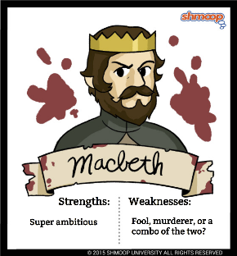
Macbeth

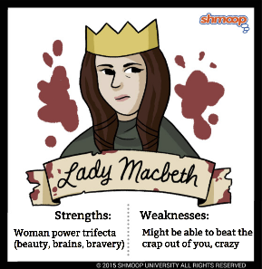
Lady Macbeth

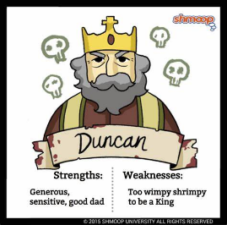
King Duncan

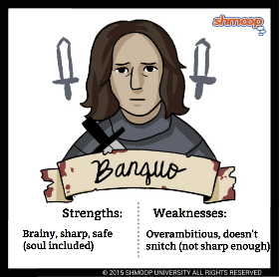
Banquo

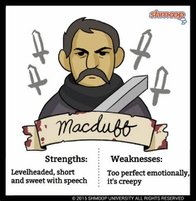
Macduff

Quotation Collection – gather 3 key quotations/ images from the play you can use

In your Knowledge Organiser, you have space to collect key quotations on the following themes:

- Ambition
- Guilt
- Supernatural
- Fate and Free Will
- Loyalty
- Nature
- Kingship
- Appearance vs Reality
- Masculinity

In the exam, you will be asked to refer to the whole text. This can be through
Quotations- an exact copy of the words from the text
Single Words- individual words used in the text
Reference- an explanation in your words, describing details that appear in the text.

Keep your knowledge organiser on the desk in your lessons so that you collect relevant, quotations, words or references from the lesson.

Ambition

Guilt

Supernatural

Fate and Free Will#

Loyalty

Nature

Kingship

Appearance vs Reality

Masculinity

Homework Tasks.

Knowledge is power, so the more you know, the more secure you will be in your learning.

Year 11: Unit 1 Homework: Macbeth
Task 1: | Due date:  WEEK 2 | - Read the review of The RSC production of Macbeth.  - Answer the 10 questions on this – these will be marked in class with your teacher
Task 2: | Due date:  WEEK 4 | - Read the article on The Witches  - Answer the 10 questions on this – these will be marked in class with your teacher
Task 3: | Due date:  WEEK 6 | - Read the article on The Gunpowder Plot and Shakespeare’s Macbeth  - Answer the 10 questions on this – these will be marked in class with your teacher
Task 4: | Due date:  WEEK 8 | - Read the article ‘Darkness does the face of earth entomb’  - Answer the 10 questions on this – these will be marked in class with your teacher
Task 5: | Due date:  WEEK 10 | - Read the article on Shakespeare’s Theatre  - Answer the 10 questions on this – these will be marked in class with your teacher
Task 6 | Due Date:  WEEK 12 | - Read the article on Exploring Tyranny and Power in Macbeth  - Answer the 10 questions on this – these will be marked in class with your teacher.
Task 7 | Due Date:  WEEK 14 | - Read the summary of Macbeth  - Answer the 10 questions on this – these will be marked in class with your teacher.

If you have ‘no homework’, or you have finished all of the above, try these tasks on a weekly basis to ensure your understanding is secure.
- Use the Wider Reading page on the back of the Knowledge Organiser and download some more practice papers from AQA.
- Add words to your key terminology grid in the Knowledge Organiser
- Read for at least 20 minutes per day – a mixture of fiction and non-fiction texts.

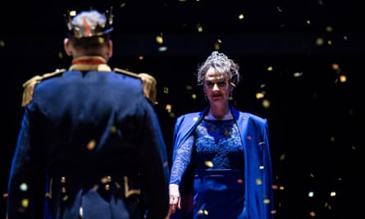
Homework 1- Review of The RSC
production of Macbeth

Macbeth review – Eccleston is every
inch the rugged soldier
Royal Shakespeare theatre, Stratford-upon-Avon

Productions of Macbeth come thick and fast. Polly Findlay’s RSC version boasts a strong cast headed by Christopher Eccleston and Niamh Cusack. But, while the production bulges with bright ideas, I sometimes feel that Findlay is not simply directing the play but also delivering a lecture on it.

Time is obviously a concept that threads through the text. Lest we miss the point, a digital clock is prominent on the upper level of Fly Davis’s design and, having registered Duncan’s murder, counts down to Macbeth’s demise. Key phrases – such as Lady Macbeth’s sense of “the future in the instant” – are projected on to an upstage screen.

Since this a play to which children, or the lack of them, is central, the three witches are incarnated in the form of young girls: a nice idea that underscores a point made by film critic Peter Bradshaw in the programme that Macbeth is the first horror film, but it means the witches’ ominous words go for little.

One idea that does work well is the ubiquity of the Porter. Not since Thomas De Quincey wrote a famous essay, On the Knocking at the Gate in Macbeth (1823), has the character seemed so pivotal. As played by Michael Hodgson, who is on stage throughout, he fulfils multiple roles: a creepy caretaker who hoovers the carpet on which the bulk of the action takes place; a sinister third murderer; an observer who chalks up Macbeth’s escalating murders; and a symbol of fate who, in the final scene, points Macduff in Macbeth’s direction. In Findlay’s interpretation, the play is seen from the Porter’s perspective.

I still think we should be more fixated on Macbeth himself, whom Eccleston plays perfectly creditably. When Lady M tells her husband to “sleek o’er your rugged looks”, she hits on the ideal adjective. Eccleston is every inch the vigorous, rugged soldier, with so little concern for diplomacy that Duncan is forced to wipe the blood off his hand after Macbeth has kissed it, and so ambitious that he presumptuously steps forward when Duncan names his heir. Eccleston also has a good moment when, once crowned, he beats his head on the ground in frustration at the tormented insecurity of kingship. But, while he gives us a robust account of a man of action whose instinct is to kill all opposition, his speaking of the verse lacks irony or light and shade.

Cusack invests Lady Macbeth with a febrile energy – the downside is that director Polly Findlay never lets her be still, so that much of what she says loses its weight. The idea is palpably that Lady M is driven mad by her exclusion from her husband’s tyranny – we even see her listening to a tape of the murder of Macduff’s children. But it is carried too far in the sleepwalking scene, where Cusack descends into the stalls to invite a surprised patron to “give me your hand”.

There are many good things in this production. Edward Bennett movingly registers Macduff’s grief, Luke Newberry’s Malcolm is shadowed by impending danger and Raphael Sowole is a sturdily watchful Banquo. The action also moves at a tremendous lick. This is a lively production in which there has been much throwing about of brains, yet it all too often advertises its ideas instead of allowing them to emerge subliminally.

Answer the questions on the following page about this article

 | Write your answer in the box below each question. | 
1 | Which two actors lead the cast of Macbeth?
2 | Who directed this version of Macbeth?
3 | Which concept threads through the text?
4 | What is the clock counting down to?
5 | How are the witches presented differently than usual?
6 | Who wrote the famous essay ‘On the Knocking at the Gate in Macbeth’?
7 | Which roles does the porter take on in this production?
8 | What is the ideal adjective to describe Eccleston’s Macbeth?
9 | How is Macbeth’s ambition shown through Macbeth’s stage direction?
10 | What does the writer believe is the downside of this portrayal of Lady Macbeth?
TOTAL /10

Homework 2 – Character Analysis: The Witches

Article written by Carol Atherton
Published: 19 May 2017

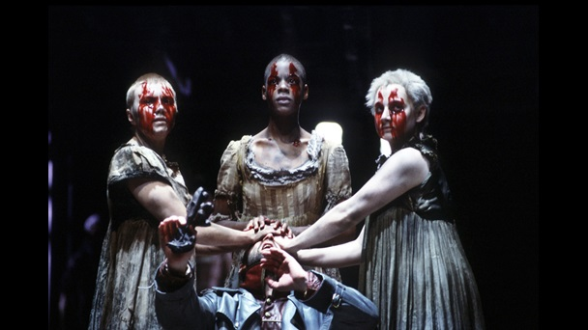
Looking at context, language and form, Carol Atherton provides a close analysis of the Witches in Act 1, Scene 3 of Macbeth.

Key quotation:
Drum within
THIRD WITCH A drum, a drum!
Macbeth doth come.

ALL The weird sisters, hand in hand,
Posters of the sea and land,
Thus do go, about, about:
Thrice to thine, and thrice to mine,
And thrice again, to make up nine.
Peace, the charm's wound up. (1.3.30–37)

Setting the scene
At the start of Act 1, Scene 3 of Macbeth, we see the Witches preparing for their first encounter with Macbeth. The First Witch tells her companions that she has been insulted by a sailor’s wife who refused to give her some of the chestnuts that she was eating (‘“Give me!” quoth I. / “Aroint thee, witch!” the rump-fed ronyon cries’ (1.3.5–6)). The First Witch says that she will take revenge by punishing the woman’s husband, describing in detail what ‘I'll do, I'll do, and I'll do’ (1.1.10) to him: she will deprive him of sleep (‘Sleep shall neither night nor day / Hang upon his penthouse lid’ (1.3.19–20)) and ensure that his ship is tossed by the waves (‘tempest-toss’d’ (1.3.25)) and unable to find safe harbour. The passage ends with the Witches chanting a spell as they prepare to meet Macbeth, repeating a movement three times in the direction of each Witch in order to consolidate their power.

How does Shakespeare present the Witches here?
Shakespeare wrote Macbeth at a time when interest in witchcraft bordered on hysteria. Witches were blamed for causing illness, death and disaster, and were thought to punish their enemies by giving them nightmares, making their crops fail and their animals sicken. Witches were thought to allow the Devil to suckle from them in the form of an animal, such as ‘Graymalkin’ and ‘Paddock’, the grey cat and the toad mentioned by the Witches in Act 1, Scene 1. Those who were convicted were often tortured, their trials reported in grisly detail in pamphlets that circulated in their hundreds. Often, those accused of witchcraft lived on the edges of society: they were old, poor and unprotected, and were therefore easy to blame.
King James VI of Scotland was deeply concerned about the threat posed by witches. He believed that a group of witches had tried to kill him by drowning him while he was at sea (a curse echoed here by the First Witch). During his reign thousands of people in Scotland were put on trial for witchcraft. In 1604, under his rule as king of England and Wales, witchcraft was made a capital offence, meaning that anyone who was found guilty of being a witch could be executed. When Shakespeare wrote Macbeth in 1606, then, he knew that his audience would have felt a mixture of fear and fascination for the three ‘weird sisters’, their imaginations captivated by the mysterious meeting on the desolate heath with which the play begins.
Shakespeare’s portrayal of the Witches in Act 1, Scene 3 draws directly on many of the beliefs about witchcraft that his audience would have held. They harm animals (as when the Second Witch reports, matter-of-factly, that she has been ‘killing swine’ (1.3.2)). Their power over the elements means that they can control the winds and raise storms. They use gruesome ingredients such as body parts (the ‘pilot’s thumb’ (1.3.28)) in their spells. They are also deeply vindictive. The First Witch vows to make the sailor suffer simply because his wife refuses to give in to her gluttonous demand. Her reaction is shockingly, disproportionately cruel: she vows to drain the life out of him until he is ‘dry as hay’ (1.3.18) and curses him with a tortuous inability to sleep, declaring ‘He shall live a man forbid’ (1.3.21) and that he shall ‘dwindle, peak and pine’ (1.3.23). This is a clear example of the crime known in Shakespeare’s day as ‘mischief following anger’, a punishment inflicted as a result of some kind of grievance. Shakespeare uses this passage, then, to demonstrate the Witches’ vindictive nature, leaving the audience in no doubt as to their connection with the powers of evil.

How does this scene fit into Macbeth as a whole?
This is the second time that we’ve met the Witches, and the second time that they’ve mentioned Macbeth, building a sense of anticipation for their forthcoming encounter. In Act 1, Scene 2, Macbeth is presented as a loyal warrior, a hero who fights valiantly on the battlefield to defend his country against invasion and treachery. Yet the association between Macbeth and the Witches introduces a different side to his character. The battle referred to by the Second Witch in Act 1, Scene 1 could be interpreted as not just a literal battle (the conflict raging between Scotland and Norway) but also a metaphorical battle: the battle for Macbeth’s soul. It’s significant, therefore, that Macbeth’s first words to the Witches – ‘So foul and fair a day I have not seen’ (1.3.38) – echo the Witches’ chant, ‘Fair is foul, and foul is fair’, from Act 1, Scene 1 (l. 11). Banquo soon echoes the Witches, too, asking Macbeth, ‘Good sir, why do you start, and seem to fear / Things that do sound so fair?’ (1.3.51–52). This allusion is loaded with dramatic irony: while Banquo perceives the Witches’ prophecies as ‘fair’, the audience is already aware things are not necessarily what they seem. Banquo introduces an element of doubt, too, by framing his observation within a question. The Witches’ paradox – which indicates that appearances can be deceiving – is central to the play and reverberates through the major characters. Take Lady Macbeth, for example: ‘look like th' innocent flower, / But be the serpent under't’ (1.5.65–66).
When Macbeth and Banquo meet the Witches, their reactions give us an important insight into their personalities. Banquo is unafraid, but Macbeth ‘start[s]’ (1.3.51), or flinches, and ‘seems rapt’ (1.3.57), so mystified by their greeting that he is rendered speechless. Once he has regained his composure, he challenges the Witches to tell him more. They vanish, but it is not long before Macbeth finds that he is to become Thane of Cawdor – a ‘truth’ that immediately sets him wondering how the Witches’ final prophecy will come about, and losing himself in the ‘horrible imaginings’ (1.3.138) that will eventually lead to the murder of King Duncan. Later in the play, it is Macbeth who seeks out the Witches, cementing his willingness to give himself over to the ‘instruments of darkness’ (1.3.124).

Answer the questions on the following page about this article

 | Write your answer in the box below each question.
1 | What did the sailor’s wife do to insult the first witch?
2 | What were witches blamed for during Shakespeare’s time?
3 | Who was usually accused of witchcraft?
4 | ‘King James believed witches tried to kill him. How did they try and do this?
5 | What was made a capital offence during King James’s reign?
6 | What does capital offence mean?
7 | Which gruesome ingredients did the witches use in Act 1 Scene 3?
8 | What metaphorical battle are the witches referring to?
9 | How do Macbeth and Banquo react differently when they meet the witches?
10 | Which of the witches prophecies is the first to come true?
TOTAL /10

Homework 3 – The Gunpowder Plot and Shakespeare’s Macbeth
Blog from The Globe Theatre

Shakespeare’s ‘Scottish Play’ was probably written in 1606, just three years after King James I (VI of Scotland) was crowned as Elizabeth I’s successor, and so undoubtedly seems to be paying homage to the succession of the Scottish King to the English throne.
But within that time, in November 1605, the Gunpowder Plot had been discovered: the plan to blow up the Houses of Parliament, kill James, and replace him with a Catholic monarch failed, and the plotters were tortured and horribly executed. The impact of the event was so dramatic, we still remember it today on Bonfire Night (‘Remember, Remember, the fifth of November, Gunpowder, Treason and Plot’, goes the traditional rhyme…), so we can only imagine the enormity of the event for Shakespeare and his contemporaries.

It is often said Macbeth is a comment on the Gunpowder Plot, so why, and how are the two connected? Firstly, many of Macbeth’s themes resonate with the attempted revolt: it’s a play about treason, the overthrow of a King, and the downfall of his murderers. Even more importantly, King James was commonly believed to be descended from Banquho the thane of Lochquhaber, the historical counterpart of Shakespeare’s Banquo, the friend who Macbeth betrays and has murdered. With this in mind the witches’ prophesy that Banquo’s descendants will be kings takes on a new meaning: it is referring to Banquo’s descendant James Stuart, King of Scotland and England. By extension, it has been suggested that the escape of Fleance, Banquo’s son, from Macbeth’s murder plot is designed to echo James’s own escape from the Gunpowder Plot and to subtly compliment the House of Stuart as legitimate and truly-descended rulers.

At the beginning of Act 2, Scene 3, the Porter amuses himself by pretending he is the gatekeeper of hell, letting in new arrivals. He exclaims

Knock, knock! Who’s there, in the other devil’s name? Faith, here’s an equivocator that could swear in both the scales against either scale, who committed treason enough for God’s sake, yet could not equivocate to heaven. Oh, come in, equivocator.

The insistent reference to equivocation seems to be alluding to the Catholic priest Henry Garnet, who was hung, drawn and quartered for his role in the Gunpowder Plot and was deeply criticised for equivocating. Allegedly, Garnet had heard confession from Robert Catesby, one of the plotters, which revealed his intention to kill the King, but obeyed the Seal of the Confessional by keeping it secret. Jesuits were particularly associated with equivocation, which is a way of avoiding the sin of lying by implying something untrue through ambiguous phrasing. Garnet’s defence of equivocation was extremely damaging in his trial, and the Porter’s light-hearted remarks seem to be playing on popular derision of the priest.
It is also through equivocation that Macbeth is tricked to his downfall: the Witches’ prophecies are ambiguous and lull Macbeth into a false sense of security.

Interestingly, it is also through equivocation that Macbeth is tricked to his downfall: when the Witches tell him he shall never vanquish’d be until Great Birnam Wood to high Dunsinane Hill Shall come against him and ‘none of woman born/ Shall harm Macbeth’ they imply that he will always be safe, as both ideas seem impossible. The Witches’ deception may well be intended to be resonant of the deceptions of Catholicism and Garnet: when Macbeth is told that the wood is moving he realises he must ‘begin/ To doubt the equivocation of the fiend,/ That lies like truth’.

Macbeth’s allusions to the sensational events of the Gunpowder Plot and its aftermath are typical of Shakespeare’s often reserved way of referring to topical issues, but leave a fascinating insight into a contemporary dramatist’s response to the momentous event.

Answer the questions on the following page about this article

 | Write your answer in the box below each question.
1 | When was Macbeth supposedly written?
2 | When was the Gunpowder Plot discovered?
3 | What did the plotters try and do?
4 | Who was King James believed to be descended from?
5 | How are the witches prophecies connected to King James?
6 | How was Henry Garnet punished for his involvement in the Gunpowder Plot?
7 | Finish the quote: who committed _______ enough for God’s sake, yet could not ____________ to _____________.
8 | What is equivocation?
9 | How do the witches prophecies lead Macbeth to his own downfall?
10 | What is the witches deception intended to reflect?
TOTAL /10

Homework 4 - ‘Darkness does the face of earth entomb’ By Dr Will Tosh

Macbeth is overwhelmingly a play of night-time and the hours just before and after dark. It drew on all the resources of Shakespeare’s indoor theatre when it opened its doors in 1609

On a Saturday in April 1611, the quack physician Simon Forman took in ‘Mackbeth at the Glob’, as he recorded it in his Bocke of Plaies, a journal of his play-going habits. At the Bankside amphitheatre, Forman was struck in particular by the moment ‘Mackbetes quen did rise in the night in her sleep, and walke and talked and confessed all, and the docter noted her wordes.’ Forman’s medical amour-propre might account for his special mention of the doctor, but he also paid attention to the night-time setting of Lady Macbeth’s sleepwalking scene.

In the Globe, of course, the play was performed in full daylight – Forman probably noticed the giveaway taper carried by the queen as a prop that denoted darkness – but just across the river, he would have had the chance to see the play in very different circumstances.

In 1609 the King’s Men had taken possession of the Blackfriars, the lavish indoor playhouse that became their winter home, and a new venue for their dramatic repertory. Intimate in scale and lit by candlelight, the Blackfriars offered theatrical effects unavailable in the outdoor amphitheatres. In the years before the King’s Men’s takeover, indeed, the Blackfriars had pioneered the development of stage lighting effects. In 1606 the writer Thomas Dekker alluded to these practices in his pamphlet The Seven Deadly Sins of London when he observed that the city, in the grip of one of its periodic outbreaks of plague, resembled ‘a private playhouse, when the windows are clapped down, as [if] some nocturnal, or dismal tragedy, were presently to be acted.’ By ‘nocturnal’, Dekker meant a play, usually comic, in which a significant proportion of the action took place at night; his off-hand reference suggests that theatre artists were already exploring ways to change the lighting states on their stages to replicate night-time or to create an atmosphere of tragic gloom.

Macbeth bears some of the characteristics of a distinctly un-comic nocturnal, or a tragic ‘night-piece’. The play’s two central murders occur in the dark, a state which induces paralysing fear in Macbeth after Duncan’s killing, and leads to the gory botching of the attack on Banquo and Fleance, who is able to escape in the confusion. Key scenes of hospitality, such as Duncan’s arrival at the Macbeths’ castle, are attended by torches, as called for in the stage directions of the folio text. Memorable scenes take place at the break of day or at the approach of ‘seeling night’.

Night occupied an ambiguous position in the minds of early modern men and women. On the one hand, darkness was a familiar condition. Few homes were lit with the extravagance of the indoor playhouses; after nightfall, most people made do with a single candle, carried frugally from room to room. As Banquo says to his son on the starless night of Duncan’s murder, ‘there’s husbandry in heaven, / Their candles are all out’: thrifty housekeepers snuffed out lights to save money on beeswax and tallow. But darkness was also a time for misbehaviour. The theatrical ‘nocturnals’ mentioned in The Seven Deadly Sins tended to feature their fair share of comedic bed-hopping and midnight knavery, and in another publication, the cony-catching handbook Lantern and Candlelight (1608), Thomas Dekker revealed the seedy world of London’s night-time rogues and vagabonds.

Pitch darkness might have been familiar, but that didn’t make its terrors any easier to bear. After dark, one was vulnerable to assault from one’s fellow subjects, to infection from miasmic air, or to visitation from demonic forces. Above all, night-time was the province of fear, the emotion that, said Michel de Montaigne, ‘exceeds all other disorders in intensity.’ The most chilling manifestation of fear in early modern imaginings was the dread of the hereafter, the spectre of sin and damnation that hovered over every human soul. According to the theologian Thomas Rogers in a treatise of 1576 on the workings of the mind, ‘fear riseth from a conscience convicted guilty of some offence.’ Remorse and guilt – those emotions associated so strongly with Macbeth in the present day – found their origin in this fear of purgatorial punishment. Not for nothing has Macbeth been identified by the scholar Ewan Fernie as ‘Shakespeare’s Faustus’…

Macbeth ‘is obsessed with fear,’ observed the Shakespeare critic Allison Hobgood. A ‘fear-sickness’ stalks this dark play, seeding the language of its characters with a vocabulary of dread: the word ‘fear’ is spoken forty eight times. The bloody deeds committed by the Macbeths come back to haunt the perpetrators in phantasms both ‘real’ and unseen; and overseeing all is a trio of ‘weïrd women’, prophetic beings with the power to summon apparitions from the spirit world. If the tyrannical Macbeth meets his end by human hand, he is dispatched on his way by the misleading prognostications of the weïrd sisters and their black magic.

Shakespeare’s play, written for the Globe in 1606 in the aftermath of the Gunpowder Plot, captures the fearfulness and anxiety of that era in a tragedy that unfolds in unsettling gloom or abjectly frightening darkness. If Shakespeare was inspired by the structural possibilities of the ‘nocturnal’ genre, he gave his night-time scenes a fresh jolt of terror. And in 1609, he and his dramatic collaborators were granted the opportunity to rethink the darkness of his Scottish tragedy after the move indoors to the Blackfriars, equipped with its irresistibly flexible candlelight. We don’t know if the King’s Men ‘clapped down’ the windows and extinguished the candles for the dark scenes in Macbeth, but the play’s likely emendation by dramatist Thomas Middleton in the years after 1616 suggest that the company were minded to keep it up to date with theatrical fashion beyond the playwright’s death, and they may well have experimented with the sort of lighting effects for which the indoor playhouses were well known. Perhaps the King’s Men discovered that Macbeth thrived in the dimly glittering, intimate space of the Blackfriars, where the ‘good things of day’ could be shut outside, for ‘night’s black agents’ to begin their devilish work.

Answer the questions on the following page about this article

 | Write your answer in the box below each question.
1 | Which prop was used in The Globe Theatre to indicate it was night?
2 | Which theatre did Shakespeare move to after using The Globe Theatre?
3 | What atmosphere did theatre artists try to create for their ‘nocturnal’ plays?
4 | Which two key moments in Macbeth take place in the dark?
5 | Why were most households used to the dark in this time period?
6 | What are you vulnerable to after dark?
7 | Which two emotions are strongly associated with Macbeth?
8 | According to Alison Hobgood, what is Macbeth obsessed with?
9 | How many times is the word ‘fear’ spoken in the play Macbeth?
10 | How does Macbeth meet his end?
TOTAL /10

Homework 5 – Shakespeare’s Theatre

Contemporary Productions
Macbeth is one of Shakespeare's shortest and most intense dramas. Its straightforward plot and its strong characterization make it appealing for actors, directors, and audiences alike. The following brief discussion looks at the various theatrical contexts of the play from Shakespeare's time to ours.
The theatre in Elizabethan and Jacobean times was basically a courtyard, surrounded on three sides by tall raised balcony areas. Other buildings in London, specifically public houses (taverns) and bear-baiting pits, were similarly designed. In a famous contemporary engraving of London, the Globe theatre — where Macbeth was performed in 1611 — is famously confused with the Bear-baiting pit. In this context, it is interesting to note Macbeth's lines (Act V, Scene 7) "They have tied me to a stake . . . but bear-like I must fight the course."
At the centre and to the back of the courtyard was a raised stage, above which hung a depiction of the heavens — a blue roof, fretted with golden stars. The stage contained a trapdoor through which ghosts could appear and into which the souls of the damned could disappear. At the back of the stage was a curtain leading to the actors' dressing area — the tiring room.
The courtyard was open to the sky, so lighting was largely natural, but in some indoor theatres or palaces such as Hampton Court, where Macbeth was first performed in 1606 in front of King James I, candles were probably used to create an artistic tension between natural and "unnatural" (or artificial) light. Lady Macbeth has a candle "by her continually" in Act V, Scene 1, by which time natural light may well have already become gloomy. In fact, the numerous references to natural daylight and night-light in Macbeth make it a fascinating study for any historian of theatre.
Shakespeare's play underwent several revisions during its lifetime. Specifically, the allusions to the Gunpowder Plot and the nature of kingship (Act IV, Scene 1) could have been added for the first performance in front of the king. What remains certain is that Macbeth has always been a highly visual and physical play: The apparitions, the references to parts of the body (hands, head), the fighting in Act V — all point to a play full of gesture and body language.
Modern Productions
As well as stage presentations, in recent years there have been a number of film adaptations, including Macbeth by Roman Polanski (1971) and Throne of Blood by Akiro Kurosawa (1957). Despite the play's bold outline, there are specific difficulties which any director must confront. The first of these is the role and staging of the supernatural elements of the play, specifically the Witches, the dagger, and Banquo's ghost.
The Witches are a vital component of the play because their prophecies in Act I, Scene 3 and Act IV, Scene 1 provide Macbeth with motivation for his actions. Banquo gives a hint as to their appearance when he refers to their chapped fingers, skinny lips, and beards; they need not, however, be costumed in the traditional form of the Halloween hag. They must have the capability of vanishing. Complex stage machinery in the Elizabethan theatre could have allowed them to "fly," but this is not necessary, because vanishing tricks can be performed in other ways, particularly by using a gauze curtain, which can be transparent or opaque depending on how it is lit. As an alternative, modern productions might also make use of visual projection or the voice-over.
The fact that the ghost of Banquo in Act III, Scene 4 has no lines means that it is frequently played in modern productions as simply a lighting effect, perhaps accompanied by a rushing of wind. This treatment reinforces Lady Macbeth's incredulity at her husband's reaction. She compares her husband's belief in Banquo's ghost with his faith in the earlier apparition of an "air-drawn dagger." A question therefore arises: Should all such effects be played invisibly to the audience?
To do so may increase the psychological realism of the play, but it forces the audience to see Macbeth as a victim of hallucination. Such an interpretation may be confusing: After all, the Witches are real enough, because Banquo also sees them. Perhaps we only see the apparitions we want to see. If that's the case, we can reasonably assume that Macbeth must actually see a ghostly dagger as well as a ghostly Banquo.
The apparitions that the Witches conjure in Act IV, Scene 1 also require careful thought: The original stage direction for the third of these refers to a king carrying a looking-glass, and modern directors have had fun with this, employing several mirrors to create an infinite regression effect, for example. A final staging problem occurs with the appearance of Birnam Wood. Merely adding leafy camouflage to helmets does run the risk of looking rather silly.
The relationship between Macbeth and his wife — in particular the degree of responsibility which she has for the events of the play — is most important. Does her line "Unsex me here" make her chillingly asexual, or is she a heatedly sexual being whose relationship with Macbeth is more physical than intellectual? One thing is certain: Both Macbeth and Lady Macbeth must be able to move with ease between states of certainty and doubt. Her descent into madness and Macbeth's rapid swings between absolute self-knowledge and howling self-doubt are tests for any actor.

Answer the questions on the following page about this article

 | Write your answer in the box below each question.
1 | What makes Macbeth so appealing to actors, directors and audiences?
2 | Finish the quotation: “They have tied me to a __________ …. but __________ I must fight the course.”
3 | What was displayed above the stage at The Globe Theatre?
4 | When did King James first see Macbeth performed?
5 | Which aspects of the play were potentially added in later revisions of the play?
6 | Which difficulties have directors of film adaptations had to face?
7 | In which scenes fo the witches share their prophecies?
8 | Why might a director decide not to show Banquo’s ghost?
9 | In Act 4 Scene 1, what is the apparition of the king carrying?
10 | Macbeth rapidly swings between which two emotions?
TOTAL /10

Homework 6 – Exploring Tyranny and Power in Macbeth By Tom Davey

Violent power struggle does not begin or end with the Macbeths. The play is couched in violence.

King Duncan’s reign has, after all, not been a peaceful one. In the gruesome description of ‘brave’ Macbeth’s heroics in battle, we are introduced to a violent world. A world in which loyalty and allegiance are up for grabs and any treacherous acts are decisively and emphatically punished in an effort to create order and maintain power. Macbeth is to reap a reward from such a punishment; the previous Thane of Cawdor is swiftly dispatched after straying from the fold, a ‘most disloyal traitor’.

Over the course of the play, many characters are left to question their allegiances and ponder their own deepest, darkest desires. Yet, fascinatingly, even in the midst of this savage world, we’re also aware of a moral compass within each of the characters. Some try to suppress it, whilst others desperately cling to it.

Macbeth and Lady Macbeth talk of loyalty but are, we might think, astonishingly prepared to seize the moment by stabbing an old man to death in his bed. Lady Macbeth’s decisiveness in Act 1 Scene 5 is almost awe inspiring, whilst Macbeth’s descent into ‘hell-hound’ is fairly swift. We’re left wondering how often they might have talked through potential plots and schemes before the witches’ prophecy.

Nevertheless, these two go-getters grapple with their own humanity and it trips them up repeatedly. Lady Macbeth foresees this challenge after reading her husband’s letter: Macbeth is ‘too full o’ the milk of human kindness’ and she calls on the supernatural world to help her suppress her own inherent goodness: ‘Fill me from the crown to the toe top-full / Of direst cruelty!’ Even as the plan to kill the King is in motion, Lady Macbeth checks herself, moved by Duncan resembling ‘[her] father as he slept’. In Act 1 Scene 7, Macbeth too longs for a kind of conscience holiday where one can reap the benefits of a course of action without the agony of actually doing it. In this couple, Shakespeare has not given us a pair of psychopathic despots but a man and a woman struggling to keep their humanity at bay.

It’s not just the Macbeths experiencing inner turmoil. Banquo’s response to the witches is intriguing. He seems to scoff at his friend’s awe-struck reaction: ‘Good Sir, why do you start and seem to fear / Things that do sound so fair?’ He then demands the weird sisters’ attention himself, claiming to ‘neither beg nor fear / Your favours nor your hate’. Is this detached scepticism authentic? Or is he, in fact, like Macbeth: susceptible to the stirrings of powerful ambition? We know that he dwells on what the witches have said to him.

After Duncan’s death, Banquo worries about what Macbeth might have done, before pondering his own potential rise. The witches’ words have set Banquo ‘up in hope’ and it’s ambiguous whether he would be prepared to take action and force Fate’s hand. Of course, the assassins ensure that we never find out. Was Macbeth right to fear him?

Malcolm, urged by Macduff to lead his country, is fearful of the dangerous tyrant within himself and almost manages to walk away from greatness, fearing that ‘Macbeth will seem as pure as snow and the poor state / Esteem him as a lamb, being compared / With my confineless harms.’ Ironically, it is Macduff’s very human suffering after his wife and children are ‘savagely slaughter’d’ that draws Malcom heartily into the fray. Now, Malcolm says, ‘the tune goes manly’. We have to hope at the end of the play that he proves to be a better leader than he fears he might be.

This is a world where the moral bar has been lowered; a world which ‘sinks beneath the yoke’. In the Macbeths, we see just how terribly the human soul can be corrupted. However, this struggle is played out within other characters too. Perhaps we’re left wondering: in such a dog-eat-dog world, how would we fare?

Answer the questions on the following page about this article

 | Write your answer in the box below each question.
1 | Who betrayed King Duncan in Act 1 Scene 2?
2 | What is astonishing about Macbeth and Lady Macbeth’s actions?
3 | What are Macbeth and Lady Macbeth grappling with throughout the play?
4 | Finish the quotation: too full of the __________ of ____________ ______________”
5 | Who does Duncan remind Lady Macbeth of when he is asleep?
6 | Finish the quotation: “why do you ________ and seem to ________ things that do sound so ________”
7 | What is ambiguous about Banquo’s intentions?
8 | What is Malcolm fearful of?
9 | What motivates Malcolm to join the fray (the fight)?
10 | On line 44, what does ‘the moral bar has been lowered’ mean?
TOTAL /10

Homework 7 – Macbeth Plot Summary

The play begins with the brief appearance of a trio of witches and then moves to a military camp, where the Scottish King Duncan hears the news that his generals, Macbeth and Banquo, have defeated two separate invading armies—one from Ireland, led by the rebel Macdonwald, and one from Norway. Following their pitched battle with these enemy forces, Macbeth and Banquo encounter the witches as they cross a moor. The witches prophesy that Macbeth will be made thane (a rank of Scottish nobility) of Cawdor and eventually King of Scotland. They also prophesy that Macbeth’s companion, Banquo, will beget a line of Scottish kings, although Banquo will never be king himself.

The witches vanish, and Macbeth and Banquo treat their prophecies sceptically until some of King Duncan’s men come to thank the two generals for their victories in battle and to tell Macbeth that he has indeed been named thane of Cawdor. The previous thane betrayed Scotland by fighting for the Norwegians and Duncan has condemned him to death. Macbeth is intrigued by the possibility that the remainder of the witches’ prophecy—that he will be crowned king—might be true, but he is uncertain what to expect. He visits with King Duncan, and they plan to dine together at Inverness, Macbeth’s castle, that night. Macbeth writes ahead to his wife, Lady Macbeth, telling her all that has happened.

Lady Macbeth suffers none of her husband’s uncertainty. She desires the kingship for him and wants him to murder Duncan in order to obtain it. When Macbeth arrives at Inverness, she overrides all of her husband’s objections and persuades him to kill the king that very night. He and Lady Macbeth plan to get Duncan’s two chamberlains drunk so they will black out; the next morning they will blame the murder on the chamberlains, who will be defenceless, as they will remember nothing. While Duncan is asleep, Macbeth stabs him, despite his doubts and a number of supernatural portents, including a vision of a bloody dagger. When Duncan’s death is discovered the next morning, Macbeth kills the chamberlains—ostensibly out of rage at their crime—and easily assumes the kingship. Duncan’s sons Malcolm and Donalbain flee to England and Ireland, respectively, fearing that whoever killed Duncan desires their demise as well.

Fearful of the witches’ prophecy that Banquo’s heirs will seize the throne, Macbeth hires a group of murderers to kill Banquo and his son Fleance. They ambush Banquo on his way to a royal feast, but they fail to kill Fleance, who escapes into the night. Macbeth becomes furious: as long as Fleance is alive, he fears that his power remains insecure. At the feast that night, Banquo’s ghost visits Macbeth. When he sees the ghost, Macbeth raves fearfully, startling his guests, who include most of the great Scottish nobility. Lady Macbeth tries to neutralize the damage, but Macbeth’s kingship incites increasing resistance from his nobles and subjects.

Frightened, Macbeth goes to visit the witches in their cavern. There, they show him a sequence of demons and spirits who present him with further prophecies: he must beware of Macduff, a Scottish nobleman who opposed Macbeth’s accession to the throne; he is incapable of being harmed by any man born of woman; and he will be safe until Birnam Wood comes to Dunsinane Castle. Macbeth is relieved and feels secure, because he knows that all men are born of women and that forests cannot move. When he learns that Macduff has fled to England to join Malcolm, Macbeth orders that Macduff’s castle be seized and, most cruelly, that Lady Macduff and her children be murdered.

When news of his family’s execution reaches Macduff in England, he is stricken with grief and vows revenge. Prince Malcolm, Duncan’s son, has succeeded in raising an army in England, and Macduff joins him as he rides to Scotland to challenge Macbeth’s forces. The invasion has the support of the Scottish nobles, who are appalled and frightened by Macbeth’s tyrannical and murderous behaviour. Lady Macbeth, meanwhile, becomes plagued with fits of sleepwalking in which she bemoans what she believes to be bloodstains on her hands. Before Macbeth’s opponents arrive, Macbeth receives news that she has killed herself, causing him to sink into a deep and pessimistic despair. Nevertheless, he awaits the English and fortifies Dunsinane, to which he seems to have withdrawn in order to defend himself, certain that the witches’ prophecies guarantee his invincibility. He is struck numb with fear, however, when he learns that the English army is advancing on Dunsinane shielded with boughs cut from Birnam Wood. Birnam Wood is indeed coming to Dunsinane, fulfilling half of the witches’ prophecy.

In the battle, Macbeth hews violently, but the English forces gradually overwhelm his army and castle. On the battlefield, Macbeth encounters the vengeful Macduff, who declares that he was not “of woman born” but was instead “untimely ripped” from his mother’s womb (what we now call birth by caesarean section). Though he realizes that he is doomed, Macbeth continues to fight until Macduff kills and beheads him. Malcolm, now the King of Scotland, declares his benevolent intentions for the country and invites all to see him crowned at Scone.

Answer the questions on the following page about this summary

 | Write your answer in the box below each question.
1 | Which two armies are attacking Scotland in Act 1?
2 | How do Macbeth and Banquo initially treat the prophecies?
3 | How does Macbeth tell Lady Macbeth about the prophecies?
4 | Who comes up with the plan to kill King Duncan?
5 | Who is blamed for the murder of Duncan?
6 | Why do the King’s sons, Malcolm and Donalbain, flee Scotland?
7 | Why is Macbeth angry that Fleance escaped?
8 | Why does Macbeth feel relieved after the second prophecies?
9 | Why do the Scottish nobles support Malcolm?
10 | Why was Macduff not ‘of woman born’?
TOTAL /10

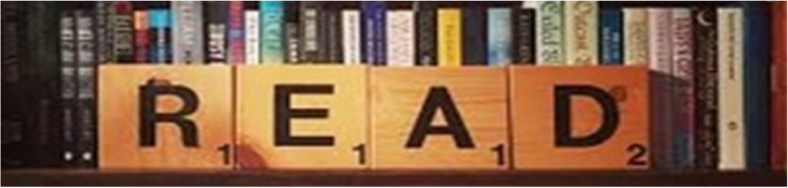

Wider reading list + Revision resources
Make sure you are reading a wide range of texts at home and use the Library in school to help support you when selecting a text to read.

Some useful revision resources you can use to help support your practice of the exam questions are below:

Literature Paper 1:
Mr Bruff’s YouTube Channel
https://www.youtube.com/user/mrbruff

Stacey Reay’s YouTube Channel
https://www.youtube.com/channel/UCJhuqpyhE8NzYZFkwTzi_7g

SENECA Learning
Log into your account and start quizzing!
https://senecalearning.com/en-GB/

MASSOLIT
Lectures and additional resources you can listen to
https://www.massolit.io/

Other tragedies by Shakespeare
Othello – a man is misled into thinking his beloved is cheating on him.
Hamlet – a prince is led into taking revenge on his Uncle.
King Lear – a King makes the wrong choice of heir and suffers.

Film adaptations
(be careful of plot changes!)

Macbeth (dir. Roman Polanski) 1971
Macbeth (dir. Justin Kurzel) 2016

