

Knowledge Organiser
Year 11: Additional English Unit 1
GCSE English Language Paper 1
Explorations in Creative Reading and Writing

Name:
Class:

Y11 Additional English Unit 1 Big Questions

The big question for the unit is: How do writers explore the idea of conflict?

Week 1 | - How can I effectively read and annotate a fiction text?  - How can I successfully analyse language methods used by a writer?
Week 2 | - How can I successfully analyse language methods used by a writer?  - How can I develop my appreciation and analysis of language?
Week 3 | - How can I identify structural features?  - How can I structure my writing to build tension?
Week 4 | - How can I structure my writing to build tension?  - How can I successfully analyse the structure of a fiction text?
Week 5 | - How can I critically evaluate?  - How does a writer use language to describe?
Week 6 | - How does a writer use structure to interest the reader?  - How can I develop my analysis of structure?
Week 7 | - How can I use figurative language to describe emotion?  - How can I structure my description to interest my reader?

Our study of English Language Paper 1 will follow the structure below:

AQA GCSE English Language Paper 1 Exam Details
AO1 | Pick out and understand pieces of explicit and implicit information from the text(s).  Collect and put together information from different texts.
AO2 | Explain how writers use language and structure to achieve their purpose and influence readers.  Use technical terms to support your analysis of language and structure.
AO3 | Identify different writers’ ideas and perspectives.  Compare the method used by different writers to convey their ideas.
AO4 | Critically evaluate texts, giving a personal opinion about how successful the writing is.  - Provide detailed evidence from the text to support your opinion.
AO5 | Write clearly and imaginatively, adapting your tone and style for various purposes and audiences.  Organise your writing into a clear structure.
AO6 | Use a wide variety of sentence structures and vocabulary, so that your writing is clear and purposeful.  - Write accurately, paying particular attention to spelling, punctuation and grammar.

 | Question | Time | Skills assessed
15 minutes reading time
Paper One  1hr 45mins | Q1: List four things…  4 marks | 5 minutes | AO1
Paper One  1hr 45mins | Q2: How does the writer use language…  8 marks | 10mins | AO2
Paper One  1hr 45mins | Q3: How does the writer use structure…?  8 marks | 10mins | AO2
Paper One  1hr 45mins | Q4: Statement and to what extent do you agree?  20 marks | 20mins | AO4
Paper One  1hr 45mins | Q5: Creative writing  40 marks | 45mins | AO5 and AO6

Question breakdowns

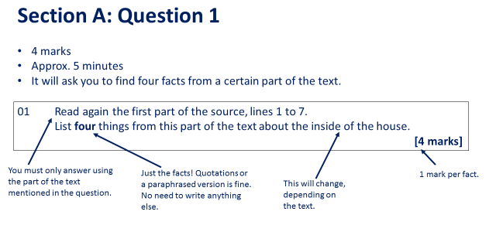

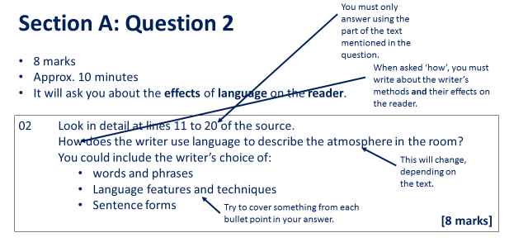

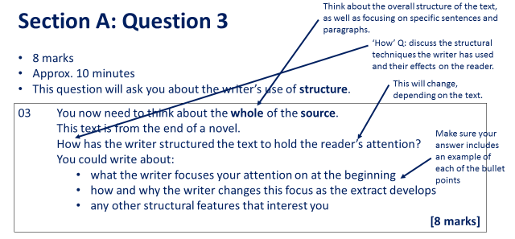
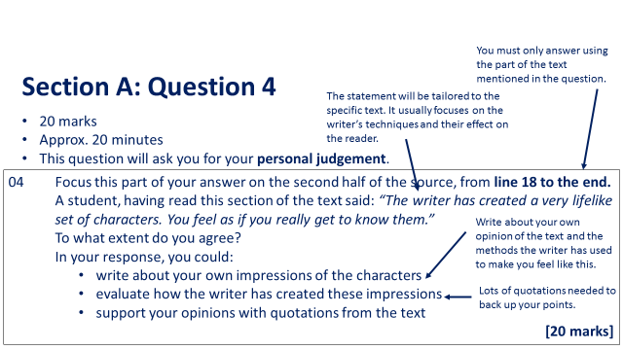

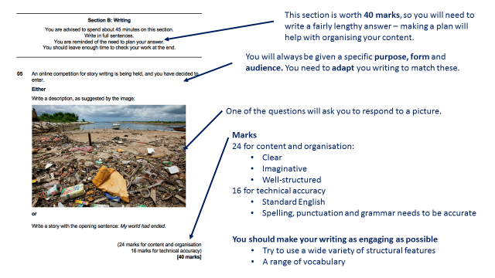

Key Terminology
 | Term | Definition
1 | Adjective | A word that is used to describe a noun. ‘The ugly man.’
2 | Adverb | A word that explains where, when or how something was done.
3 | Alliteration | When words start with the same sound or letter ‘Sammy sold seashells’
4 | Chronology | The arrangement of events in time order – or as they occurred in sequence.
5 | Climax | The height of the action in a text.
6 | Connotations | Ideas and feelings created by a word in additional to the main meaning.
7 | Exposition | The start of a story where the main ideas are presented (mood, setting, characters etc)
8 | Foreshadowing | Where a writer drops hints in the text at events to come later on.
9 | Imagery | Language in a text that helps create a visual image for the reader.
10 | Juxtaposition | Placing two images or ideas close together for the purpose of comparison similarity or contrast.
11 | Metaphor | A direct comparison of two things in which it is representative or symbolic of something else.
12 | Noun | A naming word of a person, place or thing.
13 | Personification | Giving an object human characteristics
14 | Pronoun | A word used to refer to a specific person or group instead of using the noun.
15 | Resolution | The ending of a story where the plot concludes
16 | Rising Action | A related series of incidents that build to the climax.
17 | Simile | A comparison of two things using the words ‘like’ and/or as’
18 | Semantic Field | When we have words that are all linked in meaning used to create a particular image/ feeling and keep this consistent in the mind of the reader
19 | Shift in Focus | When a writer deliberately crafts the text to draw our attention to something else.
20 | Verb | A word used to express an action or state/ a doing or being word.

Space for Additional Terminology

Mark schemes
Question 2
How does the writer use language to…?

AO2
Explain, comment on and analyse how writers use language and structure to achieve effects and influence readers, using relevant subject terminology to support their views.
This question assesses Language ie: Word/Phrases/Language Features/Language Techniques/Sentence Forms
Level | Skills Descriptors
Level 4  Perceptive, detailed analysis  7-8 marks | Shows perceptive and detailed understanding of language:  - Analyses the effects of the writer’s choices of language  - Selects a range of judicious textual details  - Makes sophisticated and accurate use of subject terminology
Level 3  Clear, relevant explanation  5-6 marks | Shows clear understanding of language  - Explains clearly the effects of the writer’s choice of language  - Selects a range of relevant textual detail  - Makes clear and accurate use of subject terminology
Level 2  Some understanding and comment  3-4 marks | Shows some understanding of language  - Attempts to comment on the effect of language  - Selects some appropriate textual details  - Makes some use of subject terminology, mainly appropriately
Level 1  Simple, limited comment  1-2 marks | Shows simple awareness of language  - Offers simple comment on the effect of language  - Selects simple reference(s) or textual detail(s)  - Makes some use of subject terminology, not always appropriately
Level 0  No marks | Nothing to reward

Question 3
How does the writer structure the text to engage you as the reader?

AO2
Explain, comment on and analyse how writers use language and structure to achieve effects and influence readers, using relevant subject terminology to support their views.
This question assesses how the writer has structured a text. Structural features can be: at a whole text level e.g., beginnings/endings/perspective shifts; at a paragraph level e.g. topic change/aspects of cohesion; and at a sentence level when judged to contribute to the whole structure.
Level | Skills Descriptors
Level 4  Perceptive, detailed analysis  7-8 marks | Shows perceptive and detailed understanding of structural features:  - Analyses the effects of the writer’s choices of structural features  - Selects a range of judicious examples  - Makes sophisticated and accurate use of subject terminology
Level 3  Clear, relevant explanation  5-6 marks | Shows clear understanding of structural features  - Explains clearly the effects of the writer’s choice of structural features  - Selects a range of relevant examples  - Makes clear and accurate use of subject terminology
Level 2  Some understanding and comment  3-4 marks | Shows some understanding of structural features  - Attempts to comment on the effect of structural features  - Selects some appropriate examples  - Makes some use of subject terminology, mainly appropriately
Level 1  Simple, limited comment  1-2 marks | Shows simple awareness of structural features  - Offers simple comment on the effect of structural features  - Selects simple reference(s) or example(s)  - Makes some use of subject terminology, not always appropriately
Level 0  No marks | Nothing to reward

Question 4:
To what extent do you agree?

AO4
Evaluate texts critically and support this with appropriate textual references
Level | Skills Descriptors
Level 4  Perceptive, detailed evaluation  16-20 marks | Shows perceptive and detailed evaluation:  - Evaluates critically and in detail the effect(s) on the reader  - Shows perceptive understanding of the writer’s methods  - Selects a range of judicious textual details  - Develops a convincing and critical response to the focus of the statement
Level 3  Clear, relevant evaluation  11-15 marks | Shows clear and relevant evaluation  - Evaluates clearly the effect(s) on the reader  - Shows clear understanding of the writer’s methods  - Selects a range of relevant textual references  - Makes a clear and relevant response to the focus of the statement
Level 2  Some evaluation  6-10 marks | Shows some attempts at evaluation  - Makes some evaluative comment(s) on effect(s) on the reader  - Shows some understanding of writer’s methods  - Selects some appropriate textual reference(s)  - Makes some response to the focus of the statement
Level 1  Simple, limited comment  1-5 marks | Shows simple, limited evaluation  - Makes simple, limited evaluative comment(s) on effect(s) on reader  - Shows limited understanding of writer’s methods  - Selects simple, limited textual reference(s)  - Makes a simple, limited response to the focus of the statement
Level 0  No marks | Nothing to reward

Question 5
Creative Writing Task

AO5 Content and Organisation
Communicate clearly, effectively and imaginatively, selecting and adapting tone, style and register for different forms, purposes and audiences.
Organise information and ideas, using structural and grammatical features to support coherence and cohesion of texts.
Level 4  19-24 marks  Compelling, Convincing Communication | Upper Level 4  22-24 marks | Content  - Communication is convincing and compelling  - Tone, style and register are assuredly matched to purpose and audience  - Extensive and ambitious vocabulary with sustained crafting of linguistic devices  Organisation  - Varied and inventive use of structural features  - Writing is compelling, incorporating a range of convincing and complex ideas  - Fluently linked paragraphs with seamlessly integrated discourse markers
Level 4  19-24 marks  Compelling, Convincing Communication | Lower Level 4  19-21 marks | Content  - Communication is convincing  - Tone, style and register are convincingly matched to purpose and audience  - Extensive vocabulary with conscious crafting of linguistic devices  Organisation  - Varied and inventive use of structural features  - Writing is compelling, incorporating a range of convincing and complex ideas  - Fluently linked paragraphs with seamlessly integrated discourse markers
Level 3  13-18 marks  Consistent, Clear Communication | Upper Level 3  16-18 marks | Content  - Communication is consistently clear  - Tone, style and register are clearly and consistently matched to purpose and audience  - Increasingly sophisticated vocabulary and phrasing, chosen for effect with a range of successful linguistic devices  Organisation  - Effective use of structural features  - Writing is engaging, using a range of clear, connected ideas  - Coherent paragraphs with integrated discourse markers
Level 3  13-18 marks  Consistent, Clear Communication | Lower Level 3  13-15 marks | Content  - Communication is generally clear  - Tone, style and register are generally matched to purpose and audience  - Vocabulary clearly chosen for effect and appropriate use of linguistic devices  Organisation  - Usually effective use of structural features  - Writing is engaging, with a range of connected ideas  - Usually coherent paragraphs with a range of discourse markers
Level 2  7-12 marks  Some successful Communication | Upper Level 2  10-12 marks | Content  - Communicates with some sustained success  - Some sustained attempt to match tone, style, register to purpose and audience  - Conscious use of vocabulary with some use of linguistic devices  Organisation  - Some use of structural features  - Increasing variety of linked and relevant ideas  - Some use of paragraphs and some use of discourse markers
Level 2  7-12 marks  Some successful Communication | Lower Level 2  7-9 marks | Content  - Communicates with some success  - Attempts to match tone, style and register to purpose and audience  - Begins to vary vocabulary with some use of linguistic devices  Organisation  - Attempts to use structural features  - Some linked and relevant ideas  - Attempt to write in paragraphs with some discourse markers, not always appropriate
Level 1  1-6 marks  Simple, Limited Communication | Upper Level 1  4-6 marks | Content  - Communicates simply  - Simple awareness of matching tone, style and register to purpose and audience  - Simple vocabulary; simple linguistic devices  Organisation  - Evidence of simple structural features  - One or two relevant ideas, simply linked  - Random paragraph structure
Level 1  1-6 marks  Simple, Limited Communication | Lower Level 1  1-3 marks | Content  - Limited communication  - Occasional sense of matching tone, style and register to purpose and audience  - Simple vocabulary  Organisation  - Limited or no evidence of structural features  - One or two unlinked ideas  - No paragraphs
Level 0  No marks | Students will not have offered any meaningful writing to assess.  Nothing to reward.

AO6 Technical Accuracy
Students must use a range of vocabulary and sentence structure for clarity, purpose and effect, with accurate spelling and punctuation. (This requirement must constitute 20% of the marks for each specification as a whole.)
Level | Skills Descriptors
Level 4  13-16 marks | - Sentence demarcation is consistently secure and consistently accurate  - Wide range of punctuation I used with a high level of accuracy  - Uses a full range of appropriate sentence forms for effect  - Uses Standard English consistently and appropriately with secure control of complex grammatical structures  - High level of accuracy in spelling, including ambitious vocabulary  - Extensive and ambitious use of vocabulary
Level 3  9-12 marks | - Sentence demarcation is mostly secure and mostly accurate  - Range of punctuation is used, mostly with success  - Uses a variety of sentence forms for effect  - Mostly uses Standard English appropriately with mostly controlled grammatical structures  - Generally accurate spelling, including complex and irregular words  - Increasingly sophisticated use of vocabulary
Level 2  5-8 marks | - Sentence demarcation is mostly secure and sometimes accurate  - Some control of a range of punctuation  - Attempts a variety of sentence forms  - Some use of Standard English with some control of agreement  - Some accurate spelling of more complex words  - Varied use of vocabulary
Level 1  1-4 marks | - Occasional use of sentence demarcation  - Some evidence of conscious punctuation  - Simple range of sentence forms  - Occasional use of Standard English with limited control of agreement  - Accurate basic spelling  - Simple use of vocabulary
Level 0  No marks | Students’ spelling, punctuation etc. is sufficiently poor to prevent understanding of meaning.

Homework Tasks.

Knowledge is power, so the more you know, the more secure you will be in your learning.

Year 11: Unit 1 Homework: Language Paper 1 – Explorations in Creative Reading and Writing
Task 1: | Due date:  WEEK 2 | - Read through the key vocabulary list on pages 6-7  - Copy out the definitions  - Practise the spellings of the key words by writing them out three times.  EXTENSION: Annotate the extract from Homework 2 with the key vocabulary
Task 3: | Due date:  WEEK 4 | - Read the Exam Paper for Homework 2  - Complete Q2 & Q3  - Use the exemplar from AQA that has been annotated by the examiner to help you  EXTENSION: Write the opening paragraph of a story where someone is scared.
Task 3: | Due date:  WEEK 6 | - Re-read the Exam Paper for Homework 2  - Complete Q4  - Use the exemplar from AQA that has been annotated by the examiner to help you  EXTENSION: Write the ending of a story either with a cliff-hanger or a resolution

If you have ‘no homework’, or you have finished all of the above, try these tasks on a weekly basis to ensure your understanding is secure.
- Use the Wider Reading page on the back of the Knowledge Organiser and download some more practice papers from AQA.
- Complete all of the Extension tasks on the homework.
- Add words to your key terminology grid on page 7 of the Knowledge Organiser
- Read for at least 20 minutes per day – a mixture of fiction and non-fiction texts.
- Use YouTube and Mr Bruff revision videos for English Language and English Literature to revise key content for your exams.

Homework 1 – spellings and definitions of key terms
 | Term | Copy out the spelling three times and copy the definition from page 6-7
1 | Adjective
 | Definition of adjective
2 | Adverb
 | Definition of adverb
3 | Alliteration
 | Definition of alliteration
4 | Chronology | .
Definition of
chronology
5 | Climax
Definition of
climax
6 | Connotations
 | Definition of connotations
7 | Exposition
Definition of
exposition
8 | Foreshadowing
 | Definition of foreshadowing
9 | Imagery
 | Definition of imagery
10 | Juxtaposition
 | Definition of juxtaposition
11 | Metaphor
 | Definition of metaphor
12 | Noun
 | Definition of noun
13 | Personification
 | Definition of personification
14 | Pronoun
 | Definition of pronoun
15 | Resolution
 | Definition of resolution
16 | Rising Action
 | Definition of rising action
17 | Simile
 | Definition of simile
18 | Semantic Field
 | Definition of semantic field
19 | Shift in Focus | .
 | Definition of shift in focus
20 | Verb
 | Definition of verb

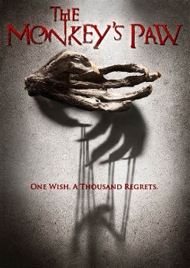
Homework 2

Read the exam Paper Extract Below.

SOURCE A
In this extract, from The Monkey’s Paw, an elderly couple are grieving the death of their son in an accident at work a week earlier. The wife has demanded her husband use a talisman from India – a monkey’s paw - with reputed magical powers to grant its owner three wishes. She has asked her husband to wish their son, Herbert, alive again.

He went down in the darkness, and felt his way to the sitting room, and then to the mantelpiece. The monkey’s paw was in its place, and a horrible fear that the unspoken wish might bring his mutilated son before him before he could escape from the room seized upon him, and he caught his breath as he found that he had lost the direction of the door. His brow cold with sweat, he felt his way round the table, and groped along the wall until he found himself in the small passage with the dreadful thing in his hand. Even his wife's face seemed changed as he entered the room. It was white and hopeful, and to his fears seemed to have an unnatural look upon it. He was afraid of her.
"Wish!" she cried, in a strong voice.
"It is foolish and wicked," he faltered.
"Wish!" repeated his wife.
He raised his hand. "I wish my son alive again."
The monkey’s paw fell to the floor, and he regarded it fearfully. Then he sank trembling into a chair as the old woman, with burning eyes, walked to the window and raised the blind. He sat until he was chilled with the cold, glancing occasionally at the figure of the old woman peering through the window. The candle end, which had burnt below the rim of the china candlestick, was throwing pulsating shadows on the ceiling and walls, until, with a flicker larger than the rest, it expired. The old man, with an unspeakable sense of relief at the failure of the monkey’s paw, crept back to his bed, and a minute or two afterward the old woman came silently beside him. Neither spoke, but both lay silently listening to the ticking of the clock. A stair creaked. A squeaky mouse scurried noisily through the wall. The darkness was oppressive. After lying for some time screwing up his courage, the husband took the box of matches, and striking one, went downstairs for a candle.
At the foot of the stairs the match went out, and he paused to strike another, and at the same moment a knock, so quiet and stealthy as to be scarcely audible, sounded on the front door. The matches fell from his hand. He stood motionless, his breath suspended until the knock was repeated. Then he turned and fled swiftly back to his room, and closed the door behind him. A third knock sounded through the house.
"What's that?" cried the old woman, starting up.
"A rat," said the old man, in shaking tones-- "a rat. It passed me on the stairs."
His wife sat up in bed listening. A loud knock resounded through the house.
"It's Herbert!" she screamed. "It's Herbert!"
She ran to the door, but her husband was before her, and catching her by the arm, held her tightly.
"What are you going to do?" he whispered hoarsely.
"It's my boy; it's Herbert!" she cried, struggling mechanically. "I forgot it was two miles away. What are you holding me for? Let go. I must open the door."
"For God's sake, don't let it in," cried the old man trembling.
"You're afraid of your own son," she cried, struggling. "Let me go. I'm coming, Herbert; I'm coming."
There was another knock, and another. The old woman with a sudden wrench broke free and ran from the room. Her husband followed to the landing, and called after her appealingly as she hurried downstairs. He heard the chain rattle back and the bottom bolt drawn slowly and stiffly from the socket. Then the old woman's voice, strained and panting. "The bolt," she cried loudly. "Come down. I can't reach it."
But her husband was on his hands and knees groping wildly on the floor in search of the paw. If he could only find it before the thing outside got in. A series of deafening knocks echoed through the house, and he heard the scraping of a chair as his wife put it down in the passage against the door. He heard the creaking of the bolt as it came slowly back, and at the same moment he found the monkey's paw, and frantically breathed his third and last wish.
The knocking ceased suddenly, although the echoes of it were still in the house. He heard the chair drawn back and the door opened. A cold wind rushed up the staircase, and a long loud wail of disappointment and misery from his wife gave him courage to run down to her side, and then to the gate beyond. The street lamp flickering opposite shone on a quiet and deserted road.

Q2. Look in detail at this extract from lines 12-21.
The monkey’s paw fell to the floor, and he regarded it fearfully. Then he sank trembling into a chair as the old woman, with burning eyes, walked to the window and raised the blind. He sat until he was chilled with the cold, glancing occasionally at the figure of the old woman peering through the window. The candle end, which had burnt below the rim of the china candlestick, was throwing pulsating shadows on the ceiling and walls, until, with a flicker larger than the rest, it expired. The old man, with an unspeakable sense of relief at the failure of the monkey’s paw, crept back to his bed, and a minute or two afterward the old woman came silently beside him. Neither spoke, but both lay silently listening to the ticking of the clock. A stair creaked. A squeaky mouse scurried noisily through the wall. The darkness was oppressive. After lying for some time screwing up his courage, the husband took the box of matches, and striking one, went downstairs for a candle.

How does the writer use language to describe the man?
You could include the writer’s choice of:
- Words and phrases
- Language features and techniques

Write your answer below. Remember to use WHAT HOW WHY.

_______________________________________________________________________________________________________________________________________________________________________________________________________________________________________________________________________________________________________________________________________________________________________________________________________________________________________________________________________________________________________________________________________________________________________________________________________________________________________________________________________________________________________________________________________________________________________________________________________________________________________________________________________________________________________________________________________________________________________________________________________________________________________________________________________________________________________________________________________________________________________________________________________________________________________________________________________________________________________________________________________________________________________________________________________________________________________________________________________________________________________________________________________________________________________________________________________________________________________________________________________________________________________________________________________________________________________________________________________________________________________________________________________________________________________________________________________________________________________________________________________________________________________________________________________________________________________________________________________________________________________________________________________________________________________________________________________________________________________________________________________________________________________________________________________________________________________________________________________________________________________________________________________________________________________________________________________________________________________________________________________________________________________________________________________________________________________________________________________________________________________________________________________________________________________________________________________________________________________________________________________________________________________________________________________________________________________________________________________________________________________________________________________________________________________________________________________________________________________________________________________________________________________________________________________________________________________________________________________________________________________________________________________________________________________________________________________________________________________________________________________________________________________________________________________________________________________________________________________________________________________________________________________________________________________________________________________________________________________________________________________________________________________________________________________________________________________________________________________________________________________________________________________________________________________________________________________________________________________________________________________________________________________________________________________________________________________

Q3. You now need to think about the whole of the source.

How has the writer structured the text to interest you as a reader?

You could write about:
- What the writer focuses your attention on at the beginning of the source
- How and why the writer changes this focus as the source develops
- Any other structural features that interest you
[8 marks – 10 minutes]

Write your answer below. Remember to use WHAT HOW WHY.

______________________________________________________________________________________________________________________________________________________________________________________________________________________________________________________________________________________________________________________________________________________________________________________________________________________________________________________________________________________________________________________________________________________________________________________________________________________________________________________________________________________________________________________________________________________________________________________________________________________________________________________________________________________________________________________________________________________________________________________________________________________________________________________________________________________________________________________________________________________________________________________________________________________________________________________________________________________________________________________________________________________________________________________________________________________________________________________________________________________________________________________________________________________________________________________________________________________________________________________________________________________________________________________________________________________________________________________________________________________________________________________________________________________________________________________________________________________________________________________________________________________________________________________________________________________________________________________________________________________________________________________________________________________________________________________________________________________________________________________________________________________________________________________________________________________________________________________________________________________________________________________________________________________________________________________________________________________________________________________________________________________________________________________________________________________________________________________________________________________________________________________________________________________________________________________________________________________________________________________________________________________________________________________________________________________________________________________________________________________________________________________________________________________________________________________________________________________________________________________________________________________________________________________________________________________________________________________________________________________________________________________________________________________________________________________________________________________________________________________________________________________________________________________________________________________________________________________________________________________________________________________________________________________________________________________________________________________________________________________________________________________________________________________________________________________________________________________________________________________________________________________________________________________________________________________________________________________________________________________________________________________________________________________________________________________________________________________________________________________________________________________________________________________________________________________________________________________________________________________________________________________________________________________________________________________________________________________________________________________________________________________________________________________________________________________________________________________________________________________________________________________________________________________________________________________________________________________________________________________________________________________________________________________________________________________

Exemplar answer from AQA: Q2

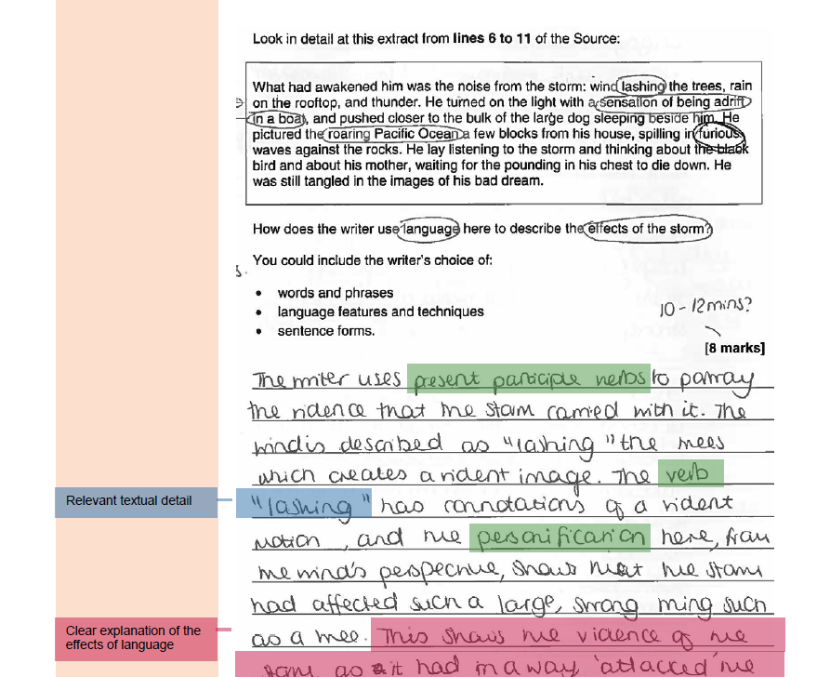

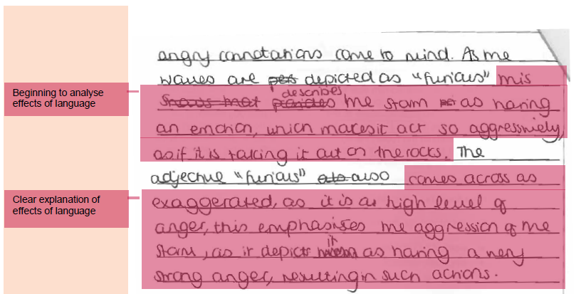

Exemplar answer from AQA: Q3

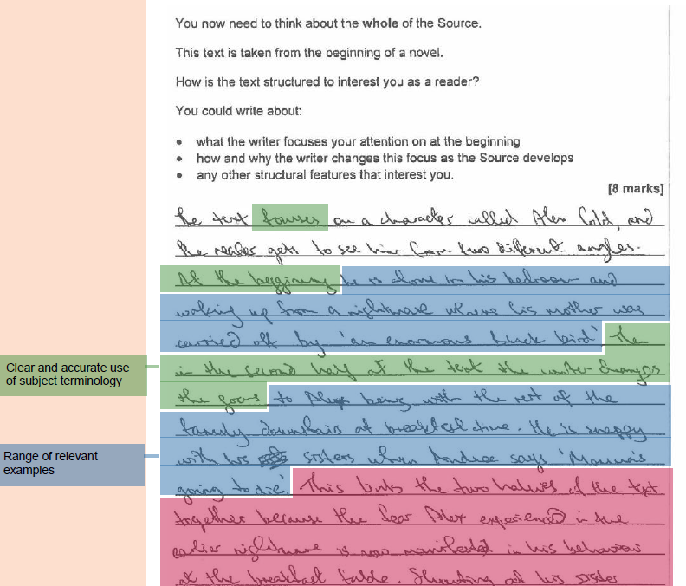

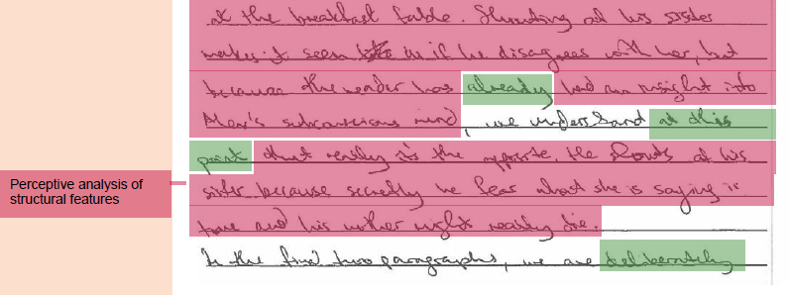

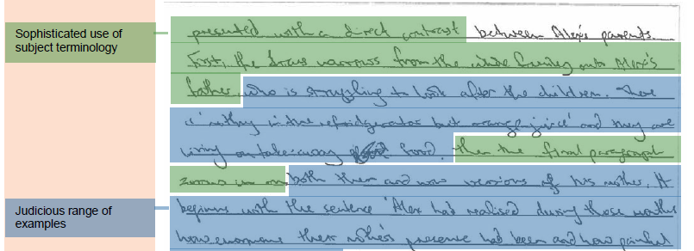

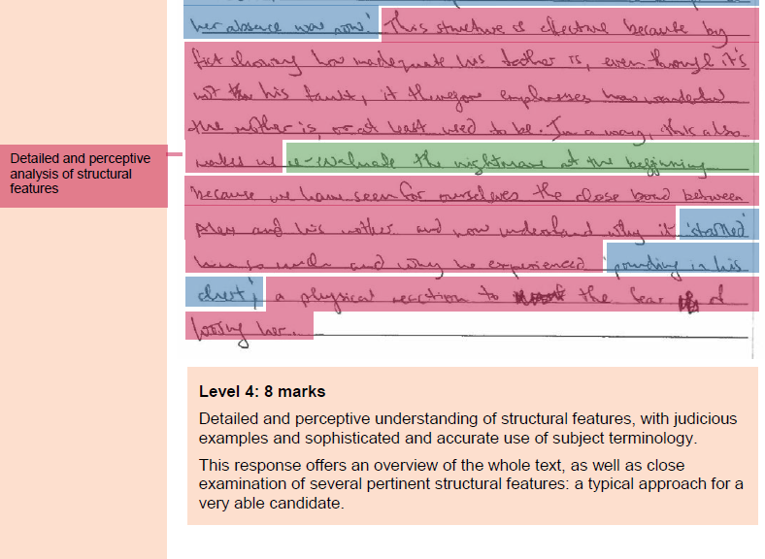

Extension Tasks for Homework 2
Complete the opening of a Q5 Creative Writing task using the extract you have just read from The Monkey’s Paw as inspiration.

Q5. Write the opening of a story where someone is scared.

(24 marks for content and organisation
16 marks for technical accuracy)
[40 marks – 45 minutes]

________________________________________________________________________________________________________________________________________________________________________________________________________________________________________________________________________________________________________________________________________________________________________________________________________________________________________________________________________________________________________________________________________________________________________________________________________________________________________________________________________________________________________________________________________________________________________________________________________________________________________________________________________________________________________________________________________________________________________________________________________________________________________________________________________________________________________________________________________________________________________________________________________

Homework 3
Q4. Focus this part of your answer on the second part of the source, from line 22 to the end.

A student who read this extract commented “This part of the text builds tension and highlights the man’s fear. He does not want to open the door.’

To what extent do you agree?

In your response, you could:
- Consider your own impressions of the tension
- Evaluate how the writer presents the tension and the man’s feelings
- Support your response with references to the text
[20 marks – 20 minutes]

Write your answer below. Remember to use WHAT HOW WHY. And write 3 clear paragraphs giving reasons why you agree/ disagree.

_________________________________________________________________________________________________________________________________________________________________________________________________________________________________________________________________________________________________________________________________________________________________________________________________________________________________________________________________________________________________________________________________________________________________________________________________________________________________________________________________________________________________________________________________________________________________________________________________________________________________________________________________________________________________________________________________________________________________________________________________________________________________________________________________________________________________________________________________________________________________________________________________________________________________________________________________________________________________________________________________________________________________________________________________________________________________________________________________________________________________________________________________________________________________________________________________________________________________________________________________________________________________________________________________________________________________________________________________________________________________________________________________________________________________________________________________________________________________________________________________________________________________________________________________________________________________________________________________________________________________________________________________________________________________________________________________________________________________________________________________________________________________________________________________________________________________________________________________________________________________________________________________________________________________________________________________________________________________________________________________________________________________________________________________________________________________________________________________________________________________________________________________________________________________________________________________________________________________________________________________________________________________________________________________________________________________________________________________________________________________________________________________________________________________________________________________________________________________________________________________________________________________________________________________________________________________________________________________________________________________________________________________________________________________________________________________________________________________________________________________________________________________________________________________________________________________________________________________________________________________________________________________________________________________________________________________________________________________________________________________________________________________________________________________________________________________________________________________________________________________________________________________________________________________________________________________________________________________________________________________________________________________________________________________________________________________________________________________________________________________________________________________________________________________________________________________________________________________________________________________________________________________________________________________________________________________________________________________________________________________________________________________________________________________________________________________________________________________________________________________________________________________________________________________________________________________________________________________________________________________________________________________________________________________________________________________________________________________________________________________________________________________________________________________________________________________________________________________________________________________________________________________________________________________________________________________________________________________________________________________________________________________________________________________________________________________________________________________________________________________________________________________________________________________________________________________________________________________________________________________________________________________________________________________________________________________________________________________________________________________________________________________________________________________________________________________________________________________________________________________________________________________________________________________________________________________________________________________________________________________________________________________________________________________________________________________________________________________________________________________________________________________________________________________________________________________________________________________________________________________________________________________________________________________________________________________________________________________________________________________________________________________________________________________________________________________________________________________________________________________________________________________________________________________________________________________________________________________________________________________________________________________________________________________________________________________________________________________________________________________________________________________________________________________________________________________________________________________________________________________________________________________________________________________________________________________________________________________________________________________________________________________________________

Exemplar answer from AQA: Q4

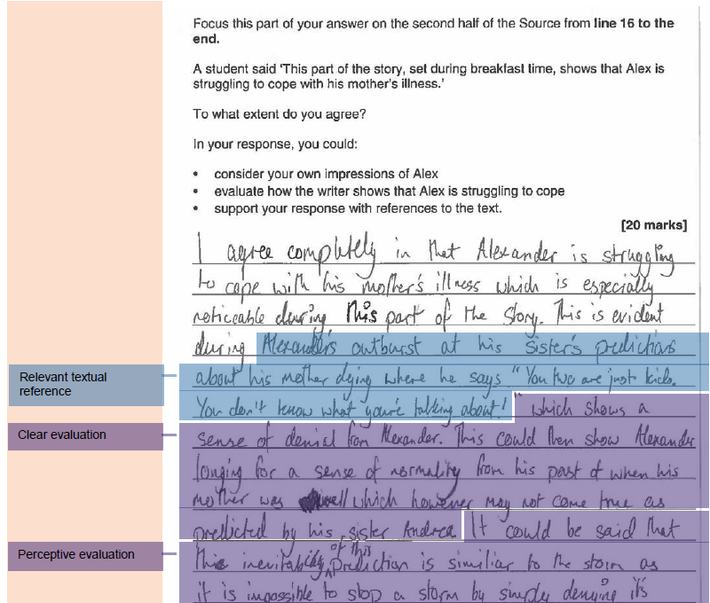

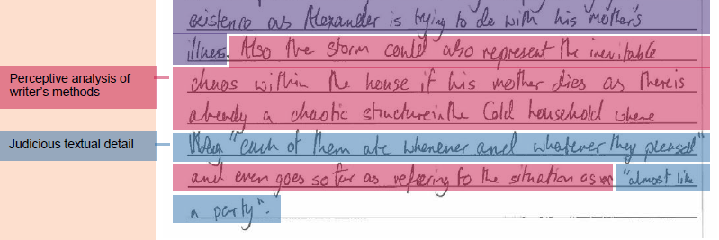

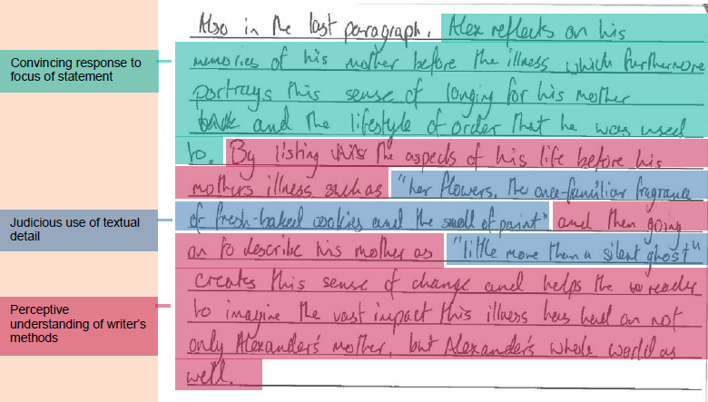

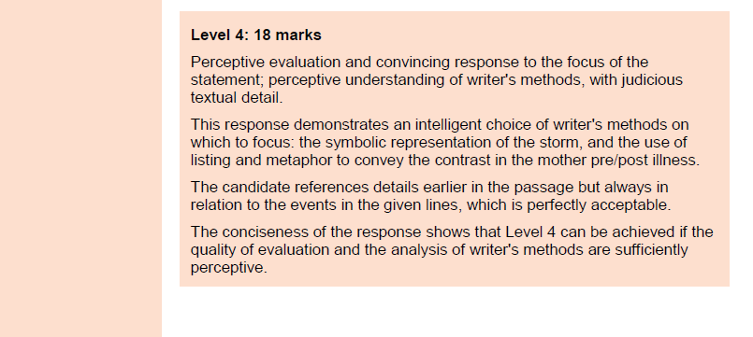

Extension Task for Homework 3
Complete an additional practice Q5 Creative Writing task using the extract you have just read from The Monkey’s Paw as inspiration.

Q5. Write the ending of a story where someone is scared. Either end it on a cliff-hanger or end with a resolution.

(24 marks for content and organisation
16 marks for technical accuracy)
[40 marks – 45 minutes]

________________________________________________________________________________________________________________________________________________________________________________________________________________________________________________________________________________________________________________________________________________________________________________________________________________________________________________________________________________________________________________________________________________________________________________________________________________________________________________________________________________________________________________________________________________________________________________________________________________________________________________________________________________________________________________________________________________________________________________________________________________________________________________________________________________________________________________________________________________________________________________________________________

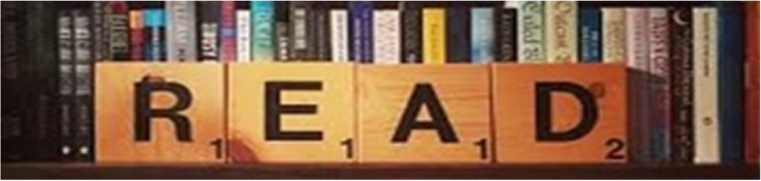

Wider reading list + Revision resources
This unit is all about your ability to read for meaning.
Make sure you are reading a wide range of Fiction texts at home and use the Library in school to help support you when selecting a text to read.

Some useful revision resources you can use to help support your practice of the exam questions are below:

Mr Bruff’s YouTube Channel
Language Paper 1 Playlist – lots of useful videos and resources for you to use here
https://www.youtube.com/playlist?list=PLqGFsWf-P-cAlttmXkEvJXCxqT-ZzFqAN

AQA English Language Past Papers
Language Paper 1 samples for you to practice with – lots of resources for home study
https://www.aqa.org.uk/subjects/english/gcse/english-language-8700/assessment-resources?f.Component%7C7=Paper+1

Stacey Reay’s YouTube Channel
Language Paper 1 Playlist – lots of useful videos and resources for you to use here
https://www.youtube.com/playlist?list=PLQE65hp6MwUpHmFqAJxsqvQZtdceH9D-J

AQA English Revision – website
Some good tips and practice questions can be found here
https://www.aqaenglishrevision.com/lang-paper-1

