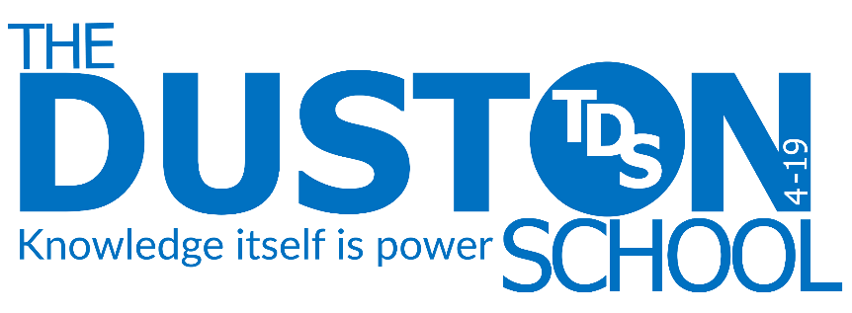
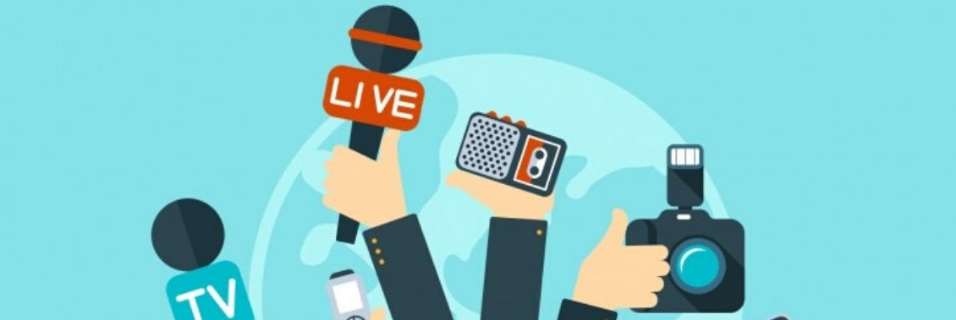

Class:
Name:
Year 10 Media
Knowledge Booklet

Term 2

Knowledge Organiser - GCSE Media Studies – Term 2
- Magazines
Big Questions
- What is print media?
- What are the key terms and conventions in relation to the topic of magazines?
- How can key concepts from the previous topic of Film and Film Marketing be applied to the topic of magazines?
- How can we effectively deconstruct a text through annotations?
- To explore the explicit and implicit meaning of cover images and key images.
- How do magazines target and gratify their core buyer?
- How are magazines and feature pages constructed to appeal to audiences?
- How can Uses and Gratifications Theory (UGT) be used to explain why audiences buy magazines?
- What are colour connotations?

- What are the key elements of the history of the magazine/fashion industry and how does it help our understanding of social, cultural and technological contexts?
- How are groups represented differently in different in magazines? (eg. How does the representation of gender or ethnicity differ between magazines?)
- How are groups and issues represented on the covers of GQ Magazine and Vogue Magazine (set products)?
SET PRODUCT 1: Vogue Magazine (July 2021)
SET PRODUCT 2: GQ Magazine (August 2019)

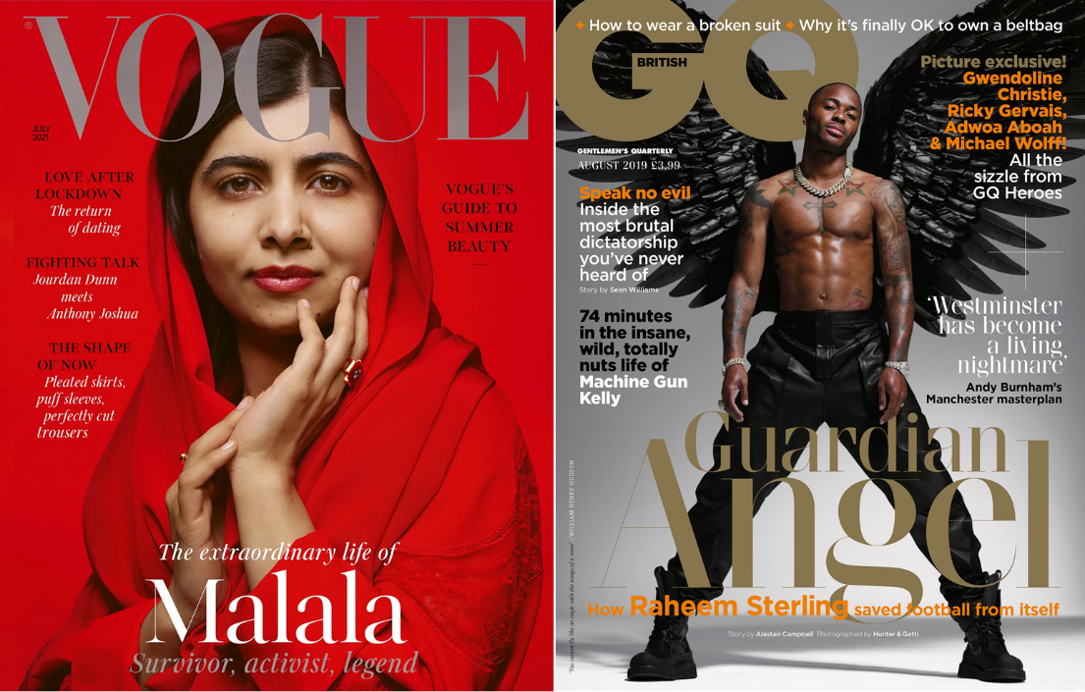

MEDIA STUDIES: MAGAZINE TERMINOLOGY
Institution  A type of industry within the media. E.g. Magazine or Film. | Mise-en-scene  Everything used within an image. Eg. Props, costume, etc. | Colourisation  Colour choices made by the magazine.
Non-verbal Communication  The meaning created by an image through facial expression, pose or symbolically. | General Interest Magazines  Non-specific magazines containing content on a number of topics (lifestyle magazines). E.g. Country Living Magazine. | Specialist Magazines  Magazines created around a specific topic for a niche audience. E.g. Grand Designs Magazine.
Masthead  The iconic design, colour and font of the title at the top of the magazine. | Coverline  Main story headlines on the magazine cover. Eg. MAN UP! | Strapline  Brief description of coverline directly under it. Eg. How to be a man in 2016
Pull Quote  A key quote taken from an article or interview and blown up. | Typography  Font choices made by the magazine. | House Style  Recurring theme or styles in magazines, including colour schemes and typography.
Mainstream Market  A target audience of most people. | Niche Market  A target audience of a few, specific people. | Key Image  The main image or most important/relevant to a story.
Direct Address  Speaking to or looking directly at the reader. | Anchorage  Key ideas linked to other things. Eg. The term ‘pride’ has several meanings anchored to it. | Explicit Meaning  Literal, obvious or surface meaning (denotation).
Implicit Meaning  Less obvious, deeper or implied meaning (connotation). | Core Buyer  A specific description of the typical person who buys a product. | Logo  The symbol or other small design adopted by an organisation for its product.
Left Third  The left side of a magazine cover, typically left visible on a shop shelf or coffee table. | Z-Layout  The idea that in Western culture we read from left-right and up-down. Therefore, texts/product layouts are made accordingly. | Feature Article  Any article featured in a magazine.

SET PRODUCT 1: GQ Front Cover (August 2019)

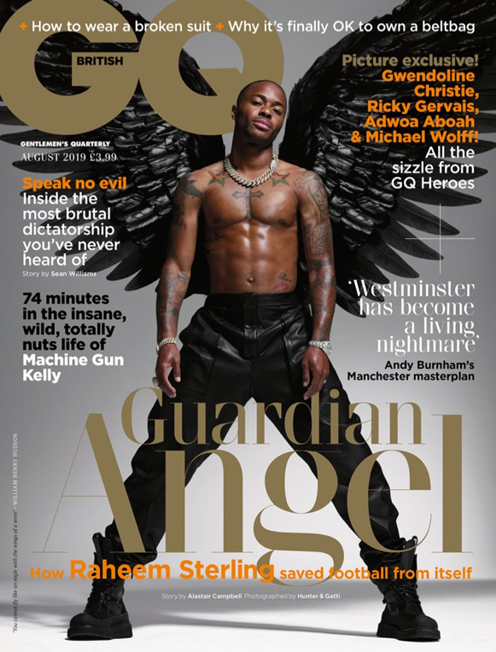

GCSE Component 1: Exploring the Media
Focus areas:
• Media language
• Representation
• Media contexts
THE PRODUCT
Launched in 1931, GQ began its life as quarterly publication called Gentleman’s Quarterly, aimed specifically at fashion industry insiders. Its popularity with customers caused its rebranding in 1967 to GQ.
• Produced by Condé Nast, today GQ is a multiplatform brand. Each issue is published in print and digitally; it has its own acclaimed website and apps.
• Published monthly, British GQ sells itself as “The greatest magazine around. The men’s magazine with an IQ. Whether it’s fashion, sport, health, humour, politics or music, GQ covers it all with intelligence and imagination.”
• GQ is aimed at ABC1 men aged between 20 and 44, has a 212,000 monthly print readership, with online boasting over 2 million monthly unique users, and more than 2 million social media followers.
• Funded by magazine sales and advertising, GQ says that 88% of its audience have bought or plan to buy products they’ve seen in GQ and 93% of GQ’s audience own designer fashion.
PART 1: STARTING POINTS – Media language
How media language creates and communicates meaning
The typical codes and conventions of print magazines are used here to construct the GQ front cover:
• The branded masthead is conventionally placed in the top left-hand corner (Z-rule) and stands out with the choice of gold font, connoting luxury and exclusivity – traits that the brand associates with.
The limited colour palette of black, white, gold and orange create a sense of cohesion to the design, whilst also reinforcing the magazines messages of luxury, sophistication and masculinity.
• There is a long shot of footballer and celebrity Raheem Sterling, ensuring the magazine has star appeal for the audience.
• The cover price further reinforces this is a print magazine aimed at an ABC1 audience with disposable income.
• Consider the selection process that took place when creating this magazine cover – there was clearly a conscious decision to aim it at men who are interested in fashion, celebrity, politics, music and sport.
• Sterling is looking directly at the audience, seemingly making eye contact. This is a common convention of magazines and helps to add to the more personal approach of this format. His cool, relaxed gaze and slight smile looks down at the reader, suggesting he should be admired, looked up to.
• Sterling’s leather combat trousers and boots are more high fashion than practical and connote luxury and masculinity, whilst also indicating to readers that GQ is a lifestyle magazine.
• Sterling’s professional role as a footballer is anchored in the main cover line “Guardian Angel. How Raheem Sterling saved football from itself”. GQ calls Sterling a “Guardian Angel”, which has multiple connotations, including a sense of guidance and protection, suggesting he is looking after players and the values of the game by rooting out racism. The idea that he is doing morally good work is reinforced through his black angel wings and cross tattoo. This also frames him as a Proppian Hero, which is conventional for magazine cover stars.
• The top cover lines “How to wear a broken suit” and “Why it’s finally OK to own a belt bag” should be considered when thinking about the magazine’s target audience. In today’s competitive society, which focuses heavily on aesthetics and where having the ‘right’ look is apparently very important, the reader begins to yhink of this magazine as a casual ‘how to’ guide when it comes to being a fashionable man.
At the top right of the page, there is another cover line advertising a picture special from ‘GQ Heroes’. “All the sizzle” implies gossip and celebrity intrigue, while the term “exclusive” suggests the reader won’t be able to find it anywhere else and they need to purchase the magazine to be in on the secrets.
On the right-hand side of the page the reader is offered some politics, “Westminster has become a living nightmare. Andy Burnham’s Manchester masterplan.” This hyperbolic language is a reference to the elected Mayor of Manchester, Andy Burnham, who is calling for more devolved power to be given to cities rather than held by the government in London. By including some serious journalism, as well as entertainment and fashion advice, the magazine is broadening its offering for its audience members.
Possible areas for further investigation:
• Genre: codes and conventions of magazine covers – layout, house style, by-lines. Genre conventions of magazines, their ever-changing nature and hybridity.
• Narrative: cover lines on the front cover tease people to want to read certain stories within the magazine (could be linked to Roland Barthes’ enigma codes), for example “Speak no evil. Inside the most brutal dictatorship you’ve never heard of.”
PART 2: STARTING POINTS – Representation and contexts
Social, cultural and historical contexts:
• Historically, British black men have been underrepresented on magazine front covers due to systemic racism within the industry. In a 2018 study, completed by The Guardian, into glossy magazines, it was revealed that of 214 covers published by the 19 bestselling glossies in 2017, only 20 featured a person of colour. That’s 9.3%, whereas 13.7% of the UK are BAME. Of all the mainstream media outlets there has arguably been the smallest shift in magazine front covers representing a diverse range of people. However, sister magazine at Conde Nast, Vogue appointed editor Edward Enninful in 2017. He has turned one of the nation’s most respected fashion magazines into a celebration of all beauty – not excluding blackness but championing it. This, alongside the 2020 global anti-racism protests, has meant that recently there has been a wider range of ethnicities and races on the front of British GQ.
In 1994, Mark Simpson – an author and journalist – coined the word ‘Metrosexual’. He is famously quoted as saying “I had seen the future of masculinity and it was moisturised.” In the early 2000s it became more socially acceptable for men to openly care about their looks, clothing and skincare regime. Men’s magazines embraced this through their content and advertising and according to the magazine, 80% of its readers buy at least one male grooming product per month. In 2014, Simpson then introduced the term ‘spornosexuals’, men who are extremely body focused. The selection of the GQ cover shot, with Sterling’s six-pack and muscles on show, even though he is a footballer, supports this concept.
In December 2018, Raheem Sterling took to social media to highlight racism in the British press. Sterling screen-grabbed two MailOnline articles, which juxtaposed how his Manchester City teammates (Phil Foden and Tosin Adarabioyo) had been treated for buying their mums a house. Sterling used his platform to highlight this racial inequality in response to personally receiving racist abuse on the pitch from fans. That same week in 2018 saw a Tottenham Hotspur supporter arrested for throwing a banana skin at Pierre-Emerick Aubameyang and Motherwell’s Christian Mbulu received racial abuse. Since the social media post, Sterling has become a soughtafter spokesperson for charities, activists and other social causes. Gary Lineker has called him “perhaps the most influential player in the game” off-field. The full GQ article by Alistair Campbell can be read on GQ.co.uk for free.
GQ Heroes is an event aimed at “luxury business and creative minds”. Held annually in Oxfordshire, it has a programme of speakers “who are shaping society and culture around us”.
Representations of ethnicity and gender:
• Using a hugely successful black cover star (Raheem Sterling is British Jamaican) as their dominant image, GQ is presenting a role model for its readers, someone to aspire to be like. Although Sterling’s sporting success might be outside of most reader’s possibilities, his work ethic, principles and desire to want to better himself is not.
• The choice to represent Sterling topless with his tattoos on show reinforces the stereotype of men as having to be hyper masculine, strong and muscular. The tattoos themselves represent different aspects of his identity – the cross on his chest illustrates his Christian faith, while the baby on his arm represents him as a father. The black wings represent him as a supernatural figure suggesting his extraordinary skills on the pitch. The wings, combined with the main cover line “Guardian Angel” and the low angle shot construct him as a protective figure, fighting for justice. His wide stance and the choice of costume represent him as a dominant, confident figure. Meanwhile the thick silver jewellery and watch represent his wealth and modern masculinity.
• The main cover line reads, “How Raheem Sterling saved football from itself”. The reader understands this to mean that he is a success on a much grander scale than just the pitch; he is an influencer. His thick silver jewellery reinforces the capitalist ideology that for a man to be thought of as successful you must be wealthy and make a lot of money.
• All the men named on the cover are represented as successful in their own field, which conforms to the genre conventions of glossy magazines. Andy Burnham (white British) is framed as having a “masterplan” for Manchester representing men as clever, powerful and forward-thinking. This is juxtaposed with the representation of Machine Gun Kelly (white American), whose life is described as “insane, wild and totally nuts”, however this extreme lifestyle is more what the reader would expect from a rapper than a politician, so the cover lines serve to reinforce our preconceived ideas of these roles. The Machine Gun Kelly cover line is not judgemental, but celebratory, inviting readers in to see what his apparently crazy life is like.
• For modern men, there is a societal expectation that they must ‘have it all’ – health, wealth and strength – and the image of Sterling supports this as he epitomizes all three. Also, just like their female counterparts, the very essence of men’s lifestyle magazines is consumerism and so the images and cover lines will always seek to support this, informing men of what they supposedly need, “How to wear a broken suit” and also showing them what to covet, “Why it’s finally ok to wear a belt bag”. This is like the female lifestyle magazines that tell their readers how to be beautiful, get fit and dress well. The importance of body image and consumerism doesn’t change just because of gender.
Areas for further investigation:
• The choice of the two women – Gwendoline Christie and Adwoa Aboah – represented on the front cover.
- The changing perception of tattoos in media representations.

SET PRODUCT 2: Vogue Magazine (July 2021)
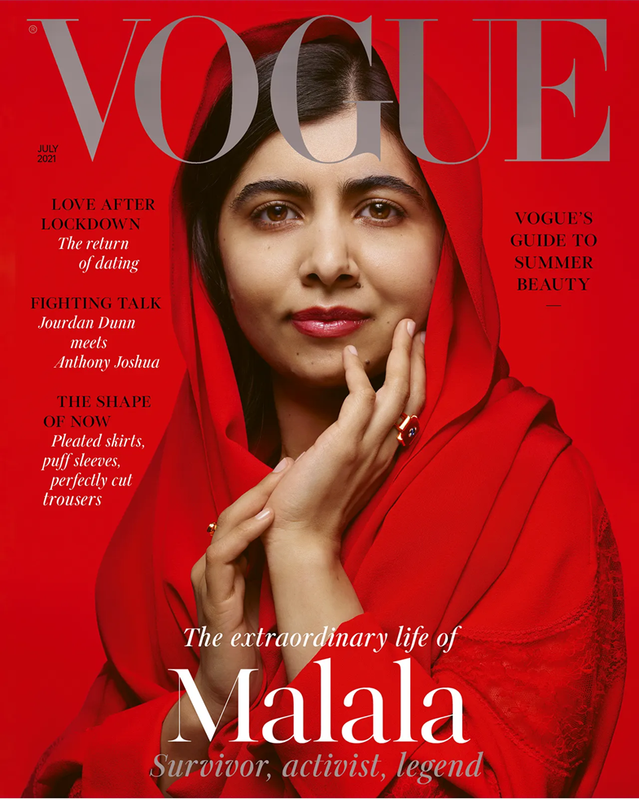

PRODUCT CONTEXT

• Vogue was first issued in New York in 1892 a high society diary before it was bought by American publisher Conde Nast in 1905. Conde Nast made it into a women’s fashion magazine, though still aimed at the upper classes. They also created different overseas versions: British
Vogue was launched in 1916.

• Vogue is still produced by Conde Nast and continues to be successful in the UK, despite dwindling print sales in the magazine marketplace. Edward Enninful was appointed editor in December 2017. A former model, he brought with him a strong social media following. He has made some important changes to the content and representations featured in the magazine, which have not only increased digital subscriptions and stabilised print sales of the magazine but have also influenced significant changes in the wider magazine marketplace. In 2021, British Vogue had an average circulation figure of 191,000 issues of the print magazine each month. Vogue claims to have 5.3 million digital subscriptions and a social media following of 14.3 million.

• Vogue is classed as a glossy, monthly, women’s lifestyle consumer magazine.

“British Vogue is the authority on fashion, beauty and lifestyle, and is a destination for women to learn, be challenged, inspired and empowered. Under
Edward Enninful’s unmatched global editorial status, British Vogue has become the undisputed Fashion Bible in the United Kingdom and is leading the cultural zeitgeist worldwide, powered by purpose.”

• Vogue is aimed at ABC1 fashion and style conscious women who are educated, sophisticated and wealthy. Whilst it traditionally targeted an older female audience of 30–45-yearolds, you could say that this audience has now broadened to appeal to, inspire and empower younger readers too, as well as a much more culturally diverse audience, under the influence of the new editor.

• Vogue is still hugely dependent on advertising revenue. Most of its pages are adverts for high-end consumer brands. To appeal to advertisers, Vogue emphasises the wealth and status of its ABC1 readership who spend an average of £8k a year on fashion and over a thousand pounds a year on cosmetics.

Media language

How media language creates and communicates meaning:

Vogue is a mainstream magazine, so it uses the typical codes and conventions of print to construct the front cover. Over a long period of time, Vogue has also acquired its own unique house style so that its brand identity is instantly recognisable.

• The same classic Didot font has been used for the VOGUE masthead since the 1950s; perhaps it is now better known as the Vogue font. The all-uppercase serif font gives it a classic, architectural look, an aesthetic that commands respect. Tall, slim and sculpted, the letters proclaim their own statuesque style. The word vogue means something that is trendy or popular.

• The VOGUE masthead is always capitalized and centrally placed, like a banner across the top of the magazine. In this edition, the masthead is laid over the forehead of the cover model, Malala Yousafzai. Perhaps she is an unlikely cover model for a fashion magazine, but this effect immediately anchors her as a Vogue star, in combination with her caption: ‘Survivor, Activist, Legend’. The use of the same silvergrey colour for this caption and the Vogue masthead links and reinforces that message: Malala is a Vogue role model.

• On the cover you can see the limited colour palette of red, silver-grey, black and white, which suggests the confidence of a sophisticated design that is associated with a high-end magazine. The use of the dominant colour red in this context suggests celebration, joy, luxury, power and strength, a call to action to identify with Malala, the survivor/activist/legend. The understated silver-grey and gentle glint of gold from her jewellery give a sense of elegance and glamour.

• The main coverline, the caption of Malala’s own name, is the brightest text on the page. The white clearly contrasts with the red background celebrating her name and her status. Malala’s name and her importance is highlighted and framed by the italicised text: “The extraordinary life of” in white and “Survivor, activist, legend” in silver. This offers a measured sense of symmetry with the masthead at the top. The composition of the front cover follows the principles of traditional design. Applying the rule of thirds, the masthead at the top and the centred
Malala captions at the bottom frame the main image of Malala symmetrically, enhancing her status.
While the focus on the eyes seems slightly high for the rule of thirds, the graceful hand gesture leads the viewer back to look Malala in the eye, making her centre of attention. This format, together with the flow of text at the top and bottom, follows the traditional Z-rule. Malala is shown in a medium close-up shot that draws attention to both her facial expression as well as her body language and attire. The headscarf she wears indicates her culture and her religion and is an essential part of her identity: Malala is a survivor because she was shot in the face by the Taliban for being a 15-year-old Muslim girl who was seeking an education. (She has since graduated from Oxford.) She engages the reader with direct eye contact and a slight smile – a mode of address that is personal and welcoming but confident and self-assured. She is at a level angle with us: we are invited to get closer to her, to identify with her, but also admire her and look up to her as a role model, a legend even.
On the cover, you can see how the captions used to anchor the cover model elevate her status and importance. “Survivor” suggests she has overcome being a victim and is now a powerful “activist”, taking a political stance to drive her own
“extraordinary” narrative forwards. At the age of just 23, she has achieved the accolade of a “legend” in less than 10 years.

The coverlines on the left-hand side all follow the same chic minimalist design, a black uppercase headline with an italicised subheading in white to draw the reader into what is more familiar territory for women’s lifestyle magazines: fashion, romance, celebrities.

Vogue asserts its authority here to show you how to get back into the dating game, with ‘LOVE AFTER
LOCKDOWN’, and to tell you what is in fashion in ‘THE SHAPE OF NOW: how to keep up, what to do and what to buy’. The use of alliterative language (with Ls) is a rhetorical device that tells us that Vogue is an authority on the subject.

The important coverline on the right-hand side, ‘Vogue’s Guide to Summer Beauty’, affirms Vogue’s authority as the fashion bible. Sitting on a red background, just above Malala’s shoulder, it doesn’t need to say any more. It balances the layout with the design of the left-hand side coverlines.

The coverline ‘FIGHTING TALK’ broadens the reader’s appeal from fashion fans of the model
Jourdan Dunn to sporting fans of the champion boxer Anthony Joshua. This is another unlikely feature for the magazine but shows how Vogue is widening the scope of its more traditional readers, whilst possibly appealing to new readers who wouldn’t expect a heavyweight boxing champion in the pages of Vogue. It demonstrates how Enninful is taking his readers by surprise and leading the way.

Possible areas for further investigation:

• High production values are part of Vogue’s branding, and using Nick Knight as star photographer emphasises this. You could research his other work as a photographer and the recognition and accolades he has achieved.

• Explore the selection of Jourdan Dunn and Anthony Joshua. What do they represent? Why have they been paired together in an interview?
Who do you think this article would appeal to?

Representation and contexts
Social, cultural and historical contexts:

• To show a Muslim woman wearing a headscarf on the cover is highly unusual, even today. Historically, the editors of mainstream women’s magazines claimed that featuring models of colour on their front covers badly affected sales of the magazine. Black and Asian models were underrepresented to such an extent that there was little evidence to support their claim: it was simply accepted as fact. Naomi Campbell has famously challenged the industry for this systemic racism throughout her career, advocating wider diversity for all, from the 1990s through to the 21st century. She was the first Black cover model on Vogue in many of its international editions, and she first featured on the cover of British Vogue in December 1987.

Black models on the covers of Vogue UK were few and far between. According to The Guardian newspaper, between the August 2002 edition of British Vogue (with Naomi Campbell as the cover star) and 2014, a period of 12 years, “146 covers have been shot, edited and distributed to newsstands and not one has featured an individual black model.”

https://www.theguardian.com/sustainablebusiness/
black-model-british-vogue-naomicampbell-
racism

Conde Nast would have deliberately addressed this when they appointed Edward Enninful as editor in 2017, not only the first man to edit the magazine but also the first Black person. Since then, Vogue covers have celebrated diversity not just through race and ethnicity but also age, gender and size. Naomi Campbell has joined Ed
Enninful’s board of directors at Vogue.

• In April 2018, British Vogue’s cover featured a group of models of all colours, ages and sizes, and included the first model to wear a hijab as a symbol of her religion. It got everyone talking about it, prompting wider cultural awareness of issues of representation. “You might not care about fashion but having women of colour represented on the UK cover of the fashion bible is a big deal. This is how true diversity happens” wrote Chitra Ramaswamy.

https://www.theguardian.com/lifeandstyle/2018/
apr/03/halima-aden-why-a-model-wearing-ahijab-
on-the-cover-of-vogue-matters

• In terms of its political historical context, this issue was published at a time when British and American troops were preparing to leave Afghanistan for good, in August 2021, after a twenty-year battle to combat al-Qaeda and extremist terrorist following the attacks of 11 September 2001. The Taliban were taking control of the country and there were concerns for the safety of people left behind. Malala was making her voice heard on an international stage, calling for world leaders to protect humanitarian rights and work for peace and democracy in
Afghanistan and its neighbouring countries. In a Newsnight interview (August 2021), she expressed her concerns for the physical safety of women and girls in Afghanistan, their access to education and their freedom to work. Although there is no direct reference to this on the cover,
Malala is recognised as an education activist opposed to the Taliban, and the news media were full of stories discussing concerns about the plight of ordinary Afghan people following the evacuation at this time. The activist caption on the cover anchors this.
Listen to this interview with Malala on her fears for the rights of Afghan women and girls:
https://www.bbc.co.uk/sounds/play/p09sfp7d.

Representations of ethnicity and gender:
• As a female education activist of Pakistani origin, Malala seems like an unlikely cover model for the fashion bible. The editor explains their choice: she is an inspirational figure who has achieved so much, against all odds, at such a young age. In the introduction to the issue, Enninful writes:
“When it comes to people I admire, Malala Yousafzai is right at the top. At
23, the world’s most famous university graduate has already lived so many lives. Activist, author, tireless campaigner for girls’ education, daughter, sister, student and survivor. It’s hard to believe it was only a decade ago that she was a young teenager with a passion for learning, living in Pakistan’s Taliban-controlled Swat Valley, blogging about her experience for the BBC and giving a voice to girls denied the right to learn. A near-fatal attempt on her life in 2012
– or what she calls “the incident” – brought her to Britain for specialist surgery. But she didn’t stop there.”
(SOURCE: Editor’s letter, Vogue issue July 2021
https://www.vogue.co.uk/news/article/malalavogue-
cover)

• The construction of Malala’s representation includes the choice of the colour red for her outfit, headscarf and lipstick all merging with the warm red background. You could explore various cultural codes for what the colour red
symbolises. In this context, the red is joyous, strong and powerful. One important connotation for Malala’s religion and culture is that red is a colour of celebration, often the colour used for marriage.

• The headscarf Malala wears, a dupatta rather than a hijab, is an important part of her cultural identity. In the interview inside the magazine, she explains that the headscarf is a “cultural symbol for us Pashtuns” and represents her roots as a Sunni Muslim of Pashtun ethnicity. She continues, “And Muslim girls or Pashtun girls or Pakistani girls, when we follow our traditional dress, we’re considered to be oppressed, or voiceless, or living under patriarchy. I want to tell everyone that you can have your voice within your culture, and you can have equality in your culture.” The way the soft fabric is gently folded over her neck and shoulders creates a classic elegant look that is iconic and even gives it a mythic status, which links with the caption “legend”. In contrast, her lipstick, nail polish and gold jewellery suggest that she is also at home in her new culture, living as a confident young woman in Britain today.

(SOURCE https://www.vogue.co.uk/news/
article/malala-vogue-interview)

• The graceful positioning of her hands, following the flow of the fabric of the scarf, could be seen as an expression of femininity and as a gesture of both thoughtfulness and modesty. It could also suggest the importance of hand gestures in traditional Indian dance.

• The light catching her eyes as she looks out towards the reader to meet our gaze suggests a personal, direct and honest connection: that she is a figure to be trusted. This encourages us to aspire to be like her, an extraordinary and iconic young woman.

Areas for further investigation:

• Look at the awards Edward Enninful has received since becoming a trailblazing editor at
Vogue.

• Compare how British magazine covers have celebrated cultural diversity on their covers in response to Ed Enninful’s lead.

• Research Malala’s achievements since “the incident”.

• You could research how different audiences responded to this Malala Vogue cover. Once again, Ed Enninful got everyone talking about it, but not everyone liked it.

Homework Series:
Date Due:

HOMEWORK 1: Labelling a Magazine Cover. Label the below cover with the following terms: Masthead, key image, main cover line, additional cover lines, direct address, as well as all relevant mise-en-scene terms, eg. pose

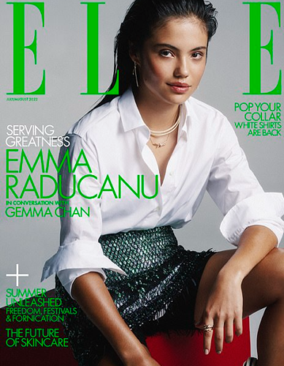

Extension: Fully annotate the magazine cover in detail. Consider: Target audience, layout, colourisation, house style, typography, image, mise-en-scene, camera angle, language, ideology, theory, etc. Remember, you are deconstructing a media text/product. In other words, annotate anything and everything for the intended effect on the target audience/demographic and how or why it has been constructed that way. Try to include annotations on Mise-en Scene, Typography, Layout and any other new magazine terminology such as Masthead, Pull-Quote and Cover Line.

HOMEWORK 2: PREPARE FOR THE FOLLOWING QUIZ QUESTIONS:

Give a definition for the term ‘Demographic’
Date Due:

Name 8 elements of mise-en-scene.

Give a definition for the term ‘Core Buyer’

Give a definition for the term ‘Mission Statement’

What is a Masthead?

Why is the ‘left third’ of a magazine important?

What is a ‘cover line’ on a magazine?

What is the difference between a denotation and a connotation?

Name the four elements of Uses and Gratifications Theory (Hint: PIES).

Name the 5 ideologies: P… C… B… F... H…

HOMEWORK 3: READ
Date Due:

THE SET PRODUCT FACTSHEETS

It is very important that you know the 2 set products for this topic.
TASK: Read through, highlight and annotate pages 4-11 of this knowledge organiser.

