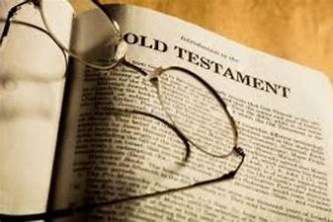

Year 7
Biblical Literacy 1

Knowledge Organiser & Homework Booklet

Name……………………………………………………………

Knowledge Organiser
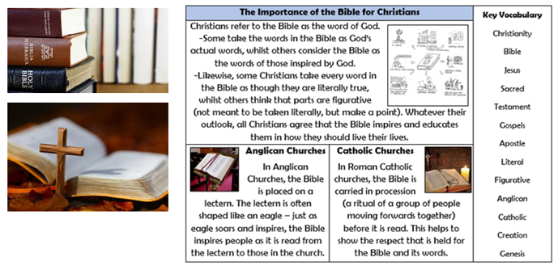
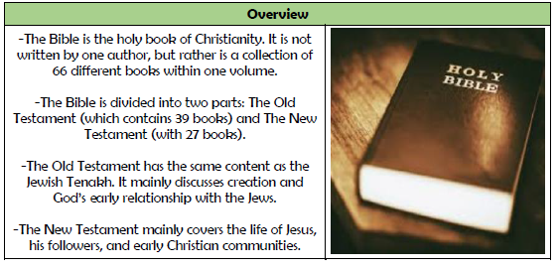
-The Old Testament was originally written in Hebrew and tells the early history of the Jewish people.  -It starts with the beginning of the universe and ends with the prophets that were God’s messengers that predicted the coming of Jesus.  -It is made up of many different parts including, the law, the prophets, songs, prophecies, stories and history. | 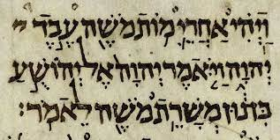  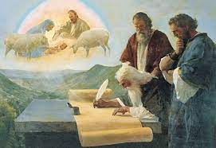
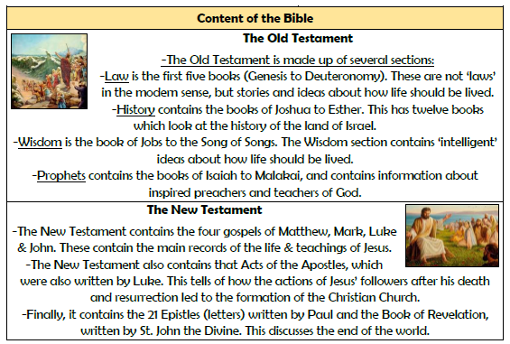
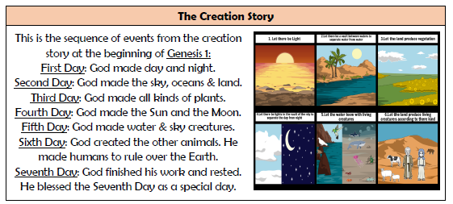
Big Questions:
- What is the Bible and how do I use it?
- What is unique about Christian beliefs on creation?
- Why do Christians believe humans are special?
- How did humans fall out with God?
- What is the message of the story of Cain and Abel for Christians?
- Howe did God rewards and punish those in the Old Testament?
- How did being willing to kill his son lead to Abraham being rewarded by God?
- How do Christians believe they can fix this broken relationship with God?



