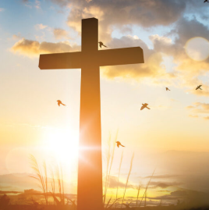

Year 10
Christian Beliefs

Knowledge Organiser

Name……………………………………………………………



 

