
Class:

Knowledge Organiser
Year 11 Additional: Unit 3
English Literature: A Christmas Carol

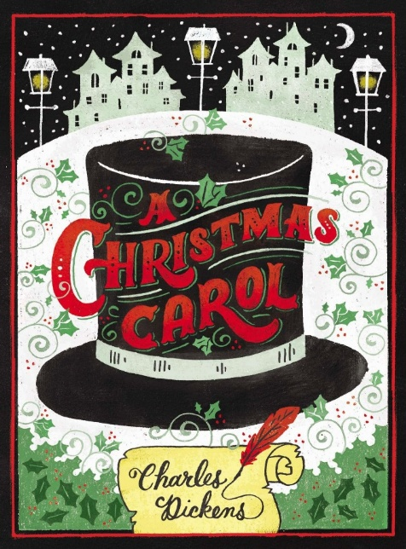

Name:

Class:

Contents Page

3 | Big Questions
4 | Key Terminology
5-7 | Key Quotations
7 | Character Map
8 | Scrooge’s journey
9 | Exam Details
10 | Writing Strengths and Areas for Improvement Grids
11-12 | Example Questions
13 | Example Essay
14 | Essay Writing Framework
15 | Homework Overview and Dates
16-20 | Homework Trackers
21 | Sparx Reader Guide
22-27 | Revision Space
28 | Revision Resources

Big Questions

Our study revising A Christmas Carol will follow the outline below:
Week 1 | How does Dickens present the character of Scrooge at the beginning of the novella?
Week 1 | How does Dickens use language to describe Scrooge?
Week 1 | How does Scrooge treat others?
Week 2 | How does Scrooge feel about his past?
Week 2 | How do I address Assessment Objective 1 in my literature essay?
Week 3 | How do I address Assessment Objective 2 in my literature essay?
Week 3 | How do I address Assessment Objective 3 in my literature essay?
Week 3 | How does Dickens use the ghosts to help Scrooge change his attitudes and behaviour? Assessment Point 1
Week 4 | How can I improve my analytical writing? Whole Class Feedback
Week 4 | How does Dickens present Scrooge's reaction to the Cratchits?
Week 5 | How does Scrooge treat others at the end of the novella?
Week 5 | How has Scrooge changed by the end of the novella?
Week 5 | How does Dickens present the lessons that Scrooge learns? Assessment Point 2
Week 6 | How can I improve my analytical writing? Whole Class Feedback
Week 6 | How can I revise for my exam?

Key Terminology
 | Term | Definition
1 | adjective | A describing word/ describes a noun
2 | adverb | Describing how something is done/ describes a verb
3 | benevolent | kind, well-meaning, good
4 | characterisation | the way a character has been created by the writer, what makes them who they are
5 | contrast | two opposing things that are used to highlight a difference
6 | juxtaposition | two opposing things placed next to each other to emphasise the difference
7 | misanthropic | having or showing a dislike of other people, unsociable
8 | noun | The name of a place, person or object
9 | redemption | the action of being saved from sin, error or evil
10 | remorseful | filled with regret, feeling sorry for something you have done wrong
11 | solitary | existing alone, single
12 | stoic | a person who can endure pain or hardship without showing their feelings or complaining
13 | symbolism | using objects to represent ideas
14 | verb | A doing or being word/ the action or movement that is happening
15 | writer's intention | what a writer is aiming to do

Key quotations from A Christmas Carol
 | “Hard and sharp as flint”
 | “As solitary as an oyster”
 | “As merry as a schoolboy”
 | ”As light as a feather”
 | “External heat and cold had little influence” ”frosty rime”
 | “Tight-fisted hand at the grindstone”
 | “a bright clear jet of light, by which all this was visible”
 | “Another idol has displaced me”
 | “A solitary child, neglected by friends”
 | “its genial face, its sparkling eye, its open hand, its cheery voice”
 | “brave in ribbons”
 | “if the shadows remain unaltered by the future, the child will die”
 | “This boy is Ignorance. This girl is Want”
 | “The phantom slowly, gravely, silently approached”
 | “He was so fluttered and so glowing with good intentions”
 | “God bless us, everyone!”
 | “Oh tell me I may sponge away the writing on this stone!”
 | “The time before him was his own to make amends in”

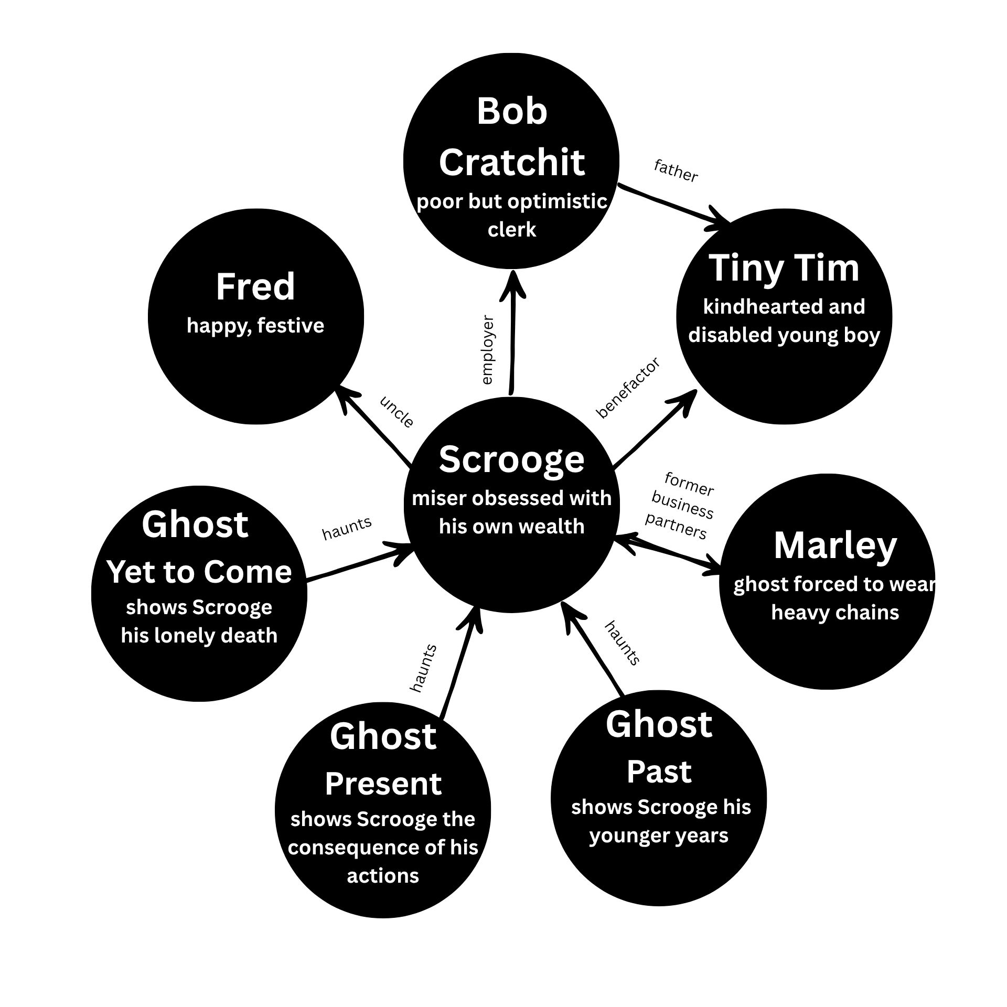
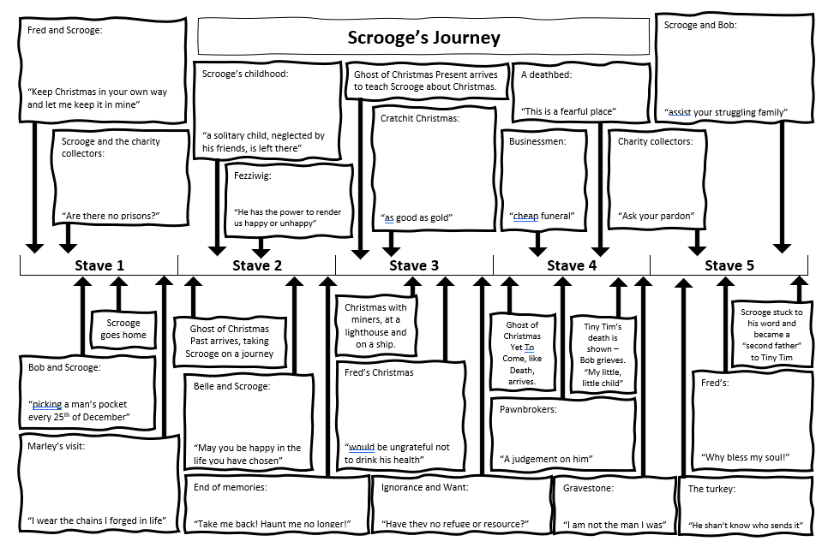
AQA GCSE English Literature Specification

You will sit two GCSE English Literature papers.

Paper 1: Shakespeare and the 19th-century novel

What's assessed?
Section A: Macbeth
Section B: A Christmas Carol

You will answer one question on their novel of choice. They will be required to write in detail about an extract from the novel and then to write about the novel as a whole.

How it's assessed
Written exam: 1 hour 45 minutes
64 marks
40% of GCSE
Assessment Objectives
The GCSE mark scheme can be confusing as it is written for examiners, not students. Below is a simplified mark scheme telling you what you need to do.

Assessment Objective | Marks | Meaning
AO1 | 12 | - Write an essay with a clear argument based on your own opinions  - All parts of the essay must directly answer the question  - Select quotations and references from both the extract and the rest of the novel  - Quotations must provide evidence for the points you make in your argument
AO2 | 12 | - Explain the author’s choices to support your argument  - Evidence can be analysis of the language used by the author, as well as the form and structure of the novel  - Mention techniques used if you can fully explain the effect and relevance to your argument
AO3 | 6 | - Use context and perspectives to support your argument and to provide further explanation to the author’s choices

Use the questions below to check your own answers and to identify your strengths an gaps in your own writing

AO1 |  |  | 
Have I included a thesis statement in my introduction?
Does my thesis statement include a central argument based on my own opinions?
Does my thesis statement include keywords from the question?
Have I included topic sentences for all of my paragraphs?
Do all of my paragraphs directly answer the question?
Have I included a conclusion that sums up my argument and links to my thesis?
Have I chosen two or three quotations from the extract?
Have I linked these quotations, and ideas presented in the extract, to other parts of the novel?
Have I chosen at least three other quotations and references from elsewhere in the novel?
Do all of my references directly support my argument?
Does each reference I have included support the points made in my topic sentences?

AO2
Does my analysis provide evidence for the points in my argument?
Have I moved from close word-level analysis to whole-text analysis?
Have I included analysis on structure and/or form?
Have I explained my analysis in terms of the author’s overall message?
Have I removed any unnecessary technique spotting?
Have I removed any unnecessary naming of word classes?
Have I explained the author’s use of techniques in terms of their overall message?

AO3
Have I removed any irrelevant contextual information?
Is all my context linked to the ideas and perspectives of the author’s time?
Does all my context provide additional insight into my main argument?

Sample Question
This tells you WHERE in the novella is from and a brief outline of the main event in the extract. Use this information to help you with your planning

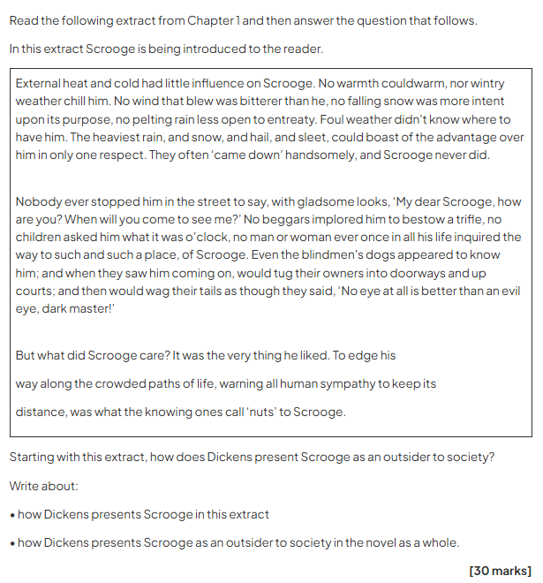
HIGHLIGHT the focus of the question.
This information reminds you that you MUST write about the EXTRACT AND ELSEWHERE IN THE NOVELLA
If you don’t, the maximum score you can achieve is 10/30



Example Analytical Writing: Paper 1, A Christmas Carol

A Christmas Carol- Level 4 response

In the extract, it becomes quite clear that Scrooge is frightened of the ghosts of Christmas yet to come. This is shown by Scrooge’s uncertainty of the ghost implied in Scrooge’s quote “Is that so, spirits?”. This suggests Scrooge is scared of what he will see or what may become of him also.
When in the extract it says “when it came near him, Scrooge slowly bent down upon his knee” this shows that Scrooge is trying to honour and respect the ghost so it wont harm him due to Scrooge’s attempt of flattery.

Additionally, Dickens presents Scrooge’s fear through when Scrooge gives in and confesses his fear directly to the ghost clearly shown by the quote “I fear you more than any spectre I have ever seen”.
When the extract says “Scrooge feared the silent shape so much that his legs trembled”, this suggests the sole aspect of Scrooges fear at the time is the characteristics and look of the ghost.

Dickens presents Scrooge’s fears in the novel as a whole to be no just of the supernatural aspects but others also. When Belle, Scrooge’s love relationship partner, quotes “you fear the world too much” this implies that Scrooges fears poverty to put the quote into context, Scrooge has just explained how he’d prefer money over love to Belle supporting the idea of his fear of poverty.
Dickens presents Scrooge to be fearful of Tiny Tim’s condition. When Scrooge learns of what may become of Tim, this is a major turning point in Scrooge’s attitude as he cares about Tims illness shown by “will the boy live”.

When in the extract it says “The spirit paused a moment, as observing his condition and giving him time to recover” this suggests Scrooge is physical as well as mentally traumatised by the presence of the ghost to the that he needed time to recover.

Ultimately scrooge fears death when the Ghost of Christmas yet to come shows him his grave. Scrooge is fear is shown by him pleading to be released from death and be allowed to live out the rest of his life to the ghost. This shows how scrooge has been taught other values apart from money such as love, family and kindness and that by sticking to these you will be a happier person which is illustrated through the character Fred, Scrooge’s nephew who does live by these values.

AQA Examiner Commentary
This is a consistent level 3 in approach and content until the final parts of the response. The level 3 nature of the writing is characterised by it being comment-approach rather than more clearly explanatory. In other words, the candidate doesn’t ‘stay’ with any of their ideas long enough to develop them into a clear explanation of what they mean, until the final paragraph which is much more focused on the task and the ideas which are the focus of it. In order to develop further, this candidate needs to develop the ability to explain their ideas in detail. (17 marks)
Practice your own response, using the framework below:
Introduction
- Scrooge, as the sound of his name suggests, is presented in the extract as…
- He is unlike other characters in the novel because…
- Dickens purposefully exaggerates Scrooge’s appearance and attitudes to emphasise…

Paragraph 1 – Extract
‘No warmth could warm, no wintry weather chill him’
  - As the extract begins, the narrator reveals that…
  - This is significant because it shows that Scrooge is…
  - Once again, Dickens uses exaggeration to emphasise…

Paragraph 2 – Extract
‘Nobody ever stopped him in the street to say, with gladsome looks, ‘My dear Scrooge, how are you?’
- It is particularly revealing that people in the street do not…
- As such, Scrooge is presented as…
- Dickens develops this presentation by using the humorous scenario of…
- Ultimately, in the extract, Dickens works hard to establish Scrooge as a figure of criticism because...

Paragraph 3 – Fred
‘he was all in a glow; his face was ruddy and handsome; his eyes sparkled, and his breath smoked again’
- In contrast to Scrooge, Fred is presented as…
- Unlike Scrooge, he is associated with…
- This is important because…
- Despite Fred’s good humour and patience, Scrooge treats him…
- For example…

Paragraph 4 – The Two Gentlemen
‘decrease the surplus population’
- Towards the middle of the stave, Scrooge is approached by…
- Scrooge is totally unmoved by…
- This reinforces the earlier presentation of Scrooge as…
- It is notable that Dickens was writing at a time when…
- As such, he encourages the reader to…
Conclusion
- In conclusion, Scrooge is defined as a character who is…
- Dickens encourages the reader to be critical of…


Homework Tasks


https://sparxreader.com/

Username | @thedustonschool.org
Password

 | Completion Date | Teacher Checked
Homework 1
Complete 300 SRP on Sparx Reader and complete the weekly tracker.

Homework 2
Complete 300 SRP on Sparx Reader and complete the weekly tracker.

Homework 3
Complete 300 SRP on Sparx Reader and complete the weekly tracker.

Homework 4
Complete 300 SRP on Sparx Reader and complete the weekly tracker.

Homework 5
Complete 300 SRP on Sparx Reader and complete the weekly tracker.

Homework 6  Complete 300 SRP on Sparx Reader and complete the weekly tracker. |  | To be checked after half term.
Half Term- Opportunity for extra House Points for any reading completed.

Sparx Reading Homework Trackers:

Week 1  Monday 5th- Sunday 11th January 2026 | Minimum SRP Total: 300 | Accuracy Rating:
Week 1  Monday 5th- Sunday 11th January 2026 | Your SRP: | Excellent
Week 1  Monday 5th- Sunday 11th January 2026 | Your SRP: | Good
Week 1  Monday 5th- Sunday 11th January 2026 | Your SRP: | OK
Week 1  Monday 5th- Sunday 11th January 2026 | Your SRP: | Low
Week 1  Monday 5th- Sunday 11th January 2026 | Your SRP: | Very Low
Books Read this week:
Comments:
Favourite Book? Favourite Genre? Best part you read?
Parent/Guardian Signature

Week 2  Monday 12th- Sunday 18th January 2026 | Minimum SRP Total: 600 | Accuracy Rating:
Week 2  Monday 12th- Sunday 18th January 2026 | Your SRP: | Excellent
Week 2  Monday 12th- Sunday 18th January 2026 | Your SRP: | Good
Week 2  Monday 12th- Sunday 18th January 2026 | Your SRP: | OK
Week 2  Monday 12th- Sunday 18th January 2026 | Your SRP: | Low
Week 2  Monday 12th- Sunday 18th January 2026 | Your SRP: | Very Low
Books Read this week:
Comments:
Favourite Book? Favourite Genre? Best part you read?
Parent/Guardian Signature

Week 3  Monday 19th- Sunday 25th January 2026 | Minimum SRP Total: 900 | Accuracy Rating:
Week 3  Monday 19th- Sunday 25th January 2026 | Your SRP: | Excellent
Week 3  Monday 19th- Sunday 25th January 2026 | Your SRP: | Good
Week 3  Monday 19th- Sunday 25th January 2026 | Your SRP: | OK
Week 3  Monday 19th- Sunday 25th January 2026 | Your SRP: | Low
Week 3  Monday 19th- Sunday 25th January 2026 | Your SRP: | Very Low
Books Read this week:
Comments:
Favourite Book? Favourite Genre? Best part you read?
Parent/Guardian Signature

Week 4  Monday 26th- Sunday 1st February 2026 | Minimum SRP Total: 1200 | Accuracy Rating:
Week 4  Monday 26th- Sunday 1st February 2026 | Your SRP: | Excellent
Week 4  Monday 26th- Sunday 1st February 2026 | Your SRP: | Good
Week 4  Monday 26th- Sunday 1st February 2026 | Your SRP: | OK
Week 4  Monday 26th- Sunday 1st February 2026 | Your SRP: | Low
Week 4  Monday 26th- Sunday 1st February 2026 | Your SRP: | Very Low
Books Read this week:
Comments:
Favourite Book? Favourite Genre? Best part you read?
Parent/Guardian Signature

Week 5  Monday 2nd -Sunday 8th February 2026 | Minimum SRP Total: 1500 | Accuracy Rating:
Week 5  Monday 2nd -Sunday 8th February 2026 | Your SRP: | Excellent
Week 5  Monday 2nd -Sunday 8th February 2026 | Your SRP: | Good
Week 5  Monday 2nd -Sunday 8th February 2026 | Your SRP: | OK
Week 5  Monday 2nd -Sunday 8th February 2026 | Your SRP: | Low
Week 5  Monday 2nd -Sunday 8th February 2026 | Your SRP: | Very Low
Books Read this week:
Comments:
Favourite Book? Favourite Genre? Best part you read?
Parent/Guardian Signature

Week 6  Monday 9th - Sunday 15th February 2026 | Minimum SRP Total: 1800 | Accuracy Rating:
Week 6  Monday 9th - Sunday 15th February 2026 | Your SRP: | Excellent
Week 6  Monday 9th - Sunday 15th February 2026 | Your SRP: | Good
Week 6  Monday 9th - Sunday 15th February 2026 | Your SRP: | OK
Week 6  Monday 9th - Sunday 15th February 2026 | Your SRP: | Low
Week 6  Monday 9th - Sunday 15th February 2026 | Your SRP: | Very Low
Books Read this week:
Comments:
Favourite Book? Favourite Genre? Best part you read?
Parent/Guardian Signature

Half Term Reading:
What did you read? Which book did you enjoy the most? Fill this page with pictures of characters, titles of books and any book reviews you have for extra House Points from your teacher.
Book Tracker:
Write the date on the spine of a book each time you finish a Sparx book or a physical book. You can also colour in the book to track your progress.
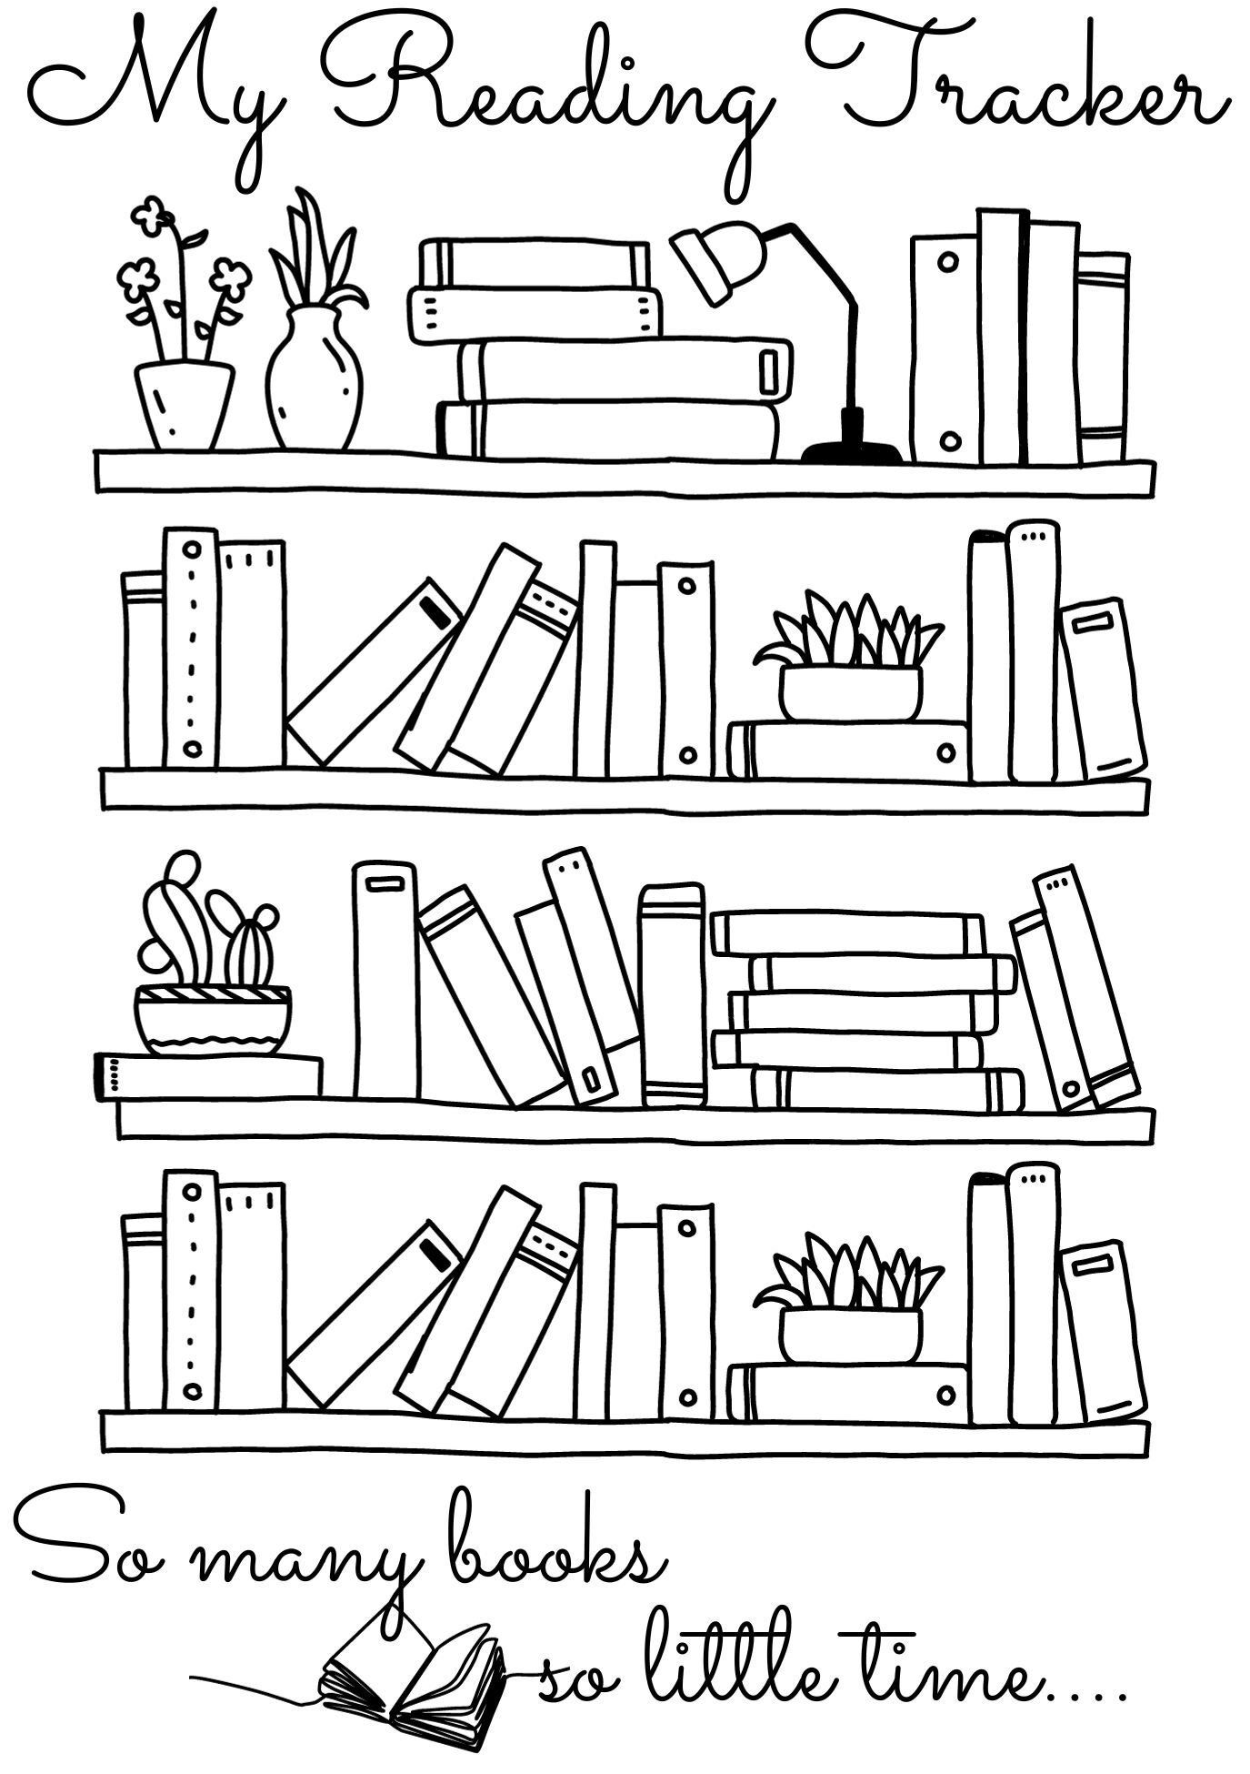
Sparx Reader: A Guide
Helping you to build reading stamina, literacy skills, and perseverance—one book at a time.

What Is Sparx Reader?
Sparx Reader is an online platform where you will complete weekly reading homework. It will help you:
✅ Practise meaningful, independent reading
🧠 Improve literacy and focus
🎯 Build perseverance and reading stamina

How Does It Work?
You will be able to choose ebooks at your reading level. As you read:
📝 You will answer questions to check comprehension
🎯 Earn Sparx Reader Points (SRP) for correct answers
📈 Climb the leaderboard by reading consistently

What Does Reading Look Like?
When you log in, you will see your current task and progress:
- Current Task: 0 / 200 SRP
- Due Date: 28 July
- Latest Book: Poison for Breakfast by Lemony Snicket
You can switch books anytime and unlock rewards like ⭐ Gold Reader status.

What Are the Questions Like?
✅ Simple if read properly
❌ Hard to guess if skimmed
🔍 Focused on key story elements
⏳ Text disappears before questions appear to encourage careful reading

What Is Gold Reader?
Gold Reader rewards consistent, careful reading. Once unlocked you can:
📚 Read any paper book from home or the library
📷 Scan the barcode to log reading
📝 Fill in a reading log to earn SRP


FAQs
How do I log in? At sparxreader.com using your school email address and
personal password

What devices are supported? Any device with internet and a web browser.

What if I can’t access Sparx Reader at home? If you are unable to access Sparx Reader from home, you can complete your homework in the library at the following times:
- Breaks and Lunches (except Tuesday)
- Monday after school until 4pm
- Wednesday after school until 4pm
- Thurs-Friday after school until 3.30pm
Revision Space
Plot outline
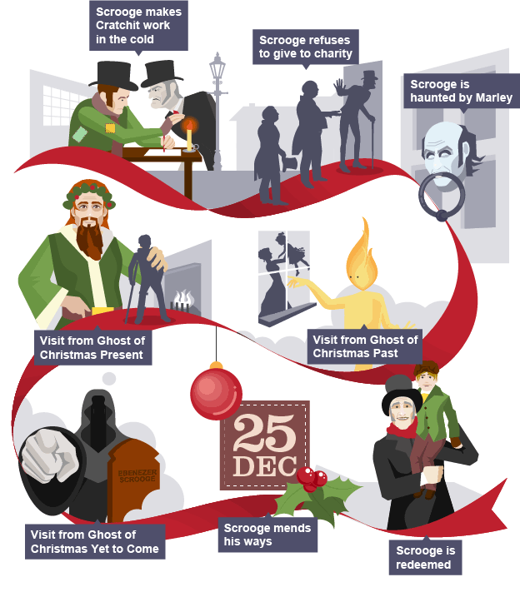
How will this help you prepare for an exam?
_____________________________________________________________________________________________________________________________________________________________________________________________________________________________________________________________________
____________________________________________________________________________________________________________________________________________________________________________________________________________________________________________________________________________________________________________________________________________________________
_______________________________________________________________________________________

Character or Theme Based mind-map with quotations and explanations
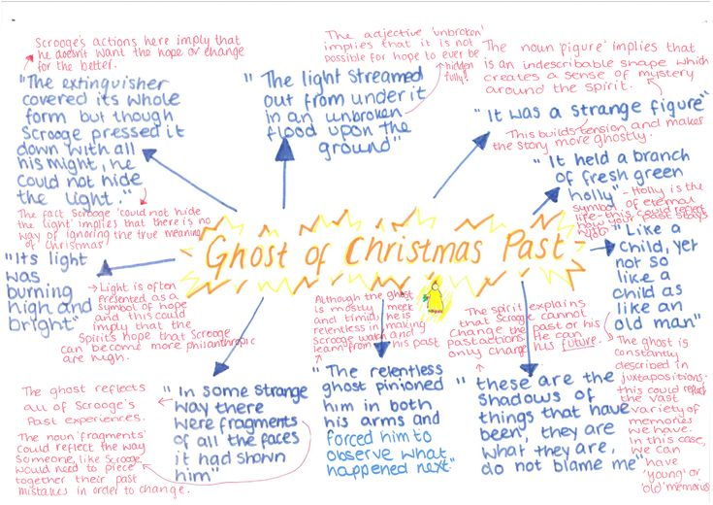

How will this help you prepare for an exam?
____________________________________________________________________________________________________________________________________________________________________________________________________________________________________________________________________________________________________________________________________________________________________________________________________________________________________________________________________________________________________________________________________________________________________________________________________________________________________________________________________________________________________________________________________________________________________________________________________________________________________________________________________________________________________________________________________________________________________________________________________________________________________________________________________________________

Flashcards
“another idol has displaced me…a golden one”  Who said it?  What does it mean?  Which methods does the writer use here? |  | “secret, self-contained and solitary as an oyster”  Who said it?  What does it mean?  Which methods does the writer use here?
Who said it? Belle  What does it mean? She feels that he loves money more than he loves her. It implies he is greedy as he looks up to money and wealth.  Which methods does the writer use here?  Symbolism of wealth- golden idol= money  Religious language- idolatry  Metaphor- golden idol= money |  | Who said it? Narrator about Scrooge  What does it mean? Scrooge keeps to himself, he does not like to spend time with people or share his feelings with them. Also implies he hoards his wealth.  Which methods does the writer use here?  Sibilance- repeated S sound to imply he is sinister  Adjectives- to describe Scrooge  Simile- comparing Scrooge to an oyster to suggest he has a hard outer shell but has something precious inside.

How will this help you prepare for an exam?
___________________________________________________________________________________________________________________________________________________________________________________________________________________________________________________________________________________________________________________________________________________________________________________________________________________________________________________________________________________________________________________________________________________________________________________________________________________________________________________________________________________________________________________________________________________________________________________________________________________________________________________________________________________________________________________________________________________________________________________________________________________________________________________________________________________________________________________________________________________________________________

Thinking and Linking Grid – Paired revision

Scrooge | Light | Tiny Tim | Marley’s chains | Memory | Forgiveness
Family | The Ghost of Christmas Yet to Come | Scrooge as a school boy | Martha Cratchit | Fan | Peter Cratchit
Gratitude | Christmas | Reform | Poverty | Cold | The Ghost of Christmas Past
Marley’s ghost | The charity collectors | Bob Cratchit | Ignorance and Want | Mrs Cratchit | Generosity
Hope | The Ghost of Christmas Present | Compassion | The workhouses | Redemption | Fezziwig
Repentance | Isolation | Belle | Responsibility | Fred | Guilt

You’ll also need a pair of dice
- In your pairs, roll your dice to get the co-ordinates of your first box and find the word/phrase in it. Start with the numbers along the side first. For example:
would equal ‘poverty’.
- Discuss how your word/phrase links to ‘A Christmas Carol’ with your partner. For example, for ‘poverty’ you could talk about how people are poor and needy because of the ignorance of the rich. You could talk about how Dickens wrote ‘A Christmas Carol’ to try and make people aware of the existence of poverty and its consequences.
Roll the dice again to find a new word.
would equal ‘the workhouses’
- Write both words in the blank table below the grid. Discuss how the two words/phrases link together with your partner before writing your answer in the table. You have space to make ten links.

Practice crafting strong analytical sentences
Crafting Sentences on A Christmas Carol

- Expand the sentences
- Scrooge is unpleasant.
- Fred is patient.
- Fezziwig is generous.

- Embed each quotation into a single sentence
- ‘tight-fisted’ (S1)
- ‘solitary as an oyster’ (S1)
- ‘ruddy and handsome’ (S1)
- ‘solitary child’ (S2)
- ‘dear brother’ (S2)

- Analyse language in each of the quotations
- ‘Old Marley was as dead as a doornail’ (S1)
- ‘his eyes sparkled’ (S1)
- ‘A positive light appeared to issue from Fezziwig's calves’ (S2)

- Connect two sentences using each of the conjunctions
- ‘Additionally’
- ‘Contrastingly’
- ‘However’

- Use the fragments to form single sentences
- ‘a caricature’ and ‘emphasise’
- ‘a foil to’ and ‘this is vividly shown’

- Use the fragments to form single sentences about Scrooge
- ‘not only… but also…’
- ‘significant because… and…’

Because, But, So
Explain causes, contrasts and results
- People avoid Scrooge when passing him on the street because he is so unpleasant
- Fred invites Scrooge to Christmas dinner, but he immediately refuses
- Scrooge is a miserly character, so he refuses to donate money to charity

Appositives
Include extra details to add depth
- Fezziwig, a joyful and generous employer, holds a wonderful Christmas party

Although, Despite
Express contrasting ideas
- Although Belle cares deeply about Scrooge, she chooses to end their engagement
- Despite Scrooge’s criticism of marriage, Fred remains cheerful and calm

Before, After
Clarify the order of events
- Before the ghost of Jacob Marley appears, Scrooge sees his face in the door-knocker
- After visiting the Cratchit household, Scrooge is taken to visit Fred’s family

Embed Short Quotations
Support your ideas with precisely chosen evidence
- Scrooge is as ‘solitary as an oyster’ in the sense that he is an isolated figure

Compare and Contrast
Make links across the text
- Compared to Fezziwig, Scrooge’s lack of empathy and generosity is emphasised
- In contrast to Scrooge, Fred is associated with light and warmth

Make sure you are reading a wide range of texts at home and use the Library in school to help support you when selecting a text to read.
Some useful revision resources you can use to help support your practice of the exam questions are below:

Mr Bruff’s YouTube Channel for Literature Paper 1 →


Stacey Reay’s YouTube Channel →


SENECA Learning
Log into your account and start quizzing! →


Massolit
Sign up to Massolit with your school email to access a whole range of resources for your Year 11 Revision! →

Film adaptations you can watch:
A Christmas Carol (2009) Jim Carey on Disney+
A Christmas Carol (1999) Patrick Stewart
A Christmas Carol (1984) George C Scott


GCSE English Language
BBC Bitesize Guide to English Language →


AQA Information and Past Papers/ Mark Schemes →


Wider reading list + Revision resources

