

Knowledge Organiser
Year 10: Unit 2
Language Paper 2 & An Inspector Calls

Name:
Class:
Contents Page

3 | Big Questions
4 | Exam Information
5-7 | Mark Scheme
8-11 | Key Terminology
12-14 | Example Questions and Essay
15 | Homework Overview and Dates
16-34 | Homework Tasks
35-36 | Quotation Banks
37-45 | Character Arcs
46-48 | Wider Reading
49 | Revision Resources

Big Questions

Our study of Language Paper 2 and An Inspector Calls will follow the structure below:
Language Paper 2: | - BQ: How can I effectively analyse a non-fiction text? [Q1]  - BQ: What makes an effective summary? [Q2]  - BQ: How can I analyse the effect of language in a non-fiction text? [Q3]  - BQ: How can I effectively compare writers’ attitudes and perspectives? [Q4]  - BQ: What makes a compelling and convincing letter? [Q5]  - BQ: How can I effectively select information to summarise the differences and similarities between texts? [Q1 + Q2]  - BQ: How can I develop my response to Q1 and Q2 on Language Paper 2?  - BQ: What should I consider when analysing language in a non-fiction text? [Q3]  - BQ: What do I need to look at when comparing attitudes and perspectives? [Q4]  - BQ: How can I structure an argument in an essay? [Q5]  - BQ: How can I write a summary that makes inferences? [Q1 + Q2]  - BQ: How can I analyse language in a perceptive way? [Q3]  - BQ: What do I need to consider when comparing writers’ ideas and attitudes? [Q4]  - BQ: How can I plan an engaging and effective speech? [Q5]  - BQ: How can I write an engaging and effective speech? [Q5]  - BQ: How can I summarise two texts clearly and make perceptive inferences? [Q1 +Q2]  - BQ: How can I craft a convincing and compelling article? [Q5]  BQ: How can I develop my inclusion of Ethos, Pathos and Logos in my writing?
An Inspector Calls | - BQ: What compelled Priestley to write the play? (Big Lecture)  - BQ: How does Priestley use dramatic irony in Act 1? (2 lessons)  - BQ: How is Mr Birling presented at the start of the play? (Assessment Point 1)  - BQ: How does Priestley construct the character of the Inspector?  - BQ: How does Priestley introduce the character of Eva Smith?  - BQ: How does Priestley show the impact of the Inspector on Sheila?  - BQ: How does Priestley present the relationship between Sheila and Mrs Birling?  - BQ: How does Priestley present Gerald in Act 2?  - BQ: How can Gerald be seen as an ambiguous character?  - BQ How is Gerald presented? (Assessment Point 2)  - BQ: What is the significance of the name ‘Daisy Renton’?  - BQ: How is Mrs Birling presented in Act 2?  - BQ: How is the character of Eric Birling presented in Act 3?  - BQ: How does Priestley construct the character of Eric Birling?  - BQ: What is the significance of the Inspector’s final speech?  - BQ: How is the Inspector presented as an omniscient character?  - BQ: How have the characters developed over the course of the play?  - BQ: How are the two generations presented in the play? (Assessment Point 3)  - BQ: How can An Inspector Calls be read as a morality play?  - BQ: What are the big ideas and themes of the play?  - BQ: How is a good GCSE Literature essay structured?  - BQ: Why does Priestley use a cyclical structure?  - BQ: How does Priestley use symbols to convey his ideas?  - BQ: How does Priestley present hypocrisy/duplicity in the play?  - BQ: How does Priestley present social class in the play?  - BQ: How does Priestley present gender in the play?  - BQ: How does Priestley present power in the play?  - BQ: How does Priestley present selfishness in the play?
Exam Criteria and Assessment Objectives for Language Paper 2

Assessment Objectives
AO1 | Pick out and understand pieces of explicit and implicit information from the text(s).  Collect and put together information from different texts.
AO2 | Explain how writers use language and structure to achieve their purpose and influence readers.  Use technical terms to support your analysis of language and structure.
AO3 | Identify different writers’ ideas and perspectives.  Compare the method used by different writers to convey their ideas.
AO4 | Critically evaluate texts, giving a personal opinion about how successful the writing is.  - Provide detailed evidence from the text to support your opinion.
AO5 | Communicate clearly, effectively and imaginatively, selecting and adapting tone, style and register for different forms, purposes and audiences. Organise information and ideas, using structural and grammatical features to support coherence and cohesion of texts.
AO6 | Students must use a range of vocabulary and sentence structures for clarity, purpose and effect, with accurate spelling and punctuation.

Paper Timings for Language Paper 2

 | Question | Time | Skills assessed
15 minutes reading time
Paper Two  1hr 45mins | Q1: Find the 4 true statements  4 marks | 5 minutes | AO1
Paper Two  1hr 45mins | Q2: Summary of the differences  8 marks | 10mins | AO2
Paper Two  1hr 45mins | Q3: How does the writer use language…?  12 marks | 10mins | AO2
Paper Two  1hr 45mins | Q4: Compare the ways the writer presents their views on…  16 marks | 20mins | AO4
Paper Two  1hr 45mins | Q5: Transactional writing  40 marks | 45mins | AO5 and AO6

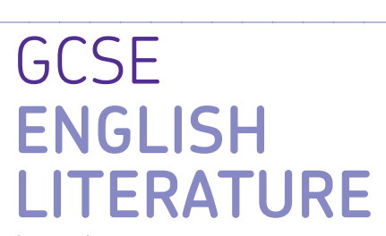
AQA GCSE English Literature Paper 2

Paper 2: Modern texts and poetry

What’s assessed = Modern Prose or Drama text, Poetry Anthology, Unseen Poetry

How it’s assessed: Written exam 2 hours 15 minutes, 96 marks, 60% of GCSE

Questions:

Section A Modern Prose or Drama: students will answer one essay question from a choice of two on their studied modern text

Section B Poetry: students will answer one comparative question on one named poem printed on the paper from their chosen anthology cluster.

Section C Unseen Poetry: students will answer one question on one unseen poem and one question comparing this unseen poem to another unseen poem.

Mark schemes Literature Exams

Assessment objectives (AOs)

AO1 Read, understand and respond to texts. Students should be able to:

• maintain a critical style and develop an informed personal response

• use textual references, including quotations, to support and illustrate interpretations.

AO2 Analyse the language, form and structure used by a writer to create meanings and effects, using relevant subject terminology where appropriate.

AO3 Show understanding of the relationships between texts and the contexts in which they were written.

AO4 Use a range of vocabulary and sentence structures for clarity, purpose and effect, with accurate spelling and punctuation
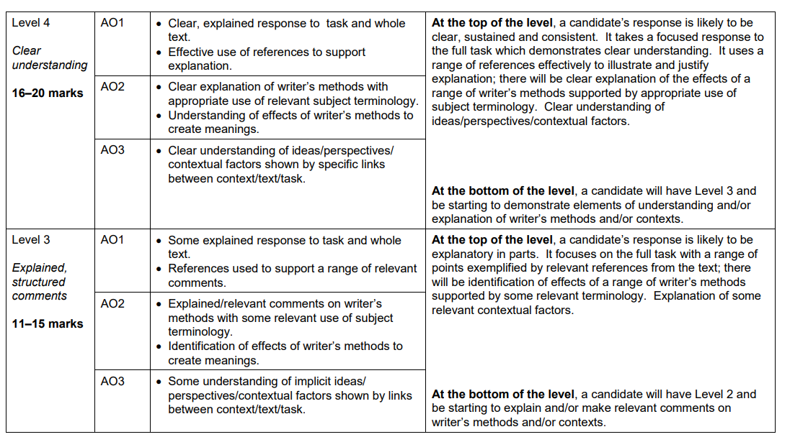
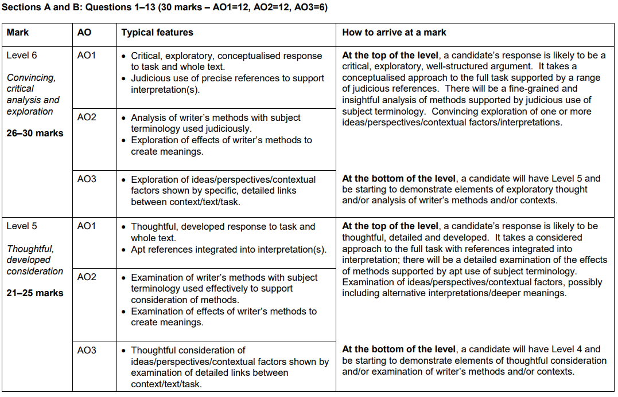

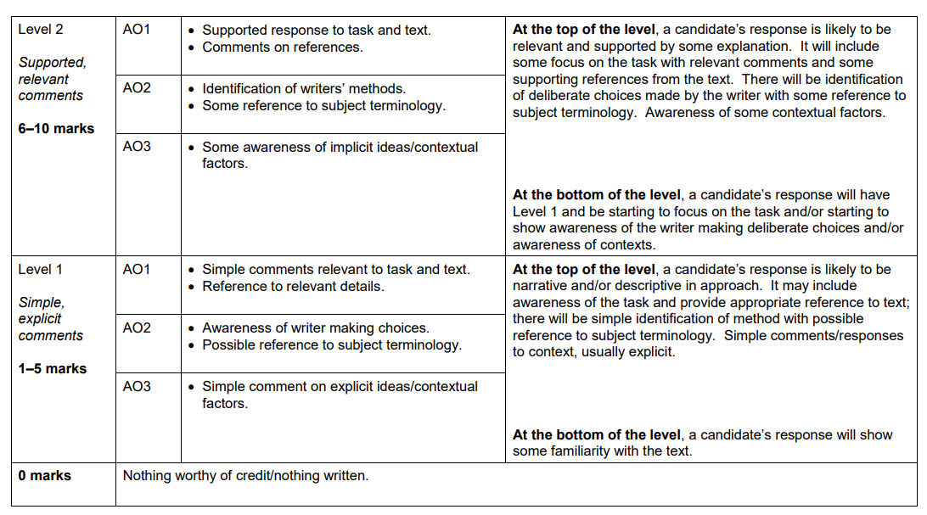


Key Terminology: Language

 | Term | Definition
1 | Anecdote | A short amusing or interesting story about a real person or incident.
2 | Anaphora | Starting each sentence with the same words.
3 | Antithesis | Use of direct opposites.
4 | Chiasmus | A rhetorical device where you use parallel phrases in reverse e.g. When the going gets tough, the tough gets going.
5 | Collective Pronoun | Using pronouns such as ‘we’, ‘our’ and ‘us’.
6 | Declarative Sentence | A sentence that makes a statement.
7 | Direct Address | Use of a proper noun (you) to address an audience.
8 | Emotive Language | Words or phrases that evoke a particular emotion in the audience or reader.
9 | Ethos | Credibility. "You should believe my argument because you believe me." or perhaps "...believe in me. “
10 | Extended Metaphor | A metaphor that goes into detail across a text.
11 | Hyperbole | Deliberate exaggeration to emphasise a point.
12 | Imperative Verbs | Verbs that give an order or command – used to demand. e.g. in the following sentence ‘Give me your pen!’ Give= imperative
13 | Interrogative Sentence | A sentence that asks a question.
14 | Logos | Using logic and reason as your appeal: facts and figures.
15 | Modal Verb | Verbs that are used to show something is likely/ possible or you have the ability to do it e.g. should, could, must, shall, can, may, might.
16 | Pathos | Having an emotional influence on the audience or reader. The aim is to make them feel something.
17 | Rhetorical Question | A question that is designed to make the audience/ reader think and does not require an answer.
18 | Statistic | A numerical piece of factual information e.g. 1 in 10 people experience/ 56% of those surveyed stated etc.
19 | Tone | How something sounds.
20 | Tricolon | Use of a list of three, or repetition of something three times to emphasise a point.

Space for Additional Terminology
Key Terminology: Literature

 | Term | Definition
1 | Ambiguous | A situation or statement that is unclear because it can be understood in more than one way.
2 | Capitalism | A political or social viewpoint that believes key values of Capitalism which are individual responsibility, private ownership of a country’s trade and industry and rewards for those that are most financially successful.
3 | Didactic | Intended to teach (often in a moral way).
4 | Dramatic irony | Where the audience know something that the characters do not.
5 | Hypocrisy | Claiming an idea or belief and then not following it yourself.
6 | Empathy | The ability to understand and share the feelings of another.
7 | Ignorant | To have a lack of knowledge or information.
8 | Injustice | Lack of fairness or justice.
9 | Inequality | Difference in size, degree, circumstances, etc.; lack of equality.
10 | Intuitive | A feeling or instinct that something is true.
11 | Microcosm | A community or situation that represents the features of something much larger, like a complete society.
12 | Naïve | Showing a lack of experience, wisdom, or judgement.
13 | Omniscient | Knowing everything.
14 | Patriarchy | A system, society or government that is led by men.
15 | Prejudiced | Having a dislike or distrust of a person or people based upon little evidence.
16 | Privilege | A special right, advantage only available to a particular person or group of people.
17 | Remorseful | Sorry or full of regret for actions or behaviour.
18 | Socialism | The set of beliefs that states that all people are equal and should share equally in a country’s money or the political systems based on these beliefs.
19 | Stage directions | An instruction in the text of a play indicating the movement, position, or tone of an actor, or the sound effects and lighting.
20 | Sympathy | To feel sorry for someone.

Space for Additional Terminology

Example questions

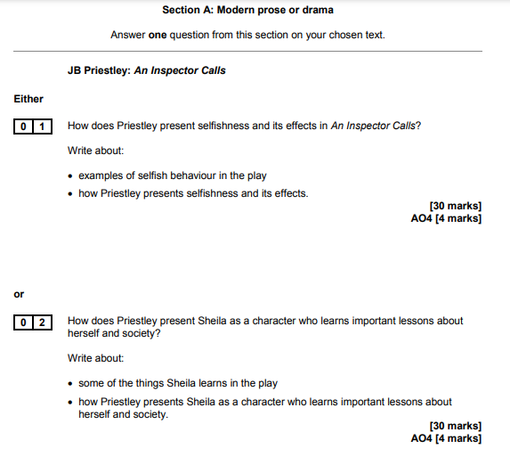

Example essay

How does Priestley use the character of the Inspector to suggest that society needed to change?

‘An Inspector Calls’ is about how people should be more responsible. Priestley uses the Inspector as his mouthpiece, to challenge the selfish capitalist views of many of the middle and upper classes and to promote his belief in greater equality for everyone. Through the Inspector’s questioning of each of the characters, Priestley demonstrates how a lack of responsibility for others can have tragic consequences. Eric and Sheila’s ability to take responsibility for their actions conveys Priestley’s belief in the chance for a better society for the future.

The Inspector’s questioning of Arthur Birling reveals how poorly some of the working classes were treated by wealthy business owners. Early in the play, Arthur Birling proudly boasts that ‘a man has to mind his own business, look after himself and his own’. Priestley makes it clear that Arthur Birling prioritises his own interests above the interests of his workers. When questioned by the Inspector about how he responded to his workers’ request for a payrise, Birling responds with the words ‘I refused of course’. The words ‘of course’ demonstrate the arrogance in Arthur Birling’s character; he feels entirely justified in behaving in the way he did and does not wish to be questioned by the Inspector. The fact that Birling ‘refused’ without even discussing the payrise with his workers, and went as far as firing the person leading the strike, demonstrates how few rights the working classes had in 1912. Priestley deliberately presents Arthur Birling as a character who is unable to accept any responsibility for his actions and who remains concerned with his own reputation throughout, even offering the Inspector ‘thousands’ in order to keep quiet. Priestley does this in order to demonstrate to his audience that society will only improve if wealthy business owners like Arthur Birling admit their mistakes and try to take more responsibility for their workers.

Priestley uses the Inspector’s questioning of Sybil Birling to demonstrate the need for a welfare system to help the working classes. When questioned about her actions, Priestley makes it clear that Sybil Birling was prejudiced towards Eva Smith. Priestley has Sybil refer to the working classes as ‘girls of that class’ and ‘of that sort’, which demonstrates that she is snobbish and looks down on the working classes. He also has Sybil proudly say she was ‘perfectly justified’ in doing what she did, admitting that she was prejudiced against Eva Smith due to her ‘impertinent’ use of the Birling name. Priestley deliberately chooses to have Sybil Birling run a private charity as he is able to use her character to suggest that charities run by wealthy people would never offer the help that society needed. Priestley wanted to make the case for a welfare state, which would offer more help to the working classes. Many of Priestley’s 1945 audience would have voted for the Labour Party, who came into power in 1945 and established the NHS, thus would have felt equally critical of Sybil Birling’s actions.

Through the Inspector’s questioning of Sheila and Eric, Priestley demonstrates that the younger generation may be able to change society for the better. Whereas Sybil and Arthur Birling are relieved and delighted when they realise the Inspector wasn’t real, Sheila and Eric remain guilty and remorseful for their actions. Eric challenges his parents for pretending that ‘nothing really happened at all’, which highlights the difference in the way the characters take responsibility for their actions. Priestley wanted to propose to the audience that the younger generation, many of whom may have voted for the recently elected Labour Party in 1945, would be able to change society for the better, as they were more willing to recognise their mistakes.

The Inspector is Priestley’s mouthpiece throughout, challenging capitalist views and proposing different ways of thinking. Priestley uses stage directions to indicate that the inspector is willing to interrupt the Birling’s capitalist views by having the inspector cut ‘in massively’ while the Birlings are talking. Whereas Sybil and Arthur Birling believe themselves to be superior, Priestley makes clear it is in fact the inspector that is more powerful. Priestley’s choice to have the inspector ‘cutting in’ on Birling’s and Sybil’s speeches conveys that the inspector is not intimidated by their superior class. Priestley could have decided to have the inspector cut in on the Birlings to show that capitalist viewpoints deserve to be interrupted and ended. Furthermore, the adverb ‘massively’ demonstrates that what the inspector has to say is more important than what the Birlings have to say. The audience is therefore encouraged to trust the Inspector and to believe the things he is saying to the Birlings. Priestley has the Inspector promote socialist ideals when he says to the Birlings ‘We are all members of one body. We are all responsible for each other’. Priestley’s repetition of the pronoun ‘we’ when the Inspector talks contrasts with the way Arthur and Sybil Birling speak, as they more often say the word ‘I’, seeming more preoccupied with their own interests. This demonstrates Priestley’s belief in the clear distinction between socialism, which focuses on the many, and capitalism, which focuses on self-interest.

Homework Tasks.

Knowledge is power, so the more you know, the more secure you will be in your learning.

Year 10: Unit 2 Homework: English Language Paper 2 and An Inspector Calls
Task 1: | Due date:  WEEK 2 | - Read through Source A taken from a teacher’s diary in 1849 on pg 16-17  - Answer the question that follow on pg 17-18.
Task 2: | Due date:  WEEK 4 | - Read the article called ‘An Introduction to An Inspector Calls’ by Chris Power on pg 19-20  - Answer the 10 questions on pg 21 – these will be marked in class with your teacher
Task 3: | Due date:  WEEK 6 | - Read the article called ‘Priestley’s Political Journey’ on pg 21-23  - Answer the 10 questions on pg 24 – these will be marked in class with your teacher
Task 4: | Due date:  WEEK 7 | - Read the article called ‘An Inspector Calls: An overview’ on pg 25-26  - Answer the 10 questions on pg 27 – these will be marked in class with your teacher
Task 5: | Due date:  WEEK 9 | - Read the programme essay for a production Of An Inspector Calls on pg 28-30  - Answer the 10 questions on pg 31- these will be marked in class with your teacher.
Task 6: | Due date:  WEEK 11 | - Read through Source B taken from a speech on Child Poverty on pg 32  - Answer the language analysis question on pg 33-34.  - Fill in the Self-Assessment Grid on pg 34 based on your response.

If you have ‘no homework’, or you have finished all of the above, try these tasks on a weekly basis to ensure your understanding is secure.
- Use the Wider Reading and Revision Resources pages on the back of the Knowledge Organiser and download some more practice papers from AQA.
- Add words to your key terminology grid in the Knowledge Organiser
- Read for at least 20 minutes per day – a mixture of fiction and non-fiction texts.
- Revise online using YouTube and refer to Mr Bruff, Stacey Reay and AQA revision channels QR codes are on the back page.

Homework 1
Source A is taken from a diary written in 1849 by a teacher at a ragged school. Ragged schools were set up to teach children whose parents were too poor to pay for their education. The schools were often housed in unsuitable buildings in poor areas of the city.

Oct. 29th 1849 –
On the way to the school this morning, it was a dismal scene . . . nothing but squalid dirt and idleness – the lanes leading to the school were full of men, women and children: shouting, gossiping, swearing, and laughing in a most discordant manner. The whole population seemed to be on the eve of a great outbreak of some kind or another, ready for anything but work . . . These lanes are a moral hell . . . We prepared the school by placing benches for the division of the scholars into four classes, and as they came tumbling and bawling up the stairs, we directed them to seats. Shortly after ten o’clock I spoke to them kindly, and then asked them to join with me in prayer.
No school can be possibly worse than this. Here the very appearance of one’s coat is to them the badge of class and respectability, for they know very well that we are the representatives of beings with whom they have ever considered themselves at war.
I had occasion to punish a boy slightly this morning. He swore most horribly, and rushed from the school. I took little notice of this display, and sat down calmly to hear the class read. I was suddenly startled by a large stone passing my ear. If it had struck me on the head, I must have been severely hurt. I got out of the reach of stones thrown through the window, and continued the lesson. Several followed – half-a-dozen at least. He was ready in the courtyard with a brick in his hand, to have his revenge when I came out.
Several visitors called in the afternoon, and they had scarcely left when a most distressing scene occurred. Two girls of twelve or thirteen years of age quarrelled. The first notice I had of this was to see the pair boxing most viciously. Before I could get at them, they had hold of each other's hair, and were yelling most fearfully. They fought like furies, but before we could separate them, one had received a severe and lasting injury in the eye, and her nose bled profusely. I sent her home, and went again to work, but it had not been quiet for ten minutes when a fearful outbreak took place. Seven women rushed into the school and outside, at least fifty women had collected. These were the mothers and friends of the girls who had fought. Having abused me in no measured terms – they proceeded to fight. Our boys cheered most tremendously. The women swore and shrieked. Those outside responded. Never, surely, was such a noise heard before. I did not believe that human beings resident in this city could so behave . . .
So by the help of God we must work harder. It is a post of honour. It is a forlorn hope.
Oct. 30th 1849 –
If possible the scholars were more unruly to-day than they were yesterday, but no serious outbreak took place. All our copybooks have been stolen, and proofs exist that the school is used at night as a sleeping-room. We must get a stronger door to it. I must also get a tub to stand by the pump in the courtyard, and a piece of coarse towelling and soap. My duties must resolve themselves into –
First – To see the boys and girls well washed and scrubbed
Secondly – To try to get prayers said decently
Thirdly – To give them a lesson in their duties and privileges
Fourthly – Some religious instruction
Fifthly – Reading
Sixthly – Writing
Seventhly – Arithmetic

- Read again the first part of Source A from lines 1 -17. Select 4 true statements.
[4 marks]
- The streets on the way to school were busy.
- The people on the streets seemed ready for work.
- There were four classes of students.
- The students prayed before 10 o’clock.
- The teacher calmly disciplined a student
- The punished student cried after his punishment.
- The teacher was hit by a stone.
- The stone had been thrown by the punished student.

- Using lines 2-5, what can you infer about the town?
________________________________________________________________________________________________________________________________________________________________________________________________________________________________________________________________________________________________________________________________________________________________________________________________________________________________________________________________________________________________________________________________________________________________________________________________________________________________________________________________________________________________________________________

- Using lines 12-17, what can you infer about the children’s attitude towards school?
________________________________________________________________________________________________________________________________________________________________________________________________________________________________________________________________________________________________________________________________________________________________________________________________________________________________________________________________________________________________________________________________________________________________________________________________________________________________________________________________________________________________________________________

- Using line 29, what conclusion does the teacher come to after the events of the day?
________________________________________________________________________________________________________________________________________________________________________________________________________________________________________________________________________________________________________________________________________________________________________________________________________________________________________________________________________________________________________________________________________________________________________________________________________________________________________________________________________________________________________________________

- Using lines 31-34, summarise how the next day was different from the first?
________________________________________________________________________________________________________________________________________________________________________________________________________________________________________________________________________________________________________________________________________________________________________________________________________________________________________________________________________________________________________________________________________________________________________________________________________________________________________________________________________________________________________________________

Homework 2: Read the article and answer the 10 questions that follow.
An Introduction to An Inspector Calls by Chris Power
https://www.bl.uk/20th-century-literature/articles/an-introduction-to-an-inspector-calls

Chris Power introduces An Inspector Calls as a morality play that denounces (criticises) the hypocrisy and callousness (cruelty) of capitalism and argues that a just society can only be achieved if all individuals feel a sense of social responsibility.
J B Priestley’s play An Inspector Calls, first performed in 1945, is a morality play disguised as a detective thriller. The morality play is a very old theatrical form, going back to the medieval period, which sought to instruct audiences about virtue and evil. Priestley’s play revolves around a central mystery, the death of a young woman, but whereas a traditional detective story involves the narrowing down of suspects from several to one, An Inspector Calls inverts this process as, one by one, nearly all the characters in the play are found to be guilty. In this way, Priestley makes his larger point that society is guilty of neglecting and abusing its most vulnerable members. A just society, he states through his mysterious Inspector, is one that respects and exercises social responsibility.
What is social responsibility?
Social responsibility is the idea that a society’s poorer members should be helped by those who have more than them. Priestley was a socialist, and his political beliefs are woven through his work. There are many different types and degrees of socialism, but a general definition is as follows: an ideal socialist society is one that is egalitarian – in other words, its citizens have equal rights and the same opportunities are available to everybody; resources are shared out fairly, and the means of production (the facilities and resources for producing goods) are communally owned.
Therefore, socialism stands in opposition to a capitalist society, such as ours, where trade and industry is mostly controlled by private owners, and these individuals or companies keep the profits made by their businesses, rather than distributing them evenly between the workers whose labour produced them.
It is precisely this difference between a socialist and a capitalist society that Arthur Birling is discussing in Act 1 when Inspector Goole arrives:
MR BIRLING: “But the way some of these cranks talk and write now, you’d think everybody has to look after everybody else, as if we were all mixed up together like bees in a hive – a man has to mind his own business and look after himself…”

The Inspector’s arrival cuts Arthur Birling off mid-sentence, enacting in miniature the clash between two ideological positions that unfolds throughout the rest of the play.
The play’s structure and setting
An Inspector Calls is a three-act play with one setting: the dining room of ‘a fairly large suburban house belonging to a fairly prosperous manufacturer’. The year is 1912, and we are in the home of the Birling family in the fictional industrial city of Brumley in the North Midlands. In the dining room five people are finishing their dinner: four members of the Birling family and one guest. Arthur Birling is a factory owner; his wife Sibyl is on the committee of a charity, and is usually scolding someone for a social mistake. Their adult children are Sheila and Eric, and their guest is Gerald Croft, Sheila’s fiancé, who is from a wealthier manufacturing family than the Birlings. One other person is present: Edna the maid, who is going back and forth to the sideboard with dirty plates and glasses.
Priestley’s description of the set at the beginning of the play script stresses the solidity of the Birlings' dining room: ‘It is a solidly built room, with good solid furniture of the period’. But a later section of this scene-setting – on the walls are ‘imposing but tasteless pictures and engravings’, and the ‘general effect is substantial and comfortable and old-fashioned but not cosy and homelike’ – suggests that although the Birling’s have wealth and social standing, they are not loving to one another or compassionate to others. The setting of the play in a single room also suggests their self-absorption, and disconnectedness from the wider world.
Priestley establishes each of the characters in this opening scene. Arthur Birling is a capitalist businessman through and through, entirely focussed on profit even when discussing the marriage of his daughter:
Mr BIRLING: I’m sure you’ll make her happy. You’re just the kind of son-in-law I’ve always wanted. Your father and I have been friendly rivals in business for some time now – though Crofts Limited are both older and bigger than Birling and Company – and now you’ve brought us together, and perhaps we may look forward to the time when Crofts and Birlings are no longer competing but are working together – for lower costs and higher price
Homework 2 Task: Now answer the questions on the article.
 | Write your answer in the box below each question. | 
1 | What does Chris Power argue that all individuals need to feel for a just society?
2 | When was the play first performed?
3 | What type of play is it?
4 | According to Priestley, what is society guilty of neglecting?
5 | What is social responsibility?
6 | What is socialism? Look up a definition if you can’t find the answer in the article.
7 | What is capitalism? Look up a definition if you can’t find the answer in the article.
8 | An ‘act’ is a section of a play. How many acts are there in the play, An Inspector Calls?
9 | What does the Birling family’s dining room suggest about them?
10 | What is Mr Birling focussed on even when discussing his daughter’s marriage?
TOTAL

Homework 3: Read the article and answer the questions that follow.

‘Priestley’s Political Journey’
https://www.bl.uk/20th-century-literature/articles/an-inspector-calls-and-j-b-priestleys-political-journey

Alison Cullingford explores how J B Priestley's childhood in Bradford and experiences during two world wars shaped his socialist beliefs and fuelled the anger of his play An Inspector Calls, a work that revolves around ideas of social responsibility and guilt.
An Inspector Calls poses troubling questions: how can people live together? To what extent are individuals responsible for others? Gareth Lloyd Evans described the play as ‘perhaps the clearest expression made by Priestley of his belief that “no man is an island” – the theme is guilt and social responsibility’. This article explores how and why J B Priestley came to this belief.
‘Substantial and heavily comfortable’: Bradford before the War
Priestley was born in 1894 in Bradford, in Yorkshire’s West Riding. Bradford was an industrial town soon to become a city (in 1897), which had grown very quickly around the wool and dyeing industries. Young ‘Jack’ Priestley himself found work in the wool trade, as a junior clerk with Helm and Company, whose offices were in the (now demolished) Swan Arcade.
Jack found this work dull, but otherwise, for a youngster who enjoyed sport, landscape, literature, music, art and socialising, Bradford had much to offer. In his novel Bright Day, he looked back from the austerity of 1946 to a golden age of freedom, plenty, hospitality, conviviality, generosity, solid comfort and strong community, where, at Christmas, brass bands played and choirs sang in the streets; you went not to one friend’s house but to a dozen; acres of rich pound cake and mince-pies were washed down by cataracts of old beer and port, whisky and rum; the air was fragrant and thick with cigar smoke, as if the very mill chimneys had taken to puffing them.
The bright young lad realised even then, though, that Bradford was not perfect. Working and living conditions had improved from the hellish days of the 1840s, when cholera and starvation were serious threats, but many still lived in poverty. Priestley’s political views were heavily influenced by the West Riding’s strong socialist traditions, represented by the Bradford Pioneer newspaper and his schoolteacher father, Jonathan.
Jack also noticed that the city’s respectable folk could be smug (too pleased with themselves), even hypocritical: ‘badly-divided men’ were pompously religious on Sundays, but on Saturday nights could be seen ill-using young women. In When We Are Married (1937), Priestley made great comedy of turning the world of three respectable couples upside down when it emerged that they had not been legally married. An Inspector Calls also shattered the world of an outwardly respectable family, this time, however, revealing the true social and political consequences of the selfishness of the Birlings and others like them
The First World War: men thrown away for nothing
This world was itself shattered by the Great War, which broke out in August 1914. Twenty-year-old Jack, drawn to prove himself, went alone to Halifax to volunteer for the Duke of Wellington’s West Riding Regiment. He served in the British Army for five years, as a private and lance-corporal, and, much later, as an officer with the Devonshires.
Despite being buried alive by a trench mortar explosion and gassed, Priestley survived relatively unscathed physically; but the experience of war changed him forever. He bore witness to the horrors of the front and his realisation of the implications of social inequalities that went far beyond what he had seen in his home city. As he wrote in his memoir, Margin Released (1962):
‘The British command specialised in throwing men away for nothing. The tradition of an officer class, defying both imagination and common sense, killed most of my friends as surely as if those cavalry generals had come out of the chateaux with polo mallets and beaten their brains out. Call this class prejudice if you like, so long as you remember … that I went into that war without any such prejudice, free of any class feeling. No doubt I came out of it with a chip on my shoulder; a big, heavy chip, probably some friend’s thigh-bone’.
Bradford could never be the same for Priestley after the war: so many of his friends had been killed, many of them in the 'Bradford Pals' battalions destroyed at the Battle of the Somme. After a venture into academia, taking his degree at the University of Cambridge, he decided to focus on writing and moved to London. The 1920s were years of hard work to make a living. We have the sense that he had a kind of survivor's guilt: he had to make something of his life when so many better men had been killed.
Homework 3 Task: Now answer the questions on the article.
 | Write your answer in the box below each question.
1 | What political beliefs did Priestley have?
2 | What are the big ideas that An Inspector Calls revolves around?
3 | What questions does the play pose?
4 | When and where was Priestley born?
5 | How could the city’s “respectable folk” act?
6 | When did WW1 break out?
7 | Which regiment did J.B. Priestley join?
8 | What happened to Priestley during the war?
9 | What did Priestley think men were thrown away for during the war?
10 | What did Priestley mean when he thought he had “survivor’s guilt”?
TOTAL

Homework 4: Read the article and answer the 10 questions that follow.

https://www.bl.uk/works/an-inspector-calls

‘An Inspector Calls: An overview’

An Inspector Calls is J B Priestley’s most performed play. It’s set in the household of a prosperous northern manufacturer, Arthur Birling. It’s 1912 and the Birling family are celebrating the engagement of daughter Sheila, when a stranger, who introduces himself as Inspector Goole, shows up at their door. He’s there to question them about the death of a young working-class woman, Eva Smith, who killed herself by drinking disinfectant. As Goole interrogates the family – Birling, his wife Sybil, his son Eric, Sheila and her fiancé Gerald – it comes to light that they have all, to some extent, been responsible for the young woman's decline in circumstances. They may not have killed her, but through action – and inaction – they all played a role in the events that led to her death. Arthur dismissed her from her job at his mill, Sheila contrived to have her fired from her new post in a department store, both Gerald and Eric slept with her and Sybil denied her charity when she came to her in desperation.

After Goole departs, Birling becomes suspicious and calls the chief constable. He discovers that there is no Inspector Goole and there have been no recent suicides. Birling and his wife see this as cause for celebration, but their children are more chastened by the night’s events. The ending twists things further, concluding with a phone call to the Birlings telling them that the police are on their way to talk to them about the death of a young woman in a suspected case of suicide.

An Inspector Calls is scathing in its criticism of middle-class hypocrisy. The play gives voice to Priestley’s strong socialist principles, and carries a clear moral message, stressing the importance of social responsibility: ‘We don’t live alone. We are members of one body. We are responsible for each other’.

Key productions of An Inspector Calls

The play was first performed in Russia (then part of the USSR) in 1945, before being produced in the UK in 1946. The role of Inspector Goole was written for Ralph Richardson, who starred in the original London production.

The play fell out of fashion for a while in the latter half of the 20th century. This changed in 1992, with Stephen Daldry’s lauded and award-winning revival for the National Theatre which has itself become iconic thanks to Ian McNeill’s ingenious stage design. Instead of the more familiar Edwardian interior, his set placed a miniature house in a desolate, war-ravaged landscape. Daldry’s production is often credited with generating a renewed interest in Priestley’s work.

Homework 4 Task: Now answer the questions on the article.
 | Write your answer in the box below each question.
1 | What is the Inspector investigating?
2 | What was Sheila’s involvement with Eva?
3 | What was Sybil Birling’s involvement with Eva?
4 | What happens after Goole departs?
5 | Why does the ending “twist things”?
6 | What is the play a criticism of?
7 | What does the play give a voice to?
8 | Where was the play first performed?
9 | When was the play first performed in UK?
10 | The play fell out of fashion but when did this change?
TOTAL

Homework 5: Read the article and answer the questions that follow.
The following text, by Dr John Baxendale, is a programme essay for a production Of An Inspector Calls at the Canadian Shaw Festival, 2008.
An Inspector Calls is about the death of a young woman. But it is not a whodunnit – at least, not of the conventional, forensic kind. An inspector arrives to investigate the death, but the questions he asks the well-heeled, complacent Birlings are not those of your typical policeman. In any case, the death is a suicide: there is no killer to be unmasked. Instead, a different kind of culpability (guilt) is being investigated, as we, and the Birlings, are led through a series of revelations which pass the moral blame for the girl’s death from one family member to another – and, ultimately, to a whole social system and set of values.
Priestley wrote An Inspector Calls at top speed during the last winter of the Second World War, 1944-5. Victory was now inevitable, but the climactic events of 1945 – the death of Hitler, the A-bomb, Labour’s landslide election victory – were still in the future. At that moment, Priestley was one of Britain’s best-known and most admired public figures. He had already become famous in the 1930s as a best-selling and hugely prolific novelist, playwright and journalist, but the war turned him into something more. His BBC radio broadcasts, starting in June 1940 and continuing through the Blitz, made him a popular propagandist second only to Churchill; but there was more to them than morale-boosting. As Graham Greene (who disliked Priestley’s writing) said, ‘he gave us an ideology’. Priestley spoke of the future, of how life should be after the war. For him, this was a ‘People’s War’, in which survival depended on the spirit and commitment of the ordinary people, who, if they seized the opportunity, could at last enter into their long-denied inheritance. We were not fighting for a return to the status quo – that was gone for ever – but for a new kind of society – as he put it, ‘a nobler world in which ordinary, decent folk can not only find justice and security but also beauty and delight’, a world in which we could stop thinking in terms of property and start thinking of the nation as a community. The war was making people realise, Priestley told his listeners, that we were all in the same boat – and it was a boat which could land us in a better world after the war was over.
This visionary radicalism inevitably got Priestley into trouble with more conservative members of society, including the Prime Minster, Churchill, who felt that talk of postwar reconstruction was premature and raised unrealistic expectations – and, no doubt, that things were better left to those in charge. Priestley, undaunted, was led into one of his occasional bouts of political activism, as chairman of the newly formed and rather ad hoc Common Wealth Party, which was to win several wartime by-election victories against Conservative candidates. We can see all this as part of the radical political mood of wartime, out of which the reforming Labour government of 1945-51 was to emerge. Priestley campaigned for Labour in 1945 and 1950, but his attitudes and beliefs were shaped by growin up in Bradford in the politically turbulent Edwardian years. The socialist culture of that city, and of his schoolmaster father had a big influence on him. When in 1930 he finally became successful with his runaway best-seller The Good Companions, the world slump was under way, and Priestley used the freedom which his fame and fortune gave him to turn his hand to social criticism, in popular journalism, in novels and in plays.
An Inspector Calls is undeniably a product and expression of the radical moment of 1945, but it also has roots much deeper in Priestley’s life and ideas. Brumley, where the play is set, is an industrial town much like Bradford, its self-satisfied business elite much like those satirised in Priestley’s ‘Yorkshire farcical comedy’ When We Are Married (1938). Arthur Birling, according to the stage directions ‘rather provincial in his speech’, has the air of an upwardly-mobile self-made man. His wife, we are told, is his social superior; his daughter is about to marry the scion of a wealthier business family; there may even be a knighthood in the offing. All this is the product of a philosophy which holds that ‘a man has to make his own way’, keeping his business costs down and his workers firmly in their place – and not listening to those cranks, of whom the Inspector turns out to be one, who thinks ‘everybody has to look after everybody else’, and bangs on about ‘community and all that nonsense’. When, in the climactic speech of the play, the Inspector warns the Birlings that ‘We don’t live alone. We are members of one body. We are responsible for each other’, he is echoing Priestley’s wartime message, and his hopes for the postwar world. But he also speaks for the whole English socialist tradition of which Priestley was a part, and its rejection of Birling’s laissez-faire individualism. In the 1945 election, Labour won a landslide victory and formed its first majority government. That government went on to found the National Health Service and nationalise key industries, all of which remained in place for the next three decades, until Margaret Thatcher tried to roll them back in the 1980s. Not surprisingly, when the play was revived at Britain’s National Theatre in 1992, the production was hailed as an explicit critique of the prevailing Thatcherite – or should we say Birlingite – values.
But if An Inspector Calls is ‘really’ about 1945, why is it set in 1912? The Edwardian years had a particular fascination for Priestley. They were the years of his Bradford youth, when he was working in a wool merchants’ office and trying to become a writer, before enlisting in 1914, aged 20, at the start of the Great War, after which nothing was ever the same again. For Priestley, these were years of missed opportunity: there was a fork in history’s path, and the wrong direction was taken. A more democratic England had seemed to be emerging, but the hope was lost in the mud and blood of Flanders and the monstrous betrayal of the survivors after the war ended. These were years which Priestley revisited repeatedly in his novels and plays and memoir. Many of his plays are preoccupied with time, perhaps he wanted to rewind history to the point where things could have turned out differently. Arthur Birling is a man of Edwardian Britain. He believes in progress, which has put him where he is; he believes in the technological future: aeroplanes, motor-cars, even (a little obviously, perhaps) the Titanic, that great enduring metaphor which is just about to make its first and last voyage; and he believes that progress has made war impossible. So that when the Inspector, shamelessly invoking the hindsight of the audience, threatens ‘fire, blood and anguish’ if people in 1912 will not learn the lesson that we are responsible for each other, we know something the Birlings don’t, and we may well wonder what history has in store for the two young men in the cast. This is dramatic irony on a historic scale: unlike the Birlings, 1945 audiences are being told, you’ve had two doses of ‘fire, blood and anguish’: have you learned the lesson yet? And this, remember, was written before Hiroshima.
An Inspector Calls is the work of Priestley the socialist, but even more so of Priestley the visionary. The play is not about social reform, better health care or full employment, important though these things are, but about a vision of how life could be different if we acknowledge the truth that we are all members of one another. Later in 1945, Priestley recalled for his radio audience the summer of 1940, when ‘we had a glimpse of what life might be if men and women freely dedicated themselves, not to their appetites and prejudices, but to some great communal task’, and amidst the brute threat of war there appeared on the horizon ‘the faint radiance of some far-off promised land’. Everyone must find their own interpretation of the play’s enigmatic ending, but Priestley may be telling us that second chances do come, even out of the most unpromising circumstances; and if the vision was lost in 1914, and even in 1945, all may not be lost forever. Let us hope he is right.

Homework 5 Task: Now answer the questions on the article.
 | Write your answer in the box below each question.
1 | When did WW2 end?
2 | What did Priestley become famous for in the early 1940s?
3 | The article describes Priestley as a “visionary”. Look up a definition for this word.
4 | What did Priestley believe people should be fighting for?
5 | In the play, what does the Inspector warn the Birlings?
6 | What did the 1945 Labour government go on to do?
7 | Which years had a particular fascination for Priestley?
8 | Why are Priestley’s plays ‘preoccupied with time’?
9 | Give an example of dramatic irony in the play.
10 | According to the last paragraph, what is the play really about?
TOTAL

Homework 6

Source B- This extract is taken from a speech given by former Prime Minister Gordon Brown at a Child Poverty Conference in 2001. The speech was given at the introductory meeting of the conference focusing on their aims.

Worldwide, 120 million children go without even five years of schooling, their chances crippled by disease, natural disasters and war before life’s journey has even begun.
This is the face of poverty today in the places and among the people left behind – staggering, disfiguring, galling, grinding poverty: the face of global poverty is the face of a young child.
And it is an affront to our basic belief in the equal worth, and inherent potential, of every human life. It is a challenge to the values at the core of our character.
Those of us in the developed world, many of whom are enjoying unprecedented plenty, must regard poverty on this scale not only as an economic challenge, but also a moral imperative of the highest order.
I agree with those who say that good times are as stern a test of character as bad times. In this era of prosperity, more than ever, the world’s children must become our cause.
In that spirit, let us start by paying tribute to the powerful example set by Nelson Mandela and Graca Machel. No two individuals have done more to speak up for the future. And when Nelson Mandela tells the children of the world -
‘If I could promise you every one of your days will be a day of leaning and growing, I would but I promise you what I know I can deliver: to work every day in every way to support you as you grow’;
And when Graca Machel says -
‘I have seen how one year of school changes a child … I have seen a generation of children armed with education lift up a nation’;
Then we know that, as we approach the UN Special Session on Children this September, these two leaders are inspiring – and Carol Bellamy and Unicef and UNDP are assembling – a new global partnership for children so wide, so powerful and so determined that no obstacle should be allowed to impede its path of progress.
For if this is a moment of urgency, it is also a moment of profound opportunity.

Homework 6 Task: Language Paper 2 Question 3

You now need to refer only to source B, Gordon Brown’s speech about Child Poverty and the importance of school
How does Dickens use language to show the suffering of children in poverty? [12 marks]
______________________________________________________________________________________________________________________________________________________________________________________________________________________________________________________________________________________________________________________________________________________________________________________________________________________________________________________________________________________________________________________________________________________________________________________________________________________________________________________________________________________________________________________________________________________________________________________________________________________________________________________________________________________________________________________________________________________________________________________________________________________________________________________________________________________________________________________________________________________________________________________________________________________________________________________________________________________________________________________________________________________________________________________________________________________________________________________________________________________________________________________________________________________________________________________________________________________________________________________________________________________________________________________________________________________________________________________________________________________________________________________________________________________________________________________________________________________________________________________________________________________________________________________________________________________________________________________________________________________________________________________________________________________________________________________________________________________________________________________________________________________________________________________________________________________________________________________________________________________________________________________________________________________________________________________________________________________________________________________________________________________________________________________________________________________________________________________________________________________________________________________________________________________________________________________________________________________________________________________________________________________________________________________________________________________________________________________________________________________________________________________________________________________________________________________________________________________________________________________________________________________________________________________________________________________________________________________________________________________________________________________________________________________________________________________________________________________________________________________

Self-Assessment Grid
Have you started your paragraphs with a clear idea that answers the question?
Have you used at least three quotations from the text?
Have you identified at least three different methods used by the speaker to present their ideas?
Have you explained the methods using analytical verbs (highlights/ suggests/ implies etc)?

‘AN INSPECTOR CALLS’ QUOTATIONS BY CHARACTER
MR BIRLING | MRS BIRLING | ERIC | SHEILA | GERALD | THE INSPECTOR
‘…Crofts and Birlings… working together, for lower costs and higher prices.’  ‘We’re in for a time of steadily increasing prosperity.’  ‘I’m talking as a hard-headed, practical man of business. And I say there isn’t a chance of war.’  There’ll be peace and prosperity and rapid progress everywhere.’  ‘I don’t want to lecture you two fellows again.’  ‘Community and all that nonsense’  ‘Just keep quiet, Eric, and don’t get excited.’  ‘It has nothing to do with the wretched girl’s suicide.’  ‘I can’t accept any responsibility.’  ‘She was a lively good looking-girl.’  ‘There isn’t the slightest reason why my daughter should be dragged into this unpleasant business.’  ‘It isn’t going to do us much good. The Press might easily take it up-‘  ‘Look, Inspector – I’d give thousands – yes, thousands ‘  ‘There’ll be a public scandal.’  ‘The famous younger generation who know it all. And they can’t even take a joke-‘ | ‘When you’re married you’ll realise that men with important work to do sometimes have to spend nearly all their time and energy on their business. You’ll have to get used to that, just as I had.’  ‘Girls of that class-’  ‘Though naturally I don’t know anything about this girl.’  ‘We’ve done a great deal of useful work in helping deserving cases.’  ‘I think she had only herself to blame.’  ‘I didn’t like her manner.’  ‘I did nothing I’m ashamed of.’  ‘I used my influence to have it refused.’  ‘You have no power to make me change my mind.’  ‘I’ve done nothing wrong – and you know it.’  ‘Go and look for the father of the child. It’s his responsibility.’  ‘She was here alone, friendless, almost penniless, desperate.’  ‘As if a girl of that sort would ever refuse money.’  ‘I accept no blame for it at all.’  ‘You don’t get drunk.’  ‘If you want to know, it’s you two who are being childish.’  ‘In the morning they’ll be as amused as we are.’ | ‘What about war?’  ‘What’s the joke? Started telling stories?’  ‘Yes, you’ve piled it on a bit tonight, Father’  ‘He could have kept her on instead of throwing her out. I call it tough luck.’  ‘Why shouldn’t they try for higher wages?’  ‘Could I have a drink first?’  ‘I was in that state when a chap easily turns nasty.’  ‘She was pretty and a good sport.’  ‘You’re not the kind of father a cha could go to when he’s in trouble – that’s why.’  ‘Then – you killed her. She came to you to protect me’  ‘My God – I’m not likely to forget.’  ‘The money’s not the important thing. It’s what happened to the girl and what we all did to her that matters.’  ‘You lot may be letting yourselves out nicely, but I can’t.’ | ‘Careful! I’ll never let it go out of my sight for an instant.’  ‘I can’t help thinking about this girl – destroying herself so horribly…’  ‘You talk as if we were responsible.’  ‘But these girls aren’t cheap labour – they’re people.’  ‘So I’m really responsible?’  ‘If I could help her now, I would.’  ‘It’s the only time I’ve ever done anything like that, and I’ll never, never do it again.’  ‘You mustn’t try to build up a kind of wall between us and that girl.’  ‘No, he’s giving us the rope – so that we’ll hang ourselves.’  ‘And probably between us we killed her.’  ‘You were the wonderful Fairy Prince. You must have adored it, Gerald.’  ‘I rather respect you more than I’ve ever done before.’  ‘You and I aren’t the same people who sat down to dinner here.’  ‘I suppose we’re all nice people now.’ | ‘I’ve told you – I was awfully busy at the works at the time.’  ‘And I drink to you – and hope I can make you as happy as you deserve to be.’  ‘You seem to be a nice well-behaved family’  ‘Unless Eric’s been up to something. And that would be awkward, wouldn’t it?’  ‘It’s a favourite haunt of women of the town –‘  ‘I made her go to Morgan Terrace because I was sorry for her… I didn’t ask for anything in return.’  ‘I became at once the most important person in her life.’  ‘She was very gallant about it.’  ‘I’m rather more – upset – by this business than I probably appear to be.’  ‘That man wasn’t a police officer.’  ‘But how do we know it’s the same girl?’  ‘Everything’s all right now, Sheila. What about this ring?’ | ‘He creates at once an impression of massiveness, solidity and purposefulness’  ‘She’d swallowed a lot of strong disinfectant.’  ‘She was in great agony.’  ‘A chain of events.’  ‘There are a lot of young women living that sort of existence in every city and big town in this country.’  ‘A girl died tonight. A pretty, lively sort of girl, who never did anybody any harm.’  ‘If there’s nothing else, we’ll have to share our guilt.’  ‘Public men, Mr Birling, have responsibilities as well as privileges.’  ‘I shall do my duty.’  ‘Each of you helped to kill her.’  ‘Remember what you did.’  ‘There are millions and millions and millions of Eva Smiths and John Smiths…’  ‘We are members of one body. We are responsible for each other.’  ‘They will be taught it in fire and blood and anguish.’



Character arc: Mr Birling

‘portentous man in his middle fifties with fairly easy manners but rather provincial in his speech’.

Act 3
Act 1

Act 2


Character arc: Mrs Birling

‘…about fifty, a rather cold woman and her husband’s social superior.’

Act 3
Act 1

Act 2


Character arc: Sheila Birling

‘…a pretty girl in her early twenties, very pleased with life and rather excited.’

Act 3
Act 1

Act 2


Character arc: Eric Birling

‘…in his early twenties, not quite at ease, half shy, half assertive.’

Act 3
Act 1

Act 2


Character arc: Gerald Croft

‘An attractive chap about thirty, rather too manly to be a dandy but very much the easy well-bred young man-about-town’.

Act 3
Act 1

Act 2

Character arc: Inspector Goole

Act 3
Act 1

Act 2


Character arc: Eva Smith/ Daisy Renton

Act 3
Act 1

Act 2

Wider reading list
Historical Context

The Titanic

The luxury steamship RMS Titanic sank in the early hours of April 15, 1912, off the coast of Newfoundland in the North Atlantic after sideswiping an iceberg during its maiden voyage. Of the 2,240 passengers and crew on board, more than 1,500 lost their lives in the disaster. Titanic has inspired countless books, articles and films, and her story has entered the public consciousness as a cautionary tale about the perils of human hubris.

The Titanic was the product of intense competition among rival shipping lines in the first half of the 20th century. In particular, the White Star Line found itself in a battle for steamship primacy with Cunard, a venerable British firm with two standout ships that ranked among the most sophisticated and luxurious of their time. Cunard’s Mauretania began service in 1907 and quickly set a speed record for the fastest average speed during a transatlantic crossing (23.69 knots or 27.26 mph), a title that it held for 22 years. The sinking of the Titanic also highlights the rigidity of the class system which existed in the early 1900s. Passengers travelling first class on Titanic were roughly 44 percent more likely to survive than other passengers, partly because they were offered seats on the lifeboats first, with third class locked in the depths of the ship to prevent ascent to the deck and the lifeboats which could have carried them to safety. 76% of third class passengers perished.

The Great Depression
The Great Depression was the worst economic downturn in the history of the industrialized world, lasting from 1929 to 1939. It began after the stock market crash of October 1929, which sent Wall Street into a panic and wiped out millions of investors. Over the next several years, spending and investment dropped, causing steep declines in industrial output and employment as failing companies laid off workers. By 1933, when the Great Depression reached its lowest point, some 15 million Americans were unemployed and nearly half the country’s banks had failed.

Despite assurances at the beginning of the depression from President Herbert Hoover and other leaders that the crisis would run its course, matters continued to get worse over the next three years. By 1930, 4 million Americans looking for work could not find it; that number had risen to 6 million in 1931.
Meanwhile, the country’s industrial production had dropped by half. Bread lines, soup kitchens and rising numbers of homeless people became more and more common in America’s towns and cities. Farmers couldn’t afford to harvest their crops, and were forced to leave them rotting in the fields while people elsewhere starved. In 1930, severe droughts in the Southern Plains brought high winds and dust from Texas to Nebraska, killing people, livestock and crops. The “Dust Bowl” inspired a mass migration of people from farmland to cities in search of work. The effects of the Great Depression were felt all over the world.
World War One/Two
World War I began in 1914 after the assassination of Archduke Franz Ferdinand (heir to the Austro-Hungarian Empire) and lasted until 1918. During the conflict, Germany, Austria-Hungary, Bulgaria and the Ottoman Empire (the Central Powers) fought against Great Britain, France, Russia, Italy, Romania, Japan and the United States (the Allied Powers). Thanks to new military technologies and the horrors of trench warfare, World War I saw unprecedented levels of carnage and destruction. By the time the war was over and the Allied Powers claimed victory, more than 16 million people—soldiers and civilians alike—were dead.

The total number of military and civilian casualties in World War I was about 40 million: estimates range from 20.5 to 22 million deaths and about 20 to 22 million wounded military personnel, ranking it among the deadliest conflicts in human history. The total number of deaths includes about 9 to 11 million military personnel. The civilian death toll was about 11 million, including about 8 million of them which were due to war-related famine and disease and 3 million due to military actions and war crimes.

World War II was fought between the Axis Powers (Germany, Italy, Japan) and the Allied Powers (Britain, United States, Soviet Union, France). Most of the countries in the world were involved in some way. It was the deadliest war in all of human history with around 70 million people killed. World War II started in 1939 when Germany invaded Poland. Great Britain and France responded by declaring war on Germany. The war in Europe ended with Germany's surrender on May 7, 1945. The war in the Pacific ended when Japan surrendered on September 2, 1945.

Labour troubles and strikes
The national coal strike of 1912 was the first national strike by coal miners in the United Kingdom. Its main goal was securing a minimum wage. After 37 days, the government intervened and ended the strike by passing the Coal Mines Act, establishing a minimum wage for the first time.

The dispute centred upon an attempt by the Miners Federation of Great Britain, the main trade union representing coal miners, to secure a minimum wage for miners in their district and replace the complicated wage structure then in place which often made it difficult for a miner to earn a fair day's wage. The same issues had caused a major dispute the previous year in South Wales and had become a national issue. The strike was a repeat of the unsuccessful strike of 1894 which also sought a minimum wage.

The strike began at the end of February in Alfreton, Derbyshire and spread nationwide. Nearly one million miners took part. It ended on 6 April after 37 days. The strike caused considerable disruption to train and shipping schedules.
How far does Priestley present Gerald as a sympathetic character?

Priestley’s 1945 play An Inspector Calls is a socialist fable that presents most of its characters in very unambiguous terms. It is clear that the audience are supposed to love to hate Mr and Mrs Birling, support the Inspector and find encouragement in the conversion of Eric and Sheila to the Inspector’s socialist ideas. But Gerald Croft stands apart, as the only example of a character where there is serious ambiguity about the attitude which Priestley intends for the audience to have towards him. This may be because Priestley himself indulged in the sort of philandering behaviour of which Gerald is guilty, and is therefore more apt to excuse his misdemeanours. Ironically, while socialists campaign for strict regulation and centralised management of economic affairs, they frequently support an individualistic, free-market attitude towards sexual relationships.
In the play’s opening scenes, Priestley presents Gerald as a charming and ‘well-bred’ young man who comes from a well-established upper-class family, the social superiors to the Birlings, and therefore a very good catch for their daughter Sheila. He shows his charm when he times the giving of the engagement ring very cleverly, making it appear spontaneous, but it is evidently well-planned, and the ring itself is a very valuable one which Sheila is delighted to receive. At the same time, he is already being positioned by Priestley as an ally of Birling’s. When Birling asserts that ‘we’re in for a time of steadily increasing prosperity’, Gerald replies with ‘I believe you’re right’. This alliance with Birling stems from the fact that Gerald is already involved in the running of the family business, Crofts Limited, which is ‘both older and bigger than Birling and Company’, and therefore sees political and economic matters from a thoroughly capitalist point of view. Given that Priestley has already presented Birling as a foolish, pompous and misguided man, linking Gerald with him is likely to influence the audience against him.
Gerald’s alliance with Birling becomes much clearer after the arrival of the Inspector, when the topic of the strike and Eva Smith’s dismissal is discussed. Gerald fully supports Birling’s decision to fire Eva for her leading role in the strike, firmly stating that ‘we’d have done the same thing’. The use of the first person plural, ‘we’, is significant here. It places Gerald firmly within the capitalist class, as someone who is looking to see that what Birling calls the ‘interests of capital’ are ‘protected’. At this point in the play, there is a clear divide between the generations in the Birling family, with the older generation firmly standing up for their class interests and against anything that will damage them, and showing no sympathy for the plight of the working class girl who has just suffered a terrible death, while the children, Eric and Sheila, show great sympathy for Eva, with Sheila asserting that her father’s actions were ‘mean’, while Eric says that he would have ‘kept her on’, which provokes an angry rebuttal from his father. This places Gerald in an awkward position, which Priestley dramatises by a look which Sheila gives him when he is defending her father’s actions. After Birling has insisted that he was ‘quite justified’ in firing Eva, Gerald replies, ‘Yes, I think you were’, but then he is clearly uncomfortable, as he says, ‘Don't look like that Sheila.’ He is evidently aware that Sheila’s reaction is rather different from his own, as she focuses on sympathy, while he thinks about practical business reality, in which strikes could ruin a business and must be prevented. At this point, Priestley intends the audience’s sympathy to be with Eva, and therefore to align with Sheila’s attitude rather than that of Gerald, so he is likely to go down in their estimation.
When Gerald’s affair with Eva Smith initially comes to light at the end of Act One, at first, the audience’s sympathy is likely to be with Sheila, who naturally feels anger at being betrayed, and is even more angry when Gerald tries to hide the facts from the Inspector, calling him a ‘fool’ for trying to do so. But as this part of the plot develops in Act Two, Gerald regains some audience sympathy, as well as some respect from Sheila. Sheila commends his honesty in admitting that he enjoyed his position as the ‘fairy prince’ in Eva’s life. Gerald also gains audience sympathy from the fact that he is the first character which Priestley depicts as having pity for Eva. He rescues her from a dreadful situation in which she is virtually being assaulted by a drunken old man, and at first, he only wants to help her: ‘I made her go to Morgan Terrace because I was sorry for her [. . .] I didn't ask for anything in return’. Sheila later says, ‘I believe what you told us about the way you helped her at first. Just out of pity’, and as Sheila has been established by Priestley as the moral voice in the play, the audience is likely to align their view with hers, thus making Gerald more sympathetic in their eyes.
Nevertheless, Gerald does eventually make Eva his mistress, and it is of course a very unequal relationship, which he brings to an end when it suits him. There is no suggestion that he would marry her, presumably because this would be unthinkable in 1912 for someone of his high social status. How severely they judge him for his extramarital affair will depend very much upon the audience’s attitudes towards sexual morality. Priestley puts into the mouth of the haughty Mrs Birling the word ‘disgusting’ to describe what Gerald did, but given that Mrs Birling has been presented so negatively, the audience is more likely to side with Gerald, and agree that ‘it wasn’t disgusting’. This is one of many examples in the play where Priestley attacks traditional moral views by having them expressed by a character who has been depicted as cold and unsympathetic. Just as the audience is not supposed to agree with Birling’s defence of private property (‘the interests of capital’), one suspects here that they are not supposed to agree with Mrs Birling’s defence of traditional sexual morality. The audience’s dismissal of Mrs Birling’s views is likely to be completed by her readiness to drop them later in the play once the initial shock of the revelation has passed, and she is grateful to Gerald for arguing so ‘cleverly’ in order to remove the risk of any public scandal.
In conclusion, the audience’s attitude towards Gerald is likely to be mixed, just as the attitudes of the Inspector and Sheila towards him are mixed. His relationship with Eva is presented more sympathetically than that of any of the Birlings. When the Inspector is summing up the misdeeds of the Birlings just prior to his exit, Gerald is absent, and so is spared the full force of his wrath. In fact the Inspector actually makes a positive comment about Gerald’s role, something which he never does for any of the Birlings: ‘he at least had some affection for her and made her happy for a time.’ On the other hand, there is no doubt that Gerald is aligned with Birling, and is a convinced capitalist, and given that Birling is presented as the main villain of this socialist play, this is likely to sway the audience against him.


Revision resources
Make sure you are reading a wide range of texts at home and use the Library in school to help support you when selecting a text to read.
Some useful revision resources you can use to help support your practice of the exam questions are below:


Mr Bruff’s YouTube Channel for Literature Paper 2 →


Stacey Reay’s YouTube Channel →


SENECA Learning
Log into your account and start quizzing! →


Massolit
Sign up to Massolit with your school email to access a whole range of resources for your Year 11 Revision! →

Film adaptations
An Inspector Calls (2015) BBC Production
An Inspector Calls (1982) BBC Production
A Christmas Carol (1954) Alastair Sim


GCSE English Language
BBC Bitesize Guide to English Language →


AQA Information and Past Papers/ Mark Schemes →

