Class:

Knowledge
Organiser
Year 10 Additional English: Unit 2
English Language Paper 1 Section B

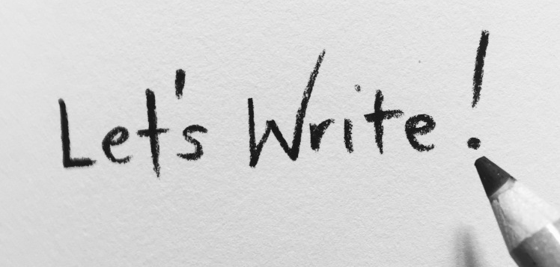

Name:
Class:

Big Questions
Week 1 | BQ: How do I approach a GCSE creative writing task?
Week 1 | BQ: How can I improve the vocabulary I use in my writing?
Week 1 | BQ: How can I vary my sentence starters?
Week 2 | BQ: How can I create an effective opening?
Week 2 | BQ: How can I create an effective ending?
Week 2 | BQ: How can I improve my creative writing?
Week 3 | BQ: How can I craft and engaging character description?
Week 3 | BQ: What makes an engaging opening?
Week 3 | BQ: How can I add more detail to my description?
Week 4 | BQ: How can I use my vocabulary choices to change the mood of my writing?
Week 4 | BQ: How can I plan and write creatively?
Week 4 | BQ: How can I improve my creative writing?
Week 5 | BQ: How can I build tension within a story or description?
Week 5 | BQ: How can I apply my knowledge of structure to my writing?
Week 5 | BQ: What makes an effective description?
Week 6 | BQ: What should I include in my creative writing?
Week 6 | BQ: What should I include in my creative writing?
Week 6 | BQ: How can I improve my creative writing?
Week 7 | BQ: How can I improve my setting description?
Week 7 | BQ: How can I improve my narrative writing?
Week 7 | BQ: How can I improve my creative writing?

Key Vocabulary
Adjective | A word that describes a place, person or thing e.g. the dangerous man. Adjectives help make your writing more exciting and help people imagine things better!
Adverb | An adverb is a word that tells us how, when, or where something happens. It usually describes a verb (an action word). E.g. the dangerous man ran quickly. Adverbs make your writing more interesting by adding extra detail to the action.
Alliteration | The repetition of the same sound at the beginning of words to create an effect e.g. the dangerous dog dashed into the park.
Colon : | A colon is a punctuation mark that looks like this: : You use a colon to show that something important is coming next, like a list, an explanation, or an example. E.g. I need to buy three things: bread, butter and jam.
Conjunction | A conjunction is a word that joins things together — like words, phrases, or sentences. It helps ideas stick together so they make sense. Think of it like glue for your words. Common conjunctions include:  and – joins things that go together  but – shows something different or opposite  because – explains why something happens  or – gives a choice  For your GCSE, using more sophisticated conjunctions will add extra levels of description and impress the examiner:  Although – shows contrast or something unexpected  Example: Although it was dangerous, she didn’t run away.  Whereas – compares two different things  Example: He stayed calm, whereas others panicked.  Nevertheless – shows that something happened despite a problem  Example: It was risky; nevertheless, he went ahead.  Provided that – shows a condition  Example: You can go outside, provided that it’s safe.  In case – shows something done to prepare for a possible event  Example: Take a torch, in case the power goes out.
Clause | A clause is a group of words that has a verb (an action or doing word). It usually tells us something about what is happening. Some clauses can be a full sentence on their own. Others need more information to make sense. E.g. I ran to the park. is a clause. It has a verb (ran) and makes sense on its own. However, Because it was raining is also a clause, but it doesn’t make sense on its own. It needs more words to complete the idea.
Ellipsis | An ellipsis is three dots like this: ... You use it in writing to show:  Something is missing or left out or a pause or a trailing off in speech or thought. E.g. I was going to say something... but I forgot. The dots show the person stopped talking or thinking. Or He opened the door and saw...The dots make you wonder what happens next!
Metaphor | A metaphor is when you say something is something else, to help people picture it better. It doesn’t mean it’s really that thing — it’s just a way to describe it. E.g. He was a ticking time bomb. This means the man was very dangerous and could explode with anger at any moment — like a bomb!  He’s not really a bomb, but the metaphor helps us understand how scary or unpredictable he is.
Onomatopoeia | Onomatopoeia is when a word sounds like the noise it makes.  These words help make writing more fun and exciting because they let you hear the action! E.g. "Boom!" – The dangerous man threw something, and it exploded with a loud boom. The word boom sounds like a real explosion.
Personification | Personification is when you give human qualities to something that is not human — like an object, animal, or even the weather. It helps readers imagine things better. E.g. The wind howled angrily through the trees.The wind can’t really howl or be angry like a person, but this sentence makes it sound scary — like danger is coming.
Perspective | Perspective means the way someone sees or thinks about something. People can see the same thing but have different ideas about it. It’s like looking at a story through someone else’s eyes. E.g. Imagine a dog runs into a classroom:  From the teacher’s perspective, it might be a problem.  From the children’s perspective, it might be funny.  From the dog’s perspective, it might be scary or confusing.
Preposition | A preposition is a word that tells us where, when, or how something happens. It shows the relationship between things in a sentence. Think of it like a word that helps you understand position, place, or time. E.g. The dog hid under the table;  under tells us where the cat is. Or, She ran away from danger; from shows the direction she ran. In the sentence He arrived after lunch, after tells us when he arrived.
Pronoun | A pronoun is a word that takes the place of a noun (a person, place, or thing). We use pronouns so we don’t have to keep saying the same name or word over and over. E.g. Tom is my friend. He likes football. He is a pronoun that replaces Tom.  The dog barked loudly. It was scared. It is a pronoun that replaces the dog. Sarah and I went to the park. We had fun. We is a pronoun that replaces Sarah and I.
Register | Register means the way you write or speak depending on who you’re talking to and why. You change your words and tone depending on the situation — like being formal or informal. E.g. Talking to your teacher: “Good morning, Miss. May I please borrow a pen?” This is formal — polite and careful. Compare this to talking to your friend: “Can I grab a pen?” This is informal — relaxed and friendly.
Semi-colon ; | A semicolon looks like this: ; It’s used to join two sentences that are closely related. It’s stronger than a comma but not as strong as a full stop. E.g. The storm was getting worse; everyone ran inside. These are two sentences that go together. The semicolon joins them without using words like and or because.
Simile | A simile is a way to describe something by comparing it to something else. It uses the words “like” or “as” to make the comparison. Similes help people imagine things better by painting a picture with words. E.g. She ran like the wind to escape danger. This means she ran very fast, just like the wind moves quickly.
Subordinate Clause | A subordinate clause is a part of a sentence that has a verb, but it doesn’t make sense on its own. It needs the main part of the sentence to help it. Think of it like a helper — it adds extra information, but it can’t stand alone. E.g. Because it was raining, we stayed inside. The subordinate clause if “Because it was raining” It tells us why we stayed inside, but it doesn’t make sense by itself.
Synonym | A synonym is a word that means the same or almost the same as another word. We use synonyms to make our writing more interesting and to avoid repeating the same word too much. E.g. Big and huge are synonyms.
Tone | Tone is the feeling or attitude in a piece of writing. It’s how the writing sounds to the reader. It can be happy, scary, angry, funny, or even serious — just like how people speak in different ways depending on how they feel.
Verb | A verb is a word that shows an action or something happening. It tells us what someone or something does. Verbs can use different tenses (to show when it happened) E.g. the verb run: Past tense (already happened): Yesterday, I ran to the shop. Present tense (happening now): I run to school every morning. Future tense (will happen later): Tomorrow, I will run in the race.

SPACE FOR ADDITIONAL VOCABULARY

Qu

Question Breakdown

 | Question | Time | Skills assessed
Paper One  1hr 45mins | Q5: Creative writing  40 marks | 45mins | AO5 and AO6
Paper One  1hr 45mins | Planning  - Gathering ideas  - Organising the structure | 10mins | AO5
Paper One  1hr 45mins | Writing  -Getting your ideas down on the page | 25 mins | AO5 and AO6
Paper One  1hr 45mins | Proofreading/ Editing  -Checking your SPAG  -Improving your vocabulary  -Adding or changing anything to improve your writing | 10 mins | AO6

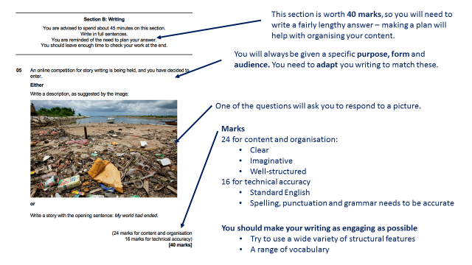

Example Answer: Paper 1, Question 5
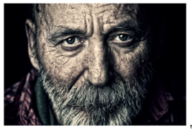
Write a description of an elderly person using your imagination, you can use the picture to help with your ideas

(24 marks for content and organisation)
(16 marks for technical accuracy)
40 marks

There stood an old man surrounded by a shroud of darkness almost an endless oblivion of emptiness. His shadow like figure stood out the most as it seemed to be the only light within the room.

I could make out his face from where I was, he had long silky grey hair with blue eyes that stood out enormously, his ears were the shape of that of a goblins ear, he had lips that were cherry red, he had little divots in his lips lined with white dry skin along the rim.

He stood stationary in solitude and peace a slight lean, perhaps a back problem of some sort. My eyes were fixed on his figure, it looked as if he had no skin or fat on his body.

His clothes drowned him as if he was too small to be in them, his pants, rolled up at the waist, were rigid and wrinkled at the bottoms, and had multiple enormous tears down either side. His skin on his hand was wrinkled like a Siamese cat’s skin, and his bone could be seen piercing through his skin like a hot knife through butter. His cheek bones were rigid an uneven like the side of a cliff, his skin overlapped and looked almost like leather.

He wore a jacket. A denim jacket to be exact, sea blue with luxurious golden buttons to seal it, his collar stood on end like a soldier saluting his country. And in the elbow, there was visible padding with the logo of the brand, the logo was purple black and pink with an italic font, it stood out massively.

The old man wore brown sandals with a with a deep dark blue strap that rose up like a wave then reconnected like the break of a wave, his heal was visible and had dry flaky skin that was peeling off the back of his foot.

He had a moustache too, very well trimmed a sort of greyish colour with a few black hairs that stood out like a giant in a crowd of normal sized people.

The man, when he walked had a limp, it was a subtle limp but it was there. I believe it was from age, or his frail old muscles finally starting to give way from his prosperous and mysterious life of solitude and loneliness.

The old man left without saying a word, he majestically strolled out of the door and disappeared into the abyss of darkness never to be seen or heard from again, at least for now.

This is an upper level 2 response because:
- The style is matched to the text type and audience
- There is some use of higher level vocabulary and language tools
- Most of your sentences are clear and have the right punctuation.

Homework Tasks.

Knowledge is power, so the more you know, the more secure you will be in your learning.

Year 10: Unit 2 Additional English Homework
Task 1: | Due date: | - Read the extract on page 7  - Answer the questions on page 8  - Select an image from page 8 or 9 as the inspiration for a descriptive paragraph.
Task 2: | Due date: | - Read the extract on page 10-11  - Annotate the structure of the extract in the margins  - Answer the question on page 11  - Continue the narrative from the extract on page 12.
Task 3: | Due date: | - Select one of the two tasks on page 13  - Make a plan in the space on page 13  - Write a full creative response on pages 14-15

Homework 1: Djinn Patrol on the Purple Line by Deepa Anappara

When local children begin to go missing on the edge of a sprawling Indian city, Jai and his friends take matters into their own hands in order to uncover the truth.
___________________________________________________________________________
Extract

I look at our house with upside-down eyes and count five holes in our tin roof. There might be more, but I can’t see them because the black smog outside has wiped the stars off the sky. I picture a djinn crouching down on the roof, his eye turning like a key in a lock as he watches us through a hole, waiting for Ma and Papa and Runu-Didi to fall asleep so that he can draw out my soul. Djinns aren’t real, but if they were, they would only steal children because we have the most delicious souls.
My elbows wobble on the bed, so I lean my legs against the wall. Runu-Didi stops counting the seconds I have been topsy-turvy and says, ‘Arrey, Jai, I’m right here and still you’re cheating-cheating. You have no shame, kya?’ Her voice is high and jumpy because she’s too happy that I can’t stay upside down for as long as she can.
Didi and I are having a headstand contest but it’s not a fair one. The yoga classes at our school are for students in Standard Six and above, and Runu-Didi is in Standard Seven, so she gets to learn from a real teacher. I’m in Standard Four, so I have to rely on Baba Devanand on TV, who says that if we do headstands, children like me will:
- never have to wear glasses our whole lives;
- never have white in our hair or black holes in our teeth;
- never have puddles in our brains or slowness in our arms and legs;
- always be No. 1 in School + College + Office + Home.
I like headstands a lot more than the huff-puff exercises Baba Devanand does with his legs crossed in the lotus position. But right now, if I stay upside down any longer, I’ll break my neck, so I flump to the bed that smells of coriander powder and raw onions and Ma and bricks and cement and Papa...

Glossary:
djinn- a spirit (lower than an angel) from Arabian and Muslim mythology who possess humans
Arrey- Hindi for Hey or an exclamation to express annoyance
kya- Hindi for What?
Baba- Father or Wise Man (a way of showing respect to an older man- like Sir)

What does the quotation: “count five holes in our tin roof” reveal about Jai’s family? ___________________
_____________________________________________________________________________________________________________________________________________________________________________________________________________________________________________________________________
How does the writer show us that the story is set in India? ________________________________________
_____________________________________________________________________________________________________________________________________________________________________________________________________________________________________________________________________

Find 4 examples from the text that indicate that Jai is a young boy?
1-_____________________________________________________________________________________
_______________________________________________________________________________________
2-_____________________________________________________________________________________
_______________________________________________________________________________________
3-_____________________________________________________________________________________
_______________________________________________________________________________________
4-_____________________________________________________________________________________
_______________________________________________________________________________________

Select one of the images above and write a descriptive paragraph focused on a child.
Try and avoid telling the reader that they are a child.
Instead use hints the way Anappara does.

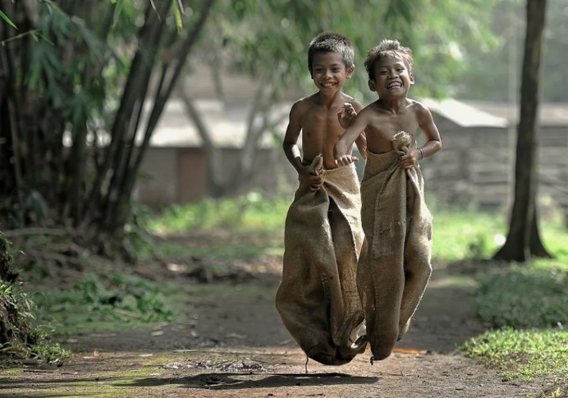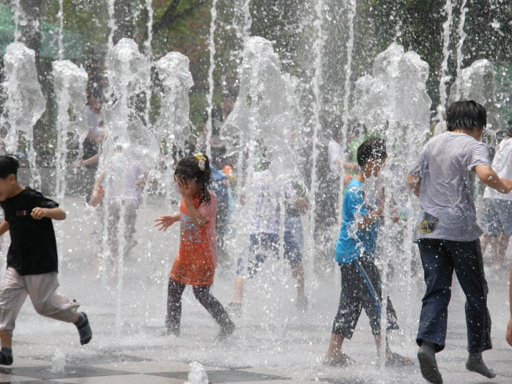
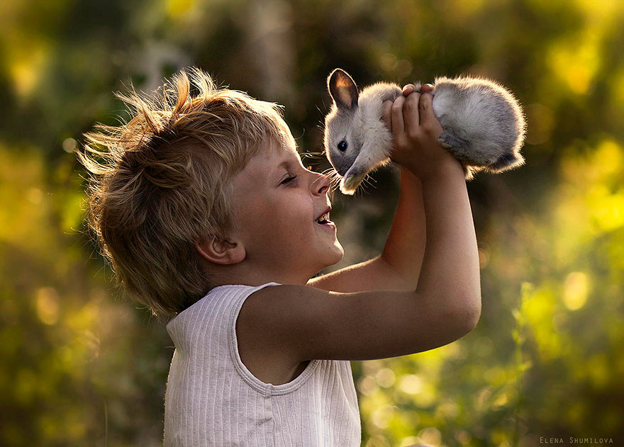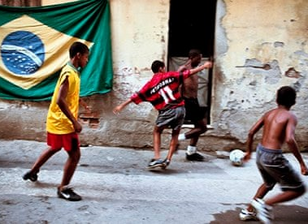

______________________________________________________________________________________________________________________________________________________________________________________________________________________________________________________________________________________________________________________________________________________________________________________________________________________________________________________________________________________________________________________________________________________________________________________________________________________________________________________________________________________________________________________________________________________________________________________________________________________________________________________________________________________________________
How have you made it clear you are describing a child?
1-_____________________________________________________________________________________
_______________________________________________________________________________________
2-_____________________________________________________________________________________
_______________________________________________________________________________________
3-_____________________________________________________________________________________
_______________________________________________________________________________________
4-_____________________________________________________________________________________
_______________________________________________________________________________________

Homework 2: Djinn Patrol on the Purple Line by Deepa Anappara
When local children begin to go missing on the edge of a sprawling Indian city, Jai and his friends take matters into their own hands in order to uncover the truth.
___________________________________________________________________________
Extract

The cold slithers up my bare feet. Shadows and voices judder
across the alley. The smog combs my hair with fingers that are
smoky but also damp at the same time. People shout, ‘What’s
happening? Has something happened? Who’s screaming? Did
someone scream?’ Goats that their owners have dressed in old
sweaters and shirts so they won’t catch a chill hide under the
charpais on both sides of the alley. The lights in the hi-fi buildings
near our basti blink like fireflies and then disappear. The current’s
gone off.
I don’t know where Ma and Runu-Didi are. Women wearing clinking
glass bangles hold up mobile-phone torches and kerosene lanterns
but their light is wishy-washy in the smog.
Everyone around me is taller than I am, and their worried hips and
elbows knock into my face as they ask each other about the screams.
We can tell by now that they are coming from Drunkard Laloo’s house.
‘Something bad is going on over there,’ a chacha who lives in our alley
says. ‘Laloo’s wife was running around the basti, asking if anyone had
seen her son. She was even at the rubbish ground, calling his name.’
‘That Laloo too, all the time beating his wife, beating his children,’ a
woman says. ‘Just you wait and see, one day his wife will also disappear.
What will that useless fellow do for money then? From where will he
get his hooch, haan?’
I wonder which one of Drunkard Laloo’s sons is missing. The eldest,
Bahadur, is a stutterer who is in my class.
The earth twitches as a metro train rumbles underground somewhere
near us. It will worm out of a tunnel, zoom past half-finished buildings,
and climb up a bridge to an above-ground station before returning to
the city because this is where the Purple Line ends. The metro station
is new, and Papa was one of the people who built its sparkly walls.
Now he’s making a tower so tall they have to put flashing red lights
on top to warn pilots not to fly too low.
The screams have stopped. I’m cold and my teeth are talking among
themselves. Then Runu-Didi’s hand darts out of the darkness, snatches
me, and drags me forward. She runs fast, as if she’s competing in a
relay race and I’m the baton she’s about to pass to a teammate.
‘Stop,’ I say, hitting the brakes. ‘Where are we going?’
‘Didn’t you hear what people were saying about Bahadur?’
‘He’s lost?’
‘You don’t want to find out more?’

Glossary:
charpais- a traditional woven bed used in South Asia
basti- a slum (shantytown) inhabited by poor people
chacha- Hindi for Uncle (in South Asian culture it is common to refer to any man or woman of the same culture as Uncle and Aunty even if they are not directly related to you)
hooch- an alcoholic drink

How has the writer structured (put each part together in the order they have) the text?
-Annotate the extract, highlighting each time the focus shifts to something new . You could use the following sentence starters to help:: Firstly the writer presents…. So that the reader feels / understands…. Then the readers attention is shifted to…

e.g. Firstly the writer presents the reader with a first person description of the character’s feelings when he says “The cold slithers up my bare feet”. This immediately places the reader in the scene as if they were the character themselves. It creates curiosity because…

How has the writer built up tension (suspense / anticipation)?
-What has the writer done to keep us interested?
-How is the information about the missing child revealed to us?
_____________________________________________________________________________________________________________________________________________________________________________________________________________________________________________________________________________________________________________________________________________________________________________________________________________________________________________________________________________________________________________________________________________________________________________________________________________________________________________________________________________________________________________________________________________________________________________________________________________________________________________________________________________________________________________________________________________________________________________________________________________________________________________________________________________________________________________________________________________________________________________________________________________________________________________________________________________________________________________________________________________________________________________________________________________________________________________________________________________________________________________________________________________________________________________________________________________________________________________________________________________________________________________________________________________________________________________________________________________________________________________________________________________________________________________________________________________________________________________________________________________________________________________________________________________________________________________________________________________________________________________________________________________________________________________________________________________________________________________________________________________________________________________________________________________________________________________________________________________________________________________________________________________________________________________________________________________________________________________________________________________________________________________________________________________________________________________________________________________________________________________________________________________________________________________________________________________________________________________________________________________________________________________________________________________________________________________________________________________

Continue writing the story from where the extract leaves off.
- Consider how you will describe Jai and his sister running through the basti at night
- Where are they running to?
- What do they find out about the missing child, Bahadur?
__________________________________________________________________________________________________________________________________________________________________________________________________________________________________________________________________________________________________________________________________________________________________________________________________________________________________________________________________________________________________________________________________________________________________________________________________________________________________________________________________________________________________________________________________________________________________________________________________________________________________________________________________________________________________________________________________________________________________________________________________________________________________________________________________________________________________________________________________________________________________________________________________________________________________________________________________________________________________________________________________________________________________________________________________________________________________________________________________________________________________________________________________________________________________________________________________________________________________________________________________________________________________________________________________________________________________________________________________________________________________________________________________________________________________________________________________________________________________________________________________________________________________________________________________________________________________________________________________________________________________________________________________________________________________________________________________________________________________________________________________________________________________________________________________________________________________________________________________________________________________________________________________________________________________________________________________________________________________________________________________________________________________________________
Homework 3: Question 5- Creative Writing
Q5: Either
Write a description based on this image using your imagination. You can use the image to help with ideas:
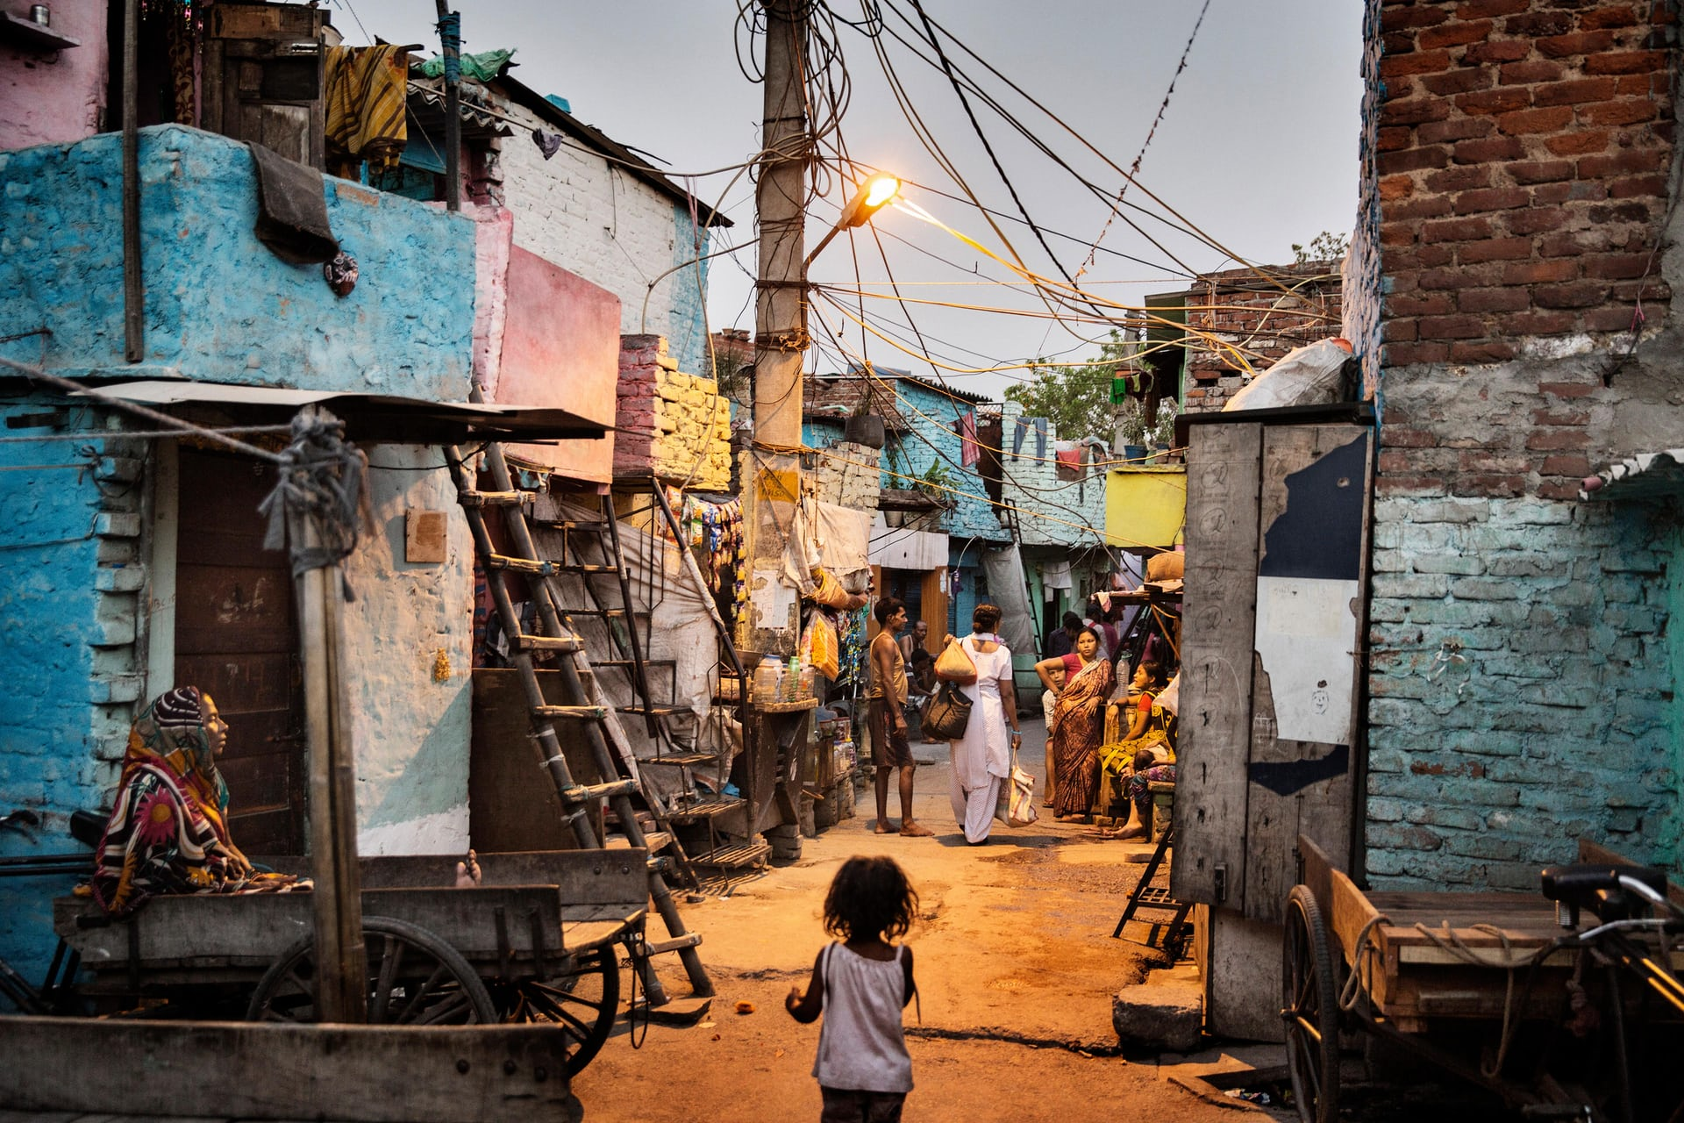
Or
Write the opening of a story involving a missing child.
(24 marks for Content and Organisation
16 marks for Technical Accuracy)
[40 marks]
Plan
_____________________________________________________________________________________________________________________________________________________________________________________________________________________________________________________________________________________________________________________________________________________________________________________________________________________________________________________________________________________________________________________________________________________________________________________________________________________________________________________________________________________________________________________________________________________________________________________________________________________________________________________________________________________________________________________________________________________________________________________________
My Writing
_____________________________________________________________________________________________________________________________________________________________________________________________________________________________________________________________________________________________________________________________________________________________________________________________________________________________________________________________________________________________________________________________________________________________________________________________________________________________________________________________________________________________________________________________________________________________________________________________________________________________________________________________________________________________________________________________________________________________________________________________________________________________________________________________________________________________________________________________________________________________________________________________________________________________________________________________________________________________________________________________________________________________________________________________________________________________________________________________________________________________________________________________________________________________________________________________________________________________________________________________________________________________________________________________________________________________________________________________________________________________________________________________________________________________________________________________________________________________________________________________________________________________________________________________________________________________________________________________________________________________________________________________________________________________________________________________________________________________________________________________________________________________________________________________________________________________________________________________________________________________________________________________________________________________________________________________________________________________________________________________________________________________________________________________________________________________________________________________________________________________________________________________________________________________________________________________________________________________________________________________________________________________________________________________________________________________________________________________________________________________________________________________________________________________________________________________________________________________________________________________________________________________________________________________________________________________________________________________________________________________________________________________________________________________________________________________________________________________________________________________________________________________________________________________________________________________________________________________________________________________________________________________________________________________________________________________________________________________________________________________________________________________________________________________________________________________________________________________________________________________________________________________________________________________________________________________________________________________________________________________________________________________________________________________________________________________________________________________________________________________________________________________________________________________________________________________________________________________________________________________________________________________________________________________________________________________________________________________________________________________________________________________________________________________________________________________________________________________________________________________________________________________________________________________________________________________________________________________________________________________________________________________________________________________________________________________________________________________________________________________________________________________________________________________________________________________________________________________________________________________________________________________________________________________________________________________________________________________________________________________________________________________________________________________________________________________________________________________________________________________________________________________________________________________________________________________________________________________________________________________________________________________________________________________________

This unit is all about your ability to read for meaning.
Make sure you are reading a wide range of Fiction texts at home and use the Library in school to help support you when selecting a text to read.

Some useful revision resources you can use to help support your practice of the exam questions are below. Scan the QR code to access the webpage.

Mr Bruff’s YouTube Channel
Language Paper 1 Playlist – lots of useful videos and resources for you to use here. →


AQA English Language Past Papers
Language Paper 1 samples for you to practice with – lots of resources for home study. →


Stacey Reay’s YouTube Channel
Language Paper 1 Playlist – lots of useful videos and resources for you to use here. →

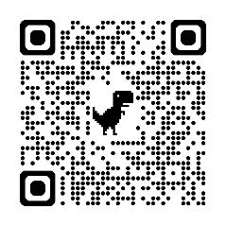
AQA English Revision – website
Some good tips and practice questions can be found here. →


Massolit
Sign up to Massolit with your school email to access a whole range of resources for your Year 10 Revision! →

Novels
Anappara, Deepa:.Djinn Patrol on the Purple Line.
Reynolds, Jason and Kiely, Brendan: All American Boys. New York: Simon & Schuster, 2015.

Films
Life of Pi (2012)
Slumdog Millionaire (2008)

Wider reading list + Revision resources

