
Class:

Knowledge Organiser
Year 10: Unit 1
Language Paper 1 Section A + A Christmas Carol

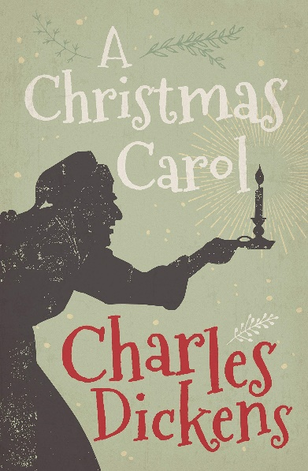


Name:
Class:

Big Questions

Our study of Language Paper 2 and A Christmas Carol will follow the structure below:
Language Paper 1: Section A | - BQ: how can I effectively read and annotate a fiction text?  - BQ: how can I successfully analyse language methods used by a writer? [Q1 + Q2 focus]  - BQ: how can I evaluate the structure of a text? [Q3 focus]  - BQ: how can I critically evaluate a text? [Q4 focus]  - BQ: how can language be used to reflect the ideas in a text? [Q1 + Q2 focus]  - BQ: how do I approach analysing language in fiction texts? [Q1 + Q2 focus]Assessment Point 1  - BQ: how can I develop my appreciation and analysis of language? Whole Class Feedback [Q1 + Q2]  - BQ: what structural methods can I evaluate in a text? [Q3 focus]  - BQ: how can I consider the semantic field of a text? [Q1 + Q2 focus]  - BQ: how does the way a text is structured impact on the message conveyed? [Q3 focus]  - BQ: how can I engage with a statement and write critically? [Q4 focus]  - BQ: how does a writer use language to describe? [Q1 + Q2 focus]  - BQ: what does a successful language analysis answer consist of? [Q1 +Q2]  - BQ: how can structure be used to build suspense? [Q3 focus]  - BQ: what makes a successful and clear critical evaluation? [Q4 focus]  - BQ: how can a writer use language to establish the genre of a text? [Q1 + Q2 focus]  - BQ: how can a writer use structure to interest a reader? [Q3 focus]  - BQ: how can I write an evaluative critical analysis? [Q4 focus] Assessment Point 2  - BQ: how can a writer use language to reflect the themes in a text? [Q1 + Q2 focus]  - BQ: how can I develop my critical analysis? Whole Class Feedback [Q4]
Literature Paper 1: A Christmas Carol | - BQ: What is the plot of A Christmas Carol?  - BQ: Why did Charles Dickens choose to write A Christmas Carol?  - BQ: How is Scrooge characterised?  - BQ: How does Dickens present the need for social responsibility?  - BQ: How does Dickens present Scrooge as an outsider to society?  - BQ: How can I improve my analytical writing?  - BQ: What is Marley’s warning to Scrooge  - BQ: What lesson does Scrooge learn from the Ghost of Christmas Past?  - BQ: How does Scrooge’s isolation impact his character?  - BQ: How does Dickens present the effects of loneliness and isolation in A Christmas Carol?  - BQ: How has Scrooge changed since the start if the novella?  - BQ: How does Dickens present the importance of generosity?  - BQ: How has the past affected Scrooge’s character?  - BQ: What is the importance of Christmas within the plot?  - BQ: How does Dickens present ideas about poverty and family?  - BQ: How does Dickens use the Cratchit family to show the struggles of the poor?  - BQ: What lesson does Scrooge learn from the Ghost of Christmas Present?  - BQ: What is the importance of Fred within the novella?  - BQ: What is Dickens attitude towards greed?  - BQ: What does Scrooge learn from the Ghost of Christmas Yet to Come?  - BQ: How does Dickens present ideas about charity and greed?  - BQ: How does Dickens present Scrooge’s fears?  - BQ: How has Scrooge changed since the start of the novella?  - BQ: How does Tiny Tim’s death affect the Cratchits?  - BQ: How does Dickens show Scrooge’s transformation?  - BQ: Does Scrooge achieve redemption?

Exam Criteria and Assessment Objectives for Language Paper 1

Assessment Objectives
AO1 | Pick out and understand pieces of explicit and implicit information from the text(s).  Collect and put together information from different texts.
AO2 | Explain how writers use language and structure to achieve their purpose and influence readers.  Use technical terms to support your analysis of language and structure.
AO3 | Identify different writers’ ideas and perspectives.  Compare the method used by different writers to convey their ideas.
AO4 | Critically evaluate texts, giving a personal opinion about how successful the writing is.  - Provide detailed evidence from the text to support your opinion.

Paper Timings for Language Paper 1

 | Question | Time | Skills assessed
15 minutes reading time
Paper One  1hr 45mins | Q1: Four Multiple-Choice questions  4 marks | 5 minutes | AO1
Paper One  1hr 45mins | Q2: How does the writer use language…  8 marks | 10mins | AO2
Paper One  1hr 45mins | Q3: How does the writer use structure to…?  8 marks | 10mins | AO2
Paper One  1hr 45mins | Q4: Statement and to what extent do you agree?  20 marks | 20mins | AO4
Paper One  1hr 45mins | Q5: Creative writing  40 marks | 45mins | AO5 and AO6

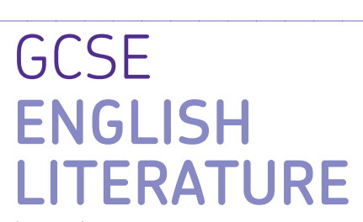
AQA GCSE English Literature Paper 1

Paper 1: Shakespeare and the 19th century Novel

What’s assessed = Macbeth & A Christmas Carol

How it’s assessed: Written exam 1 hour 45 minutes, 64 marks, 40% of GCSE

Questions:

Section A Shakespeare: students will answer one extract based essay question on their studied play.

Section B 19th century novel: students will answer one extract based essay question on their studied novel..

Mark schemes Literature Exams

Assessment objectives (AOs)

AO1 Read, understand and respond to texts. Students should be able to:

• maintain a critical style and develop an informed personal response

• use textual references, including quotations, to support and illustrate interpretations.

AO2 Analyse the language, form and structure used by a writer to create meanings and effects, using relevant subject terminology where appropriate.

AO3 Show understanding of the relationships between texts and the contexts in which they were written.

AO4 Use a range of vocabulary and sentence structures for clarity, purpose and effect, with accurate spelling and punctuation
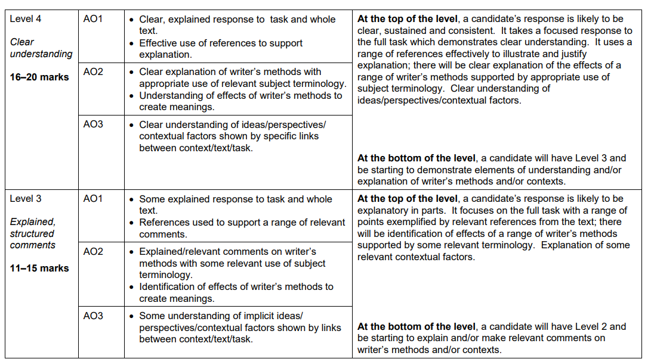
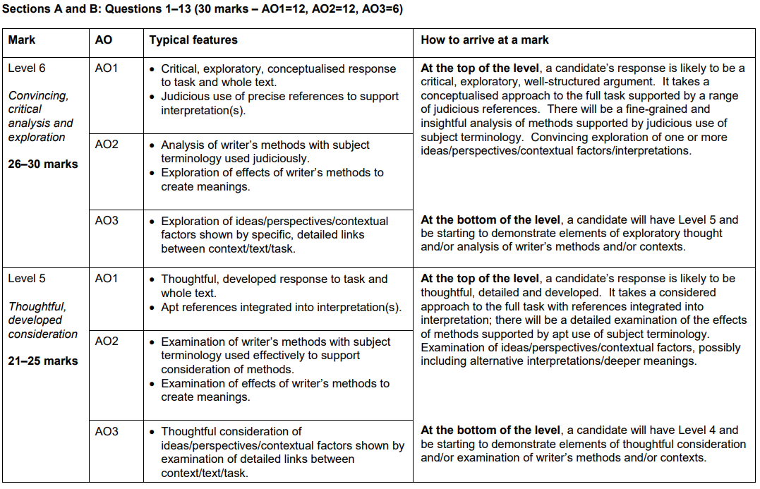

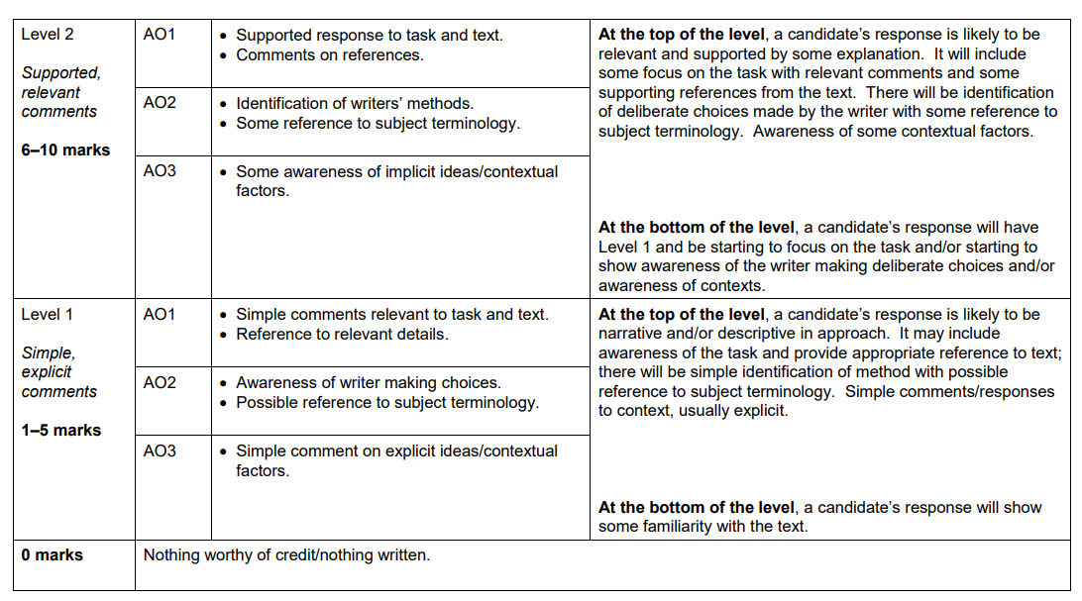

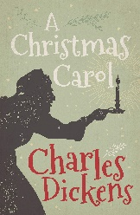
A Christmas Carol Key Terminology

 | Term | Definition
1 | Allegory | An expression created through fictional figures to expose a truth or idea about human existence.
2 | Characterisation | How a character is presented/ how they have been created/ designed.
3 | Contrast | Using two opposing things/ ideas within a text to highlight or exaggerate the difference between the two
4 | Empathy | Being able to understand someone else’s emotions, feelings or experiences by imagining what it might be like to be in that person’s particular situation
5 | Foil | A character with qualities that are in contrast with another character
6 | Generosity | The quality of being kind and being ready to give more to others than is necessary or expected
7 | Isolation | The process of being alone or apart from others
8 | Juxtaposition | Placing two opposites directly next to each other to highlight or exaggerate their difference.
9 | Metaphor | A direct comparison of something to something else
10 | Miser | A person who hoards money and wealth and spends as little money as possible/
11 | Morality | Principles, either personal or social, concerning the difference between right and wrong, going beyond legality and often religion.
12 | Motif | An element that reoccurs, such as a word, phrase, idea, image or symbol that appears throughout the play for emphasis
13 | Omniscient | All knowing/ all seeing
14 | Redemption | The action of saving or being saved from sin, error or evil
15 | Responsibility | Having a duty to deal with something/ being accountable or to blame for something
16 | Reverently | A feeling or attitude of deep respect tinged with awe, often used in relation to religion
17 | Pathetic Fallacy | Using the weather to mirror the feelings or mood within the text or to symbolise an idea.
18 | Simile | A description where you compare one thing to something else using ‘like’ or ‘as’
19 | Suppressed | To forcibly put an end to/ to avoid considering something.
20 | Symbolism | The use of symbols (objects/ descriptions) to represent ideas or qualities


Language Paper 1 Key Terminology

 | Term | Definition
1 | Adjective | A word that is used to describe a noun. ‘The ugly man.’
2 | Alliteration | When words start with the same sound or letter ‘Sammy sold seashells’
3 | Antithesis | Where two things are the direct opposite and contrast with one another.
4 | Chronology | The arrangement of events in time order – or as they occurred in sequence.
5 | Climax | The height of the action in a text.
6 | Dialogue | Sections of a text that are identifiable by characters speaking.
7 | Evaluate | To judge and assess something using evidence.
8 | Foreshadowing | Where a writer drops hints in the text at events to come later on.
9 | Imagery | Language in a text that helps create a visual image for the reader.
10 | Juxtaposition | Placing two images or ideas close together for the purpose of comparison similarity or contrast.
11 | Metaphor | A direct comparison of two things in which it is representative or symbolic of something else.
12 | Narrative Perspective | The point of view the text is written from.
13 | Oxymoron | Where two contrasting words are placed next to one another e.g. ‘Bitter Sweet’
14 | Onomatopoeia | When a word imitates a sound like ‘bang’.
15 | Pathetic Fallacy | Where the writer uses the weather and/or atmosphere to reflect the mood in a text.
16 | Personification | Giving an object human characteristic
17 | Semantic Field | When we have words that are all linked in meaning used to create a particular image/ feeling and keep this consistent in the mind of the reader
18 | Shift in Focus | When a writer deliberately crafts the text to draw our attention to something else.
19 | Simile | A comparison of two things using the words ‘like’ and/or as’
20 | Tone | The overall feeling, mood or atmosphere created by a writer.

Space for Additional Terminology

Example questions

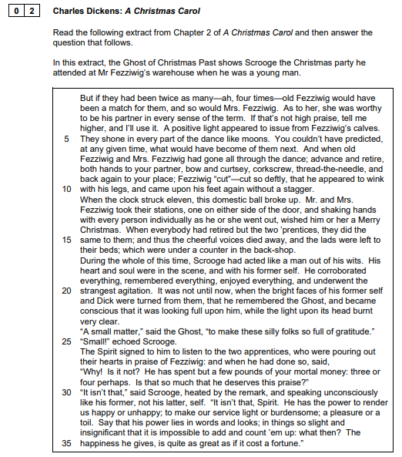

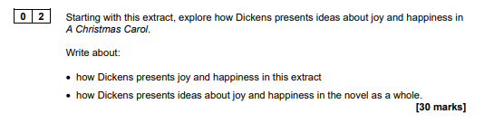

Example essay

Starting with this extract, explore how Dickens presents female characters in A Christmas Carol.

In A Christmas Carol, women are presented as a source of joy associated with the home. Whilst female characters play a role in Scrooge’s redemption, they are shown as supporting characters without their own significance, thus mirroring the role of women in Victorian society.

The extract presents young women as of little significance, and as being primarily associated with the home rather than educational settings. This is shown by Fan , who is described not by her name by as a ‘little girl’ thereby diminishing her status and establishing her as a side character with ‘little’ significance. Whilst this could describe her youth rather than her gender. Scrooge states she is ‘quite a woman’ in spite of her ‘childish eagerness’, suggesting that women are not expected to mature or learn beyond this stage. Fan’s home-making role in the novel is evident when she states that she has come ‘To bring you home, home, home!’ This quick repetition emphasises that ‘home’ is where Fan is from and where she will remain, contrasting with Scrooge’s ability to leave to attend school- albeit unhappily. Here, Fan’s situation mirrors women’s limited opportunities to move beyond the home and access education in Victorian England.

Whilst some male character in the novel, notably Scrooge, enjoy lives of power and enterprise, the role of the women is as wives and mother, confined to the home. Even when Belle leaves Scrooge in Stave Two, she does this reasoning that ‘I release you. With a full heart, for the love of him you once were’; the decisive monosyllables and a focus on ‘love’ showing that this decision is to benefit Scrooge. Further mirroring the ‘little girl’ in this extract, Mrs Cratchit is not introduced by her own name but rather as ‘Cratchit’s wife’, creating a sense of male ownership through marriage without autonomy of her own. Her role inside the home is evident, as Bob Cratchit regards the Christmas pudding as ‘the greatest success achieved by Mrs Cratchit since their marriage’. She is the home-maker, whereas Bob Cratchit’s role is leader and provider for the family, both usual roles in Victorian society. This contrast between men and women is depicted in the unseen but powerful ‘Father’ in the extract. When Fan says. ‘he said Yes, you should’. It is evident that Scrooge’s father as the man of the household, makes the key decisions.

The female characters in A Christmas Carol do, however, aid Scrooge’s redemption (when the spirits play the scenes back to him) and retain opinions of their own. In the extract, this is shown through Fan’s joyous spirit as she ‘stood on tiptoe to embrace him’, physically representing familial love and teaching Scrooge the value of this. Similarly, Belle plays a part in Scrooge’s redemption, when the scene from his youth is presented to him, her decision to leave him shows what can be lost through greed when she argues that ‘another idol has displaced me…a golden one’. The appeal of both Belle and Fan is clearly focused around pathos: they show the importance of emotion and love, thus reinforcing gender stereotypes.

Throughout the novel, the key role of women is to bring joy to the male characters. In the extract, this is shown through the happiness brought by Fan who ‘came darting in, and putting her arms about his neck, and often kissing him’, this accumulating list emphasising the joy she brings to Scrooge, an otherwise ‘solitary child, neglected by his friends’.

Overall, it is evident that women in the text, whilst aiding Scrooge’s transformation, are held back by both Victorian societal norms and the male characters in the novel. The assumption that female characters will have supporting roles as wives and mothers is never challenged by Dickens and their servitude is never included in the list of injustices portrayed in the novel.

Homework Tasks.

Knowledge is power, so the more you know, the more secure you will be in your learning.

Year 10: Unit 2 Homework: English Language Paper 1 and A Christmas Carol
Task 1: | Due date:  WEEK 2 | - Read through the extract from Lost Hearts  - Answer the questions that follow (Q1 & Q2)
Task 2: | Due date:  WEEK 4 | - Read the information on Thomas Malthus and the Poor Law  - Answer the 10 questions on this – these will be marked in class with your teacher
Task 3: | Due date:  WEEK 6 | - Select words from each quotation to analyse  - Use your notes to write a short paragraph analysing each character.
Task 4: | Due date:  WEEK 8 | - Read the example essay on the spirit of Christmas  - Answer the 10 questions on this– these will be marked in class with your teacher
Task 5: | Due date:  WEEK 10 | - Read the summary of A Christmas Carol.  - Answer the 10 questions on this- these will be marked in class with your teacher.
Task 6: | Due date:  WEEK 12 | - Re-read the final part of the extract from List Hearts.  - Answer the question that follows (Q4)

If you have ‘no homework’, or you have finished all of the above, try these tasks on a weekly
basis to ensure your understanding is secure.
- Use the Wider Reading page on the back of the Knowledge Organiser and download some more practice papers from AQA.
- Add words to your key terminology grid in the Knowledge Organiser
- Read for at least 20 minutes per day – a mixture of fiction and non-fiction texts.
- Revise online using YouTube and refer to Mr Bruff, Stacey Reay and AQA revision channels.

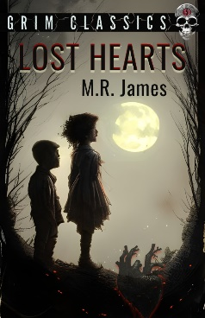
Homework 1: Practice Language Paper 1, question 1 and 2
Read the opening of a short story called ‘Lost Hearts’ by M.R. James.
Then answer the two questions that follow.

It was, as far as in September of the year 1811 that a post-chaise (horse drawn carriage) drew up before the door of Aswarby Hall, in the heart of Lincolnshire. The little boy who was the only passenger in the chaise (horse drawn carriage), and who jumped out as soon as it had stopped, looked about him with the keenest curiosity during the short interval that elapsed between the ringing of the bell and the opening of the hall door. He saw a tall, square, red-brick house, built in the reign of Anne; a stone-pillared porch had been added in the purer classical style of 1790; the windows of the house were many, tall and narrow, with small panes and thick white woodwork. A pediment, pierced with a round window, crowned the front. There were wings to right and left, connected by curious glazed galleries, supported by pillars, with the central block. These wings plainly contained the stables and offices of the house. Each was surmounted by an ornamental dome with a gilded (gold) vane.
An evening light shone on the building, making the window-panes glow like so many fires. Away from the Hall in front stretched a flat park studded with oaks and fringed with firs, which stood out against the sky. The clock in the church-tower, buried in trees on the edge of the park, only its golden weather-cock (instrument used for showing the direction of the wind) catching the light, was striking six, and the sound came gently beating down the wind. It was altogether a pleasant impression, though tinged with the sort of melancholy (melancholy = deep sadness) appropriate to an evening in early autumn, that was conveyed to the mind of the boy who was standing in the porch waiting for the door to open to him.
The post-chaise (horse drawn carriage) had brought him from Warwickshire, where, some six months before, he had been left an orphan. Now, owing to the generous offer of his elderly cousin, Mr Abney, he had come to live at Aswarby.
That night he had a curious dream. At the end of the passage at the top of the house, in which his bedroom was situated, there was an old disused bathroom. It was kept locked, but the upper half of the door was glazed, and, since the muslin curtains which used to hang there had long been gone, you could look in and see the lead-lined bath affixed to the wall on the right hand, with its head towards the window.
On the night of which I am speaking, Stephen Elliott found himself, as he thought, looking through the glazed door. The moon was shining through the window, and he was gazing at a figure which lay in the bath.
His description of what he saw reminds me of what I once beheld myself in the famous vaults of St Michan’s Church in Dublin, which possesses the horrid property of preserving corpses from decay for centuries. A figure inexpressibly thin and pathetic, of a dusty leaden colour, enveloped in a shroud-like garment, the thin lips crooked into a faint and dreadful smile, the hands pressed tightly over the region of the heart.
As he looked upon it, a distant, almost inaudible moan seemed to issue from its lips, and the arms began to stir. The terror of the sight forced Stephen backwards and he awoke to the fact that he was indeed standing on the cold boarded floor of the passage in the full light of the moon. With a courage which I do not think can be common among boys of his age, he went to the door of the bathroom to ascertain if the figure of his dreams were really there. It was not, and he went back to bed.

Q1 – 4 marks – 5 minutes
Read again the first part of the source from lines 1-11.
Answer all parts of this question.
Tick (✔) one box for each question. [4 marks]

1. Where does the post-chaise stop?

Before the door

By the right wing

By the stables

2. When is the story set?

The reign of Anne

1790

1811

3. What is the boy like at the opening of the extract?
Excited

Intrigued

Anxious

4. What is the house like?
Plain

Dilapidated

Grand

Q2– 8 marks – 10 minutes
Using lines 28-41 from the short story.
How does the writer use language to describe the strange figure (person) Stephen sees? ~
You could include the writer’s choice of:
- words and phrases
- language features and techniques
- sentence forms

Follow this paragraph structure:
WHAT: Idea linked to the question and supporting evidence (quotation)
HOW: Analyse the word choices and/ or methods in the quotation.
WHY: Writer’s intention/ purpose? Effect on the reader?

_______________________________________________________________________________________
_______________________________________________________________________________________
_______________________________________________________________________________________
_______________________________________________________________________________________
_______________________________________________________________________________________
_______________________________________________________________________________________
_______________________________________________________________________________________
_______________________________________________________________________________________
_______________________________________________________________________________________
_______________________________________________________________________________________
_______________________________________________________________________________________
_______________________________________________________________________________________
_______________________________________________________________________________________
_______________________________________________________________________________________
_______________________________________________________________________________________
_______________________________________________________________________________________
_______________________________________________________________________________________
_______________________________________________________________________________________
_______________________________________________________________________________________
_______________________________________________________________________________________
_______________________________________________________________________________________
_______________________________________________________________________________________
_______________________________________________________________________________________
_______________________________________________________________________________________
_______________________________________________________________________________________
______________________________________________________________________________________________________________________________________________________________________________
_______________________________________________________________________________________
_______________________________________________________________________________________
_______________________________________________________________________________________
______________________________________________________________________________________________________________________________________________________________________________
_______________________________________________________________________________________
______________________________________________________________________________________________________________________________________________________________________________
______________________________________________________________________________________________________________________________________________________________________________
_______________________________________________________________________________________
______________________________________________________________________________________________________________________________________________________________________________
Homework 2: Thomas Malthus and The Poor Law.

Read the information below and answer all 10 questions

Thomas Malthus wrote ‘An Essay on the Principle of Population’ in 1798, which influenced economic beliefs in the 18th century. The essay proposes the theory that reproduction should be limited because the growth of the population would always outrun the growth in the production of food, and thus the life and living conditions for all could only be sustained with a cap on the number of children born. This economic theory is now often known as Malthusianism.

- ‘growth of the population would always outrun the growth in the production of food’. What does this mean?
____________________________________________________________________________________________________________________________________________________________________________________________________________________________________________________________________________________________________________________________________________________________

Malthus proposed the impact of the scarcity of food would be most keenly felt by the ‘lower classes of society’, preventing any ‘great permanent amelioration (improvement) of their condition.’

- Who did Malthus believe would be most affected by this issue?
______________________________________________________________________________________________________________________________________________________________________________

Malthus seems to have been of the view that in supporting the poor financially, there was little incentive on reducing the number of children families had and thus:
‘while every man felt secure that all his children would be well provided for by general benevolence… the most natural and obvious check seemed to be to make every man provide for his own children; that this would operate in some respect as a measure and guide in the increase of population, as it might be expected that no man would bring beings into the world, for whom he could not find the means of support.’

- Who did Malthus believe was responsible for providing for children?
______________________________________________________________________________________________________________________________________________________________________________

This shocking view was directly at odds with the work of the Prime Minister of the day, William Pitt the Younger, who had proposed as part of the Poor Bill ‘a shilling a week to every labourer for each child he has above three.’ Malthus stated that he believed that money would not ‘increase the produce of the country’ and so, despite support for the less well off, ‘the necessary and inevitable consequence appears to be that the same produce must be divided among a greater number’.

- What did the Prime Minister at the time aim to do to support the poor?
______________________________________________________________________________________________________________________________________________________________________________

Not only this, but Malthus was of the view that people who did not have the means to support themselves were to blame for their situation: in his view, they had ‘inconsiderately plunged [themselves] and innocent children in misery and want.’

- Who did Malthus blame for the amount of people living in poverty?
______________________________________________________________________________________________________________________________________________________________________________

In 1834, the Poor Law was established which meant that the to receive support from the government, the poor needed to go into workhouses which were made intentionally horrible to put people off from going there. This law was influenced by Malthus’ theory and the increasingly popular belief that the poor were poor out of choice and laziness.

- How could the poor receive support under the Poor Law?
____________________________________________________________________________________________________________________________________________________________________________________________________________________________________________________________________________________________________________________________________________________________

- In your own words, summarise what you have read.
___________________________________________________________________________________________________________________________________________________________________________________________________________________________________________________________________________________________________________________________________________________________________________________________________________________________________________________
- What is your opinion on Mathus’ theory?
___________________________________________________________________________________________________________________________________________________________________________________________________________________________________________________________________________________________________________________________________________________________________________________________________________________________________________________
- What do you think Scrooge would think of Malthusian theory?
___________________________________________________________________________________________________________________________________________________________________________________________________________________________________________________________________________________________________________________________________________________________________________________________________________________________________________________
- Dickens campaigned against the beliefs shared by Malthus. Why do you think this might have been?
____________________________________________________________________________________________________________________________________________________________________________________________________________________________________________________________________________________________________________________________________________________________

Homework 3: Scrooge and Fezziwig analysis

Scrooge and Fezziwig’s physicality
5. ‘skipping down from the high desk with wonderful agility’
Fezziwig
Scrooge


1. ‘A frosty rime was on his head’
1. ‘organ of benevolence’

2. ‘eyes red’ / ‘thin lips blue’

2. ‘comfortable, oily, rich, fat, jovial voice’
3. ‘grating voice’ / ‘growled Scrooge’

3. ‘rubbed his hands’
‘sharp clap of his hands’

4. (Upon seeing Marley) ‘Scrooge fell upon his knees, and clasped his hands before his face.’

4. ‘A positive light appeared to issue from Fezziwig's calves. They shone in every part of the dance like moons.’

5. ‘The clerk promised that he would; and Scrooge walked out with a growl.’

Task 1: Consider each quotation. Pick one word from each quotation and complete single word analysis in the space provided. Remember, your words should be to do with Scrooge and Fezziwig’s physicality (physicality means their physical appearance or actions)

Scrooge
Word from the quotation | Single Word Analysis
1. “frosty” | The word frost suggests white hair, indicating that Scrooge is old. It also connects to the idea of coldness which mirrors Scrooge’s personality and attitude to others.
2.
3.
4.
5.

Fezziwig
Word from the quotation | Single Word Analysis
1. “benevolence” | The word benevolence means kindness and generosity which suggests that it is in Fezziwig’s nature to provide for others.
2.
3.
4.
5.

Task 2: Using your notes, consider what Scrooge and Fezziwig are like physically, psychologically and emotionally. Summarise your comparisons in a short paragraph.
_______________________________________________________________________________________________________________________________________________________________________________________________________________________________________________________________________________________________________________________________________________________________________________________________________________________________________________________________________________________________________________________________________________________________________________________________________________________________________________________________________________________________________________________________________________________________________________________________________________________________________________________________________________________________________________________________________________________________________________________________________________________________________________________________________________________________________________________________________________________________________________________________________________________________________________________________________________________________________________________________________________________________________________________________________________________________________________________________________________________________________________________________________________________________________________________________________________________________________________________________________________________________________________________________________________________________________________________________________________________________________________________________________________________________________________________________________________________________________________________________________________________________________________________________________________________________
Homework 4 Example essay on the spirit of Christmas
TASK: Read through the following example response and answer the 10 questions that follow.

Read the following extract from Stave Three of A Christmas Carol and then answer the question that follows.
In this extract, The Ghost of Christmas Present and Scrooge visit a street where people are preparing for Christmas.

Nor was it that the figs were moist and pulpy, or that the French plums blushed in modest tartness from their highly-decorated boxes, or that everything was good to eat and in its Christmas dress; but the customers were all so hurried and so eager in the hopeful promise of the day, that they tumbled up against each other at the door, crashing their wicker baskets wildly, and left their purchases upon the counter, and came running back to fetch them, and committed hundreds of the like mistakes, in the best humour possible; while the Grocer and his people were so frank and fresh that the polished hearts with which they fastened their aprons behind might have been their own, worn outside for general inspection, and for Christmas daws to peck at if they chose.
But soon the steeples called good people all, to church and chapel, and away they came, flocking through the streets in their best clothes, and with their gayest faces. And at the same time there emerged from scores of bye-streets, lanes, and nameless turnings, innumerable people, carrying their dinners to the bakers’ shops. The sight of these poor revellers appeared to interest the Spirit very much, for he stood with Scrooge beside him in a baker’s doorway, and taking off the covers as their bearers passed, sprinkled incense on their dinners from his torch. And it was a very uncommon kind of torch, for once or twice when there were angry words between some dinner-carriers who had jostled each other, he shed a few drops of water on them from it, and their good humour was restored directly. For they said, it was a shame to quarrel upon Christmas Day. And so it was! God love it, so it was!
In time the bells ceased, and the bakers were shut up; and yet there was a genial shadowing forth of all these dinners and the progress of their cooking, in the thawed blotch of wet above each baker’s oven; where the pavement smoked as if its stones were cooking too.
“Is there a peculiar flavour in what you sprinkle from your torch?” asked Scrooge.
“There is. My own.”
“Would it apply to any kind of dinner on this day?” asked Scrooge.
“To any kindly given. To a poor one most.”
“Why to a poor one most?” asked Scrooge.
“Because it needs it most.”

Starting with this extract, explore how Dickens presents the spirit of Christmas in A Christmas Carol.
Write about:
- how Dickens presents the spirit of Christmas in this extract
- how Dickens presents the spirit of Christmas in the novel as a whole.
[30 marks]

In this extract, Dickens presents the goodwill and values of Christmas; notably the generosity and communal spirit which is rooted in the celebration. Through the prominence of this theme, Dickens emphasises the importance of the values of Christmas and suggests that these values should extended beyond the occasion itself.
Dickens presents the importance of community in the spirit of Christmas, as it brings people together in warmth and generosity. As the extract opens with ‘scores of by-streets, lanes and nameless turnings, innumerable people’, the vital importance of community is shown. The rule of three of the ‘by-streets, lanes and nameless turnings’ makes the community seem bigger when infused with the Christmas spirit. Dickens’ cyclical structure furthers the presentation of the spirit of Christmas, its impacts being revealed as the story develops. Mirroring Scrooge’s process of redemption as he gains a deeper understanding of Christmas, the extravagance of the endless list of ‘turkeys, geese, game, poultry’ at the start of Stave Three is revealed to have a spiritual meaning in this extract. Here, the ghost acts as the embodiment of Christmas, infusing the dinners of passers-by with his own ‘flavour’ which creates increased love and compassion. The monosyllabic ‘My own’, in the extract, suggests this love and compassion is a simple attitudinal change brought by the Christmas spirit: Dickens suggests that this depends on the simple, but vital values of community and generosity.
By contrasting the spirit of Christmas and Scrooge’s initial beliefs, Dickens shows the social message behind these Christmas values. In Stave One, Scrooge abides by the views of Thomas Malthus, arguing that ‘if they [the poor] would rather die…they had better do it, and decrease the surplus population’. In stark contrast the spirit’s generosity in this extract, giving incense ‘to a poor one most’, represents the social message of the importance of charity, understanding and generosity towards the people who need it most. The impact of these values is evidence through the contrast between the ‘’good humour’ of the community in the extract and the misery of Scrooge shown through the simile ‘solitary as an oyster’ in Stave One. Dickens shows how the spirit of Christmas can bring generosity to the community and joy to the individual.
Dickens further presents the spirit of Christmas through the characters which embody it- notably, Fred, who in his first line of dialogue, exclaims ‘A merry Christas, uncle!’, thus setting out his views of Christmas from the start and from which he never wavers. His loyalty to these views is evident through his shock that his uncle refuses to ‘Keep it!’ Fred’s shock, shown by the plosive ‘keep’, conveys his strident determination and generosity in line with the spirit of Christmas. This communal spirit is mirrored in the extract, as the genial shadowing’ remains after ‘the bakers were shut up.’ This immortality of the spirit of Christmas is further shown by the Ghost of Christmas present, who ‘on its head [it] wore no other covering that a holly wreath’. Whilst this wreath could be a reference to the Biblical teachings of Christmas, it could also symbolise the cyclical spirit of Christmas- as eternal and vital.
The impact of the spirit of Christmas is evidence through Scrooge’s redemption. Mirroring the spirit in the extract, as he sprinkled incense on their dinners from is torch’, Scrooge embraces the spirit of Christmas in Stave Five through his generous act of sending a turkey ‘twice the size of Tiny Tim’ to the Cratchit household. The impact of this increased generosity has on Scrooge himself is evident through the simile that he was ‘as light as a feather’ in Stave Five, in start contrast to the image of his ‘neglected grave’ in Stave Four. It is thus evident that Scrooge’s happiness and redemption are due to him embracing the spirit of Christmas, clearly displaying Dickens’ social message of the importance of these values in everyday life.
Overall, the spirit of Christmas is presented as being one of generosity, a sense of community and goodwill, in both this extract and throughout the text. Dickens shows the importance of the values of generosity and sharing, not just at Christmas but all year round, through Scrooge’s redemption and the joy that Christmas brings in the extract.

Homework 4 Questions
Question and Answer | Correct?
- In the thesis statement, which key point has the student decided to focus their response on?
- Which three methods does the student analyse in the second paragraph (Line _____)?
- In the third paragraph, the student compares Scrooge’s views to the views of which Victorian economist?
- Which two quotations does the student contrast to show the impact of people values on their behaviour?
- How is Fred connected to the idea of Christmas spirit?
- What does the student argue the ‘holly wreath’ symbolises? (They give two alternative interpretations)
- Which reference does the student use from Stave Five to support the idea that Scrooge is redeemed?
- How does this contrast the representation of Scrooge from Stave 4?
- What does the student believe is Dickens message about Christmas?
- Which other moment from the novella could the student have referred to show how Christmas spirit is shown through generosity?
Total | /10
Homework 5
Read the following summary of A Christmas Carol and answer the 10 questions that follow:

A mean-spirited, miserly old man named Ebenezer Scrooge sits in his counting-house on a frigid Christmas Eve. His clerk, Bob Cratchit, shivers in the anteroom because Scrooge refuses to spend money on heating coals for a fire. Scrooge's nephew, Fred, pays his uncle a visit and invites him to his annual Christmas party. Two portly gentlemen also drop by and ask Scrooge for a contribution to their charity. Scrooge reacts to the holiday visitors with bitterness and venom, spitting out an angry "Bah! Humbug!" in response to his nephew's "Merry Christmas!"
Later that evening, after returning to his dark, cold apartment, Scrooge receives a chilling visitation from the ghost of his dead partner, Jacob Marley. Marley, looking haggard and pallid, relates his unfortunate story. As punishment for his greedy and self-serving life his spirit has been condemned to wander the Earth weighted down with heavy chains. Marley hopes to save Scrooge from sharing the same fate. Marley informs Scrooge that three spirits will visit him during each of the next three nights. After the wraith disappears, Scrooge collapses into a deep sleep.
He wakes moments before the arrival of the Ghost of Christmas Past, a strange childlike phantom with a brightly glowing head. The spirit escorts Scrooge on a journey into the past to previous Christmases from his earlier years. Invisible to those he watches, Scrooge revisits his childhood school days, his apprenticeship with a jolly merchant named Fezziwig, and his engagement to Belle, a woman who leaves Scrooge because his lust for money eclipses his ability to love another. Scrooge, deeply moved, sheds tears of regret before the phantom returns him to his bed.
The Ghost of Christmas Present, a majestic giant clad in a green fur robe, takes Scrooge through London to unveil Christmas as it will happen that year. Scrooge watches the large, bustling Cratchit family prepare a miniature feast in its meager home. He discovers Bob Cratchit's crippled son, Tiny Tim, a courageous boy whose kindness and humility warms Scrooge's heart. The specter then zips Scrooge to his nephew's to witness the Christmas party. Scrooge finds the jovial gathering delightful and pleads with the spirit to stay until the very end of the festivities. As the day passes, the spirit ages, becoming noticeably older. Toward the end of the day, he shows Scrooge two starved children, Ignorance and Want, living under his coat. He vanishes instantly as Scrooge notices a dark, hooded figure coming toward him.
The Ghost of Christmas Yet to Come leads Scrooge through a sequence of mysterious scenes relating to an unnamed man's recent death. Scrooge sees businessmen discussing the dead man's riches, some vagabonds trading his personal effects for cash, and a poor couple expressing relief at the death of their unforgiving creditor. Scrooge, anxious to learn the lesson of his latest visitor, begs to know the name of the dead man. After pleading with the ghost, Scrooge finds himself in a churchyard, the spirit pointing to a grave. Scrooge looks at the headstone and is shocked to read his own name. He desperately implores the spirit to alter his fate, promising to renounce his insensitive, avaricious ways and to honor Christmas with all his heart. Whoosh! He suddenly finds himself safely tucked in his bed.
Overwhelmed with joy by the chance to redeem himself and grateful that he has been returned to Christmas Day, Scrooge rushes out onto the street hoping to share his newfound Christmas spirit. He sends a giant Christmas turkey to the Cratchit house and attends Fred's party, to the stifled surprise of the other guests. As the years go by, he holds true to his promise and honors Christmas with all his heart: he treats Tiny Tim as if he were his own child, provides lavish gifts for the poor, and treats his fellow human beings with kindness, generosity, and warmth.

Homework 5 Questions
Question and Answer | Correct?
- Why was Bob Cratchit so cold in the counting house?
- What does Scrooge’s reaction to Fred and the gentlemen from the charity reveal about his attitude to Christmas?
- What was Marley’s punishment for his selfish life?
- List the visions Scrooge sees from his past.
- How does Scrooge react to witnessing the Cratchit family’s Christmas Day?
- Who lives under the coat of the Ghost of Christmas Present?
- What can you learn about the dead man from the reaction of the visions from the Ghost of Christmas Yet to Come?
- How does Scrooge promise to change after he sees his name on the grave?
- How does Scrooge celebrate Christmas?
- What does Scrooge’s transformation reveal about how people should spend Christmas?
Total | /10

Homework Task 6: Language Paper 1, Question 4
Re-read the final section of the story from Homework 1 – ‘Lost Hearts’ by M.R. James.
Then answer the Language Paper 1, question 4 that follows:

The post-chaise (horse drawn carriage) had brought him [the little boy] from Warwickshire, where, some six months before, he had been left an orphan. Now, owing to the generous offer of his elderly cousin, Mr Abney, he had come to live at Aswarby.
That night he had a curious dream. At the end of the passage at the top of the house, in which his bedroom was situated, there was an old disused bathroom. It was kept locked, but the upper half of the door was glazed, and, since the muslin curtains which used to hang there had long been gone, you could look in and see the lead-lined bath affixed to the wall on the right hand, with its head towards the window.
On the night of which I am speaking, Stephen Elliott found himself, as he thought, looking through the glazed door. The moon was shining through the window, and he was gazing at a figure which lay in the bath.
His description of what he saw reminds me of what I once beheld myself in the famous vaults of St Michan’s Church in Dublin, which possesses the horrid property of preserving corpses from decay for centuries. A figure inexpressibly thin and pathetic, of a dusty leaden colour, enveloped in a shroud-like garment, the thin lips crooked into a faint and dreadful smile, the hands pressed tightly over the region of the heart.
As he looked upon it, a distant, almost inaudible moan seemed to issue from its lips, and the arms began to stir. The terror of the sight forced Stephen backwards and he awoke to the fact that he was indeed standing on the cold boarded floor of the passage in the full light of the moon. With a courage which I do not think can be common among boys of his age, he went to the door of the bathroom to ascertain if the figure of his dreams were really there. It was not, and he went back to bed.

Q4: For this question focus on the second part of the source, from line 20 to the end.

In this part of the source, the dream could be seen as vivid and creepy.

To what extent do you agree or disagree with this statement?
In your response, you could:
• consider your own impressions about the dream
• comment on the methods the writer uses to present the dream as vivid or creepy
• support your response with references to the text.

Follow this paragraph structure:
WHAT: Idea linked to the question and supporting evidence (quotation)
HOW: Analyse the word choices and/ or methods in the quotation.
WHY: Writer’s intention/ purpose? Effect on the reader?
_______________________________________________________________________________________
_______________________________________________________________________________________
_______________________________________________________________________________________
_______________________________________________________________________________________
_______________________________________________________________________________________
_______________________________________________________________________________________
_______________________________________________________________________________________
_______________________________________________________________________________________
_______________________________________________________________________________________
_______________________________________________________________________________________
_______________________________________________________________________________________
_______________________________________________________________________________________
_______________________________________________________________________________________
_______________________________________________________________________________________
_______________________________________________________________________________________
_______________________________________________________________________________________
_______________________________________________________________________________________
_______________________________________________________________________________________
_______________________________________________________________________________________
_______________________________________________________________________________________
_______________________________________________________________________________________
_______________________________________________________________________________________
_______________________________________________________________________________________
_______________________________________________________________________________________
_______________________________________________________________________________________
______________________________________________________________________________________________________________________________________________________________________________
_______________________________________________________________________________________
_______________________________________________________________________________________
_______________________________________________________________________________________
_______________________________________________________________________________________
_______________________________________________________________________________________
_______________________________________________________________________________________
_______________________________________________________________________________________
_______________________________________________________________________________________
_______________________________________________________________________________________
_______________________________________________________________________________________
_______________________________________________________________________________________
_______________________________________________________________________________________
___________________________________________________________________________________________________________________________________________________________________________
_______________________________________________________________________________________
_______________________________________________________________________________________
_______________________________________________________________________________________
_______________________________________________________________________________________
_______________________________________________________________________________________
_______________________________________________________________________________________
_______________________________________________________________________________________
_______________________________________________________________________________________
_______________________________________________________________________________________
_______________________________________________________________________________________
_______________________________________________________________________________________
_______________________________________________________________________________________
_______________________________________________________________________________________
_______________________________________________________________________________________
_______________________________________________________________________________________
_______________________________________________________________________________________

Key Quotations
and Stave Timelines
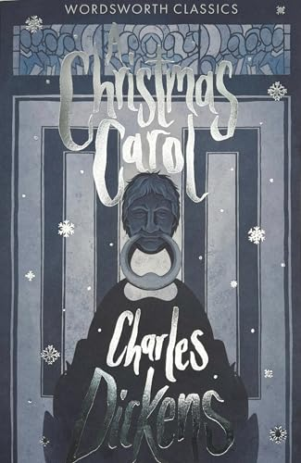
Key Quotations from each Stave

Stave | Key Quote | Info / Analysis
Stave One:  Marley’s Ghost visits Scrooge | Marley was dead, to begin with. | Suggests that rationality and logic do not apply here. Sets supernatural tone. Ghost story!
Stave One:  Marley’s Ghost visits Scrooge | Oh! But he was a tight-fisted hand at the grindstone, Scrooge! A squeezing, wrenching, grasping, scraping, clutching, covetous, old sinner! | Didactic narrator demonstrates his dislike of Scrooge.
Stave One:  Marley’s Ghost visits Scrooge | Hard and sharp as flint  (Flint = hard rock used to make tools) | Metaphor for Scrooge.
Stave One:  Marley’s Ghost visits Scrooge | Solitary as an oyster | Simile of loneliness, but with a pearl?
Stave One:  Marley’s Ghost visits Scrooge | External heat and cold had little influence on Scrooge. No warmth could warm, no wintry weather chill him. No wind that blew was bitterer than he, no falling snow was more intent on its purpose…” | Scrooge has an almost supernatural imperviousness to the effects of heat and cold.
Stave One:  Marley’s Ghost visits Scrooge | “I don’t make myself merry at Christmas, and I can’t afford to make idle people merry.” | Scrooge shows no pathos or empathy. Sees the poor as the ‘idle’.
Stave One:  Marley’s Ghost visits Scrooge | “Every idiot who goes about with ‘Merry Christmas’ on his lips should be boiled with his own pudding and buried with a stake of holly through his heart” | Scrooge thrills in his dour dislike of Christmas. An amusing, entertaining line – exaggerative villainy.
Stave One:  Marley’s Ghost visits Scrooge | “It’s enough for a man to mind his own business, and not to interfere with other people’s.” | Doesn’t see man’s role as one of responsibility for his fellow man.
Stave One:  Marley’s Ghost visits Scrooge | “Are there no prisons? Are there no workhouses?” | A cold, economic set of questions that shows his Malthusian view of the poor. Haunts and follows him.
Stave One:  Marley’s Ghost visits Scrooge | Bred and hidden in mountains of unseemly rags, masses of corrupted fat, and sepulchres of bones.  Marley’s ghost jaw drops down | Uses gothic horror imagery. Marley’s jaw almost amusingly grotesque.
Stave One:  Marley’s Ghost visits Scrooge | “I wear the chain I forged in life” Jacob Marley | Marley doomed to a purgatory of watching and not being able to do good. Chain the weight of his greed/sins. Miltonic phrasing.
Stave One:  Marley’s Ghost visits Scrooge | “There is no light part of my penance” Jacob Marley | He is weighed down by his punishment. (see chain imagery).
Stave One:  Marley’s Ghost visits Scrooge | “shun the path I tread” | Warning to Scrooge – hints at scope for redemption still.

Stave | Key Quote | Info / Analysis
Stave Two:  Ghost of Christmas Past | From the crown of its head there sprung a bright clear jet of light | Refers to Ghost of Christmas Past. The light symbolises enlightenment, joy, truth etc.
Stave Two:  Ghost of Christmas Past | “Your reclamation, then. Take heed!” Ghost of Christmas Past | The ghosts drive the recovery of Scrooge.
Stave Two:  Ghost of Christmas Past | “Your lip is trembling,” said the Ghost. “And what is that upon your cheek?” | Scrooge shows self-pity and remorse in seeing his younger self. He becomes unusually emotive. Tears are foreign to his cheeks.
Stave Two:  Ghost of Christmas Past | A solitary child, neglected by his friends, is left there still | Description of Scrooge. Scrooge knows this is him.
Stave Two:  Ghost of Christmas Past | “He has the power to render us happy or unhappy […] The happiness he gives is quite as much as if it cost a fortune.” | Scrooge sees the power of generosity in Fezziwig’s party.
Stave Two:  Ghost of Christmas Past | “I have seen your nobler aspirations fall off one by one, until the master passion, Gain, engrosses you.” | Belle leaves Scrooge because he is becoming a grasper of wealth. Belle means beauty in French. Beauty abandons him.
Stave Two:  Ghost of Christmas Past | “Another idol has displaced me; and if it can cheer and comfort you in time to come, as I would have tried to do, I have no just cause to grieve.” | Shows greed as a sin, a ‘false idol’.
Stave Two:  Ghost of Christmas Past | One vast substantial smile – Mrs Fezziwig | A rather limp description, since Dickens is best when describing the grotesque and gothic.
Stave Two:  Ghost of Christmas Past | “Remove me!” Scrooge exclaimed. “I cannot bear it!” | Scrooge is not ready to fully face his actions with the first ghost.

Stave | Key Quote | Info / Analysis
Stave Three  Ghost of Christmas Present | Scrooge entered timidly, and hung his head before this Spirit | Scrooge is compliant, believing and submissive to them by the second ghost.
Stave Three  Ghost of Christmas Present | As good as gold…and better  He hoped the people saw him in the church, because he was a cripple, it might be pleasant of them to think on Christmas Day, of who made lame beggars walk and blind men see. | Tiny Tim symbolising the noble poor.
Stave Three  Ghost of Christmas Present | “odious, stingy, hard, unfeeling” boss | Mrs Cratchit’s distaste for Scrooge.
Stave Three  Ghost of Christmas Present | “at all a small pudding for a large family”; Peter’s shirt is a hand-me down | Reinforces values of community and gratitude at Christmas. Is the materialism on show here problematic for the story?
Stave Three  Ghost of Christmas Present | Hallo! A great deal of steam! The pudding was out of the copper. A smell like washing day! That was the cloth. A smell like an eating-house and a pastrycook’s next door to each other, with a laundress’s next to that! That was the pudding! | Deeply excited and energetic portrayal of a meagre feast – celebrating with what they have.
Stave Three  Ghost of Christmas Present | “To hear the insect on the leaf pronouncing on the too much life amongst his hungry brothers in the dust!” | The Ghost reminds Scrooge of his earlier words about decreasing the population of the poor. He compares Scrooge to an insect.
Stave Three  Ghost of Christmas Present | With an interest he had never felt before…”No,no…Oh no, kind Spirit! Say he will be spared’ | Scrooge is affected by Tiny Tim’s childish innocence – just like he pities his own childish innocence in earlier visions. This drives his change.
Stave Three  Ghost of Christmas Present | “If he die, he better do it, and decrease the surplus population” | His own Malthusian words echoed back.
Stave Three  Ghost of Christmas Present | “I am sorry for him […] Who suffers by his ill whims? Himself, always.” | Fred pities Scrooge.
Stave Three  Ghost of Christmas Present | Uncle Scrooge had imperceptibly become so gay and light of heart | Scrooge just glad to be mentioned.
Stave Three  Ghost of Christmas Present | “This boy is Ignorance. This girl is Want. Beware them both.” “They are Man’s” | The two children are symbols of the failings of mankind and the dreadful impact of ignorance. Should be more wary of ignorance = we need education.
Stave Three  Ghost of Christmas Present | Yellow, meagre, ragged, scowling, wolfish; but prostrate too, in their humility. Where their faces should be plump in youth, a stale and shrivelled hand, like that of age, had pinched and twisted them, and pulled them to shreds | The horror of poverty.

Stave | Key Quote | Info / Analysis
Stave Four:  Ghost of Christmas Yet to Come | plundered and bereft, unwatched, unwept, uncared for, was the body of this man | Scrooge’s fate.
Stave Four:  Ghost of Christmas Yet to Come | Avarice, hard dealing, griping cares? They have brought him to a rich end, truly! | Scrooge sees the consequences of his actions before realising it is himself he describes.
Stave Four:  Ghost of Christmas Yet to Come | “Are these the shadows of the things that Will be, or are they the shadows of the things that May be only?” | Scrooge wonders if he can still be saved. He can – never too late for redemption.
Stave Four:  Ghost of Christmas Yet to Come | “Men’s courses will foreshadow certain ends” | Actions breed consequences.

Stave | Key Quote | Info / Analysis
Stave Five:  Scrooge is transformed | “No fog, no mist; clear, bright, jovial…heavenly sky, sweet, fresh air” | Change from earlier weather: (“it was cold, bleak, biting weather; foggy withal”)
Stave Five:  Scrooge is transformed | “I am as light as a feather, I am as happy as an angel, I am as merry as a schoolboy…I am as giddy as a drunken man” | Uses similes because he is not fluent in describing positive feelings.
Stave Five:  Scrooge is transformed | “I don’t know how long I have been among the Spirits. I don’t know anything. I’m quite a baby.” | He is reborn. Christian symbolism.
Stave Five:  Scrooge is transformed | Scrooge delighted everyone with a delighted smile. | He spreads good-will and cheer.
Stave Five:  Scrooge is transformed | He became as good a friend, as good a master, and as good a man, as the good old city knew | There are layers to his change – it is not superficial but total.
Stave Five:  Scrooge is transformed | His own heart laughed: and that was quite enough for him | His heart has changed, this being to Dickens the most important change a person might undergo. He learns to feel and love. Suggests inner contentment.

Stave 1

Scrooge
Charity
Marley

Fred
Bob

Stave 2

Ghost of Christmas Past
Little Fan
Belle

Fezziwig
School

Stave 3

Ghost of Christmas Present
Cratchits
Fred

Ignorance and Want
Visits
Streets

Stave 4

Ghost of Christmas Yet to Come
Pawn Shop
Graveyard

Business Men
Cratchits

Stave 5

Scrooge
Charity Men
Bob

Fred
Boy/ Turkey


Wider reading list + Revision resources
Make sure you are reading a wide range of texts at home and use the Library in school to help support you when selecting a text to read.
Some useful revision resources you can use to help support your practice of the exam questions are below:

Mr Bruff’s YouTube Channel for Literature Paper 1 →


Stacey Reay’s YouTube Channel →


SENECA Learning
Log into your account and start quizzing! →


Massolit
Sign up to Massolit with your school email to access a whole range of resources for your Year 11 Revision! →

Film adaptations
A Christmas Carol (2009) Jim Carey on Disney+
A Christmas Carol (1999) Patrick Stewart
A Christmas Carol (1984) George C Scott


GCSE English Language
BBC Bitesize Guide to English Language →


AQA Information and Past Papers/ Mark Schemes →

