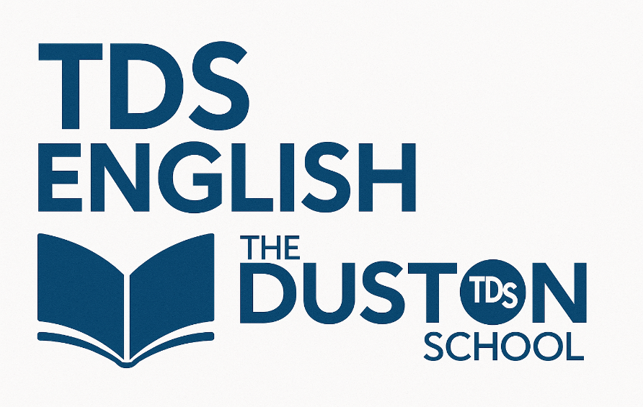
Name:
Class:

Knowledge Organiser
Year 9: Unit 2
Oppression and Empowerment

Name:
Class:

Contents Page

Page | Content
3 | Big Questions
4 | Unit content
5-6 | Key Terminology
7-8 | Homework Dates
9-15 | Homework Trackers
15 | Daily Reading Tracker
16 | Creative Book Tracker
17 | Sparx Reader Guide
18-25 | Wider Reading

Big Questions
Week 1 | Why is tolerance important?
Week 1 | What are gender stereotypes?
Week 1 | How are gender stereotypes presented in fairy tales?
Week 2 | How are gender stereotypes subverted in modern fairy tales?
Week 2 | Assessment Point 1: How are gender stereotypes shown in fairy tales?
Week 2 | Whole Class Feedback: How can I improve the explanation of my knowledge?
Week 3 | How can society’s expectations affect each gender?
Week 3 | Extension Lesson: How can poetry subvert gender stereotypes?
Week 3 | How can society’s expectations affect each gender?
Week 4 | How does Angelou create a sense of empowerment in Still I Rise?
Week 4 | How do poets present ideas about empowerment?
Week 4 | Assessment Point 2: What is oppression and empowerment?
Week 4 | Whole Class Feedback: How can I improve the explanation of my knowledge?
Week 5 | What is a Patriarchy?
Week 5 | Extension Lesson: How can language be used to present gender discrimination?
Week 5 | How does the media reinforce gender stereotypes?
Week 6 | What is toxic masculinity?
Week 6 | What is male rage and misogyny?
Week 6 | Assessment Point 3: How do writers use language to present ideas about inequality and gender stereotypes?
Week 7 | Whole Class Feedback: How can I improve the explanation of my knowledge?
Week 7 | What is sexualisation?
Week 7 | How does bias affect gender representation?
Week 8 | How does bias affect gender representation?
Week 8 | Extension Lesson: What is a feminist?
Week 8 | What are society’s expectations of women today?
Week 9 | How can we subvert societal expectations?
Week 9 | Extension Lesson: How is feminism expressed through poetry?
Week 9 | Assessment Point 4: How do gender stereotypes affect us
Week 9 | Whole Class Feedback: How can I improve the explanation of my knowledge?
Week 10 | How can language be used to express the need for acceptance?
Week 10 | Assessment Point 5: How does Zephaniah expose oppression caused by racial stereotypes in No Problem?
Week 11 | Whole Class Feedback: How can I improve my poetry analysis?
Week 11 | Extension Lesson:: How can language be used to show exclusion?
Week 11 | What makes us human?

Content you will study during this unit
Extracts from Fiction Texts
Tender Earth by Sita Brahmachari
Little Red Riding Hood by Wilhelm and Jacob Grimm
The Werewolf by Angela Carter
Little Women by Louisa May Alcott
Great Expectations by Charles Dickens
The myth of Atalanta
Gloria’s Monologue from the Barbie Movie
The Island at the End of Everything by Kiran Millwood Hargrave
The Colour of Humanity by Bali Rai
Non-Fiction Texts
Article on Toxic Masculinity from The Independent
The Role of Male Rage and Misogyny from The Sentinel Assam
The Woman Who Split the Atom: The Life of Lise Meitner by Marissa Moss.
Article Britney Spears: 'I am too sexualised by the music industry'
Introduction by Scarlett Curtis. An extract from Feminists don’t wear pink and other lies.
Emma Watson’s He for She Speech at the UN
Poetry
Havisham by Carol Ann Duffy
For Fear by Charlotte Perkins Gilman
Still I Rise by Maya Angelou
Milk and Honey by Rupi Kaur
Barbie Doll by Marge Piercy
The Right Word by Imtiaz Dharker
The British by Benjamin Zephaniah
Black by Dave
Half Caste by John Agard
No Problem by Benjamin Zephaniah

Key Terminology
 | Term | Definition
1 | Archetype | A typical example of a person or character, like a hero or villain.
2 | Bias | An unfair preference for or against someone or something.
3 | Connotations | The feelings or ideas a word makes you think of, beyond its basic meaning.
4 | Disempowerment | Taking away someone’s confidence, control, or ability to act.
5 | Empathy | Understanding how someone else feels and imagining what it’s like to be in their situation.
6 | Empowerment | Giving someone strength, confidence, or control over their life.
7 | Femininity | Qualities often linked to being female, like gentleness or caring.
8 | Gender | Social and cultural roles linked to being male, female, or non-binary.
9 | Inequality | When people are treated unfairly or don’t have the same chances.
10 | Sex | A person’s biological identity — male, female, or intersex.
11 | Masculinity | Qualities often linked to being male, like strength or bravery.
12 | Misogyny | Hatred or unfair treatment of women.
13 | Oppression | Cruel or unfair control over people, often through power or prejudice.
14 | Power | The ability to influence or control people, actions, or decisions.
15 | Reception | How something is received or reacted to by others.
16 | Representation | How people or groups are shown in media, stories, or society.
17 | Stereotype | A fixed idea about a group that’s often unfair or untrue.
18 | Societal expectation | What society thinks people should do or be, based on roles or norms.
19 | Tolerance | Accepting and respecting differences in others.
20 | Unconventional | Different from what’s usual or expected.

Additional Terminology
 | Term | Definition

1

2

3

4

5

6

7

8

9

10

11

12

13

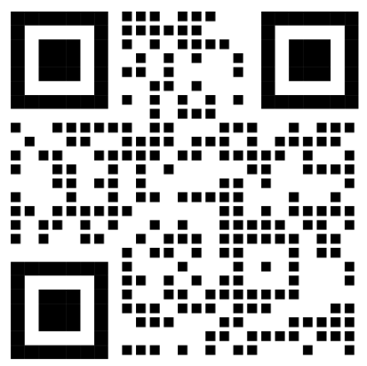
Homework Tasks


https://sparxreader.com/

Username | @thedustonschool.org
Password

 |  | Completion Date |  | Teacher Checked
Homework 1
Complete 300 SRP on Sparx Reader and complete the weekly tracker.

Homework 2
Complete 300 SRP on Sparx Reader and complete the weekly tracker.

Homework 3
Complete 300 SRP on Sparx Reader and complete the weekly tracker.

Homework 4
Complete 300 SRP on Sparx Reader and complete the weekly tracker.

Homework 5
Complete 300 SRP on Sparx Reader and complete the weekly tracker.

Homework 6  Complete 300 SRP on Sparx Reader and complete the weekly tracker. |  |  |  | To be checked after half term.
Half Term- Opportunity for extra House Points for any reading completed.
Homework 7
Complete 300 SRP on Sparx Reader and complete the weekly tracker.

Homework 8
Complete 300 SRP on Sparx Reader and complete the weekly tracker.

Homework 9
Complete 300 SRP on Sparx Reader and complete the weekly tracker.

Homework 10
Complete 300 SRP on Sparx Reader and complete the weekly tracker.

Homework 11  Complete 300 SRP on Sparx Reader and complete the weekly tracker. |  |  | To be checked after half term

Sparx Reading Homework Trackers:

Week 1  Monday 5th- Sunday 11th January 2026 | Minimum SRP Total: 300 | Accuracy Rating:
Week 1  Monday 5th- Sunday 11th January 2026 | Your SRP: | Excellent
Week 1  Monday 5th- Sunday 11th January 2026 | Your SRP: | Good
Week 1  Monday 5th- Sunday 11th January 2026 | Your SRP: | OK
Week 1  Monday 5th- Sunday 11th January 2026 | Your SRP: | Low
Week 1  Monday 5th- Sunday 11th January 2026 | Your SRP: | Very Low
Books Read this week:
Comments:
Favourite Book? Favourite Genre? Best part you read?
Parent/Guardian Signature

Week 2  Monday 12th- Sunday 18th January 2026 | Minimum SRP Total: 600 | Accuracy Rating:
Week 2  Monday 12th- Sunday 18th January 2026 | Your SRP: | Excellent
Week 2  Monday 12th- Sunday 18th January 2026 | Your SRP: | Good
Week 2  Monday 12th- Sunday 18th January 2026 | Your SRP: | OK
Week 2  Monday 12th- Sunday 18th January 2026 | Your SRP: | Low
Week 2  Monday 12th- Sunday 18th January 2026 | Your SRP: | Very Low
Books Read this week:
Comments:
Favourite Book? Favourite Genre? Best part you read?
Parent/Guardian Signature

Week 3  Monday 19th- Sunday 25th January 2026 | Minimum SRP Total: 900 | Accuracy Rating:
Week 3  Monday 19th- Sunday 25th January 2026 | Your SRP: | Excellent
Week 3  Monday 19th- Sunday 25th January 2026 | Your SRP: | Good
Week 3  Monday 19th- Sunday 25th January 2026 | Your SRP: | OK
Week 3  Monday 19th- Sunday 25th January 2026 | Your SRP: | Low
Week 3  Monday 19th- Sunday 25th January 2026 | Your SRP: | Very Low
Books Read this week:
Comments:
Favourite Book? Favourite Genre? Best part you read?
Parent/Guardian Signature

Week 4  Monday 26th- Sunday 1st February 2026 | Minimum SRP Total: 1200 | Accuracy Rating:
Week 4  Monday 26th- Sunday 1st February 2026 | Your SRP: | Excellent
Week 4  Monday 26th- Sunday 1st February 2026 | Your SRP: | Good
Week 4  Monday 26th- Sunday 1st February 2026 | Your SRP: | OK
Week 4  Monday 26th- Sunday 1st February 2026 | Your SRP: | Low
Week 4  Monday 26th- Sunday 1st February 2026 | Your SRP: | Very Low
Books Read this week:
Comments:
Favourite Book? Favourite Genre? Best part you read?
Parent/Guardian Signature

Week 5  Monday 2nd -Sunday 8th February 2026 | Minimum SRP Total: 1500 | Accuracy Rating:
Week 5  Monday 2nd -Sunday 8th February 2026 | Your SRP: | Excellent
Week 5  Monday 2nd -Sunday 8th February 2026 | Your SRP: | Good
Week 5  Monday 2nd -Sunday 8th February 2026 | Your SRP: | OK
Week 5  Monday 2nd -Sunday 8th February 2026 | Your SRP: | Low
Week 5  Monday 2nd -Sunday 8th February 2026 | Your SRP: | Very Low
Books Read this week:
Comments:
Favourite Book? Favourite Genre? Best part you read?
Parent/Guardian Signature

Week 6  Monday 9th - Sunday 15th February 2026 | Minimum SRP Total: 1800 | Accuracy Rating:
Week 6  Monday 9th - Sunday 15th February 2026 | Your SRP: | Excellent
Week 6  Monday 9th - Sunday 15th February 2026 | Your SRP: | Good
Week 6  Monday 9th - Sunday 15th February 2026 | Your SRP: | OK
Week 6  Monday 9th - Sunday 15th February 2026 | Your SRP: | Low
Week 6  Monday 9th - Sunday 15th February 2026 | Your SRP: | Very Low
Books Read this week:
Comments:
Favourite Book? Favourite Genre? Best part you read?
Parent/Guardian Signature
Half Term Reading:
What did you read? Which book did you enjoy the most? Fill this page with pictures of characters, titles of books and any book reviews you have for extra House Points from your teacher.

Week 7  Monday 23rd -Sunday 1st March 2026 | Minimum SRP Total: 2100 | Accuracy Rating:
Week 7  Monday 23rd -Sunday 1st March 2026 | Your SRP: | Excellent
Week 7  Monday 23rd -Sunday 1st March 2026 | Your SRP: | Good
Week 7  Monday 23rd -Sunday 1st March 2026 | Your SRP: | OK
Week 7  Monday 23rd -Sunday 1st March 2026 | Your SRP: | Low
Week 7  Monday 23rd -Sunday 1st March 2026 | Your SRP: | Very Low
Books Read this week:
Comments:
Favourite Book? Favourite Genre? Best part you read?
Parent/Guardian Signature

Week 8  Monday 2nd - Sunday 8th March 2026 | Minimum SRP Total: 2400 | Accuracy Rating:
Week 8  Monday 2nd - Sunday 8th March 2026 | Your SRP: | Excellent
Week 8  Monday 2nd - Sunday 8th March 2026 | Your SRP: | Good
Week 8  Monday 2nd - Sunday 8th March 2026 | Your SRP: | OK
Week 8  Monday 2nd - Sunday 8th March 2026 | Your SRP: | Low
Week 8  Monday 2nd - Sunday 8th March 2026 | Your SRP: | Very Low
Books Read this week:
Comments:
Favourite Book? Favourite Genre? Best part you read?
Parent/Guardian Signature

Week 9  Monday 9th -Sunday 15th March 2026 | Minimum SRP Total: 2700 | Accuracy Rating:
Week 9  Monday 9th -Sunday 15th March 2026 | Your SRP: | Excellent
Week 9  Monday 9th -Sunday 15th March 2026 | Your SRP: | Good
Week 9  Monday 9th -Sunday 15th March 2026 | Your SRP: | OK
Week 9  Monday 9th -Sunday 15th March 2026 | Your SRP: | Low
Week 9  Monday 9th -Sunday 15th March 2026 | Your SRP: | Very Low
Books Read this week:
Comments:
Favourite Book? Favourite Genre? Best part you read?
Parent/Guardian Signature

Week 10  Monday 16th - Sunday 22nd March 2026 | Minimum SRP Total: 3000 | Accuracy Rating:
Week 10  Monday 16th - Sunday 22nd March 2026 | Your SRP: | Excellent
Week 10  Monday 16th - Sunday 22nd March 2026 | Your SRP: | Good
Week 10  Monday 16th - Sunday 22nd March 2026 | Your SRP: | OK
Week 10  Monday 16th - Sunday 22nd March 2026 | Your SRP: | Low
Week 10  Monday 16th - Sunday 22nd March 2026 | Your SRP: | Very Low
Books Read this week:
Comments:
Favourite Book? Favourite Genre? Best part you read?
Parent/Guardian Signature

Week 11  Monday 23rd - Sunday 29th March 2026 | Minimum SRP Total: 3300 | Accuracy Rating:
Week 11  Monday 23rd - Sunday 29th March 2026 | Your SRP: | Excellent
Week 11  Monday 23rd - Sunday 29th March 2026 | Your SRP: | Good
Week 11  Monday 23rd - Sunday 29th March 2026 | Your SRP: | OK
Week 11  Monday 23rd - Sunday 29th March 2026 | Your SRP: | Low
Week 11  Monday 23rd - Sunday 29th March 2026 | Your SRP: | Very Low
Books Read this week:
Comments:
Favourite Book? Favourite Genre? Best part you read?
Parent/Guardian Signature

Daily Reading Tracker:
Daily Reading Goal: __________ minutes

Colour in the box for every day you read.
Or use a different colour to track whether you meet your target.

 | Didn’t meet |  | Met |  | Exceeded

 | 1 | 2 | 3 | 4 | 5 | 6 | HT | 7 | 8 | 9 | 10 | 11
M

T

W

T

F

S

S

Book Tracker:
Write the date on the spine of a book each time you finish a Sparx book or a physical book. You can also colour in the book to track your progress.
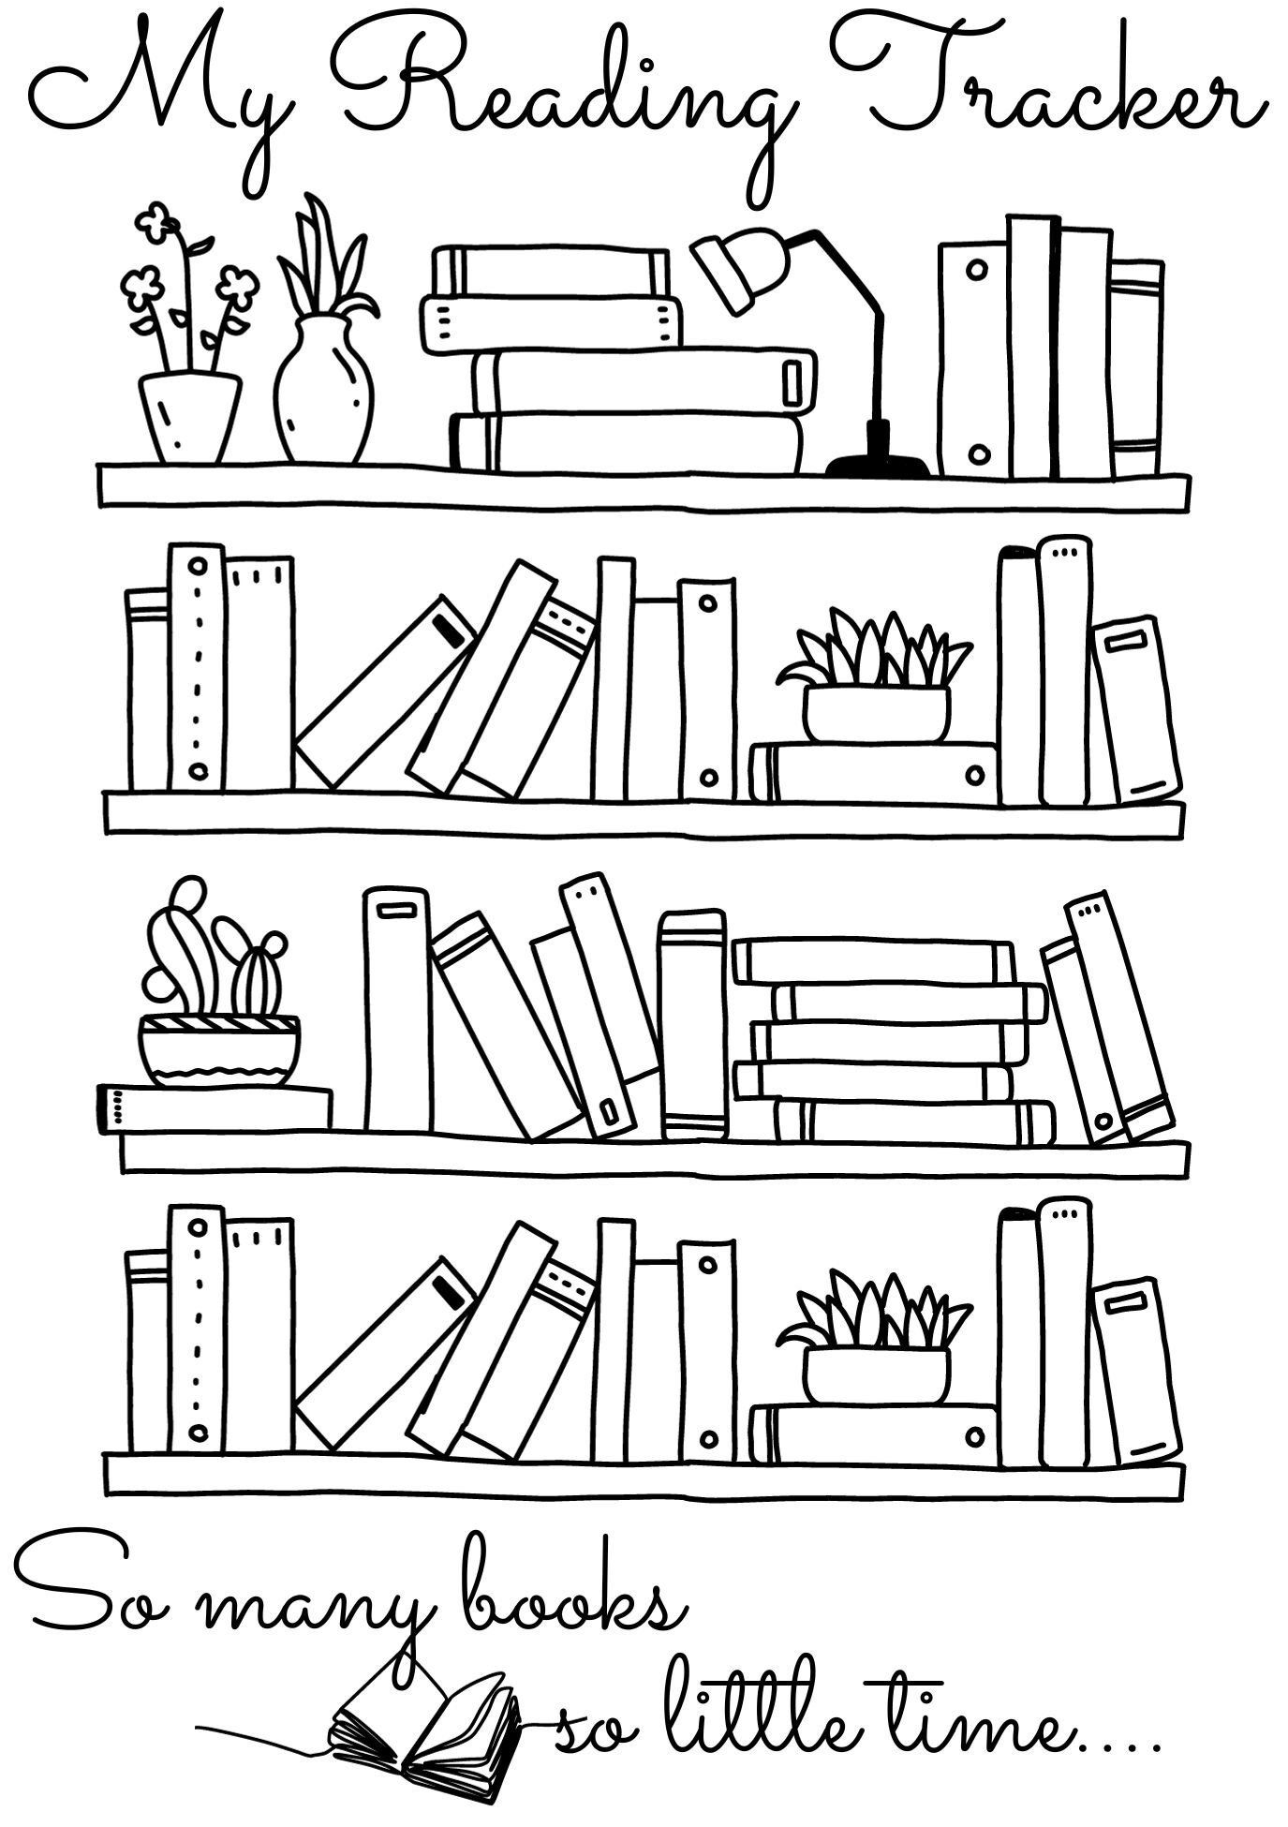
Sparx Reader: A Guide
Helping you to build reading stamina, literacy skills, and perseverance—one book at a time.

What Is Sparx Reader?
Sparx Reader is an online platform where you will complete weekly reading homework. It will help you:
✅ Practise meaningful, independent reading
🧠 Improve literacy and focus
🎯 Build perseverance and reading stamina

How Does It Work?
You will be able to choose ebooks at your reading level. As you read:
📝 You will answer questions to check comprehension
🎯 Earn Sparx Reader Points (SRP) for correct answers
📈 Climb the leaderboard by reading consistently

What Does Reading Look Like?
When you log in, you will see your current task and progress:
- Current Task: 0 / 200 SRP
- Due Date: 28 July
- Latest Book: Poison for Breakfast by Lemony Snicket
You can switch books anytime and unlock rewards like ⭐ Gold Reader status.

What Are the Questions Like?
✅ Simple if read properly
❌ Hard to guess if skimmed
🔍 Focused on key story elements
⏳ Text disappears before questions appear to encourage careful reading

What Is Gold Reader?
Gold Reader rewards consistent, careful reading. Once unlocked you can:
📚 Read any paper book from home or the library
📷 Scan the barcode to log reading
📝 Fill in a reading log to earn SRP

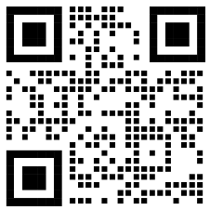
FAQs
How do I log in? At sparxreader.com using your school email address and
personal password

What devices are supported? Any device with internet and a web browser.

What if I can’t access Sparx Reader at home? If you are unable to access Sparx Reader from home, you can complete your homework in the library at the following times:
- Breaks and Lunches (except Tuesday)
- Monday after school until 4pm
- Wednesday after school until 4pm
- Thurs-Friday after school until 3.30pm

Wider Reading 1:
Key Information on Gender and Power throughout time

Timeline of Power and Gender Movements
400 BC – Agnodice - Recognized as one of the first female gynaecologists, Agnodice is said to have courageously practiced medicine in Greece when women faced the death penalty for doing so.
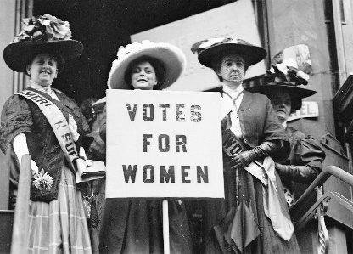
1691 - Sor Juana Inés de la Cruz - Defended women’s rights to education in 1691 by proclaiming “one can perfectly well philosophize while cooking supper."
1863 - Kate Sheppard, along with fellow campaigners, presented a “monster”
petition to Parliament demanding women’s suffrage with nearly 32,000
signatures
1918 - Women over 30 are granted the right to vote in Britain.
1928 - All women in Britain gain equal voting rights with men.
1969 – Stonewall Riots in New York City after police raid the Stonewall Inn, a gay club, sparking riots over the police’s unjust use of violence.
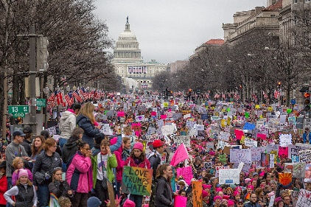
1975 - The Sex Discrimination Act makes it illegal to discriminate against
women in work, education and training. This is another act pushed
through by the women’s movement.

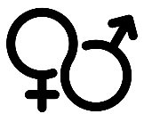
2017 - Women’s March - was a worldwide protest on January 21, 2017,
the day after the inauguration of President Donald Trump. Tensions
rose due to his statements, considered by many as anti-women or
otherwise offensive
Gender Roles - Ancient Greece
In Ancient Greece, gender was an important aspect of social hierarchy; power was not evenly distributed and only men were allowed to participate in activities such as politics, law, or the military. Therefore, it was vital that men prove their masculinity, in order to prove their worth and to earn their place in the major social institutions, and that women exhibit qualities that would suit them for life in the home, on the farm, or in whatever role suited their class and family circumstances.

Paintings provided artists and their patrons with a system of communication through which to create, reflect on, and perpetuate ideas about what it meant to be a man, or a woman, what men and women do, separately and together.
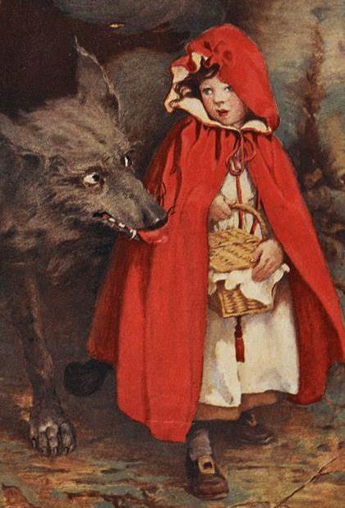
Little Red Riding Hood
History: The story of Little Red Riding Hood shows some similarities to
stories from Greece and Rome such as a local legend in which, each year,
a virgin girl was offered to a malevolent spirit dressed in the skin of a wolf.
Then, one year, a boxer came along, slew the spirit, and married the girl
who had been offered as a sacrifice.The Roman poet Horace refers to a
tale in which a male childis rescued alive from the belly of Lamia, an ogre
in classical mythology..
Interpretations: Some people see Little Red Riding Hood as a story about a rite of passage, a puberty rite where the girl leaves home and enters a state of disorientation and, by going through the acts of the tale, is transformed into an adult woman by coming out of the wolf's stomach. Others believe that Little Red Riding Hood is a violent tale that has negative connotations of abduction. However, others see the grandma and Little Red Riding Hood overcoming a second wolf attack and a symbol for female empowerment.

Marriage
Marriages weren’t always about love:
- The Anglo-Saxons saw marriage as a strategic tool to establish diplomatic and trade ties
- In the 11th Century, marriage was about securing an economic or political advantage. The wishes of the married couple and their consent were not important. The bride, particularly, had to adhere to her father's wishes and the marriage arrangements made on her behalf.
Social Expectations:
- Parents were no longer content to marry their children off to just "anyone in a neighbouring group". They wanted to marry them to somebody as least as wealthy and powerful as themselves
- it wasn't until the Victorian era that love became accepted as a foundation for marriage
- The parental giving of a dowry in exchange for a daughter's hand in marriage is an ancient custom that has been practiced all over the world. A dowry was expected as a condition to accept a marriage proposal.

During the wedding ceremony, the custom of giving away the bride was an acknowledgment that the dowry had been negotiated and the bride had her father's blessing. A hefty dowry could serve to increase the desirability of a woman for marriage. Men could potentially consider a marriage proposal based on the size of their expected dowry to build power and wealth for their own families.

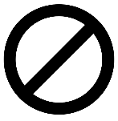
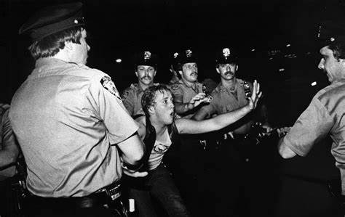
Stonewall Riots
- Homosexuality was once considered a
mental illness.
- In New York in 1960 sex between
members of the same sex was illegal.
- People could be arrested if they were
wearing less than 3 items of clothing
appropriate to their gender.
- Even holding hands in public with a member of the same sex could result in a prison sentence.
- Bars and business refused to serve queer people and you could be fired if it was suspected that you were queer.
- People had to keep their sexuality a secret as they could lose their job, their friends and their family.
- The Stonewall Inn was a safe space where queer people could escape the hatred they faced daily. Drag queens were often found in the Stonewall Inn.

- The NYC Police regularly raided gay bars and looked for ways to close them down.
- 28th June 1969, they tried to close The Stonewall Inn.
- Marsha P. Johnson, a drag queen and black trans woman, and Sylvia Rivera, a Latina trans woman, spearheaded the resistance when police tried to arrest people from inside the Stonewall Inn.
- Over the next six days, thousands of people took to the streets to protest against the hatred and mistreatment they had suffered from their whole lives.
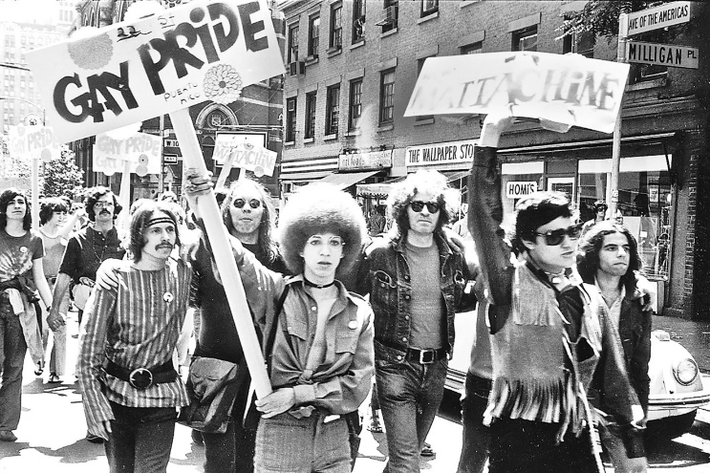
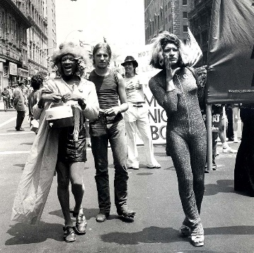

Wider Reading 2: Protect the Protest! Why we must save our right to protest.

Peaceful protest is a dynamic and public way of exercising our human rights. Throughout history, protests have enabled individuals and groups to express dissent, opinions and ideas, expose injustice and abuse, and demand accountability from those in power. With collective mobilization, creativity and defiance, people who protest are a thorn in the side of the powerful. Helping to shake up rigid and unaccountable power dynamics and structures, protesting has been a vehicle for advancing human rights. In a world with increasing inequality and persisting discrimination, armed conflict, authoritarianism and crises of governance, as well as mounting global threats on livelihoods and the planet, protests are widespread and on the rise.
Instead of addressing pressing concerns and promoting dialogue to find solutions to injustice, abuses and discrimination, states often respond by stigmatizing and cracking down on peaceful protesters. In all regions of the world, Amnesty International has documented a wide array of undue restrictions on protest in ordinary and emergency legislation, criminalization of protesters, and the unlawful use of force to disperse protesters and to intimidate and deter others from joining these mobilizations. As digital technologies enable new ways to mobilize and express dissent, those seeking to deter protests are also developing new methods to obstruct this right, ranging from intrusive digital surveillance to shutting down the internet and digital communication networks.
There are further barriers to protest: people who face inequality and discrimination, whether based on race, gender, sexual orientation, gender identity, religion, age, disability, occupation, or social, economic, migratory or other status are more likely to be affected by restrictions and repression, and less able to participate in protests. Yet, many advances in human rights around the world have been due to the courage of people who dared to fight for a more inclusive and equal society despite the risks and challenges they faced. It is therefore crucial that everyone is able to protest safely and without discrimination.
Amnesty International has long worked to protect and expand the power of protest in defending and promoting human rights. For decades, we have stood with protest movements and taken part in collective actions as part of our human rights campaigns. We are here to remind those in power that peaceful protest is a right, not a privilege, and one which states have a duty to respect, protect and facilitate. This is why Amnesty International is embarking on a global campaign that challenges the widespread assault on the ability to protest, standing by all those who dare to stand up and make their voices heard.
The role of Protest in advancing human rights
Protest is a form of non-violent direct action that provides an avenue to express grievances and demands in the public domain, especially at times when existing political, social, economic or cultural systems preclude or systematically ignore those demands. Protests are a form of engagement in the civic space that has been instrumental in attaining a range of human rights throughout history, whether through individual and collective actions such as strikes, marches, sit-ins, vigils, rallies, boycotts, street closures, pot-banging sessions, cultural or religious events, as well as a range of acts of civil disobedience. These techniques have been used in countless liberation and justice movements during the past century, and continue to grow in variety, creativity and impact.
Famous for their lasting legacy are protests such as the Salt March in India in 1930, protesting against British colonial rule; the 1950 National Day of Protest in South Africa against apartheid; the March on Washington in 1963 for civil and economic rights of Black Americans; the 1969 Stonewall riots in New York and subsequent Pride marches to demand rights for LGBTI people; the student protests against corruption and for democratic reform in Tiananmen Square and elsewhere in China in 1989; the weekly protests of the Mothers and Grandmothers of Plaza de Mayo in Argentina in the 1970s and 1980s; and the Arab Spring uprisings beginning in Tunisia in 2010, among many, many more.
Recent years have seen an explosion of protests that have crossed national boundaries in response to deep injustices and inequalities, including the Black Lives Matter demonstrations that started in the USA and spread around the world to protest against entrenched racism, the #MeToo and #MareaVerde protests to demand sexual and reproductive rights and gender equality, and the Fridays for Future protests organized by children and young people to demand prompt action against climate change.
Clearly change doesn’t often happen overnight or as a result of a few people protesting: meaningful change often requires strong social movements with clear demands and strategies, and significant engagement and participation over time. Some protests may appear to be counterproductive when they are snuffed out by violent repression, seeming to entrench unaccountable power structures. Yet even in those cases where the authorities attempt to suppress protests, their influence and legacy may become apparent years or even decades later in changing social norms and laws.
But if we look at history, change often happens by taking ‘two steps forward and one step back’. The key to understanding the contribution of protests and the social movements behind them is to look at how they gradually gain legitimacy (and with it, power), how they expose abuse and injustice, and how movements learn from each other. Their power lies in highlighting from the bottom up the lack of legitimacy of repressive, unaccountable power, and in contributing to raising awareness, shifting public debates, and changing language, minds and behaviours until there is a tipping point. Over time, these processes have led to improvements on a diverse range of issues such as better governance, labour conditions and social protections, increased gender equality and recognition of sexual and reproductive rights, justice for past human rights violations, and action on issues such as racism and discrimination, environmental destruction and climate change, to name a few.

Wider Reading 3: Extract from an interview in O Magazine between Oprah Winfrey and Maya Angelou.
Oprah: The big question I have for you is this: Where did your confidence come from? I've never seen anybody who exudes more confidence than you, and I don't mean false, modest bravado, but from the inside out, you've got the stuff.
Maya: There are so many gifts, so many blessings, so many sources that I can't say any one thing—unless that one thing is love. By love I don't mean indulgence. I do not mean sentimentality. And in this instance, I don't even mean romance. I mean that condition that allowed humans to dream of God. To make it. To imagine golden roads. That is love, and it's so much larger than anything I can conceive. And that love, and its many ways of coming into my life, has given me a great deal of confidence about life.
Oprah: So when you walk into a room and heads turn, it's not just confidence in yourself that we see?
Maya: Oh, no. That's why, though I was never pretty, I did command something—because of my reliance on life.
Oprah: When we see you, we're seeing all of your history.
Maya: That's right—all of my history as an African-American woman, as a Jewish woman, as a Muslim woman. I'm bringing everything I ever knew [and all the stories I've read]—everything good, strong, kind and powerful. I bring it all with me into every situation, and I will not allow my life to be minimized by anybody's racism or sexism or ageism. I will not.
Oprah: Just listening to you now, I'm thinking, "What is it about Maya?" I think it's that you know yourself. You know that you are supported by something bigger than yourself. That you are loved. That you have the right to stand up for yourself. And that comes from knowing who you are.
Maya: And I not only have the right to stand up for myself, but I have the responsibility. I can't ask somebody else to stand up for me if I won't stand up for myself. And once you stand up for yourself, you'd be surprised that people say, "Can I be of help?"
Oprah: That is true. I love your intolerance of whining. I've never forgotten what you told me: "Whining is just unbecoming."
Maya: It lets the brute know there's a victim for him in the neighbourhood!
Oprah: As you know, my daily quest for the show and this magazine is to help women see who they are. Women tell me over and over, "I feel like I've lost myself. I don't know who I am." How is it that you know who you are? And have you always known since the first words in Caged Bird?
Maya: When I was 19 or 20, a wonderful thing happened to me—terrifying but wonderful. When I was younger, I thought my grandmother was probably God and she just wouldn't tell anybody! She was so strong and kind. And when my grandmother died, I realized that even if I had millions of dollars, I couldn't find her anywhere on earth. And my next thought was that I would die. Finally, I had to come to grips with what was the matter with me. I looked at my life and thought, "I'm afraid to die." And I concluded that whether I was afraid or not, I would die. I don't think I've ever talked to you about this.
Oprah: No.
Maya: It was one of the most important crossroads in my life, because once I realized that no matter what, I would do this thing, the next step was to think, "If I am going to do the most difficult and frightening thing—dying—is it possible that I could do some difficult and maybe seemingly impossible things that are good?"
Oprah: Was this a conscious thought?
Maya: Yes. I thought, "Just suppose I could choreograph a ballet." And I did it. Suppose I could teach dance at the theater in Cleveland. And I did it. Suppose I could sing for a living—that I could stop these two jobs as a waitress and a salesperson.
Oprah: Had you thought about doing that before but didn't have the courage?
Maya: It had never occurred to me. I'm going to die. So why can't I do everything? And what is this idea that I worked all day yesterday, so I'm tired today? I've never believed that.
Oprah: That is why everyone marvels at your stamina—your ability to continue to be out there speaking, teaching and giving, giving, giving. We think, "How does she do it? I need a nap!"
Maya: I think a nap or a rest overnight is great. But who needs three days of rest? Please! The second day, you might die.
Oprah: So I think I've got this: You realized you would die—and not just intellectually, because we all know it intellectually.
Maya: Yes, ma'am.
Oprah: Is there nothing that frightens you? You never seem to be unsure about anything. Were you always that way?
Maya: You'd be surprised what coming to grips with the fact that you will die does for you.
Oprah: Earlier you were telling me that your life is defined by principles. And one principle you have taught me is that we can't allow ourselves to be "pecked to death by ducks."
Maya: That's true. Some people don't have the nerve to just reach up and grab your throat, so they just take....
Oprah: Little pieces of you—with their rude comments. They try to demean you.
Maya: Reduce your humanity through what Jules Feiffer called little murders. The minute I hear [someone trying to demean me], I know that that person means to have my life. And I will not give it to them.
Oprah: It's an assassination attempt by a coward.
Maya: Yes. Some people don't have the courage to just walk up to you and pull the trigger. If somebody just walked up and said "Boom!"—well, there you go. Bye. But when a person commits these little murders, and then you catch him or her at it, he or she might say, "Oh, I didn't mean it." But make no mistake: It is an assassination attempt.
Oprah: And you also don't allow anybody to say anything negative about anybody while in your home.
Maya: That's right.
Oprah: I've seen you put people out of your house for telling a racist joke! And you are not the least bit embarrassed about disrupting the whole room.
Maya: I believe that a negative statement is poison. The air between you and me is filled with sounds and images. If that were not so, how is it that I can turn on a television right now and see what's happening in New York? That means sounds and images are in the air, crowded, jammed up like bats. And Oprah, I'm convinced that the negative has power. It lives. And if you allow it to perch in your house, in your mind, in your life, it can take you over. So when the rude or cruel thing is said—the lambasting, the gay bashing, the hate—I say, "Take it all out of my house!" Those negative words climb into the woodwork and into the furniture, and the next thing you know they'll be on my skin.

