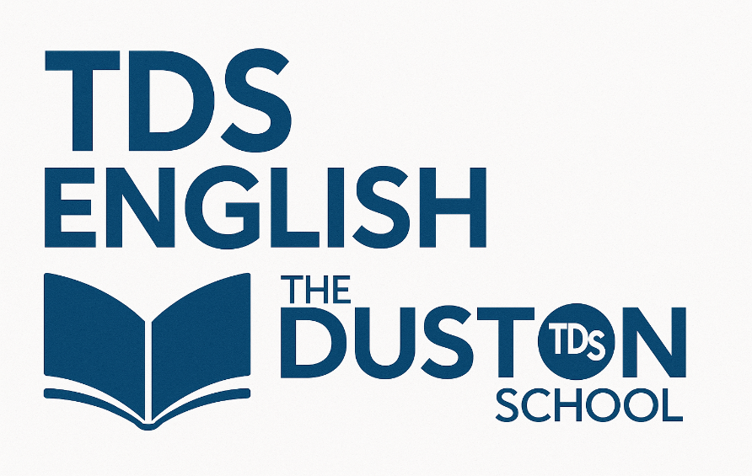

Knowledge Organiser
Year 7: Unit 1
Nura and the Immortal Palace by M.T. Khan
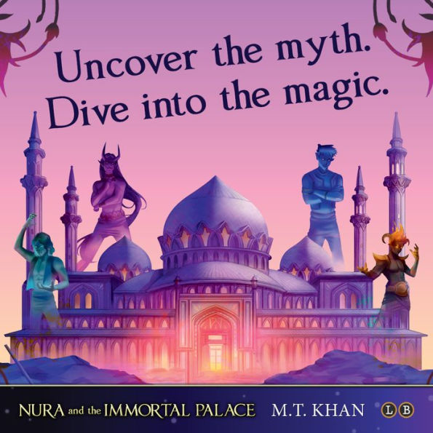

Name:
Class:

Big Questions

The big question for the unit is: How is discovery reflected in Khan’s Nura and the Immortal Palace?

Our study of Nura and the Immortal Palace will follow the structure below:
Week 1 | - What are the realities for children in poverty in modern day Pakistan?  - What motivates Nura to mine for mica?  - How important are family and religious to Nura?  - How does Nura react to the mine collapsing?
Week 2 | - How does Khan use imagery to describe Nura’s journey?  - How far has Khan created a utopian world for Nura?  - What do we learn about Nura in the opening chapters?  - How does Nura demonstrate her determination to succeed?
Week 3 | - What does Nura learn about the consequences of power?  - How does Khan use the Immortal Palace to symbolise the realities of inequality within society?  - What does Eid-al-Adha teach Nura?
Week 4 | - How does Nura accept the help of others to aid her determination to escape?  - What does a reader learn about Nura and Faisal’s relationship in Chapter 16?  - How does the Immortal Palace explore exploitation?
Week 5 | - How do Nura and the other characters plan to destroy the palace?  - How does Nura influence the others to revolt?  - How does Nura demonstrate her determination to succeed?  - What does the destruction of the Immortal Palace symbolise?
Week 6 | - What does the Immortal Palace teach Nura and the novel’s readers?  - What does the Immortal Palace teach Nura?

Chapters in Nura and the Immortal Palace

For each chapter in the book, here is a brief summary of what happens:
1 | Sparkles in the Dirt – Nura is a mica miner and who sets herself the challenge of finding the Demon’s Tongue. Her best friend is Faisal and they, along with the other children working in the mine, experience harsh conditions and are expected to dig for mica; the more mica they collect, the more money they get paid. This money is taken home to their families as they are all in poverty.
2 | The Taste of Truth – Nura walks past Mr Waleed’s cart every day and sees the sweets she so desperately wants but cannot afford. On one occasion, she buys the sweets and surprises her family. Her mother is disappointed and takes Nura back to Mr Waleed to return them.
3 | Stars Staring Down on Us – Nura, her siblings and their mother are excited about Eid-al-Adha. Nura’s mother worries about Nura working in the mine and tells her that she wants her to stop. Nura’s mother tells Nura and her siblings a story about jinn. Nura and her family rely on Islam for hope and direction.
4 | Dig a Little Deeper – Nura and the other children are digging in the mine for mica. Nura feels competitive to find the Demon’s Tongue and to get more money for her family. Despite the other children’s warnings, Nura digs deeper and deeper. Eventually, the mine collapses and Faisal is presumed dead.
5 | Nothing at All Only a Name – A rescue operation begins and children are pulled out from the rubble; Faisal still isn’t found. Nura enters the collapsed mine to find Faisal and is transported to another world.
6 | The Shadow That’s Always With Me – Nura sees the Sijj Palace (the jinn hotel) for the first time and meets her quareen, Dura.
7 | Look Below the Surface – Nura sees and experiences the luxuries her real life didn’t allow. She continues to look for Faisal but becomes distracted by what tempts her.
8 | Out of the Mines and into the Fire – Nura witnesses and takes part in an eating competition. She finds Faisal.
9 | Sultana – Nura and Faisal are rewarded for winning the eating competition; they are crowned the Sultan and Sultana of Splendour. Both Nura and Faisal are given a makeover.
10 | Dance for Me – As patrons of the Sijj Palace, Nura and Faisal are invited to attend a dance hosted by the Painted Boy. He is wealthy and is it known that whenever he is seen, he gifts whatever outfit he is wearing for free. This makes the characters at the dance want to impress the Painted Boy. Nura and Faisal try to impress him by attempting a sword dance, but Nura accidentally chops off one of the Painted Boy’s horns. It is revealed that the Painted Boy’s father is the owner of the Sijj Palace (Majood).
11 | The Trickster and the Fool – Nura and Faisal are sent to the owner’s office to be punished. There the Painted Boy and his father tell Nura that she is bound to the hotel forever. Faisal behaves strangely during the conversation and Nura learns that Faisal isn’t really Faisal, it’s Faisal’s quareen, Raisal and has been all along. Dura shoves Nura through an open door and she falls not knowing where she will end up.
12 | Curiosity Captured the Mortal – Nura realises that she has been sent to the basement of the palace where all of the lost children are kept. Nura meets the Craftsman and sees the real Faisal for the first time since she entered the Sijj Palace. Nura learns that the longer the children remain in the basement, the more their souls will be attached to the hotel and their true memories will be lost.
13 | Jinn Say, Jinn Do – It’s Eid-al-Adha and the Sijj Palace throws a beautiful party with an infinite banquet; Nura and Faisal are put to work as part of their punishment. The Painted Boy enters and delivers a speech and toasts the Demiurge; Nura and Faisal realise that the human servants are made invisible to the guests attending the Eid celebrations. Nura sparks a plan to escape and finds out that the Demiurge is the founder of the Sijj Palace.
14 | Collision Curse – The children enjoy the stolen Eid food and really miss home. The children realise that they are cursed.
15 | A Coward’s Kryptonite – Nura witnesses jinn school and is frustrated by the deceit. Faisal finds out that there’s a chore to clean the owner’s office so Nura and Faisal take it. They begin looking through the owner’s paperwork discussing their escape. The owner returns to his office to find Nura and Faisal searching through his things. Majoon, the owner of the Sijj Palace, punishes Nura and Faisal by sending them to the coal furnaces to clean.
16 | Those Who Are and Those Who Become – Nura and Faisal find it hard cleaning out the coal furnaces. When they return to the other children, they learn that Sadia has lost her memories. Under the tension, Nura and Faisal begin to argue and Faisal accuses Nura of being selfish. The Craftsman approaches Nura and offers her some advice about escaping. He tells her that the Demiurge is gone and he won’t be back.
17 | Endless Cycle – Nura goes to work as the Sijj Palace prepares for a VIP guest; the Painted Boy. Nura realises that the Sijj Palace is a place of exploitation and suffering that is hidden behind the beauty of the palace and its grandeur. Nura understands that the jinn children are rewarded for tricking human children but are then tricked into work themselves. The Painted Boy wants to reward Nura with her clever revelation.
18 | Betrayal or Betrothal – Mirza rewards Nura with a spa session. He tells Nura to take responsibility for her action of cutting off his horn by marrying him, thus being freed. Mirza offers Nura’s friends shorter days and better food but Nura refuses. Mirza grabs Faisal and begins to torture him.
19 | When Earth Meets Fire – Nura acknowledges what true greed is as Faisal is possessed by jinn. Nura takes a pair of scissors and then threatens to chop off his other horn. At the threat, Mirza releases Faisal from the jinn. Nura learns that Mirza’s father and the Demiurge opened the palace together; now, Mirza’s father is the sole owner. The Demiurge is actually the Craftsman.
20 | As Being is to Becoming, So is Truth to Belief – Nura and Faisal confront the Craftsman. Nura realises that he was once the Demiurge but he was demoted to Craftsman. The Craftsman admits that he wears a mask so the children don’t rely on him helping them escape; he doesn’t know how to get out either. The Craftsman gives Nura an original blueprint of the Sijj Palace and they plan to destroy the palace.
21 | It Was, It Is, It Shall Be – With the Craftsman’s help, Nura and Faisal plan the destruction of the palace. They aim to use the portals in order to keep everyone safe from the bomb that they’ll use.
22 | Perceive to Perform – Nura tells the children (both jinn and human) the plan. They all help to make the bomb as they get ready to bring down the Sijj Palace.
23 | Where There’s A Will, There’s A Way – Nura and Faisal enter the Space portal. They light matches and fireballs to scare the jinn and evacuate everyone. Faisal thanks Nura for coming to save him.
24 | The Fool and the Trickster – Nura searches for the centre of the Space portal to plant the bomb. She bumps into Dura who tries to persuade Nura not to follow through with the plan; they fight. Nura runs away but Dura chases her. As Nura is being chased, she remembers the strength of her mother and begins to pray. This stops Dura’s pursuit and she falls to her knees. Dura allows Nura to continue with her plan.
25 | All Thoughts Must Be Mortal – Nura makes it to the vaults of the Sijj Palace but the owner is stood in her way forbidding Nura to destroy the palace. Nura takes the bomb out of her pocket and the owner panics and tries to persuade Nura to stop. She lights the bomb and runs for the door, but the owner doesn’t move. Nura pulls the owner through the door and saves him for the sake of the Craftsman.
26 | One and Continuous – The Sijj Palace is destroyed. Memories come rushing back to the children and the Craftsman vows to build a school. He draws a map for Nura to mine for the best mica.
27 | Dirt in the Sparkles – Nura and Faisal dig for the best mica thanks to the Craftsman’s help. They find a box with a golden key; inside the box is a note written by the Craftsman. The other mining children hear that Nura and Faisal are overjoyed and Nura is reunited with her mother. They find out that the key is the Demon’s Tongue they’d all been digging for.

Characters in Nura and the Immortal Palace
Nura  - Nura lives in Pakistan and is a Muslim.  - Nura lives with her mother and three younger siblings; her father died in a mine collapse when she was seven.  - Nura mines mica to support her family. She doesn’t go to school.  - At the beginning of the novel, she is determined to find the Demon’s Tongue. This is what causes the mine to collapse.  - Her favourite sweet is gulab jamun.  - Nura makes it her mission to find Faisal, her best friend.  - Nura sparks the plan to escape from the Immortal Palace and guides the other characters to follow her. | Faisal  - Faisal lives in Pakistan and is a Muslim.  - Faisal’s best friend is Nura and he worries about Nura’s actions and behaviour.  - Faisal mines mica to support his family. He doesn’t go to school.  - Faisal isn’t as confident as Nura and has a stammer.  - Faisal is trapped when the mica mine collapses and nobody can find him.  - Faisal remains loyal to those he loves and trusts.  - Faisal helps Nura to escape from the Immortal Palace.  - Together with Nura, he helps to find the Demon Tongue at the end of the novel.
Dura  - Dura is Nura’s qareen; she has blue skin, her hair is more jagged than Nura’s but she looks exactly like Nura.  - Dura is unpredictable. She is known for showing Nura round the Sijj Palace but is also known for torturing her.  - Dura is loyal to Mirza and the owner of the palace. She is the one to push Nura into the basement.  - Dura admits to Nura that she chooses to work at the Immortal Palace because it gives her a chance that nowhere else does – the chance to trick humans.  - Dura tries to stop Nura from destroying the palace. | Raisal  - Raisal is Faisal’s quareen.  - He tricks Nura for a long time pretending to be the real Faisal; he possesses similar traits to Faisal and looks just like him. Nura believes Raisal to be the true Faisal up until Chapter 11.  - Raisal is loyal to Mirza and the owner of the palace.  - Raisal chooses to work at the Immortal Palace because it gives him the chance that nowhere else does.  - Raisal enjoys tricking humans.
The owner of the Sijj Palace (Mirza’s father; Majoon)  - Majoon and his brother (the Demiurge) opened the palace together. However, the Demiurge was punished so now Majoon is the only owner.  - He has an office that Nura and Faisal are sent to clean as punishment.  - He sees himself as above humans; he believes that he is the most magical and powerful.  - The owner takes back Nura’s patronage and banishes her to the basement of the palace.  - He tells Nura that she is bound to the palace until she has worked at the palace long enough to pay for what she has done to Mirza’s horn.  - Majoon tries to stop Nura from planting the bomb | The Craftsman (the Demiurge)  - The Craftsman is actually the Demiurge (Majoon’s brother; the original owner of the Sijj Palace). He was punished by his own brother and his entitlement taken.  - The Craftsman keeps the hotel running; he is jinn.  - He shows Nura round the basement as he describes it as “the working quarters”.  - The Craftsman has been at the Immortal Palace for years; he is knowledgeable and tells Nura what to expect.  - He is the one to say that escaping is very difficult but offers to help Nura to create a plan. He tells Nura that he doesn’t know the way out.  - He planted the Demon’s Tongue and tells Nura where to find it.
The Painted Man (Mirza)  - Mirza is wealthy and respected by everyone in the Palace. He has a pet tiger and has a lot of power. He decides who has patronage at the palace and who is to be punished.  - Mirza’s father is the owner of the Sijj Palace. His father describes him as “a figurehead, a poster boy for this hotel”.  - Whenever the Painted Boy is seen, he gifts whatever he is wearing for free.  - Nura accidentally chops off his horn and Mirza seeks revenge.  - He asks Nura to marry him but Nura refuses. | Aroofa and Sadia  - Aroofa and Sadia meet Nura in the basement of the Immortal Palace.  - They are both sisters who are known as ‘the lost children’ as noone knew where they were once the mine had collapsed. Aroofa has worked in the mines for 3 years but Sadia only started a few months ago.  - Sadia is 5-years-old and is really homsick. Aroofa is very protective of Sadia.  - Nura gives the sisters some hope as her determination keeps them positive.  - Sadia loses her memories; they are restored at the end.

Key Information
What is Islam?
Islam is one of the world’s major religions. Its founder was Muhammad (Peace Be Upon Him). The religion has more than 1.5 billion followers worldwide. Most of the followers of Islam, called Muslims, live in northern Africa, the Middle East, and southern and central Asia.

The Five Pillars of Islam
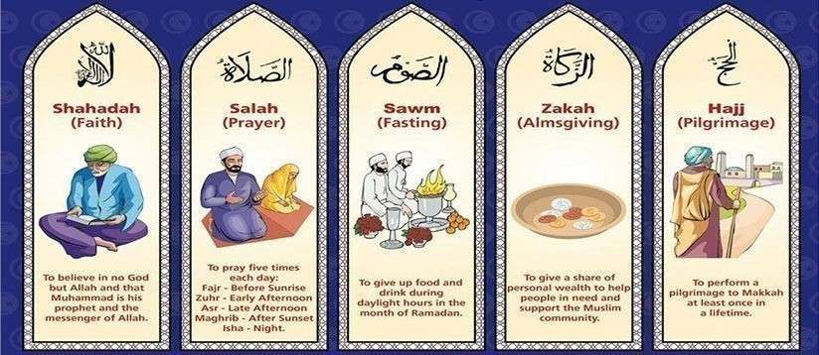
Central to Islam are the five pillars. Muslims are expected to follow these pillars throughout their lifetime. These practices are referred to as pillars because they form the foundation of Muslim life. The five pillars of Islam are Shahada, Salah, Zakat, Sawm, and Hajj.

What is a mosque?
A mosque is a place of prayer for Muslims, or followers of the religion of Islam. The first mosque was the courtyard in the home of Muhammad (PBUH), Islam’s founder. Today many mosques are large buildings with beautiful towers and domes.

The inside of a mosque always includes an open space for worship. Rugs or mats may cover the floor. A nook in one wall, called a mihrab, shows the direction of Mecca, Islam’s holiest city. To the right of the mihrab is a platform or small tower, called a minbar. Religious leaders climb steps up to the minbar, where they speak to the worshippers. Every mosque must also have a source of running water for washing. Muslims are required to wash before prayer.

Outside most mosques is a tall tower, called a minaret. From the minaret a crier, or muezzin, calls Muslims to prayer. Some mosques have up to six minarets.

Mosques are different in some ways from churches and synagogues. They do not have chairs or seats. The worshippers stand together, barefoot, in rows. They bow down and kneel when praying. Men and women worship separately. Mosques never contain statues or pictures, and music and singing are forbidden.

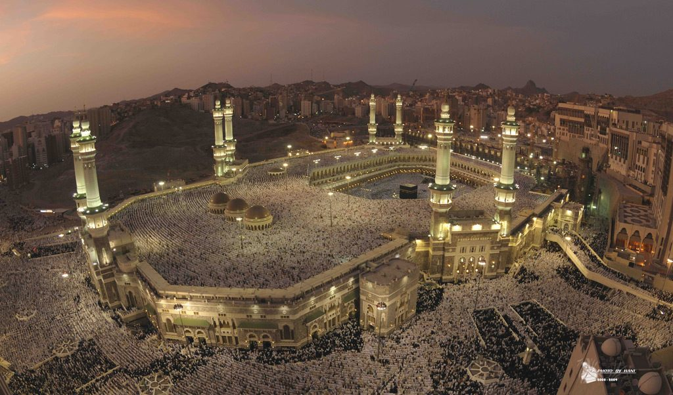
The largest mosque in the world is the Masjid al-Haram in Saudi Arabia, Mecca.

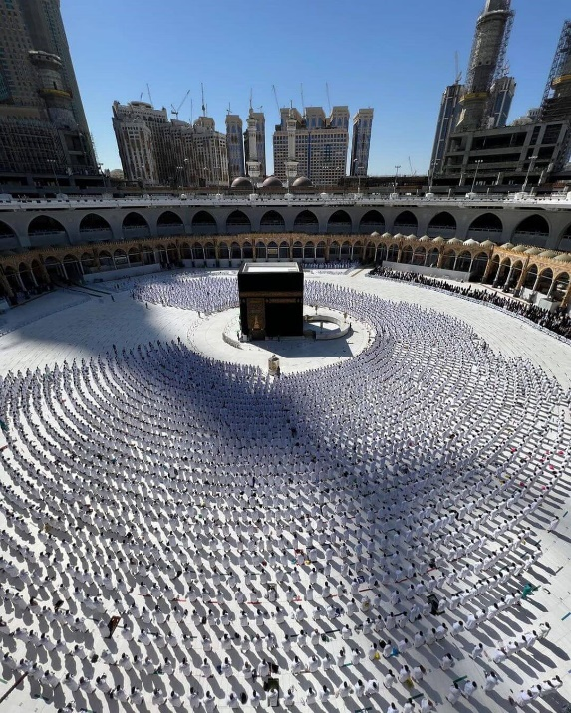
The mosque was built to encircle the Kaaba. The very first construction of the Kaaba was done by Prophet Ibrahim (PBUH) and his son Ismail as a house of worship to one God. Allah (swt) says in the Quran that this was the first house that was built for humanity to worship Allah. Soon after Prophet Ibrahim (PBUH) died, people started filling the Kaaba with idols. It was not until Prophet Muhammad (PBUH) defeated the idol-worshipers that the idols inside the Kaaba were destroyed.

One of the Five Pillars of Islam requires every Muslim to perform the Hajj pilgrimage to Mecca at least once in his or her lifetime if they are able to do so. Multiple parts of the Hajj require pilgrims to walk seven times around the Kaaba in a counter-clockwise direction.

Muslims around the world face the Kaaba during prayers, no matter where they are. This is called facing the Qiblah.

What is mica?
Mica is a highly sought after mineral due to its resilient properties and is present in more and more everyday products. We find it in nearly all eyeshadows and glow-enhancing cosmetics, even more so now that more consumers seek natural ingredients.

The trend of pearlescent paint finish in the car industry is also driving increased demand. Mica is also found in electrical products like toasters or hair-dryers and has become a resource of choice in electronics, such as drones, phones, high-res cameras and equipment that requires important data storage capacity. Mica benefits countries selling these products as a lot of money is made.


Look at the American statistics on the next page to see how much money was made from mica in 2015 compared to 2024.

In 2015, mica made America $494.4 million dollars. In 2024, it made America $669.3 million dollars.

Who collects the mica from the mines?
Women and children are especially exploited to keep labour costs close to nothing and their hands handle the delicate work better. Without equipment (mining is performed by hand) nor safety measures in place, miners (including children as young as 4 years old) face danger and health hazards daily:
- Little oxygen in mine shafts;
- Infections and lung diseases due to inhalation of fine dust particles;
- Cuts and bruises sustained in filthy environments;
- High risk of shaft collapsing on workers and trapping them under rocks.

Terre des Homes and Somo reported in 2018 that 22,000 children slave in mica mines, dropping out of school to help their family survive. When incidents occur, they are rarely reported since mining is their only hope to earn an income.

.

Key Terminology
 | Term | Definition
1 | Conscience | A conscience is the voice in your head and the feeling in your heart that tells you if something is right or wrong.
2 | Culture | The ideas, customs, and social behaviour of a particular people or society.
3 | Discrimination | When a person is treated differently because of a feature or quality about them. For example, their age, disability, gender, religion, etc.
4 | Eid-Al-Adha | One of two Islamic holidays celebrated worldwide each year. It honours the willingness of the Prophet Ibrahim (PBUH) to sacrifice his son as an act of obedience to God’s command.
5 | Exploitation | When someone or a group of people tricks or misleads a person into doing things for them that are not right.
6 | Extended metaphor | Extended metaphors are when a metaphor is sustained for longer than a single word or phrase.
7 | Identity | The fact of being who or what a person or thing is.
8 | Imagery | Visually descriptive or figurative language.
9 | Immortal | Living or lasting forever.
10 | Impoverish | To make a person or place poor.
11 | Inequality | When some people lack the rights, opportunities and fair laws of others
12 | Injustice | Violation of the rights of others.
13 | Jinn | Muslims believe in jinn to be a creation of God. Jinn are a widely misunderstood topic. Like humans, the jinn eat, drink, marry and have children, and die. However, they possess some special abilities that humans do not.
14 | Labour | Work, especially physical work.
15 | Mica mining | To dig or gain access to a part of the underground looking for mica. Usually people mine to get something from the earth or to burrow beneath the earth’s surface.
16 | Oppression | A situation or circumstance that is cruel, brutal or ruthless.
17 | Societal norms | A social norm is an accepted behaviour that a person is expected to conform to or follow in a particular group, community or culture.
18 | Symbolism | An object or idea that represents something else.
19 | Temptation | Something that entices or encourages a person to do something wrong or to act in a way they wouldn’t usually by offering them something that appears very nice.
20 | Utopia | The ideal of a perfect example; usually in reference to society.

Additional Terminology
 | Term | Definition

1

2

3

4

5

6

7

8

9

10

11

12

13

14

15

16

Example analytical writing
What does Nura learn throughout Nura and the Immortal Palace?

Throughout Nura and the Immortal Palace, Khan depicts Nura to learn the values of family and finding joy in the immaterial things she once was determined to find. Nura learns that being greedy doesn’t result in happiness; being surrounded by those you love who are treated equally and fairly is what becomes important to Nura by the end of the novel.

At the beginning of the novel, Khan shows Nura’s eagerness to find the Demon’s Tongue as she believes that by finding this, it will bring her prosperity while ensuring that her family are rewarded for her hard work. However, she soon learns that her greed has grave consequences: “All I hear is the low roar of the earth splitting apart, and the yells of the kids around me. But when I take another step, a whine pierces my ears.” The metaphor highlights that Nura’s determination to look for the Demon’s Tongue in Chapter 4 resulted in catastrophe for the other miners and their families. It could be said that this is the first time Nura truly learns that consequences can occur from her actions as a reader soon learns that Faisal is missing. The personification in “low roar” infers that the destruction from Nura digger too deep hasn’t just impacted where she is digging, but to other parts of the mine too. The verb “whine” suggests that this is the last noise Nura hears from Faisal which could imply the pain or discomfort Faisal is in when the mine collapses. Soon after this point, Faisal goes missing, showing the scale of Nura’s mistake and how Nura feels responsible to find Faisal as a result.

In the middle of the novel, Nura learns that the Sijj Palace is not a place of beauty and luxury and soon realises that the children there are being exploited by the rich adults. Nura realises that “It’s a vicious cycle with no end in sight. The poor stay poor because the rich aren’t willing to spread their resources” highlighting that everyone will continue in the cycle if nobody is willing to change. The fact that exploitation is described as a “vicious cycle” shows that there is no solution to the mistreatment of the children at the Immortal Palace; it will continue until the cycle is broken but this result is not going to happen soon. The cycle is described as “vicious” to show its brutality and cruelty to those who are exploited and Nura quickly learns that there are people to blame for the suffering that others have been inflicted upon. “The poor stay poor” because they are exploited by the rich for their own gain. This quotation highlights that the rich are to blame for the exploitation of the poor – similar to the treatment of the children by the owners of the Sijj Palace. If the rich “aren’t willing to spread their resources”, the treatment of the poor will never improve and at this point in the novel, Nura knows that she has to act in order for others to break the cycle and to stop the poverty and suffering.

At the end of the novel, Nura realises that not being greedy and instead being grateful for what she already has is what’s important. Ultimately, safety, love and equality are what’s important and Nura learns that always wanting more and never being satisfied with what she has always has consequences. At the end of the novel, Nura finds the Demon’s Tongue but tells her mother that “‘We can sell this and build a school. One big enough that none of these kids will ever to have mine mica again.’” Nura’s altered view shows what she learned during her time at the Immortal Palace; immaterial items are meaningless to her as she has realised that greed doesn’t actually benefit anyone and instead, kindness and consistency on the right things can lead to success. The negation “never” shows Nura’s determination and new desire for no child to ever be exploited or have to work in a mica mine again; risking their life and working in horrific conditions. Instead, through Nura’s journey into the jinn world, she wants equality and peace for all and, knowing her character, she won’t stop until she finds it.

Homework

Knowledge is power, so the more you know, the more secure you will be in your learning.

Year 7: Unit 1 Homework: Nura and the Immortal Palace
Task 1:  Week 2 | Due date: | - Using the key information on pages 6, 7 and 8, answer the 10 knowledge retrieval questions on page 13. These questions will be peer assessed in class and your teacher will check that you have completed your homework.
Task 2:  Week 4 | Due date: | - Read the article (wider reading) on pages 14, 15 and 16.  - Answer the 10 knowledge retrieval questions on page 17. These questions will be peer assessed in class and your teacher will check that you have completed your homework.
Task 3:  Week 6 | Due date: | - Based on your knowledge of the Nura and the Immortal Palace unit so far, answer the 10 knowledge retrieval questions on page 18. These questions will be peer assessed in class and your teacher will check that you have completed your homework.

If you have ‘no homework’, or you have finished all of the above, try these tasks on a weekly basis to ensure your understanding of the poems is secure.
- Research M.T. Khan and make some revision notes on her and her works.
- Research the characters from Nura and the Immortal Palace, the plot and the themes.

Homework Task 1 – Use the key information on pages 6, 7 and 8
 | Write your answer in the box below each question. | 
1 | Approximately how many people across the world are Muslim?
2 | What does Salah mean on the 5 Pillars of Islam?
3 | What is a mosque?
4 | What should Muslims do before they pray?
5 | What is a minaret (found outside most mosques) and what is its purpose?
6 | What is the name of the largest mosque in the world and where is it?
7 | Why was the mosque built?
8 | Who is believed to have first constructed the Kaaba?
9 | When Muslims pray around the world, why must they consider the Kaaba?
10 | Name one of the dangers miners face when working in the mines.
TOTAL

Wider Reading: Reading in a Whole New Light
https://global-zone61.renaissance-go.com/universalweb/authorizationoidc?sid=e7583f1b-3d84-40f6-af84-45b935741a3e#/GetItem

As digital screens proliferate and people move from print to pixel, how will the act of reading change?

America was founded on the written word. Its roots spring from documents – the Constitutions, the Declaration of Independence, and, indirectly, the Bible. The country’s success depended on high levels of literacy, freedom of the press, allegiance to the rule of law (found in books), and a common language across a continent. American prosperity and liberty grew out of a culture of reading and writing.
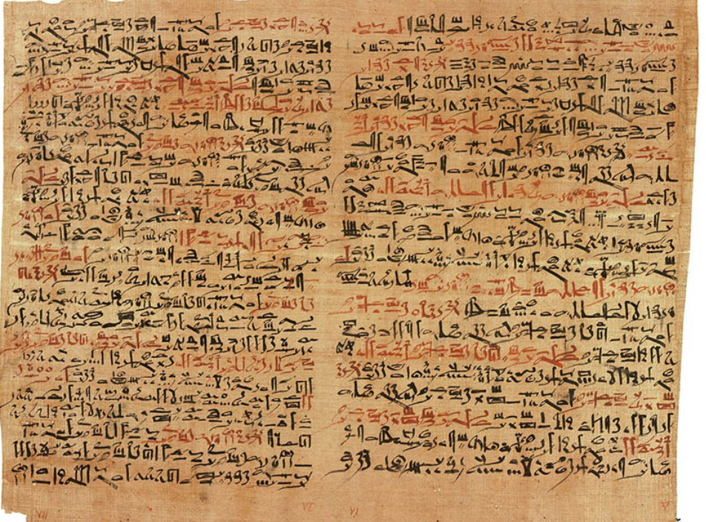

But reading and writing, like all technologies, are ever-changing. In ancient times, authors often dictated their books. Dictation sounded like an interrupted series of letters. So scribes wrote down the letters in one long continuous string, justastheyoccurinspeech. Text was written without spaces between words until the eleventh century. This continuous script made books hard to read. So only a few people were accomplished at reading them aloud to others. Being able to read silently to yourself was considered an amazing talent. Writing was an even rarer skill. In fifteenth-century Europe, only one in 20 adult males could write.

After Gutenberg’s printing press came along around 1440, mass-produced books changed the way people read and wrote. The technology of printing expanded the number of words available (from about fifty thousand words in Old English to a million words today). More word choices enlarged what could be communicated. More media choices broadened what was written about. Authors did not have to compose scholarly books. Instead, they could “waste” inexpensive books on heartbreaking love stories or publish memoirs, even if they were not kings. People could write tracts to oppose the prevailing opinion. With the coming of cheap printing, those unconventional ideas could gain enough influence to topple a king or a pope. In time, the power of authors birthed the idea of authority and bred a culture of expertise. Perfection was achieved “by the book”. Laws were compiled into official books, contracts were written down, and nothing was valid unless put into writing. Painting, music, architecture, and dance were all important. But the heartbeat of Western culture was the turning pages of a book. By 1910, three-quarters of the towns in America with more than 2500 residents had a public library. We came a people of the book.
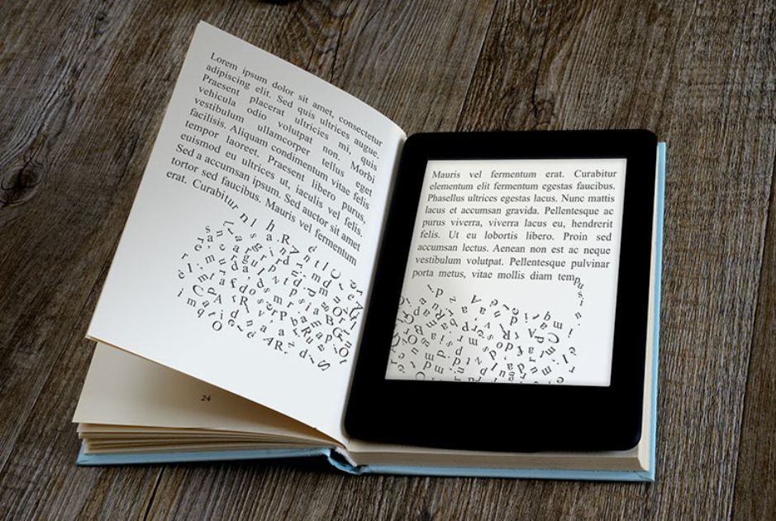

Today, some 4.5 billion digital screens illuminate our lives. Words have migrated from wood pulp to pixels on computers, phones, laptops, game consoles, television, billboards, and tablets. Letters are no longer fixed in black ink on paper. Instead, they flitter on a glass surface in a rainbow of colours as fast as our eyes can blink. Screens fill our pockets, briefcases, dashboards, living room walls, and the sides of buildings. They sit in front of us when we work – regardless of what we do. We are now people of the screen. And of course, these screens have changed how we read and write.

The first screens that overtook culture, several decades ago – the big, fat, warm tubes of television – reduced the time we spent reading to such an extent that it seemed as if reading and writing were over. Educators, intellectuals, politicians, and parents worried deeply that the TV generation would be unable to write.

The first screens that overtook culture, several decades ago – the big, fat, warm tubes of television – reduced the time we spent reading to such an extent that it seemed as if reading and writing were over. Educators, intellectuals, politicians, and parents worried deeply that the generation would be unable to write. But the cool, thin, interconnected displays of the second wave of screens launched an epidemic of writing that continues to grow. The amount of time people spend reading has almost tripled since 1980. By 2008, more than a trillion pages were added to the World Wide Web. That total grows by several billion a day. Each of these pages was written by somebody. Right now, ordinary citizens compose 1.5 million blog posts per day. Using their thumbs instead of pens, people around the world collectively write 12 billion quips per day from their phones. More screens continue to swell the volume of reading and writing.

But it is not book reading. Or newspaper reading. It is screen reading. Screens are always on. Unlike books, we never stop staring at them. This new platform is very visual, and it is gradually merging words with moving images. Words zip around, they float over images, serving as footnotes or annotations, linking to other words or images. You might think of this new medium as books we watch, or televisions we read. Screens are also intensely data-driven. Visualizing data is a new art, and reading charts a new literacy. Screen culture demands fluency in all kinds of symbols, not just letters.

And it demands more than our eyes. The most physically active we may get while reading a book is to flip the pages or dog-eared corners. But screens engage our bodies. Touchscreens respond to the ceaseless caress of our fingers. We interact with what we see. Soon enough, screens will follow our eyes to perceive where we gaze. A screen will know what we are paying attention to and for how long. In the futuristic movie Minority Report, the character played by Tom Cruise stands in front of a wraparound screen. He hunts through vast files of information with the movements of a symphony conductor. Reading becomes almost athletic. Just as it seemed weird five centuries ago to see someone read silently, in the future it will seem weird to read without moving your body.

Books were good at developing a contemplative mind. Screens encourage more practical thinking. A new idea or unfamiliar fact will provoke a reflex or to do something: to research the term, to ask your screen “friend”" for their opinions, to find alternative views, to create a bookmark to interact with, or tweet the thing rather than simply contemplate it. Book reading strengthened our analytical skills. It encouraged us to pursue an observation all the way down to the footnote. Screen reading encourages rapid pattern making, associating this idea with another, equipping us to deal with the thousands of new thoughts expressed every day. The screen rewards and nurtures thinking in real time. We review a movie while we watch it. We come up with an obscure fact in the middle of an argument. We read the owner’s manual of a gadget we spy in a store before we purchase it rather than after we get home and discover that it can’t do what we need it to do.

Screens provoke action instead of persuasion. Propaganda is less effective in a world of screens, because while misinformation travels fast, corrections do, too. On a screen, it is often easier to correct a falsehood than to tell one in the first place. Wikipedia works so well because it removes an error in a single click. In books, we find a revealed truth. On the screen, we assemble our own truth from pieces. On a networked screen, everything is linked to everything else. The status of a new creation is determined not by the rating given to it by critics but by the degree to which it is linked to the rest of the world. A person, artefact, or fact does not “exist” until it is linked.

A screen can reveal the inner nature of things. Waving the camera eye of a smartphone over the barcode of a manufactured product reveals its price, origins, and even relevant comments by other owners. It is as if the screen displays the object’s intangible essence.

As portable screens become more powerful, lighter, and larger, they will be used to view more of this inner world. Hold an electronic tablet up as you walk along a street, and it will show an annotated overlay of the real street ahead. It will show you where the clean restrooms are, which stores sell your favourite items, and where your friends are hanging out. Computer chips are becoming so small, and screens so thin and cheap, that in the next 40 years, semi-transparent eyeglasses will apply an informational layer to reality. If you pick up an object while peering through these spectacles, the object’s (or place’s) essential information will appear in overlay text. In this way, screens will enable us to “read” everything, not just text.

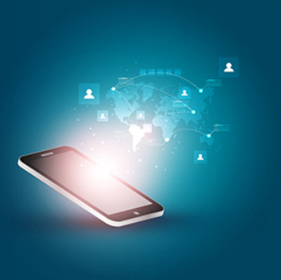
More important, our screens will also watch us. They will be our mirrors, the wells into which we look to find out about ourselves. Not to see our face, but our status. Already, millions of people use pocketable screens to input their location, what they eat, how much they weigh, their moods, their sleep patterns, and what they see. A screen both records and displays this database of activities. The result of this constant self-tracking is a perfect “memory” of our lives and an unexpectedly objective … view of ourselves, one that no book can provide. The screen becomes part of our identity.

We live on screens of all sizes – from the IMAX to the iPhone. In the near future, we will never be far from one. Screens will be the first place we’ll look for answers, for friends, for news, for meaning, for our sense of who we are and who we can be.
Homework Task 2 – Use the Wider Reading on pages 15, 16 and 17

 | Write your answer in the box below each question.
1 | Name one place that America’s writing started from.
2 | Until the 11th Century, how was text written?
3 | What was considered “an amazing talent”?
4 | By 1910, what did three-quarters of American towns have?
5 | According to the article, name two places screens can be found.
6 | Roughly how many pages were added to the World Wide Web by 2008?
7 | As well as letters, what does screen culture demand?
8 | According to the article, “books [are] good at developing a contemplative mind”, but what do screens encourage?
9 | Name one thing millions of people use pocketable screens for.
10 | What does a screen become part of within a person?
TOTAL

Homework Task 3 – Use your knowledge from your lessons
 | Write your answer in the box below each question.
1 | Why does the mica mine collapse?
2 | Why does Nura begin her journey to the Immortal Palace?
3 | What is utopia?
4 | What is the name of Nura’s quareen?
5 | What does Nura accidentally do to the Painted Boy in Chapter 10 (which ends up getting her punished)?
6 | Who does the reader learn the Painted Boy’s father actually is?
7 | Which Islamic event is celebrated in Chapter 13?
8 | Who is the Demiurge?
9 | In Chapter 21, what does the Craftsman say Nura will need to destroy the palace?
10 | What actually was the Demon’s Tongue, found at the end of the novel?
TOTAL

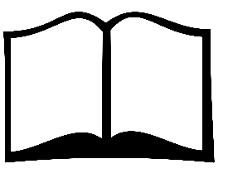
Wider reading list
Fictional books about discovery:
- Hatchet by Gary Paulsen – Brian is a city boy. Not used to living rough. Until his plane crash-lands in the Canadian wilderness. All he has is a hatchet – and a desperate will to survive. Now Brian must learn to live the hard way – or die.
- The House With Chicken Legs by Sophie Anderson – Marinka dreams of a normal life, where her house stays in one place long enough for her to make friends. Marinka’s grandmother guides spirits between this world and the next. Marinka longs to change her destiny and sets out to break free from her grandmother’s footsteps, but her house has other ideas…
- Where the River Runs Gold by Sita Brahmachari – The farm Shifa and Themba are sent to is hard and cruel. Themba won’t survive there and Shifa comes up with a plan to break them out. But they have no idea where they are – their only guide is a map drawn by strangers.
- The Dog who Saved the World by Ross Welford – Georgie befriends an eccentric retired scientist and becomes the test subject for a thrilling new experiment: a virtual-reality 3D version of the future. But then a deadly disease threatens the life of every dog in the country and Georgie’s beloved dog, Mr Mash, gets sick. And that’s only the start of her troubles.
- Once by Morris Gleitzman – Felix has been living in an orphanage for three years and eight months when the men in armbands arrive to burn the books. Going on the run in search of his parents, Felix soon learns that Poland in 1942 is not a safe place for Jewish boys. But can his gift of storytelling keep him one step ahead of the Nazis and help him find his parents?
- The Bone Sparrow by Zana Fraillon – Born in a refugee camp, all Subhi knows of the world is that he’s at least 19 fence diamonds high and one day it brings her Jimmie. Carrying a notebook that she’s unable to read, Jimmie strikes up an unlikely friendship with Subhi beyond the fence.
- Percy Jackson and the Lightning Thief by Rick Riordan – Percy Jackson is having a bad week. His life has gone from totally normal to monsters-from-Greek-mythology-randomly-appearing kind of strange. Worse still, the king of gods thinks Percy has stolen his all-powerful lightning bolt – and it seems making Zeus angry is a very bad idea.
- Chinese Cinderella by Adeline Yen Mah – Born into the world with her story already written and woven with bad luck. Adeline turns her attention to school, where she discovers that she is a talented writer, much to her father’s disapproval. But with her pen in her hand, she can’t help but wonder what it would be like to be a writer – no, an author! It won’t be easy but Adeline must have the courage to rewrite her story.
- The Recruit by Robert Muchamore – A terrorist doesn’t let strangers in her flat because they might be undercover police or intelligence agents, but her children bring their mates home and they run all over the place. The terrorist doesn’t know that one of these kids has bugged every room in her house, made copies of all her computer files and stolen her address book. The kid words for CHERUB.
- A Kind of Spark by Elle McNicoll – 11-year-old Addie campaigns for a memorial in memory of the witch trials that took place in her Scottish hometown. Addie knows there’s more to the story of these ‘witches’, just like there is more to hers. Can Addie challenge how the people in her town see her, and her autism, and make her voice heard?
- The Star Outside My Window by Onjali Rauf – Following the disappearance of her mum, 10-year-old Aniyah finds herself living in foster care. With her life in disarray, she knows just one thing for sure: her mum isn’t gone forever. Because people with the brightest hearts never truly leave. They become stars. So when a new star is spotted acting strangely in the sky, Aniyah embarks on the adventure of a lifetime to make sure everyone knows who it belongs to.
- The Last Storyteller by Donna Barba Higuera – There lived a girl named Petra Peña who wanted nothing more than to be a storyteller, like her abuelita. But Petra’s world is ending. Earth will soon be destroyed by a comet, and only a few hundred scientists and their children – among them Peta and her family – have been chosen to journey to a new planet. They are the ones who must carry on the human race.
- The Girl Who Couldn’t Lie by Radhika Sanghani – Priya Shah lies. A lot. She pretends everything in her life is perfect, so she doesn’t disappoint anyone. But when she puts on a bangle left to her by her Ba – the one person she was always honest with – she finds herself unable to tell a lie.

