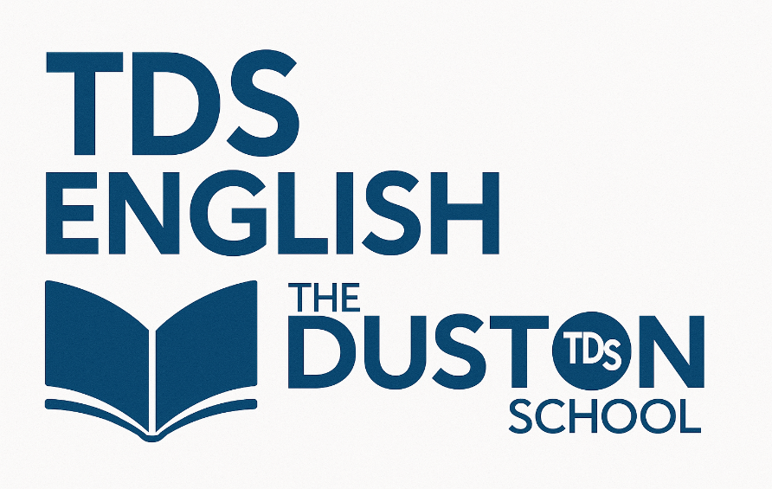

Knowledge Organiser
Year 8: Unit 1
A History of Rhetoric

Name:
Class:

Big Questions

The big question for the unit is: How do different voices use language to persuade?
Week 1 | - Why is rhetorical language important?  - What is rhetoric?
Week 2 | - How do you construct an effective argument?
Week 3 | - How is rhetoric used to drive action?
Week 4 | - How is rhetoric used to highlight injustice?
Week 5 | - How is rhetoric used to motivate?
Week 6 | - How is rhetoric used for change?
Week 7 | - How can I use rhetoric for change?

Our study of rhetoric will follow the structure below:

Historical figures you will study during this unit
Week 1 | Aristotle was one of the greatest philosophers who ever lived and the first genuine scientist in history. He made pioneering contributions to all fields of philosophy and science, he invented the field of formal logic, and he identified the various scientific disciplines and explored their relationships to each other. Aristotle was also a teacher and founded his own school in Athens, known as the Lyceum.
Week 2 | Marc Antony was a Roman general under Julius Caesar and later triumvir (holding power) who ruled Rome’s eastern provinces (43–30 BCE). He was the lover of Cleopatra, Queen of Egypt, and was defeated by Octavian (the future emperor Augustus) in the last of the civil wars that destroyed the Roman Republic. As Julius Caesar’s friend and right-hand man, he gave the funeral oration after Caesar’s assassination.
Week 3 | Queen Elizabeth I was the last Tudor monarch and inherited intelligence, determination and shrewdness from both parents. She reigned for 45 years whereby she established the Church of England. Elizabeth is known for being politically intelligent and she chose her ministers wisely. During Elizabeth’s reign, she saw many brave voyages of discovery where they prepared for England to broaden its colonisation and trade relations.
Week 4 | Sojourner Truth’s legal name was Isabella Van Wagener and she was an African American reformer who an advocate for abolition, temperance and civil and women’s rights in the 19th Century. She was the daughter of slaves and spent her childhood as an abused chattel of several masters. In 1843, she declared that the Spirit called on her to preach the truth, renaming herself Sojourner Truth.
Week 5 | Winston Churchill was a British Prime Minister twice (1940-1945 and 1951-1955) and he rallied the British people during World War II by leading his country from the brink of defeat to victory. Churchill was intensely patriotic and a believer in his country’s greatness and its historic role in Europe, the empire and the world. Churchill acquired a reputation for erratic judgement in the war itself and in the decade that followed.
Week 6 | Martin Luther King was a Baptist minister and social activist who led the civil rights movement in the United States from the mid-1950s until his death assassination in 1968. His leadership was fundamental to that movement’s success in ending the legal segregation of African Americans. King rose to national prominence as head of the Southern Christian Leadership Conference, which promoted nonviolent tactics to achieve civil rights. He was awarded the Nobel Peace Prize in 1964.
Week 7 | Lennie James is an actor and has appeared on TV and on stage. James is concerned about knife and gun crime among the young and intended to write an article about the ‘war on street crime’. However, James was particularly moved by the death of Robert Knox, an 18-year-old who was stabbed to death by a 21-year-old who was carrying two knives. As a result, Lennie James wrote an open letter to the knife-carriers, to the murderers-in-waiting and their potential victims.

For each historical figure, here is a brief summary of who they were/are and what they wanted to achieve:

Key Terminology
 | Term | Definition
1 | Alliteration | Repeating the same sound at the start of consecutive words.
2 | Anecdote | A short amusing or interesting story about a real incident or person.
3 | Anaphora | Starting each sentence with the same words.
4 | Antithesis | Direct opposites.
5 | Dialysis | ‘Don’t do this, do that.’ Presenting an alternative argument.
6 | Direct address | Use of a proper noun (you) to address the audience.
7 | Emotive language | Words or phrases that encourage the reader or audience to feel a particular emotion.
8 | Ethos | Credibility. "You should believe my argument because you believe me." or perhaps "...believe in me. “
9 | Hyperbole | Exaggeration to emphasise a point or idea.
10 | Hypophora | A question followed by the answer.
11 | Logos | Using logic and reasoning as your appeal: facts and figures.
12 | Manipulate | To influence people into thinking or acting in a particular way.
13 | Militant | Favouring violent or confrontational methods in support of political or social cause.
14 | Pathos | Pathos is the emotional influence of the speaker on the audience. Its goal is to make the audience feel something.
15 | Rhetoric | The art of persuasion: it is the art of getting people to do or think what you want.
16 | Rhetorical question | A question that doesn’t require an answer, but is instead used to make a point.
17 | Tricolon | Use of a list of three, or repetition of something three times, to emphasise a point.
18 | Tyranny | Cruel leadership

Additional Terminology
 | Term | Definition

1

2

3

4

5

6

7

8

9

10

11

12

13

14

15

16

Key Information
What is rhetoric?
Rhetoric is the art of convincing and persuading people by language through public speaking or writing. The root of the word is from Greek ῥητορικὴ [τέχνη] roughly meaning 'the art of speech'.

It is how we manage to persuade people to agree with our ideas, buy products, reconsider their opinions or drive change in wider society.

The art of rhetoric was defined by Aristotle, and many key speakers have used rhetorical speaking over the centuries to help them to speak out on behalf of groups, justify their actions or motivate people.

Rhetorical language is something that has lasted throughout history, because it is effective at manipulating or influencing people.

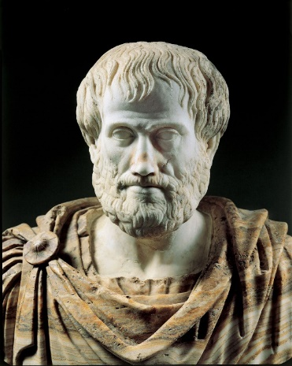
Aristotle and Rhetoric
- Aristotle lived in Ancient Greece.
- He moved to Athens to study from Plato, a lead teacher.
- Aristotle later became a lead teacher himself in many subjects: one of these was the art of rhetorical language.
- He was a famous public speaker and people wanted his expertise in how to talk persuasively to a large audience.
- He was well respected and laid the foundations for rhetoric.
- Many of his works and skills are still used today.

Ethos, Pathos, Logos
Aristotle outlined that there were three elements of rhetorical speaking that were essential to successfully rhetoric. The speaker had to include all three elements to win over their audience. Even if a speaker managed to do one really well, if the other two didn’t feature, their audience would not be convinced. This was known as the Aristotelian Triad (tri= three).

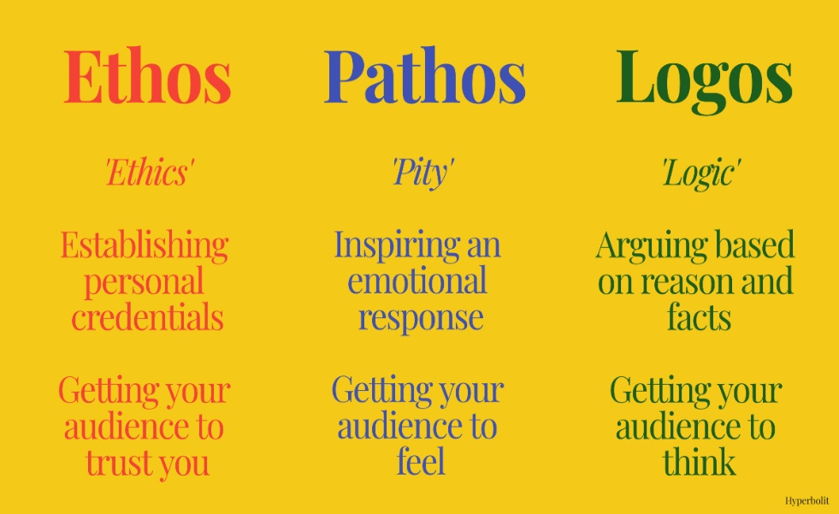

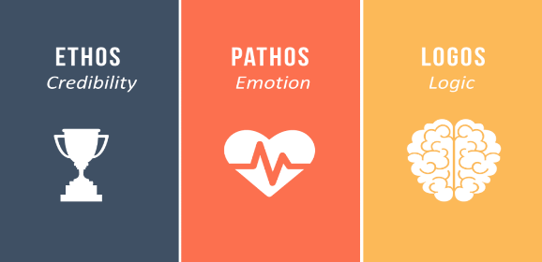
Ethos:
Ethos is to what extent you are credible. Credibility is whether the audience can trust you.

- If the audience get the impression from what you say that you are dishonest or not knowledgeable in the topic you are talking on, your speech lacks ethos.
- An example of ethos would be, ‘nine out of ten users recommend our services to others,’ or ‘I have a proven track record at working hard in Maths.’

Pathos:
Pathos is the ability to evoke or encourage a particular emotion in your reader or listener.

- This could be fear, empathy or hunger, depending upon what it is that you want to persuade them to do!
- As an example, if you wanted to raise awareness of crime, then you might use frightening language such as ‘increasing concerns’ and ‘rapid spread of crime;’ if you wanted to encourage people to buy a burger, you may use words like ‘tempting’ or ‘irresistible.’

Logos:
Logos is the logic of your argument: the proof to back up what you say is true.

- Statistics, facts and figures, or quotations from experts can help to make sure your argument includes logos.
- You might say, ‘It could be argued that Saturday school is a great way to learn, but experts state that 80% of students actually don’t improve as a result of attending six days of school,’ or ‘It is scientifically proven that not exercising will worsen your health.’

A balance of these three elements will make any argument or speech convincing and persuasive.

When do we use rhetoric?

  To encourage others to do something in reaction to your speech or writing.  Action |   To speak out against unfair treatment, normally on behalf of a group of specific people.  Injustice
  To change the way rules work and try to improve them for the benefit of yourself, or others.  Change |   To make people feel hopeful or optimistic in the hardest of situations.  Motivation

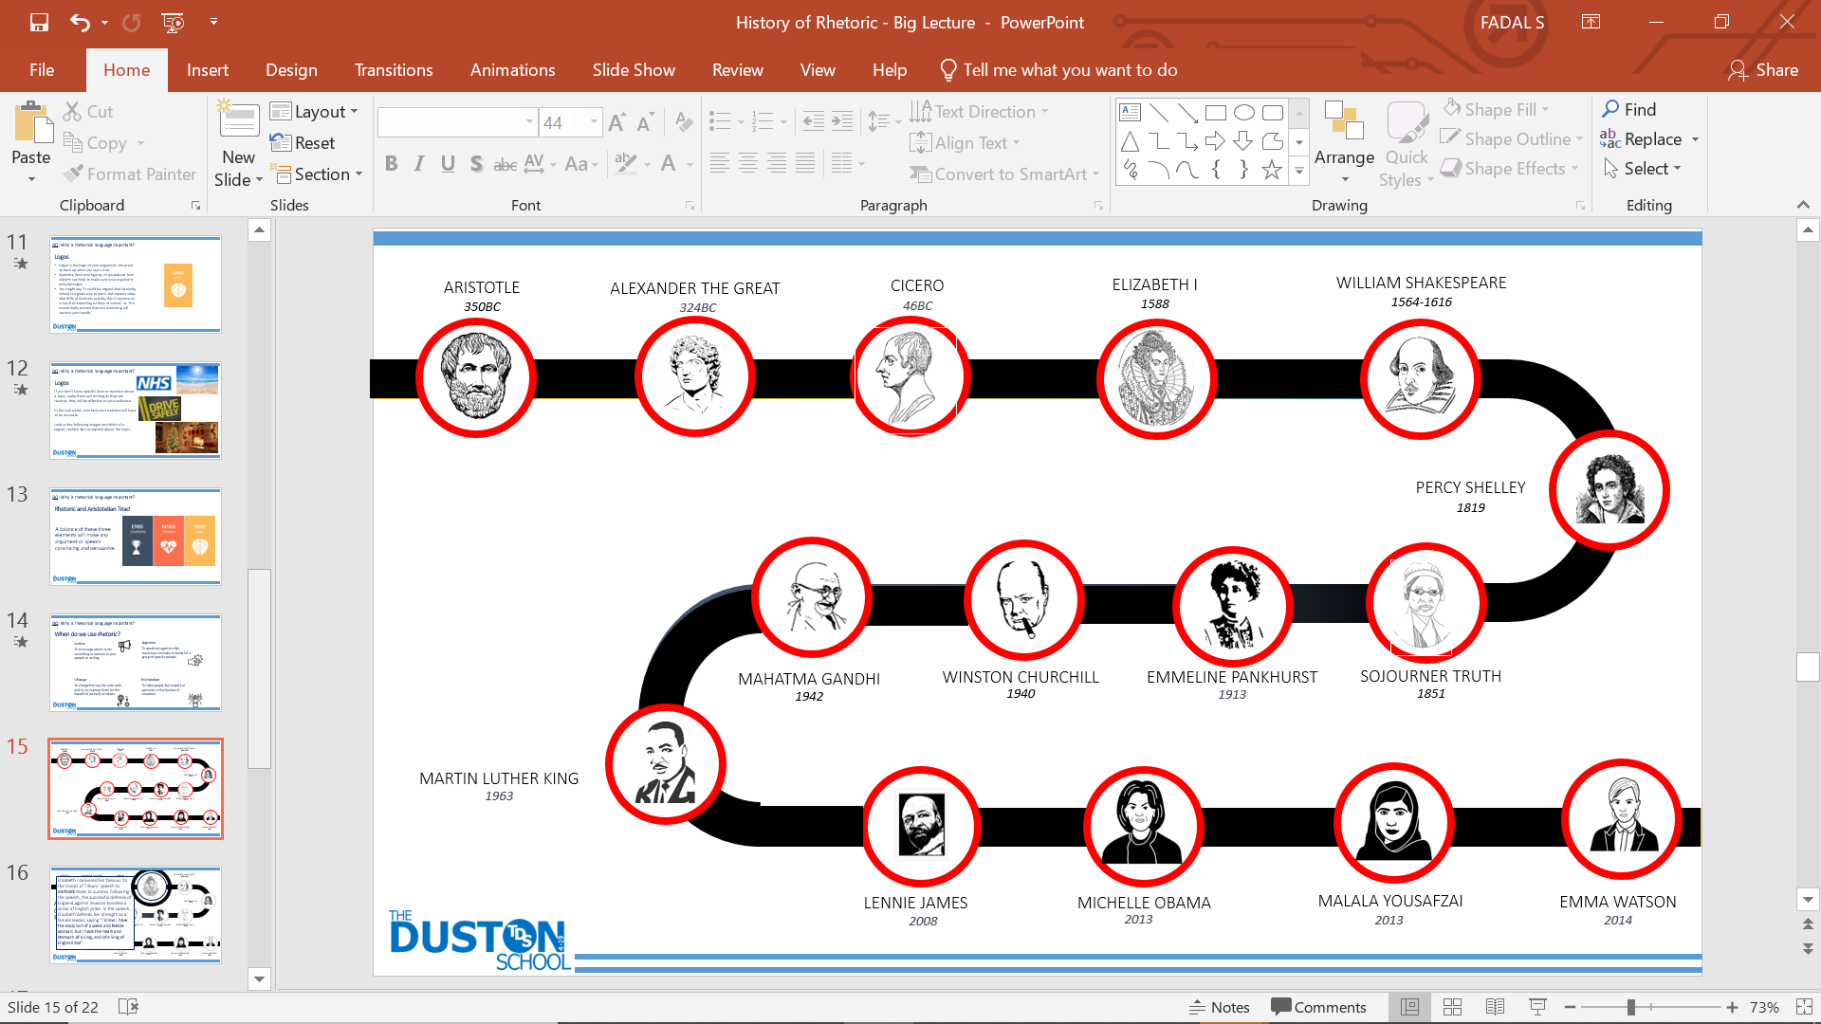
A History of Rhetoric

Elizabeth I

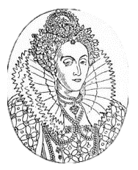
Elizabeth I delivered her famous ‘to the troops of Tilbury’ speech to motivate them to success. Following the speech, the successful defense of England against invasion boosted a sense of English pride. In the speech, Elizabeth defends her strength as a female leader, saying "I know I have the body but of a weak and feeble woman; but I have the heart and stomach of a king, and of a king of England too".

Martin Luther King
Martin Luther King Jr was an American civil rights activist, who campaigned and spoke about the injustice of racism in the United States of America. Delivered to over 250,000 civil rights supporters in Washington, D.C., his ‘I have a Dream’ speech was one of the most iconic speeches in American History. His use of pathos was clear: ‘I have a dream that my four little children will one day live in a nation where they will not be judged by the colour of their skin but by the content of their character. I have a dream today.’
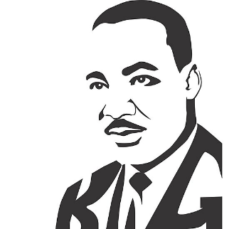

Emma Watson


British actor Emma Watson was appointed UN Women Goodwill Ambassador in July 2014. Her HeForShe speech to launch a campaign to promote gender equality (men and women being treated in the same way and have access to the same opportunities) was the beginning of a global movement to try and change laws in countries that still had policies in place to treat women unfairly. She asked men in positions of power, to speak for women and demand change. ‘We are struggling for a uniting word but the good news is we have a uniting movement. It is called HeForShe. I am inviting you to step forward, to be seen to speak up, to be the "he" for "she". And to ask yourself if not me, who? If not now, when?’

Further watching. reading and thinking
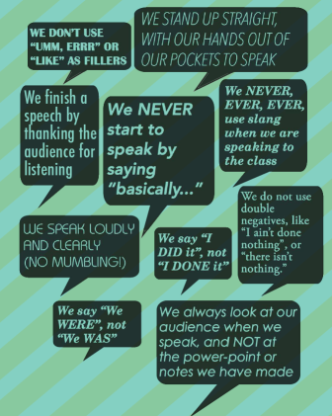
- Leonardo di Caprio’s speech at the UN about climate change: https://www.youtube.com/watch?v=vTyLSr_VCcg
- https://www.theguardian.com/theguardian/series/greatspeeches
- Think about how you present an argument! Are you persuasive?

Example analytical writing

Is capital punishment ever justified?
The way in which a society treats its criminals is, I believe, a clear indicator as to what type of society it wishes to be. It is perfectly normal to want to strive for revenge when a terrible crime is committed but the more that this desire strengthens, the more it should be resisted. Revenge is not justice. Capital punishment, therefore, is not something befitting a civilised society in the 21st Century.

In years gone by, we used to inflict hideous punishments on our criminals: we used to burn them alive, deliver the ‘hung, drawn and quartered’ punishment and execute many criminals. In a modern society, most reasonable people would agree that burning somebody alive until they die in terrible agony is not reflective of a civilised society and neither is killing criminals. If, as a state, we insist upon high moral standards and laws then we should not demean ourselves by carrying out the very heinous act that we are saying is abhorrent. Double standards and hypocrisy are not desirable traits for our cherished society.

Some people argue that killing criminals who have committed a terrible crime is the only way to keep society safe but is that really true? Surely if a criminal is imprisoned for the rest of their life in solitary confinement then, equally, there is no chance of them reoffending. Furthermore, if they are in prison and it transpires that a miscarriage of justice has taken place then they have a chance to fight for their innocence whilst being no danger to the rest of society; it is too late to pardon somebody if they are dead.

Whilst it is a perfectly reasonable human desire to want the person who committed a terrible crime against your family to be put through great pain, it does not make it morally right. You cannot blame an individual whose family has been mercilessly slaughtered for desiring to inflict pain and suffering on the assailant but that is why people who have experienced great trauma and are understandably impassioned do not make our laws. The laws of our country need to be carefully weighed up and scrutinised as to whether they best reflect the principles of our country. As a country, I believe that we pride ourselves on being compassionate and civilised and murdering criminals certainly does not seem to be civilised or a modern approach to me.

Although capital punishment might, momentarily, make a family feel better, what does it actually achieve? Surely the slaughter of a criminal only serves to act as cold revenge which takes us back to the barbaric dark ages rather than advancing our country for the better. We should aim for inclusion, compassion and justice; instead, capital punishment instils: retribution, brutality and revenge.

Example analytical writing: the writing mark scheme

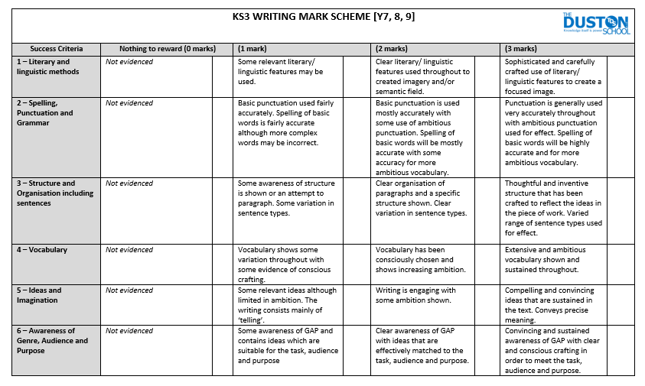

Homework.

Knowledge is power, so the more you know, the more secure you will be in your learning.

Year 8: Unit 1 Homework: A History of Rhetoric
Task 1:  Week 2 | Due date: | - Using the key information on pages 5, 6, 7 and 8, answer the 10 knowledge retrieval questions on page 12. These questions will be peer assessed in class and your teacher will check that you have completed your homework.
Task 2:  Week 4 | Due date: | - Read the article (wider reading) on pages 13, 14 and 15.  - Answer the 10 knowledge retrieval questions on page 16. These questions will be peer assessed in class and your teacher will check that you have completed your homework.
Task 3:  Week 6 | Due date: | - Based on your knowledge of the History of Rhetoric unit so far, answer the 10 knowledge retrieval questions on page 17. These questions will be peer assessed in class and your teacher will check that you have completed your homework.

If you have ‘no homework’, or you have finished all of the above, try these tasks on a weekly basis to ensure your understanding of the unit is secure.
- Select one of the key rhetorical speakers/writers from the knowledge grid to research. You should aim to find out who they were, what they were passionate about and their key achievements.
- Research other people who have given famous speeches. What were they trying to persuade people of?

Homework Task 1 – Use the key information on pages 5-8.
 | Write your answer in the box below each question. | 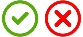
1 | What is rhetoric?
2 | Who created the idea of rhetoric?
3 | Where was he from?
4 | What is ethos?
5 | What is pathos?
6 | What is logos?
7 | Name 2 ways people use rhetoric.
8 | When did the idea of rhetoric approximately begin?
9 | What did Martin Luther King campaign and publicly speak about?
10 | Why did Emma Watson launch the HeForShe campaign?
TOTAL
Wider reading 2: Rhetoric
https://www.englishandmedia.co.uk/e-magazine/articles/15539

Sam Leith, author of You Talkin' to Me?: Rhetoric from Aristotle to Obama explores the art of rhetoric, reclaiming it from the politicians and celebrating its power in our everyday lives.

What do you think of when you hear the word 'rhetoric'? The chances are that the associations will be negative. You'll think of politicians blustering that their opponents should 'drop the rhetoric', or denouncing the 'empty rhetoric' of this corporation or that. In public life we think of rhetoric as a synonym for all that is pompous and insincere; and - when we think about it in an academic context, if we do at all - it will tend to be as a redundant discipline associated with abstruse Latin terms and Dead White European Males wearing bedsheets.

Reclaiming Rhetoric
I'd like to see the word reclaimed. Far from being a redundant discipline, the study of rhetoric has never been so relevant: we have more of it about us than at any previous point in human history. And far from being a bad thing, it is what makes modern life possible.

'Rhetoric' isn't just fancy language, and it isn't just formal speech-making. It isn't lies - or it isn't necessarily lies. It's simply the word that describes any attempt to influence another human being in words. Rhetoric is the art of persuasion. As such, it's what underpins the whole of Western civilisation. What are the two biggest and fanciest public buildings in any capital city? The parliament and the law courts. Both are temples to rhetoric.

Democracy – Governing Through Language
Democracy is, simply put, the application of the idea that you run a country by having an argument rather than by having a fight. And the idea of the criminal trial is that the accused and his or her accusers should have the chance to sway a judge or jury through argument. Rhetoric is what put us here. It's the way we order our society.

For thousands of years - ever since Aristotle first formulated its principles - there has been a body of knowledge about how rhetoric works. If you attended a grammar school at any time between the medieval period and the end of the eighteenth century, you would have been taught rhetoric. In fact, as one part of the Trivium - grammar, logic and rhetoric - it constituted fully a third of an education. It's a body of knowledge that has, bizarrely, fallen into neglect - but one whose basic principles are as true and as useful as they have ever been.

The rhetoric we find in politics and the law, as I've suggested, is still with us. But if those applications of rhetoric have been constant since ancient times, think about how many more we have now. The Greeks and Romans didn't have widely distributed codex books, or newspapers, or radio, or television, let alone the internet. More than half of the population - women - had no place in public life; which is to say, no voice.

Every day, every one of us is bombarded by advertisements and marketing. We are assailed constantly by political messages in the news. Every day, every single newspaper carries dozens of leading articles and comment columns, seeking to persuade us of a point of view.

The Rhetoric of Everyday Life
We in turn use rhetoric ourselves. We make speeches at weddings and retirement parties, in pitches for business and in job interviews. We use rhetoric to manage our colleagues - be it appeasing the boss, negotiating with a colleague, or motivating a subordinate. Any parent trying to persuade his daughter to brush her teeth before bed is using rhetoric. And the vast explosion of social media means that anyone who wants to can post a blog or a tweet, deliver a polemic on YouTube, or even publish a book to a potential public of millions.

A Teachable Skill
Rhetoric is what Aristotle called a techne - that is, a teachable skill. It is a craft. It's something we do naturally, by instinct, from the moment we can talk. But by understanding how it works, and by practising, we can improve it. To dip into the ancient body of knowledge about rhetoric not only equips us to argue better: it equips us more easily to see the false or manipulative argument when it is being used on us.

Ethos, Pathos and Logos
So what does this body of knowledge about rhetoric tell us? In the first place it is that there are three different persuasive appeals which mingle and overlap in any speech or piece of writing that seeks to persuade: ethos, pathos and logos.

Ethos – Connecting with the Audience
Ethos is the connection a speaker (or writer) makes with an audience. This is the absolute fundamental. You're more likely to go along with someone if they seem to speak the same language as you, to be sincere in what they're saying, and/or to have some expertise or authority or credibility. That's why politicians are always so keen to project themselves as empathising with ordinary people. If you think a speaker is a fool, a liar, or has a whole different set of values to you, you won't give much credit to his words. Campaigning against the slave trade in the eighteenth century, Josiah Wedgwood struck medals of a slave in chains with the legend: 'Am I not a man and a brother?' This assertion of shared humanity is one of the most powerful ethos appeals imaginable. The slave is, literally, one of us.

Pathos – Moving an Audience
Pathos is the attempt to sway an audience's emotions. That doesn't just mean sadness - the most common colloquial use of pathos nowadays - but anything from anger to pride, disgust, or even amusement. We like to think that we make decisions with our heads - but never underestimate how important the heart can be. A children's charity speaks more powerfully to its supporters through individual case-studies than through arid statistics. And to follow the promptings of one's emotions is not a sign of weakness or gullibility any more than attempting to appeal to them is 'cheating'. Feeling and fellow-feeling are at the centre of our humanity. Without them would we nurture children, build communities or stick up for those weaker than ourselves?

Logos – The Argument
Logos - coming, probably, in third place - is the actual argument itself. And here, as Aristotle realised, there's a lot more wriggle-room than you might think. Logos and logic share a root, but they aren't the same thing. Formal philosophical logic is a very exact, mathematical thing. Premise A and premise B combine to produce conclusion C by an iron chain of deduction. In rhetoric, which deals with the fallible sublunary world, we are most often arguing about probabilities. So in deliberative rhetoric (trying to persuade people of a course of action) you're arguing about the future, which is unknowable. You might say, if we invade Iraq we'll be safer as a nation, and you might even be right - but you're talking about probabilities. Likewise, in court, you're arguing about 'reasonable doubt'.

The Art of Persuasion
On top of this triad of appeals is built the whole edifice of persuasion. The overall field of rhetoric also divides into three parts. There's deliberative rhetoric, oriented towards the future: What shall we do? This is the sort you find in politics. There's forensic or judicial rhetoric, which is concerned with the past: What happened? Who's to blame? This is the sort you find in law courts. And then there's display rhetoric (also called epideictic), which is the rhetoric of praise and blame: the best man's speech at a wedding being a prime modern example.

The Five Canons of Rhetoric – a Step-by-Step Guide
The ancient authorities - prime among them Aristotle, Cicero and Quintilian, but translated, amplified and modified by many thousands of handbooks and textbooks over the centuries - provide a comprehensive scheme for the construction of a speech; and, by extension, any attempt to persuade. The so-called 'five canons of rhetoric' -Invention, Arrangement, Style, Memory and Delivery - are, you might say, a step-by-step guide.
- Invention: You think up the arguments that will best support your case.
- Arrangement: You put those arguments in the most effective order - introducing yourself at the outset, for instance, framing the terms of the argument, advancing your points, rebutting and anticipating objections, and summing up.
- Style: You find the most effective form of expression - forceful, witty, euphonious, memorable.
- Memory: This may seem an odd one in the age of autocues and PowerPoint presentations, but familiarity with what you intend to say is vital if you are to seem spontaneous and in command.
- Delivery: There's no point in having the best speech in the world if you can't put it across in a way that is engaging, charming and persuasive.

No speaker wishing for success can afford to ignore any one of these: like the chain of proverb, your speech will be as strong as its weakest link.

[…]

A Rhetorical Toolkit
Before we had linguistics, or literary criticism, it was the study of rhetoric - and pretty much only the study of rhetoric - that provided us with a vocabulary to talk about the twists and turns that makes language distinctive. Among the hundreds of figures are those that deal with everything from repetition of words or phrases - anaphora at the beginning of successive clauses; epistrophe at the end - to the putting of one word in the middle of another.

The list of figures supplies names for things you do in the wide sweep of argument - such as concession, where you concede a battle to win the war ('Yes, I maxed out the credit card; but I did so because I was buying you a birthday present'). And it supplies names for whether you use lots of conjunctions or not ('and ... and ... and ...' is polysyndeton; a list without conjunctions - 'sex, lies, videotape' - is asyndeton). Metaphor, alliteration, antithesis, zeugma - all these familiar and semi-familiar terms belong to the figures. You name it, there's probably a figure that already has.
The figures, then, like all the other terms in rhetoric, are nothing more than a toolkit, a set of labels that describe things we all do.

 | Write your answer in the box below each question.
1 | Why is rhetoric more important now than ever?
2 | Who first formed the principles of rhetoric?
3 | List three ways people are persuaded today.
4 | The writer argues that rhetoric is something that humans can formulate naturally. But, why is it so important to continue to study rhetoric?
5 | What could a text producer do to create ethos?
6 | List three emotions the writer argues pathos might create.
7 | What are the 3 parts to rhetoric?
8 | What does the deliberative rhetoric focus predominately on?
9 | What are the five canons of rhetoric?
10 | According to the writer, how has rhetoric aided the English Language?
TOTAL

Homework Task 2 – Use the Wider Reading on pages 13-15.

Homework Task 3 – Use your knowledge from your lessons.
 | Write your answer in the box below each question.
1 | What is antithesis?
2 | Give three techniques from the acronym DAFORREST.
3 | What do both Sojourner Truth and Emmeline Pankhurst use rhetoric for?
4 | What is “Friends, Romans, countrymen” an example of?
5 | Why is pathos essential to persuading an audience?
6 | What is ‘Don’t shy away from victory; face it head on’ an example of?
7 | Using a short story to illustrate a point is called what?
8 | Which aspect does emotive language help to build?
9 | What is hyperbole?
10 | What is tyranny?
TOTAL


Wider reading list
Non-Fiction books to reflect beliefs and opinions
- I Am Malala by Malala Yousafzai – When the Taliban took control of the Swat Valley in Pakistan, one girl spoke out. Malala Yousafzai refused to be silenced and fought for her right to an education.
- The Climate Book by Greta Thunberg – We still have time to change the world. From Greta Thunberg, the world's leading climate activist, comes the essential handbook for making it happen. You might think it's an impossible task: secure a safe future for life on Earth, at a scale and speed never seen, against all the odds. There is hope - but only if we listen to the science before it's too late.
- You Are A Champion by Marcus Rashford – Marcus Rashford MBE is famous worldwide for his skills both on and off the pitch – but before he was a Manchester United and England footballer, and long before he started his inspiring campaign to end child food poverty, he was just an ordinary kid from Wythenshawe, South Manchester. Now the nation's favourite footballer wants to show YOU how to achieve your dreams, in this positive and inspiring guide for life.
- The Diary of a Young Girl by Anne Frank – This abridged edition offers younger readers their first introduction to the extraordinary diary of an ordinary girl. With beautiful line drawings, family photographs and an afterword to explain why the Diary ends so abruptly, this version of one of the world's most widely known books is suitable for younger children who want to read Anne's words for themselves.
- The Extraordinary Life of Alan Turing by Michael Lee Richardson – Alan Turing started life as a quiet boy who loved maths and become a mathematician and codebreaker who helped save millions of lives in the Second World War by building a machine to decode secret enemy messages. The Extraordinary Lives series profiles modern and historical figures and is packed with figures and illustrations.
- I Dissent: Ruth Bader Ginsburg Makes Her Mark by Debbie Levy – US Supreme Court justice Ruth Bader Ginsburg spent her life disagreeing with inequality, arguing against unfair treatment and standing up for what’s right for people everywhere. This biographical picture book explains what she achieved through the lens of her many famous dissents, or disagreements.
- Through My Eyes by Ruby Bridges – In November 1960, the world watched as six-year-old Ruby Bridges joined an all-white school and faced angry mobs of parents who refused to send their children to school with her. An icon of the civil rights movement, in Through My Eyes Ruby writes for children and chronicles each dramatic step of this pivotal event in history in her own words.
- I Will Always Write Back: How One Letter Changed Two Lives by Caitlin Alifirenka, Liz Welch and Martin Ganda – Proving how some school assignments can go further than just getting you a good grade, this story tells how 12-year-old Caitlin Alifirenka's assignment to write to an unknown student in a far-off place turned into something life-changing. When Caitlin first began corresponding with Martin Ganda in Zimbabwe, she began to learn about the poverty that he and his family lived in, and it opened her eyes to how other people lived, and helped to change Martin's future.
- A Different Sort of Normal by Abigail Balfe – The story of one girl’s journey growing up with autism and the challenges she faced in the ‘normal’ world.
- A Brief History of Everyone Who Ever Lived: The stories in our genes by Adam Rutherford – The book reveals what our genes now tell us about history, and what history tells us about our genes. From Neanderthals to murder, from redheads to race, dead kings to plague, evolution to epigenetics, this is a demystifying and illuminating new portrait of who we are and how we came to be.
- Unbelievable by Jessica Ennis – The author’s sporting performances make up the main part of this autobiography, but the childhood recounts of bullying and crippling insecurity are eye-opening and inspirational.
- What If?: Serious Scientific Answers to Absurd Hypothetical Questions by Randall Munroe – Millions visit xkcd.com each week to read Randall Munroe's iconic webcomic. Fans ask him a lot of strange questions: How fast can you hit a speed bump, driving, and live? When (if ever) did the sun go down on the British Empire? When will Facebook contain more profiles of dead people than living? How many humans would a T Rex rampaging through New York need to eat a day?

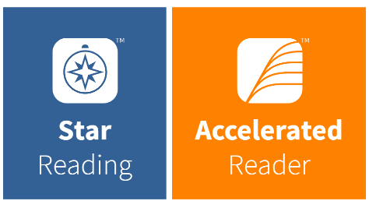
Instructions for the Star Reading Test

Step 1: Log on the Computer
Username will be your school username: Example: 23CRobinson
Enter your password (you created this in your IT/Computing lesson)

If you have not had a computing lesson

Password: dustonp456 OR Duston1234 (these are default passwords if you have not had an IT/Computing lesson.
Create a new password (this step is for students who have NOT had IT lessons)
Your password must include: 8 letters, 1 capital letter, 1 number and 1 special character. Don’t forget to write down your new password!

Step 2: Search the Renaissance website
In the search box on the desktop type: TDS
Click on the link that says: TDS Accelerated Reader

Step 3: Log into the Renaissance website
Enter the username and password that your teacher has provided to you

Step 4: The Star Reading Test
Click on the blue icon that says Star Reading and begin the reading test.

