
s

Knowledge
Organiser
Year 11 Functional: Unit 2
English Literature:
Unseen Poetry

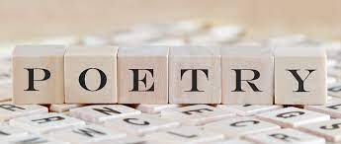

Knowledge Organiser
Year 11: Unit 1
GCSE English Language Paper 1
Explorations in Creative Reading and Writing

Name:

Class:

Big Questions

The big question for the unit is:

Our study revising Unseen Poetry will follow the outline below:
Week 1 | BQ: How does a poet use language and structure for a desired effect on the reader?
Week 1 | BQ: How does the poet convey their feelings in the poem?
Week 1 | BQ: How do writers convey specific tones in their writing?
Week 2 | BQ: How can I make inferences in a poem?
Week 2 | BQ: Why do poets use extended metaphors?
Week 2 | BQ: Extended writing: What are the similarities and differences between the way the two poets convey their feelings on youth?
Week 3 | Whole class feedback: How can I improve my writing?
Week 3 | BQ: What is enjambment and what impact can it have on a poem?
Week 3 | BQ: How could I consider language techniques in a comparative essay?
Week 4 | BQ: Why do poets use patterns in poetry?
Week 4 | BQ: How can structure convey specific ideas in a poem?
Week 4 | BQ: Extended writing: How does the poet convey feelings in the poem: ‘Funeral Blues’?
Week 5 | BQ: Whole Class Feedback: How can I improve my writing?
Week 5 | BQ: How is violence and responsibility explored in the poem: ‘Hitcher’?
Week 5 | BQ: How does the speaker feel about marriage in the poem?
Week 6 | BQ: What are the similarities and differences of Heaney’s and Blumenthal’s ideas on marriage?
Week 6 | BQ: How Does Duffy convey ideas about love in her poem ‘Valentine’?
Week 6 | BQ: How Can I show my Knowledge in a 50 Question End of Unit Multiple Choice Quiz?

Key Vocabulary
Metaphor | A direct comparison of two things in which it is representative or symbolic of something else.
Imagery | Language in a text that helps create a visual image for the reader.
Semantic Field | When we have words that are all linked in meaning used to create a particular image/ feeling and keep this consistent in the mind of the reader.
Pathetic Fallacy | Where the writer uses the weather and/or atmosphere to reflect the mood in a text.
Adjective | A word that is used to describe a noun. ‘The ugly man.’
Tone | The overall feeling, mood or atmosphere created by a writer.
Personification | Giving an object human characteristic
Antithesis | Where two things are the direct opposite and contrast with one another.
Simile | A comparison of two things using the words ‘like’ and/or as’
Oxymoron | Where two contrasting words are placed next to one another e.g. ‘Bitter Sweet’
Onomatopoeia | When a word imitates a sound like ‘bang’.
Shift in Focus | When a writer deliberately crafts the text to draw our attention to something else.
Dialogue | Sections of a text that are identifiable by characters speaking.
Alliteration | When words start with the same sound or letter ‘Tom told tales’
Chronology | The arrangement of events in time order – or as they occurred in sequence.
Foreshadowing | Where a writer drops hints in the text at events to come later on.
Juxtaposition | Placing two images or ideas close together for the purpose of comparison similarity or contrast.
Sibilance | The repeated ‘s’ sound in a succession of words to create a hissing or sinister effect or the sound of the sea – ‘Slowly, slithering amongst the grass, snakes search…’
Stanza | A verse in a poem
Enjambment | The running-over of a sentence or phrase from one poetic line to the next, without terminal punctuation; the opposite of end-stopped.
Accent | A distinctive way of pronouncing a language, especially one associated with a particular country, area, or social class.
Anaphora | The repetition of a word or phrase at the beginning of a line, clause or sentence.
Dialect | A particular form of a language, specific to a region or social group.
Caesura | A strong pause within a line, and is often found alongside enjambment.
Elegy | A poem that laments the death of someone or is simply sad or thoughtful
Octave | Stanza made up of eight lines written in iambic pentameter. Usually found in the first part of Petrarchan sonnet.
Sestet | Stanza made up of six lines written in iambic pentameter. Usually found in the second part of Petrarchan sonnet.
Quatrain | Stanza made up of four lines.
Sonnet | A poem consisting of 14 rhyming lines of equal length. Petrarchan/Italian sonnet = 8 line octave (ABBAABBA) and 6 line sestet (CDECDE OR CDCDCD). Shakespearean/English sonnet = 3 quatrains and a rhyming couplet (ABABCDCDEFEFGG).
Refrain | A phrase, line or group of lines repeated throughout a poem.

Additional Terminology
 | Term | Definition

1

2

3

4

5

6

7

8

9

10

11

12

13

14

15

16
Essay Structure, Exam Criteria, Assessment Objectives

Approaching Unseen Poetry [The Exam]

Steps for success:
- Read the question.
- Read the poem once and keep the question in mind.
- Read again and highlight the things that stand out most to you. Be selective.
- Pick three things to focus on annotate things in the poem that link to them

SAY THREE THINGS ABOUT THREE THINGS [3 in 3]
3 points backed up with 3 ideas.

Try and offer alternative interpretations for higher marks.

WHAT is your idea?
HOW has it been used [methods]?
WHY would the poet use it [effect]?

The exam will have 2 questions for you to answer:
24 mark – Poem 1 – an analysis of how an idea/ theme is presented in an Unseen Poem.
8 mark – Mini comparison of Poem 1 and another Unseen Poem, Poem 2.

Exam Criteria + Assessment Objectives

AO1 Read, understand and respond to texts. Students should be able to:
• maintain a critical style and develop an informed personal response
• use textual references, including quotations, to support and illustrate interpretations.

AO2 Analyse the language, form and structure used by a writer to create meanings and effects, using relevant subject terminology where appropriate.

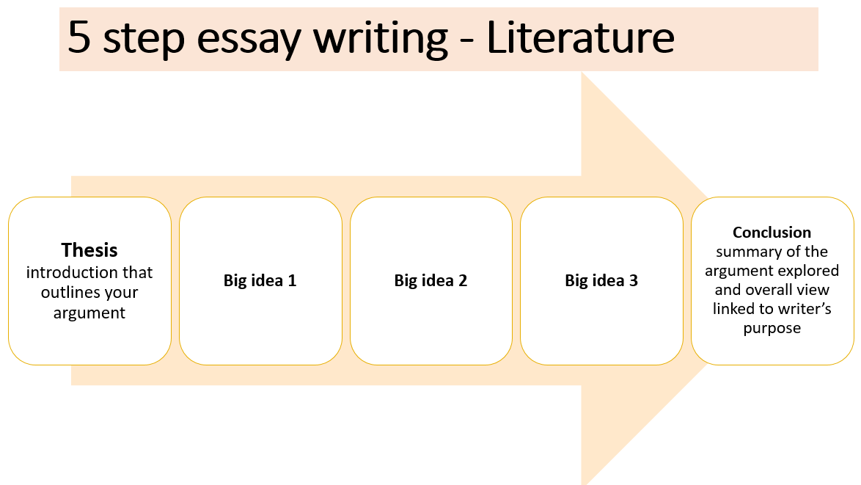

Exam Criteria + Assessment Objectives

AO1 Read, understand and respond to texts. Students should be able to:
• maintain a critical style and develop an informed personal response
• use textual references, including quotations, to support and illustrate interpretations.
AO2 Analyse the language, form and structure used by a writer to create meanings and effects, using relevant subject terminology where appropriate.
AO3 Show understanding of the relationships between texts and the contexts in which they were written.

Example Analytical Writing:
Response to question: In 'Names’, how does the poet present the speakers feelings towards Eliza?
Names

She was Eliza for a few weeks
when she was a baby –
Eliza Lily. Soon it changed to Lil.
Later she was Miss Steward in the baker’s shop
And then ‘my love’, ‘my darling’, Mother.
Widowed at thirty, she went back to work
As Mrs Hand. Her daughter grew up,
Married and gave birth.
Now she was Nanna. ‘Everybody
Calls me Nanna,’ she would say to visitors.
And so they did – friends, tradesmen, the doctor.
In the geriatric ward
They used the patients’ Christian names.
‘Lil,’ we said, ‘or Nanna,’
But it wasn’t in her file
And for those last bewildered weeks
She was Eliza once again.

Wendy Cope

Wendy Cope presents great sympathy towards Eliza in the poem ‘Names’. Through the mere
exploration of the names one woman takes on in her lifetime, Cope is able to explore identity –
particularly that of women – and express sympathy towards all women. She is also able to explore
the cruelty of dementia and how identity and relationships can all be lost in the ‘bewildered weeks’
at the end of life. In both interpretations, Eliza is a target for great sympathy.
The choice of the title ‘Names’ immediately indicates to the reader that the poet is exploring
identity. By using the voice of the granddaughter (possibly autobiographically), which is clear in the
line ‘”Lil” we said ‘or Nanna’” the poet is able to create a deeper connection between the speaker
and Eliza. The sympathy is deepened in knowing that the loss of the Eliza is a personal loss for the
speaker. The idea that the woman, Eliza, returns to the name she was given as a baby could indicate
the return of her to her baby state in more than just name. It could symbolise that mentally, through
dementia, she has returned to a baby-like state. The reference to the ‘last bewildered weeks’
strengthens this interpretation. The use of the adjective ‘bewildered’ emphasises the confusion for
Eliza and increases our sympathy for her. By adding the adjective ‘last’ we are also conscious that
she is at the end of her life, and so softened more to wards sympathy to begin with.
The structure of the poem is chronological, mirroring the content which follows the life story of Eliza.
The lack of rhyme or rhythm pattern mirrors the lack of order in the memories that Eliza shares with
the people on the ward; thus deepening our sense of the confusion of the woman and increasing our
sympathy for her dementia- state. In addition, the poet’s use of caesuras such as ‘ Eliza Lily, Soon it
changed to Lil’ create a further sense of confusion, disconnection and flow, giving the reader a
similar experience to the experience of Eliza. The poet binds us together through the use of
disjointed, un-flowing memories.
Another aspect of the poem that arguably draws our sympathy is the exploration of female identity.
The great number of different names the woman has in her life represents the great number of roles
she undertakes. She is not simply Eliza, nor even ‘Lil’, she is also identified purely by her marital
status – ‘Miss Steward’. ‘Mrs Hand’ – or her position as a nurturer – ‘Mother’ ‘Nanna’. The fact that
all the ‘Names’ referred to in the title, apart from Eliza, Eliza Lily, Lil are defined through relationship
to men and children could, perhaps, be an indictment on the treatment of women in society. Cope
could be asking us to sympathise with Eliza, and symbolically all women, due to the hijacking of their
individual identities for the sake of their husband’s and children.

Homework

Year 11: Unit 2 Functional English Homework
Task 1: | Due date:  WEEK 2 | Read the unseen poem ‘Rainy Day’ on page 11 and answer the multiple-choice questions.
Task 2: | Due date:  WEEK 4 | Read the unseen poem ‘The Park’ on page 13 and answer the multiple-choice questions.
Task 3: | Due date:  WEEK 6 | Read the unseen poem ‘A Quiet Place’ on page 16 and answer the questions using your own words. Use the poem to help you answer the questions. Write in full sentences and use capital letters and punctuation correctly.

Homework Task 1

Read the poem and answer the multiple-choice questions.

Poem: “Rainy Day”

by an anonymous poet

Pitter-patter on the ground,

Raindrops falling all around.

Coats and boots and splashing feet,

Rainy days can be a treat!

Umbrellas open in the street,

Water dancing near my feet.

Though the sky is dull and grey,

I still find some fun today.

For each question, tick or circle the correct answer.

1. What is the poem about?

A. A snowy day

B. A rainy day

C. A windy day

D. A sunny beach

2. Which clothes are mentioned in the poem?

A. Hats and gloves

B. Shorts and T-shirts

C. Coats and boots

D. Scarves and sunglasses

3. How does the speaker feel about rainy days?

A. They are boring

B. They are scary

C. They are fun

D. They are too wet

4. What is falling all around?

A. Leaves

B. Snowflakes

C. Raindrops

D. Sunshine

5. What does the sky look like in the poem?

A. Blue and bright

B. Dull and grey

C. Full of stars

D. Orange and red

Homework Task 2

Unseen Poem – Language and Structure questions

Poem: “The Park”

by an anonymous poet

I walk along the grassy path,

The breeze is soft and light.

The swings are creaking in the wind,

The sky is clear and bright.

Leaves are dancing in the air,

The flowers nod and sway.

I sit and listen to the world,

And watch the end of day.

Answer the multiple-choice questions below. For each question, either tick or circle the correct answer.

Language (Words)

1. Find one word that shows the breeze is gentle.

A. strong

B. light

C. heavy

D. stormy

2. What word makes the swings sound like they are moving slowly?

A. creaking

B. jumping

C. banging

D. clapping

3. The poet says: “Leaves are dancing.” What is this an example of?

A. A rhyme

B. A simile

C. A personification

D. A question

Structure (How the poem is built)

4. How many verses (groups of lines) does the poem have?

A. One

B. Two

C. Three

D. Four

5. Which lines rhyme in the first verse?

A. Lines 1 and 2

B. Lines 2 and 4

C. Lines 1 and 3

D. Lines 3 and 4

6. Why do you think the poet uses short lines?

(write your own answer)

_________________________________________________________________________________________________________________________________________________________________________________________________________________________________________________________________________________________________________________________________________________________________________________________________________________________________________________________________________________________________________________________________________________________________________________________________________________________________________________________________________________________________________________________________________________________________________________________________________________________________________________________________________________________________________________________________________________________________________________________________________________________________________________________________________________________________________________________________________________________________________________________________________________________________________________________________________________________________________________________________________________________________________________________________________________________________________________________________________________________________________________________________________________________________________________________________________________________________________________________________________________________________________________________________________________________________________________________________________________________________________________________________________________________________________________________________________________________________________________________________________________________________________________________________________________________________________________________________________________________________________________________________________________________________________________________________________________________________________________________________________________________________________________________________________________________________________________________________________________________________________________________________________________________________________________________________________________________________________________________________________________________________________________________________________________________________________________________________________

Homework Task 3

Read the poem below and then answer the questions that follow.

Poem: “A Quiet Place”

by an anonymous poet

There is a place I like to go,
Where flowers bloom and rivers flow.
The air is calm, the sky is blue,
And everything feels fresh and new.

I sit beneath a shady tree,
And let the peace wash over me.
No noise, no rush, no angry sound,
Just nature’s stillness all around.

1. What kind of place is the poet describing? (Use your own words.) __________________________________________________________________________________________________________________________________________________________________________________________________________________________________________________________________________________________________________________________________________________________________________________________________________________________________________________________________________________________________________________

2. How does the poet feel in this place? (Give one feeling and explain why.) _____________________________________________________________________________________________________________________________________________________________________________________________________________________________________________________________________________________________________________________________________________________________________________________________________________________________________________________________________________________________________________________________________________________________________________________________________

3. Find a line that shows the place is peaceful. (Write the line and say why it shows peace.) _____________________________________________________________________________________________________________________________________________________________________________________________________________________________________________________________________________________________________________________________________________________________________________________________________________________________________________________________________________________________________________________________________________________________________________________________________

4. Why do you think the poet goes to this place? (Give your own opinion.) ______________________________________________________________________________________________________________________________________________________________________________________________________________________________________________________________________________________________________________________________________________________________________________________________________________________________________________________________________________________________________________________________________________________________________________________________________________________________________________________________________________________________________________________________________________________________________________________________________________________________________________________________

5. What is your favourite part of the poem, and why? (You can choose a line or idea.) _____________________________________________________________________________________________________________________________________________________________________________________________________________________________________________________________________________________________________________________________________________________________________________________________________________________________________________________________________________________________________________________________________________________________________________________________________________________________________________________________________________________________________________________________________________________________________________________________________________________________________________________________________________________________________________________________________________________________________________________________



Wider reading list
Why Read More Poems?
Reading different poems helps you:

Feel more confident with unseen poetry tasks

Learn new words and ideas

Get used to different styles and topics

Practise spotting feelings, language, and structure

Suggested Poems to Start With:
“Hope is the Thing with Feathers” by Emily Dickinson

“This Is Just to Say” by William Carlos Williams

“The Eagle” by Alfred, Lord Tennyson

“Dreams” by Langston Hughes

Each is short and full of meaning—perfect for practice.



Here is your QR code that links to a collection of short, accessible poems on the Poetry Foundation website—great for wider reading practice:
Other Online Resources

Mr Bruff Videos
https://www.youtube.com/watch?v=FOeASYrxL1c

BBC Bitesize
https://www.bbc.co.uk/bitesize/subjects/zckw2hv

AQA Website for Past Papers
https://www.aqa.org.uk/subjects/english/gcse/english-literature-8702/assessment-resources

Seneca
https://senecalearning.com/en-GB/

