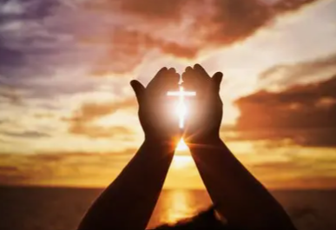

Year 10
Living the Christian Life

Knowledge Organiser

Name……………………………………………………………

LIVING THE CHRISTIAN LIFE
 | What is the basic info you need to know?
3.1 | Reference to the Book of Common Prayer, 1662. Liturgical worship as a set form of public worship which follows the Churches liturgical calendar year. Non-liturgical worship and private worship that may also involve family worship at home. Links can be made here to the different support that churches give to families by offering activities such as ‘Messy Church’, ‘Tot’s Time’ and Mother’s Union.
3.2 | The Seven Sacraments of the Catholic Church are baptism, confirmation, confession, ordination, marriage, anointing with oil and communion. Sacraments help to bring believers closer to God through receiving the grace and blessing of God throughout life. Without ordination of priests there would be no one to deliver the Holy Communion as only ordained priests are allowed to do this. In the Church of England the 39 Articles state that only baptism and taking of holy communion are essential.
3.3 | The different types of prayer can be remembered through the use of the mnemonic, PICTA. Petition, intercession, confession, thanksgiving and adoration. The Lord’s prayer is an example of a set prayer as is the ‘collect’ which is a prayer that is to be said in the church that week and is an example of a prayer contributing to liturgical worship.
3.4 | Pilgrimages have taken place for years with many medieval worshippers making the journey on foot to the Holly Land. This has been popularised in Chaucer’s Canterbury Tales. Protestant reformers felt that pilgrimages encouraged the worship if idols and broke the commandment about worshipping God: pilgrimage has become more of a Catholic tradition. Place of Pilgrimage is: Lourdes, Jerusalem, Walsingham, and Santiago di Compestela.

 | Key sources of authority and wisdom
3.1 | Book of Common Prayer:  Oldest Anglican Prayer book written by Thomas Cranmer, Archbishop under the reign of Henry VIII. Contains particular prayers for each week of the year. Also contains the wording for services such as marriage, baptism and funerals.
3.2 | 39 Articles: Those five commonly called Sacraments, that is to say, Confirmation, Penance, Orders, Matrimony, and extreme Unction, are not to be counted for Sacraments of the Gospel, being such as have grown partly of the corrupt following of the Apostles, partly are states of life allowed in the Scriptures; but yet have not like nature of Sacraments with Baptism, and the Lord's Supper, for that they have not any visible sign or ceremony ordained of God.
3.3 | The Lord’s Prayer: Our Father who art in heaven, hallowed be thy name, thy kingdom come, they will be done on earth as it is in heaven. Give us today our daily bread and forgive us our trespasses as we forgive those who trespass against us. Lead us not into temptation and deliver us from evil. For the kingdom the power and the glory are yours now and forever.
3.4 | ‘Stand at the crossroads and look; ask for the ancient paths ask where the good way is and walk in it and you will find rest for your souls…’ Jeremiah 6:16
Topic | Christian View | Importance | Impact on Christians Today
Christian worship | - Worship is showing respect to God.  - It can take different forms including:  - Liturgical – Formal set pattern of worship.  - Non-Liturgical – Less formal worship  Denominations worship in different ways | Divergent types of worship:  - Eucharist/Holy Communion/Mass (E.g. Catholic)  - Charismatic worship (E.g. Pentecostal)  - Personal/Private prayer  Silence (E.g Quakers) | - Enables Christians to become spiritually closer to God.  - Allows Christians to communicate with God in an intimate and personal way.  Christians believe that God can sometimes answer prayers or can enter the person through the Holy Spirit.
The Sacraments | - A sacrament (or ordinance) is a rite of passage or ceremony where the grace and power of God can be received.  Catholics recognise 7, most others only 2. | - Enables Christians to recognise important milestones in their lives.  The 39 articles (CofE) state that the sacraments are important signs of God’s Grace for Christians. | Sacraments include:  - Infant Baptism – Welcoming a baby into the faith.  - Adult/Believer’s baptism – Making a conscious choice.  The Eucharist – Re-enacting the Last Supper
Prayer | - Prayer is communication with God.  - The are different types/forms of prayer that include:  Traditional set prayers, spoken prayers (e.g. the Lord’s Prayer), Informal and silent prayers. | - The purpose of prayer is to:  - Get closer to God and communicate with Him.  - Praise God and thank him for what he has done.  Ask God for Help • To say sorry to God when the person feels they have sinned. | - Prayer can be a way for Christians to reach out to God and affirm their relationship with Him.  - It can strengthen the congregation and The Church.  - It can be a way to reflect, focus and find calm in life.  Children are taught to pray from a young age.
Pilgrimage | - A pilgrimage is a religious journey.  - Normally to a special or holy place.  Many pilgrimages are associated with the life of Jesus or other religious figures. | - Christian pilgrimages follow the Jewish tradition of travelling to holy sites for religious festivals etc.  As well as Jesus, Christian pilgrims visit sites of association with saints or supposed visions. | - Jerusalem – The last days of Jesus’ life.  - Iona – Scottish island associated with many saints.  - Taize, France – A spiritual place to gather as a community  Walsingham – Vision of Mary and reminder of Jesus.
The future of the Church | - The Church works hard to continue to grow.  Many Christians feel a responsibility to share their faith with others and grow The Church. | Society has changes and so Christians respond to this by trying to unite people and bring them to the faith. This can be done by education, charity and missionary work. | - Missionaries are sent on religious missions to spread the faith and undertake Evangelical work.  - Missionaries evangelise using the message of the Bible.  This continues a rich history of Christian missionary work.
The local Church | The local church has always had an important place in the community and society. Has been where key messages are shares and people meet as well as a hub for worship. | The important role of the local church community is to:  - Unite the local community.  - Provide support and comfort when needed.  - Provide advices from sources of authorities (Vicar).  Give identity and belonging to people in community. | Today the church helps the community by:  - Providing a centre of Christian identity.  - Ecumenism – bringing different denominations together.  - Outreach work in the community (E.g. for families)  Worship through living practices (e.g. rites of passage)
The worldwide church | Even though the Church contains many denominations across the world, They are all united as on Christian faith and worldwide Church. This is supported by things like charity. Most will aim to support charity in some way. | - It gives a global identity to Christians.  - It promotes unity.  - Provides support when needed –to anyone.  Shows how Christian teachings can be put into action on a global level. | - The worldwide church acts to stand together and overcome persecution.  - Christian Aid is just one example of charity which implements Christian ideas such as compassion and love to promote respect, justice and equality in the world.
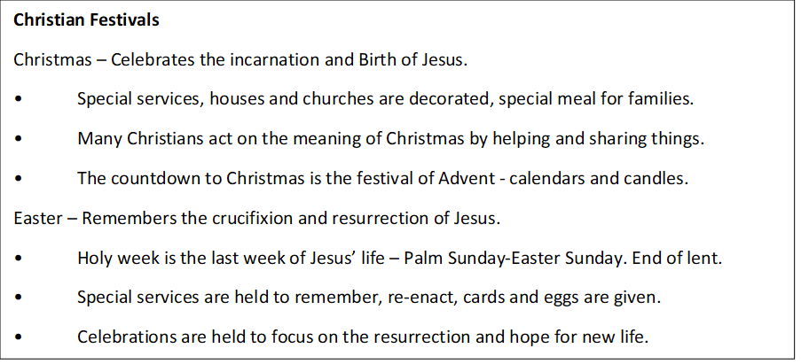

Key Quotes | Linked Topics
The Lord’s Prayer – Our father in heaven, hallowed by thy name. (Matthew 6: 9-13) – Either refer to this or quote it. | Worship, Prayer, Sacraments
And he took the bread…and broke it…saying, “This is my body given for you; do this in remembrance of me.” (Luke 22) | Worship, Sacraments, Eucharist, Easter
When you pray, go into your room, close the door and pray to your father, who is unseen. (Matthew 6:6) | Private Prayer, Worship
Pilgrimages evoke our earthly journey toward heaven and are traditionally very special occasions for renewal in prayer. | Pilgrimage
(Catechism of the Catholic Church 2691) | Holy week, Worship
Shout, daughter of Jerusalem! See your king comes to you. (Zechariah 9:9) | Christian celebrations, Future of + Local Church
A new command I give you: Love one another. (John 13:34) | Easter, Worship, Evangelism, World Church
And if Christ has not been raised, our preaching is useless and so is your faith. (1 Corinthians 15:14) | Missionary work, Evangelism, World Church
He said to them: “Go into the world and preach the gospel to all creation...” (Mark 16) | Local church, World church, Missionary work
Whoever welcomes one of these little children in my name welcomes me. (mark 9: 37) | The worldwide church, Christmas
If I give all I possess to the poor … but do not have love, I gain nothing. (1 Corinthians 13)

Key Words | Meaning
Creed | A statement of firmly held beliefs; for example, the Apostles’ Creed or the Nicene Creed.
Denominations | The name given to the main groups within the Church.
Liturgical | A set of worship, usually following agreed words.
Non-liturgical | A form of worship which is not set.
Sermon | A talk or teaching from a church leader.
Worship | Believers expressing love and respect for, and devotion to God.
39 Articles of Religion | A historical record of beliefs (or ‘doctrines’) held by the Church of England.
Anoint | Apply oil to a person’s head as a sign of holiness and God’s approval.
Sacrament | An important Christian ceremony.
Baptism | The Christian ceremony that welcomes a person into the Christian community.
Eucharist | The ceremony commemorating the Last Supper, involving bread and wine; also called Holy Communion or Mass.
Prayer | A way of communicating with God.
Pilgrimage | A journey to a religious or holy place.
Shrine | A holy place.
Vision | Seeing or hearing someone or something holy.
Advent | A season of preparation for Christmas.
Epiphany | A moment of suddenly revealing something surprising or great.
Holy Week | The week before Easter. (Palm Sunday, Holy Monday, Tuesday, Wednesday, Maundy Thursday, Good Friday, Holy Saturday)
Nativity | The birth of someone.
Prophecy | A message from God in which he communicates his will.
Vigil | Staying awake at night in order to pray; also the name given to the celebration of a festival on the eve before the festival itself.
Convert | To change from one set of beliefs to another.
Mission | Sending individuals or groups to spread the Christian message.
Missionary | A person who preaches and invites people to convert to the Christian faith.
Pentecostalism | A protestant movement that puts special emphasis on a direct and personal relationship with God through the Holy Spirit.
Alpha | A course run by churches and local Christian groups which enables people to find out more about the Christian faith in a relaxed setting.
Evangelism | Preaching the gospel in order to attract new believers.
Ecumenism | A movement that tries to bring different Christian denominations closer together.
Local church | A meeting place for local believers and the community of believers who gather there.
Outreach | An activity to provide services to people in need.
Parish | A community of local believers within a particular denomination.
Charity | Giving to those in need.
Persecution | The ill-treatment of an individual or group, usually on the grounds of religion, politics or ethnicity.
Reconciliation | Restoring peace and friendship between individuals or groups.

